YOLOv8 model Object detection for video

Name: Bhatia Parth N
Enrollment No: 25MML0018

Flowchart – Tools: [visual paradigm & mermaid-diagram]
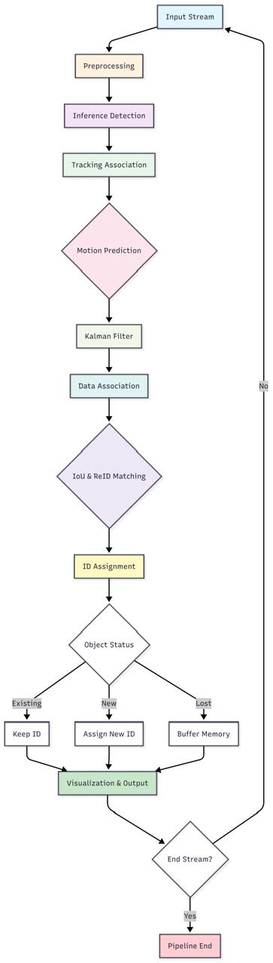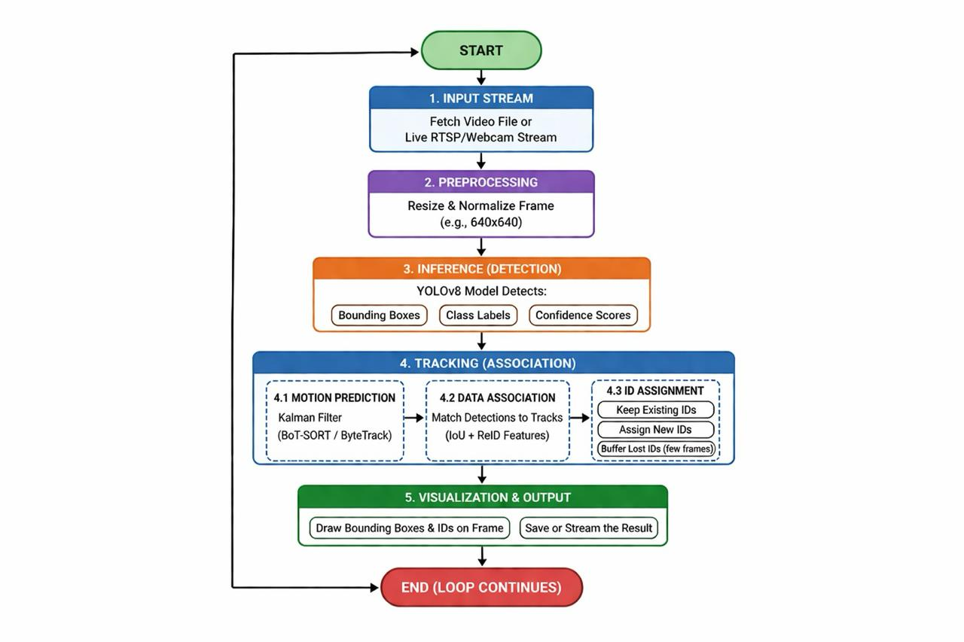\
Code:
import os
os.environ['KMP_DUPLICATE_LIB_OK'] = 'True'

import cv2
from ultralytics import YOLO

# 1. Load the YOLOv8 model (pretrained)
model = YOLO('yolov8n.pt')

# 2. Open the video file
video_path = "video.mp4"
cap = cv2.VideoCapture(video_path)

# Loop through the video frames
while cap.isOpened():
success, frame = cap.read()
if success:
# 3. Run YOLOv8 tracking on the frame
# 'persist=True' tells the tracker to remember objects from the last frame
results = model.track(frame, persist=True, tracker="botsort.yaml")

# 4. Visualize the results on the frame
annotated_frame = results[0].plot()

# 5. Display the annotated frame
cv2.imshow("YOLOv8 Tracking", annotated_frame)

# Break the loop if 'q' is pressed
if cv2.waitKey(1) & 0xFF == ord("q"):
break
else:
break

cap.release()
cv2.destroyAllWindows()

output:
Downloading https://github.com/ultralytics/assets/releases/download/v8.4.0/yolov8n.pt to 'yolov8n.pt': 100% ━━━━━━━━━━━━ 6.2MB 1.2MB/s 5.3s.2s<0.1s3s1s.6s

0: 384x640 10 cars, 76.7ms
Speed: 2.5ms preprocess, 76.7ms inference, 0.8ms postprocess per image at shape (1, 3, 384, 640)

0: 384x640 9 cars, 53.6ms
Speed: 4.2ms preprocess, 53.6ms inference, 1.1ms postprocess per image at shape (1, 3, 384, 640)

0: 384x640 9 cars, 49.8ms
Speed: 3.6ms preprocess, 49.8ms inference, 0.9ms postprocess per image at shape (1, 3, 384, 640)

0: 384x640 9 cars, 45.3ms
Speed: 3.2ms preprocess, 45.3ms inference, 0.9ms postprocess per image at shape (1, 3, 384, 640)

0: 384x640 9 cars, 42.8ms
Speed: 3.7ms preprocess, 42.8ms inference, 0.8ms postprocess per image at shape (1, 3, 384, 640)

0: 384x640 8 cars, 43.4ms
Speed: 3.0ms preprocess, 43.4ms inference, 0.8ms postprocess per image at shape (1, 3, 384, 640)

0: 384x640 9 cars, 49.6ms
Speed: 2.8ms preprocess, 49.6ms inference, 0.9ms postprocess per image at shape (1, 3, 384, 640)

0: 384x640 10 cars, 45.1ms
Speed: 2.9ms preprocess, 45.1ms inference, 0.9ms postprocess per image at shape (1, 3, 384, 640)
...
Speed: 3.4ms preprocess, 41.7ms inference, 0.8ms postprocess per image at shape (1, 3, 384, 640)
