Name: Bhatia Parth Nileshkumar

Enroll: 25MML0018
Step 1: Initialize Libraries
Import essential libraries for data manipulation (pandas, numpy), visualization (matplotlib), video processing (cv2), and progress tracking (tqdm).
import pandas as pd
import numpy as np
import matplotlib.pyplot as plt
from glob import glob
import IPython.display as ipd
from tqdm.notebook import tqdm
import cv2
Optimization: Consolidate all imports in the first cell to ensure dependencies are loaded before logic starts.

Step 2: Video Preview
Display a low-resolution preview of the sample video to verify the file path and content.
video_path = "video_sample.mp4"
ipd.Video(video_path, width=200)
<IPython.core.display.Video object>

Step 3: Extract Video Metadata
Open the video stream using OpenCV and retrieve technical specifications including total frames, resolution (height/width), and frames per second (FPS).
cap = cv2.VideoCapture(video_path)
total_frames = cap.get(cv2.CAP_PROP_FRAME_COUNT)
height = cap.get(cv2.CAP_PROP_FRAME_HEIGHT)
width = cap.get(cv2.CAP_PROP_FRAME_WIDTH)
fps = cap.get(cv2.CAP_PROP_FPS)
print(f'Total Frames: {total_frames}')
print(f'Resolution: {width}x{height}')
print(f'FPS: {fps:0.2f}')
Total Frames: 2398.0
Resolution: 1280.0x720.0
FPS: 59.94

Step 4: Extract and Visualize First Frame
Read the first frame of the video into a NumPy array and display it using Matplotlib.
### Comparison: Why we need to change the color format
# Read the frame
ret, img = cap.read()
if ret:
plt.figure(figsize=(12, 6))
# 1. Display original BGR (How OpenCV reads it)
plt.subplot(1, 2, 1)
plt.imshow(img)
plt.title("Original BGR (Wrong Colors)")
plt.axis('off')
# 2. Display converted RGB (The correct way for Matplotlib)
plt.subplot(1, 2, 2)
plt.imshow(cv2.cvtColor(img, cv2.COLOR_BGR2RGB))
plt.title("Converted RGB (Correct Colors)")
plt.axis('off')
plt.show()
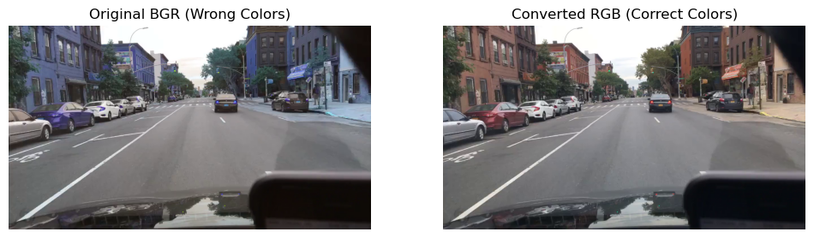
Optimization: OpenCV loads images in BGR format. For accurate colors in Matplotlib, use 'cv2.cvtColor(img, cv2.COLOR_BGR2RGB)'. Also, add 'plt.axis("off")' to remove unnecessary graph coordinates from the image view.
# OPTIMIZED CELL
cap = cv2.VideoCapture(video_path)
# 1. Metadata
info = {
"Frames": cap.get(cv2.CAP_PROP_FRAME_COUNT),
"FPS": round(cap.get(cv2.CAP_PROP_FPS), 2),
"Dims": (int(cap.get(cv2.CAP_PROP_FRAME_WIDTH)), int(cap.get(cv2.CAP_PROP_FRAME_HEIGHT)))
}
print(info)
# 2. Frame Extraction (Reads from the already open stream)
ret, img = cap.read()
if ret:
plt.imshow(cv2.cvtColor(img, cv2.COLOR_BGR2RGB))
plt.title("First Video Frame")
plt.axis('off')
cap.release()
{'Frames': 2398.0, 'FPS': 59.94, 'Dims': (1280, 720)}
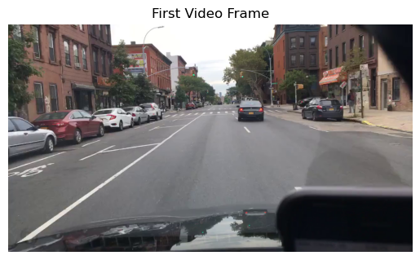

Step 5: Extract and Display Multiple Frames
This section iterates through specific intervals of the video (e.g., every 500 frames) to capture and display snapshots across the duration of the clip.
# Initialize video capture
cap = cv2.VideoCapture('video_sample.mp4')
# Calculate intervals to fit a 5x5 grid
total_frames = int(cap.get(cv2.CAP_PROP_FRAME_COUNT))
interval = total_frames // 25 # Divide into 25 equal segments
# Set up the 5x5 grid structure
fig, axs = plt.subplots(5, 5, figsize=(30, 20))
axs = axs.flatten()
for i in range(25):
frame_idx = i * interval
cap.set(cv2.CAP_PROP_POS_FRAMES, frame_idx)
ret, frame = cap.read()
if ret:
# Convert BGR (OpenCV) to RGB (Matplotlib) for correct colors
frame_rgb = cv2.cvtColor(frame, cv2.COLOR_BGR2RGB)
axs[i].imshow(frame_rgb)
axs[i].set_title(f"Frame: {frame_idx}", fontsize=12)
axs[i].axis('off')
plt.tight_layout()
plt.show()
# Release the video capture resource
cap.release()
