STAT 355

Professor Tim Keaton

NBA G.O.A.T. Debate

**Part 1**

The NBA has had over 4,500 NBA players, but 2 names have been etched in history as the greatest of all time. **LeBron James** and **Michael Jordan**. These two dominated the NBA through their hard work, sheer dominance, and unbelievable mentality. This has created an ongoing debate between the LeBron followers and the Jordan followers, and this has bled through the culture of the NBA and the world of sports. With this debate between 2 of the greatest of all time, their dominance in the playoffs stands to be the most common, with Jordan’s 6 championships and LeBron’s 4. The playoffs are a true test of a player's ability to perform under pressure, and both Jordan and James have proven their worth time and time again. I wanted to analyze their respective statistics in their playoff game log to gain insight into one of the sports world’s most heated debates. This project is made to reinforce that these claims and debates aren’t without basis, **Is the G.O.A.T conversation really that close?**

Data:



Snippet of data:

Below is a key for what the rows stand for

|  |  |  |  |  |  |
| --- | --- | --- | --- | --- | --- |
| G: Game number of the playoff | Date | Series | Tm: Team | Location | Opp: Opponent |
| G_Num: Game number of the series | Outcome | Score | MP: Minutes Player | FG: Field Goals Made | FGA: Field Goals Attempted |
| FG_Percent: Field Goal % | 3P: 3 Pointers Made | 3PA: 3 Pointers Attempted | 3P_Percent: 3 Pointer % | FT: Free Throws Made | FTA: Free Throws Attempted |
| FT_Percent: Free Throw Percentage | ORB: Offensive Rebounds | DRB: Defensive Rebounds | TRB: Total Rebounds | AST: Assists | STL: Steals |
| BLK: Blocks | TOV: Turnovers | PF: Personal Fouls | PTS: Points | GmSc: Game Score |  |

EDA:

~65.5% Win %

~66.5% Win %

This plot shows how close the winning percentages in the playoffs for the 2 dominant players.

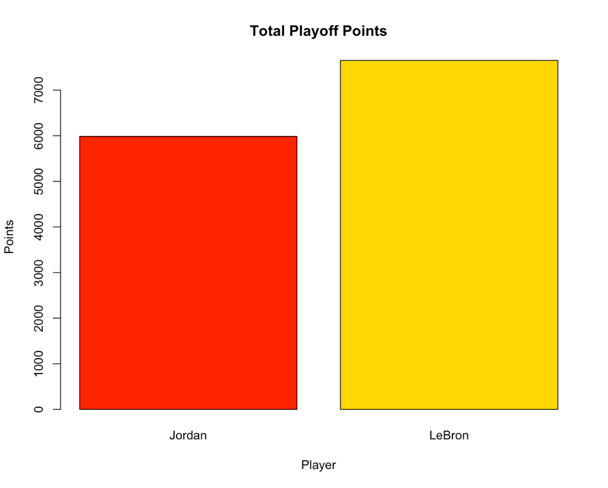

7652

5987

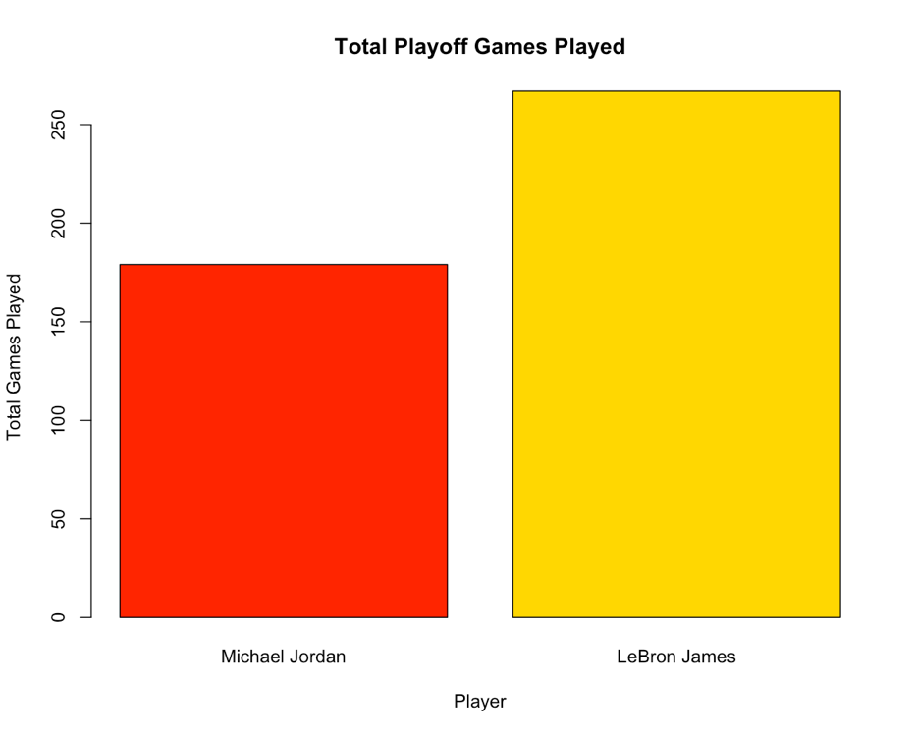

267

179

LeBron has a clear upper hand in playoff games played, even currently playing in it while Jordan is closing that gap in the total points where we can see a smaller difference in total points than total games played.

Red = Jordan

Purple = Lebron

This graph is portraying the top 50 games of Jordan and LeBron’s Game Score which is calculated by the following equation:

Game Score = PTS + 0.4 * FG - 0.7 * FGA - 0.4*(FTA - FT) + 0.7 * ORB + 0.3 * DRB + STL + 0.7 * AST + 0.7 * BLK - 0.4 * PF - TOV

This graph is made using a very careful formula made by John Hollinger as a rough measure of a player’s performance in a single game.

**Part 2**

Research Question 1: Does one player have a stronger correlation between his game score and his teams score margin than the other?

This question is one that I was very excited to answer as both players receive heavy criticism from the other’s fanbase that they have always needed to play on good teams with other greats to win games. This question would give an answer on who affected their teams to a greater extent. To answer this question, let’s break it into smaller parts. Is there a correlation between Jordan’s Game Score and his teams score margin. Is there one for LeBron. If there is for both, is there one with a stronger effect on their team’s performance?

Let’s look at the Statistic:

* Game Score in the NBA is a statistic developed by by John Hollinger and is meant to be a rough measure of a player’s performance in a single game. The formula is as follows.
  + Game Score = PTS + 0.4 * FG - 0.7 * FGA - 0.4*(FTA - FT) + 0.7 * ORB + 0.3 * DRB + STL + 0.7 * AST + 0.7 * BLK - 0.4 * PF – TOV
* Team Score Margin is the amount a team wins or losses by, “-8” would mean that your team lost by 8 points, “+16” or “16” means that your team won by 16 points.

Let’s start by looking at the game score averages for both LeBron and Jordan.

These averages are very similar with Michael Jordan having a slightly greater average. Let’s dive into the tests,

We can first look at the data and the trends on a scatterplot with a regression line to visualize the correlation.

According to the plots for both athletes, we seem to have a positive relationship for both, but the data seems to vary fairly frequently allowing me to say that the correlation seems moderate, especially for the Jordan data.

The relationship are as follows:

As Jordan's Game Score increases by 1, The score margin during that game increases by 0.3055

As LeBron's Game Score increases by 1, The score margin during that game increases by 0.5777

Before we run the test we need to make sure out assumptions are valid,

**Jordan:**

LeBron:**

Given that the residual plot displays no significant trend and the fitted line appears relatively compared to the data straight, further testing is necessary to assess how well the data fits and to determine whether the correlation is statistically significant. To do this, we will check normality in the Q-Q plot which seems like it follows a relatively linear path.

**Hypothesis Test at 𝛼 = .05**

H​0 :​ There is no significant correlation between the score margin and the player’s game score.

H​a:​ There is a significant correlation between the score margin and the player’s game score.

* We will first stat with Jordan’s data

* + Since 𝒑 = 0.006404 < 𝛼 = .05, reject H​0. We have sufficient evidence to conclude that ≠ 0. As Jordan's Game Score increases, the score margin is also expected to change.
* We will now look at LeBron’s data

* + Since 𝒑 = 1.612e-08 < 𝛼 = .05, reject H​0. We have sufficient evidence to conclude that ≠ 0. As LeBron's Game Score increases, the score margin is also expected to change.

We now know that both of the players have a correlation towards the score margin, but we do not know if there is a significant difference in the amount that they affect their respective teams, so let’s compute an ANOVA test that will result us in knowing if there is a significant difference between the correlations of Michael Jordan and LeBron James in their personal Game Score and that game's score.

**ANOVA Test at 𝛼 = .05**

H​0 :​ There is no difference in the mean Score Margin for Michael Jordan and LeBron Jamesand their respective Game Scores

H​a:​ There is a difference in the mean Score Margin for Michael Jordan and LeBron Jamesand their respective Game Scores

Since 𝒑 = 0.0734 > 𝛼 = .05, we fail to reject H​0. we do not have sufficient evidence to reject the null hypothesis that there is no difference in the mean Score for Michael Jordan and LeBron James and their respective Game Scores.

To answer the Research questions, we performed correlation tests to find out if Jordan and LeBron’s Game Score affected the score margin of that game and concluded that it did. We then ran an ANOVA test to compare the relationship between personal Game Score and game score margin for Michael Jordan and LeBron James. We received the results that we did not have enough evidence to conclude that one athlete has a stronger correlation than the other.

Research Question 2: Is there a significant difference in the average number of points scored per game by LeBron James and Michael Jordan in the playoffs?

The most basic statistic in deciding who the greatest basketball player of all time is points. Let’s compare the amount points that LeBron and Jordan.

First let’s look at a histogram of their total points.

These histograms show that Lebron had proportionally more 30+ points games than LeBron did. It also shows the consistency of Jordan and the longevity of LeBron.

Similar to the last question, we used Q-Q plots to assume normality by the linearity of the quantiles:

**Hypothesis Test at 𝛼 = .05**

H​0 :​ There is no significant difference in the mean points between Michael Jordan and LeBron James in the playoffs

H​a:​ There is a significant difference in the mean points between Michael Jordan and LeBron James in the playoffs

Since 𝒑 = 0.1.46e-08 < 𝛼 = .05, we reject H​0. we have sufficient evidence to reject the null hypothesis and conclude that there is a significant difference in the mean points between Michael Jordan and LeBron James in the playoffs

Now that we this information, we know that there is a difference in mean points between MJ and King James, but we do not know if this is because of the players effective scoring or bad shot judgement. We should test the fg% to see if there is a difference in points because one is a better (or worse scorer with a lack of judgement) scorer than the other.

H​0 :​ There is no significant difference in the mean field goal percentage between Michael Jordan and LeBron James in the playoffs

H​a:​ There is a significant difference in the mean field goal percentage between Michael Jordan and LeBron James in the playoffs

Since 𝒑 = 0.2382 > 𝛼 = .05, we fail to reject H​0. We do not have sufficient evidence to reject the null hypothesis and conclude that there is no significant difference in the mean field goal percentage between Michael Jordan and LeBron James in the playoffs.

This t-test shows us that there is no difference in the skill level of the person shooting the ball or scoring more, so if we look at the above summary of the data, we can see that Jordan is better scorer than LeBron in the Playoffs. This is supported by us rejecting the null hypothesis of “no significant difference in the mean field goal percentage between Michael Jordan and LeBron James in the playoffs” from the first t-test.

Research Question 3: Is there an affect on the location (home or away) on the variance of the points LeBron or Jordan score.

The NBA’s home field advantage is said to be the most meaningful of the 4 American sports with teams winning 60% of their home court games. Does this translate to the G.O.A.T.’s? If it does which one gets affected the most?

We can start by plotting Q-Q Plots of the 4 situations to know if we need to do a Wilcoxon test instead of a F-test, LeBron at home, LeBron away, Jordan at home, Jordan away.

These q-q plots are all linear giving us a valid assumption showing that the data is normally distributed.

H​0 :​ There are equal variance between Jordan’s points scored at home and away.

H​a:​ There are not equal variance between Jordan’s points scored at home and away.

Since 𝒑 = 0.8344 > 𝛼 = .05, we fail to reject H​0. We do not have sufficient evidence to reject the null hypothesis and conclude that there are equal variance between Jordan’s points scored at home and away.

H​0 :​ There are equal variance between LeBron’s points scored at home and away.

H​a:​ There are not equal variance between LeBron’s points scored at home and away.

Since 𝒑 = 0.1061 > 𝛼 = .05, we fail to reject H​0. We do not have sufficient evidence to reject the null hypothesis and conclude that there are equal variance between LeBron’s points scored at home and away.

The data shows that there is no evidence to reject the null hypothesis of equal variances for both LeBron James and Michael Jordan, indicating that the variances of points scored by each player in their home and away games are not significantly different.

**Data Set:** [**https://www.basketball-reference.com**](https://www.basketball-reference.com)

[**Jordan**](https://www.basketball-reference.com/players/j/jordami01/gamelog-playoffs/) **+** [**LeBron**](https://www.basketball-reference.com/players/j/jamesle01/gamelog-playoffs/)