INSTALL UBUNTU ON EXTERNAL PENDRIVE GUIDE

This is a step by step guide for installing the ubuntu operating system on any removable drive. This will create external drive having ubuntu and grub installed on it, and also detected by the UFFI boot option. So we can directly boot into the ubuntu installed on drive

Pre-requirements :-

1) An empty external hard drive (i.e. USB)
2) An another Ubuntu Linux bootable USB (or CD)(guide to make bootable drive)
3) Assuming you already have dual booted systems (if you are in AUV-IITB thats the first step)
4) Backup your important files

STEP 1:- PARTITIONING THE EXTERNAL DRIVE

You can use any tool of your choice for this , I’m using gparted.
First format the external drive.
Go to gparted delete any previous partitions if present.
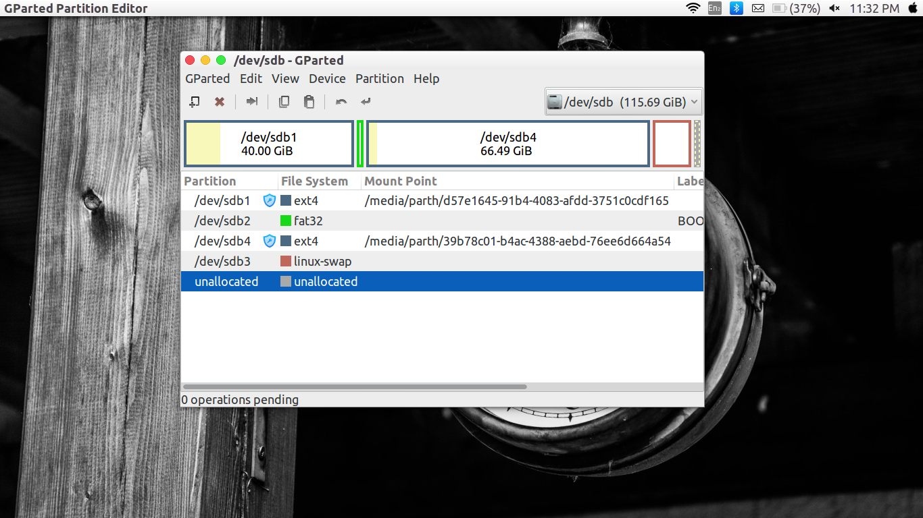
Then create four partitions in this fashion.
1) Around 40 gb ext4 partition for “/”
2) A 200 Mb FAT32 partition next to the “/”
3) Around double the ram memory (i.e. 20Gb ext4) for “swap” at the end of unallocated space
4) The middle ext4 partition for “/home”

Then Right Click on the Fat32 partition → Manage Flags → tick “esp” & “boot” & deselect rest.
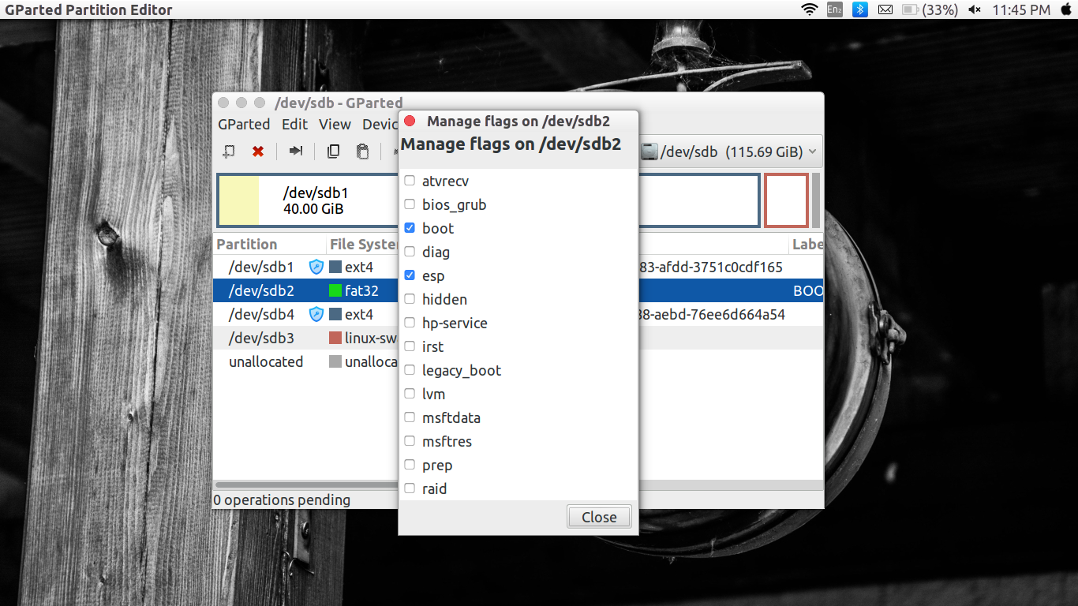
And then apply the changes.

Points to note :-
it is not necessary to name your partition.
Sizes of partition can be varied accordingly.
It is advised to keep the FAT32 partition just after “/” and of size 200Mb

STEP 2 : INSTALLING UBUNTU

Boot your computer from the Ubuntu Linux bootable USB drive. Remember that you may have to enter your computer's boot manager to do that (on Dell laptop I have to press F10; on most other BIOS I've seen it's F9; consult your BIOS documentation).
Install Ubuntu Linux regularly. When it prompts you about the disk layout choose Something Else and partition your external drive (called HDD from now).
Then select the partition you previously created and designate them the respective types
For e.g. partition 1 as ext4 and role “/”, partition 4 as swap, etc
Dont do anything for the FAT32 partition
Then install ubuntu normally.
STEP 3 : DOING BOOT REPAIR ON YOU LAPTOP
Once you install ubuntu in HDD shutdown the system remove the external drive.
Switch on your PC !!!!!!!!!!!!
CONGRATULATIONS !!!!!!!!! YOU NO MORE HAVE GRUB ON SYSTEM.

Don’t worry, reboot your system from bootable drive , then click on “Try Ubuntu”.Now once you boot up, connect to a network , open terminal and type the following commands
sudo add-apt-repository ppa:yannubuntu/boot-repair
sudo apt-get update
sudo apt-get install -y boot-repair && boot-repair

This will open a boot repair window , select “Recommended Repair” from the two options. Let the process finish. Then shutdown the system remove the bootable drive.
Then power on ,and test whether the grub is back in your laptop
note :- dont worry about the many options that appear in grub after boot repair just ignore that ,mostly ubuntu will be the first option and windows boot manager will be the second last (atleast for me it was). Try to boot into both os and test everything is working.
If the grub is not reinstalled properly you can checkout this.

STEP 4 : Create an ESP on the Ubuntu HDD

A hard drive is not bootable with UEFI unless it has an ESP (EFI System Partition). An ESP is simply a FAT32 partition with a special flag that tells the EFI BIOS to look inside it for boot information. We have to create one on your hard drive.
- Plug in your external HDD and the Ubuntu Linux bootable USB stick.
- Boot with the Ubuntu Linux bootable USB stick using the option to try Ubuntu before installing.
- Open a Terminal (CTRL-ALT-T)
- Run sudo fdisk -l to get a list of partitions.
- Identify from them the drive that has the Linux partitions, in my case /dev/sdb. I'll call it /dev/sdX from now on.
- Also identify the partition that contains the root filesystem. I will call it /dev/sdXY from now on.
- Launch GParted from the Terminal:
sudo gparted /dev/sdX
Why not just click on GParted on your desktop? Well, I kept receiving errors about the Ubuntu Linux bootable USB stick because it was already in use. Of course it is, I am using it to run the computer off it, duh!
- Resize the first partition on disk to have another 200 Mb of free space after it.
- Create a new partition on the free space, changing the file system to fat32.
- Apply operations. You need to do that now for the next step to be possible.
- Right click the new partition.
- Click on Manage Flags.
- Set the boot and esp flags. This is what makes the partition "special" to the EFI BIOS.
- One more thing! Note down the the partition that contains the ESP filesystem. I will call it /dev/sdXZ from now on.
STEP 5 : Make sure the Ubuntu installation on the external HDD can see the ESP & INSTALLING GRUB
The new ESP on the external drive must be visible by the Ubuntu installation in the HDD. Otherwise GRUB2, the Linux bootloader, won't be able to update itself, making your system unbootable after the next kernel update at the latest.
- Launch GParted from the Terminal, as we saw above:
sudo gparted /dev/sdX
- Double click the partition with your Linux root (/) filesystem on the external HDD
- Note down the UUID, e.g. 01234567-89ab-cdef-0123-4567890abcde
- Double click the new FAT32 partition and note down the UUID, e.g. 0123-ABCD
- Close GParted
- Open a Terminal (and run following commands in sequence
- There is a line with /boot/efi already in this file. Comment it by placing a # in front of it. Add the following line:
sudo umount /media/ubuntu/01234567-89ab-cdef-0123-4567890abcdety
sudo mount /dev/sdXY /mnt
sudo nano /mnt/etc/fstab
UUID=0123-ABCD /boot/efi vfat defaults 0 1
- Then run these commands again
mount /dev/sdXZ /mnt/boot/efi
for i in /dev /dev/pts /proc /sys; do sudo mount -B $i /mnt/$i; done
cp /etc/resolv.conf /mnt/etc/
modprobe efivars
sudo chroot /mnt
grub-install -d /usr/lib/grub/x86_64-efi --efi-directory=/boot/efi/ --removable /dev/sdX

AND FINALLY!!!!! WE ARE DONE.
Now reboot system into boot options and you should see a option to boot from external HDD.
If you missed anything , or facing any error please refer this.

