**WebApp for Smart Healthcare**

**By**

**Parthkumar Panchal**

**16BCE115**

**&**

**Manan Charania**

**16BCE100**



**DEPARTMENT OF COMPUTER SCIENCE & ENGINEERING**

**Ahmedabad 382481**

**WebApp for Smart Healthcare**

**Mini Project – II**

Submitted in fulfillment of the requirements

For the degree of

**Bachelor of Technology in Information Technology**

By

**Parthkumar Panchal**

**16BCE115**

**&**

**Manan Charania**

**16BCE100**

Guided By

**Dr. Sudeep Tanwar**

**[DEPARTMENT OF COMPUTER SCIENCE & ENGINEERING]**



**DEPARTMENT OF COMPUTER SCIENCE & ENGINEERING**

**Ahmedabad 382481**

# CERTIFICATE

This is to certify that the Mini Project-II entitled “WebApp for Smart Healthcare” submitted by Parthkumar Panchal (16BCE115) and Manan Charania (16BCE100), towards the partial fulfillment of the requirements for the degree of Bachelor of Technology inInformation Technology of Nirma University is the record of work carried out by him/her under my supervision and guidance. In my opinion, the submitted work has reached a level required for being accepted for examination.

Dr. Sudeep Tanwar Dr. Madhuri Bhavsar

Associate Professor Dept. of Computer Science & Engineering,

Department of Computer Science & Engg., Institute of Technology,

Institute of Technology, Nirma University,

Nirma University, Ahmedabad

Ahmedabad

# ACKNOWLEDGEMENT

We would like to express our utmost gratitude to our mentor during this Mini-Project II, Dr. Sudeep Tanwar as well as our Head of Department, Dr. Madhuri Bhavsar who have given us the wonderful opportunity to research on the topic “Healthcare System”. Working with our guide and researching this fascinating topic helped us improve in a lot of ways. It has helped us improve our people skills, learn how to do proper research, how to properly write a research paper and has given us a lot of valuable experience. The knowledge we gained from completing this project is just another bonus.

I would also like to thank our families and friends who helped us complete this project before the deadline. They would encourage us to do my very best and helped us out when we were stuck. Without them, this project would not have been as good as it is now

# ABSTRACT/ Outline

Web development is one of the most important profession today. The objective of Mini-Project 2 is to put our theoretical knowledge of HTML, CSS, JavaScript to the test by making a Web application.

Through such a project, we can experience the development process with all the problems that come with it.

Here, we are going to use PHP, HTML, JavaScript to make a HealthCare System Web application. We are using MySQL for Database Management.

We have implemented Authentication, Database Editing, also tried to implement an NLP code to find symptom disease relation.

# CONTENTS

CERTIFICATE 3

ACKNOWLEDGEMENT 4

ABSTRACT/ Outline 5

CONTENTS 6

Introduction 7

What we are building? 7

Progress 7

Comparative Study 8

Diagrams 9

Project Overview 11

Conclusion 18

# Introduction

Our project is a Smart Healthcare System webapp. We have analyzed different Healthcare apps and tried to integrate their functions in our app, and also tried to add some new features.

# What we are building?

* We are building a WebApp which facilitate users in making better health decisions.
* It helps patients maintain their regular medication.
* It helps users to maintain their diet and fitness.
* It brings medical advice to the rural areas where there is a lack of doctors.
* It will help you to find information about different medications.

# Progress

* Authentication module – Login, Sign up, change password, OTP, Hashing.
* Fitness Guidance module
* Medicine info module

# Comparative Study

|  |  |  |  |  |  |  |  |  |  |  |  |  |  |
| --- | --- | --- | --- | --- | --- | --- | --- | --- | --- | --- | --- | --- | --- |
| Sr. No. | **Country** | **Application Name** | **Invention Year** | **Current Status** | **Symptom Check** | **Physician appointments** | **Medicine Info** | **Multiple Languages** | **Health and Fitness tips** | **Report Generation** | **Objectives** | **Pros** | **Cons** |
| 1 | USA | WebMD | 1996 | In Use | yes, introduced after 2009 | Maybe | yes | Yes | yes | no | A source for trustworthy health news and information | Physician reviewed health inputs, symptom checks, interactive tools | No affiliations with doctors, only provide news |
| 2 | UK | Itriage | 2008 | Discontinued | yes | No | No | Yes, available in most popular languages | no | no | Helps patients find doctors on the base of their symptoms | ability to search symptoms, good database of doctors, one of the first to introduce symptom checks | Discontinued as did not make much revenue for the developers |
| 3 | USA | Pocket First Aid & CPR | 2009 | In Use | No | No | No | Yes, available in most popular languages | yes | no | Help people stuck in a situation without a professional | Informs you about basic first aid in difficult situations | personal data may be stored locally |
| 4 | UK | Instant Heartrate | 2010 | In Use | No | No | No | Yes, available in most popular languages | no | no | Heartrate mesurement tool | Gives a pulse waveform | Accuracy cannot be guaranteed |
| 5 | UK | Carezone | 2012 | In Use | No | No | Yes | Yes, available in most popular languages | no | no | Helps patients remember to take their medications | Medication reminder, Home delivery of medicine | No affiliations with doctors |
| 6 | USA | GoodRx | 2012 | In Use | No | No | Yes | Yes, available in most popular languages | no | no | Stop overcharging of patients for their medicines | Gives different offers on various meds, and insurance | Asks for insurance numbers |
| 7 | India | Portea | 2013 | In Use | No | Yes | yes | Yes, available in most popular languages | no | yes | Improve Health outcomes for patients, and home healthcare services | Doctor consultaion, nursing, lab tests | Works in a 24 city network |
| 8 | India | Zoctr | 2013 | In Use | No | Yes | No | Yes, available in most popular languages | no | no | Home health aggrgator platform | Allows to book doctors for home visits | Does not provide service in rural areas |
| 9 | UK | Migrane Buddy | 2014 | In Use | No | No | No | Yes, available in most popular languages | yes | yes | Diary keeping app for migrane and headaches | Gives a report, can make a timeline of migrane attacks | Only Helpful for those that suffer from migrane |
| 10 | UK | Calm: Meditation | 2014 | In Use | No | No | No | Yes, available in most popular languages | yes | no | Guided Meditation app | helps meditate, has music and guides | is based on a paid subscription, requires heavy user engagement and commitment to achive results |
| 11 | USA | Micromedex | 2014 | In Use | No | No | Yes | Yes, available in most popular languages | no | yes | Introduced by IBM to help patients learn about what drugs they take/need | Comparision of drugs, health information, imports lab reports | User needs to have a basic knowledge of science to understand the different medicine available |
| 12 | India | Practo | 2014 | In Use | No | Yes | No | Yes, available in most popular languages | no | no | Book appointments, and online consultation | Gives proper directions to doctors offices | Reviews given to doctors are controlled by the doctors themselves |
| 13 | India | Credihealth | 2015 | In Use | No | Yes | No | Yes, available in most popular languages | no | no | End to end services between patients and doctors | Book appointments, Talk wit experts | based on a paid subscription, unreliable appointments |
| 14 | USA/UK | Google Deepmind Health | 2016 | In Use | Yes | No | Yes | Yes, available in most popular languages | no | no | Put advanced technology in use to help doctors serve better | symptom check, information on handling ailments | data sharing controversy |
| 15 | UK | Diabetes-M | 2017 | In Use | No | No | No | Yes, available in most popular languages | yes | yes | Help Diabetics maintain records of blood sugar levels | Sends reports directly to physicians, Only for people with diabetes. | Relatively new, similar apps already exist |
| 16 | Germany | Ada | 2017 | In Use | yes | No | Yes | Yes, available in english and german | yes | no | Smart Assistant for healthcare | Can be interactive, Gives possible ailments after listening to symptoms | Need to know german(english has been added recently) |
| 17 | UK | Aetna Health | 2018 | In Use | yes | No | No | Yes, available in most popular languages | no | no | Helps patients find doctors on the base of their symptoms | ability to search symptoms, good database of doctors | Limited to specific few members, rebranding of Itriage with hindered functionality |
| 18 | India | Docsapp | 2018 | In Use | no | yes | no | yes, available in indian languages | no | no | help patients reach doctors | ability to chat and call doctors directly in the app | late to the party, no symptom checks |
| 19 | India | 1uphealth | 2017 | In Use | no | no | no | Yes, available in most popular languages | yes | yes | Helps patient talk and help each other | huge database of patient info, let the patients talk among themselves | provides info about patients to many healthcare organisations |
| 20 | US | Medici | 2018 | In Use | no | yes | no | Only available in Eenglish | yes | no | Chat app for Doctors and Patients | Allows patients to cat with specific doctors on thier need | does not provide based on symptoms we need to specify which doctor we want to talk to |

# Diagrams

We have created a class diagram to help with the development of this project

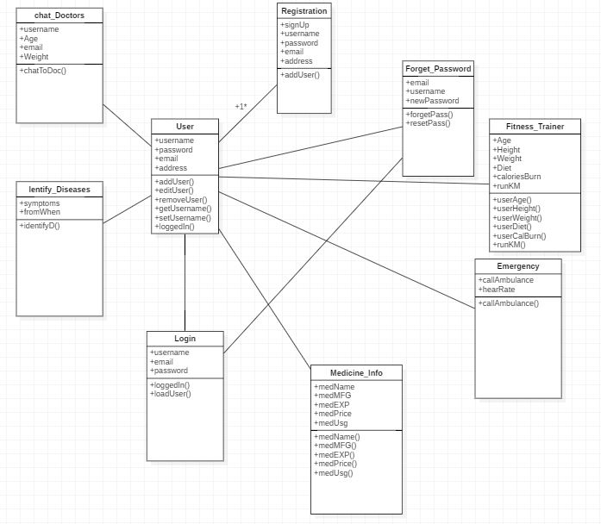

# Project Overview

Now we shall be seeing the screens of the application and describing them

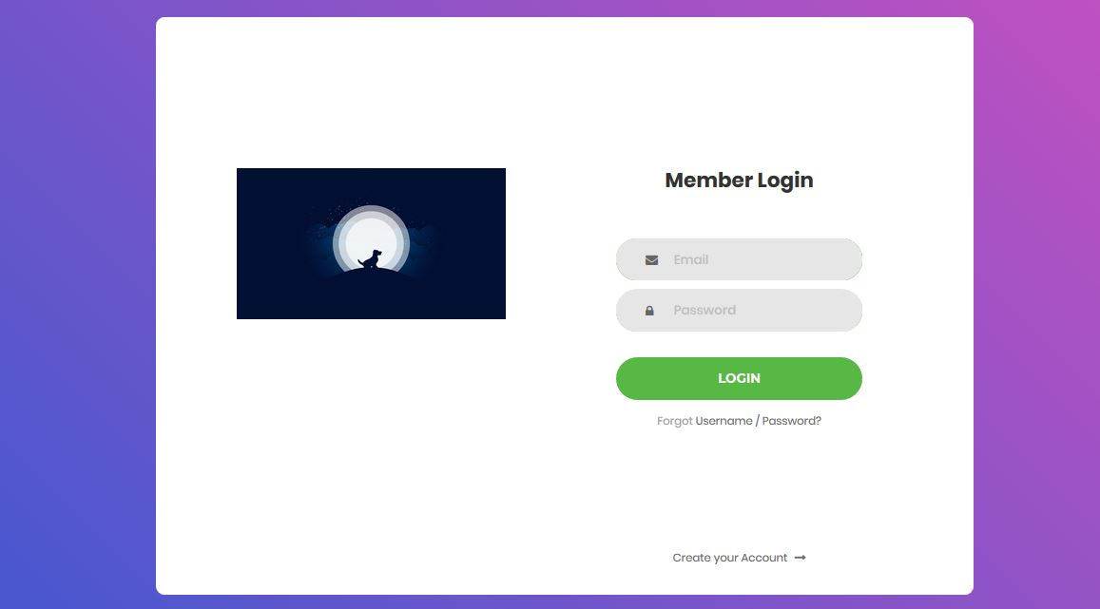

* This is the login page , it is the first page that will be shown.
* Create account and forgot password options are also given here

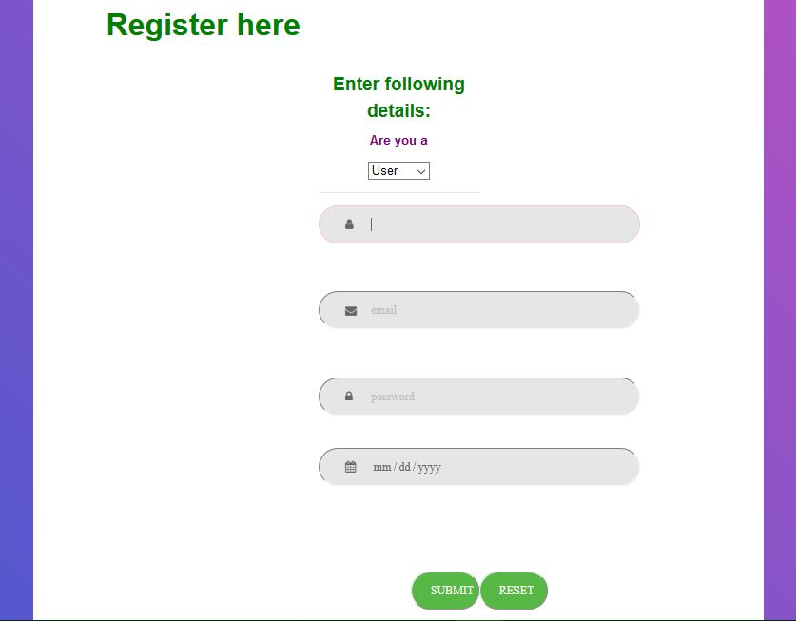

* This is the registration page , registration for user and doctors are available
* Password will be hashed and then stored in a database.
* Password and email fields also have JavaScript validation applied

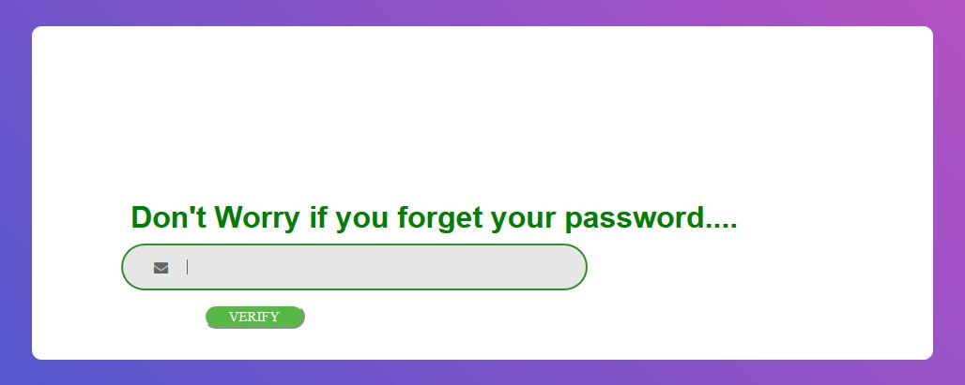

* Forget password page asks for an email Id checks if it is present on the database and then sends an email with an OTP.
* 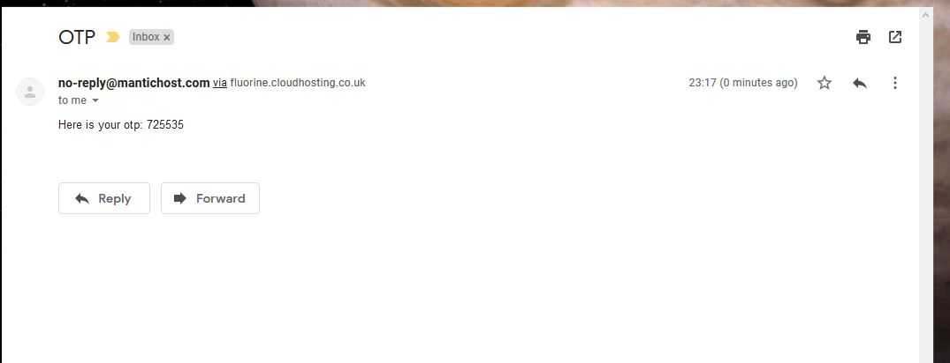
* 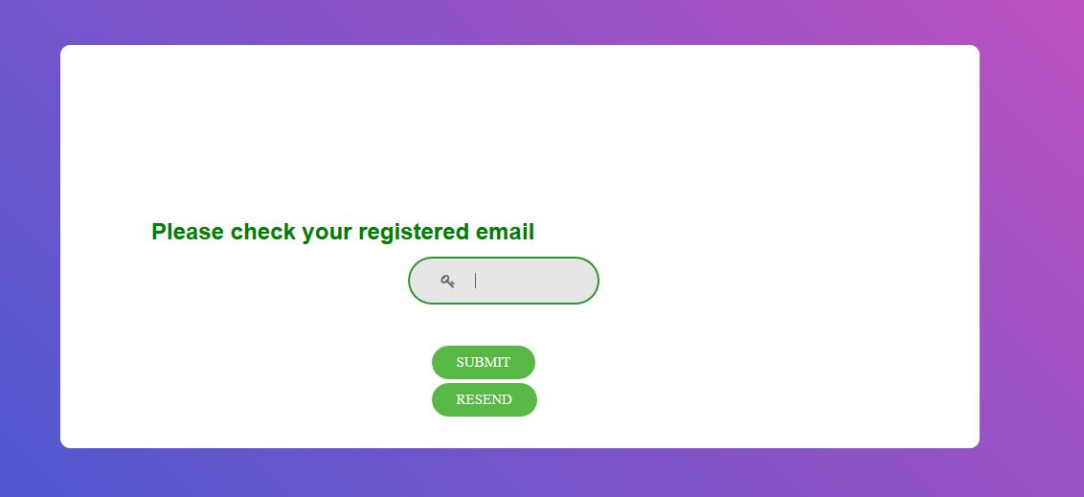
* After OTP is entered you will be asked for a new password.
* 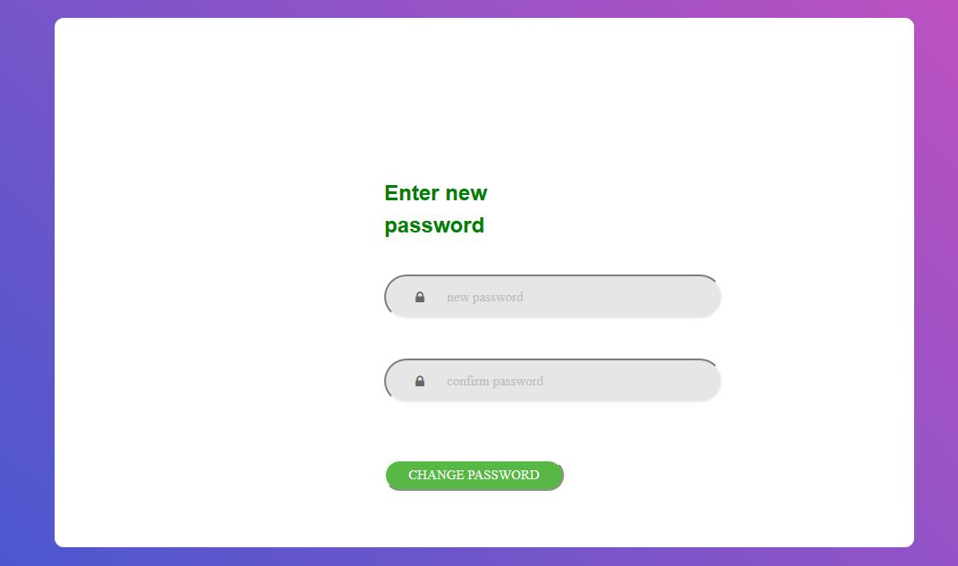

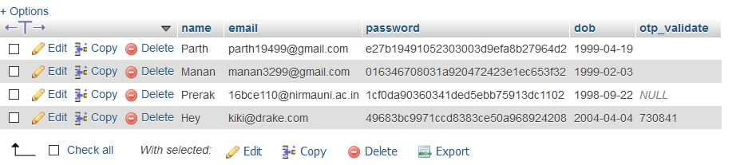

Example of primary database of users.

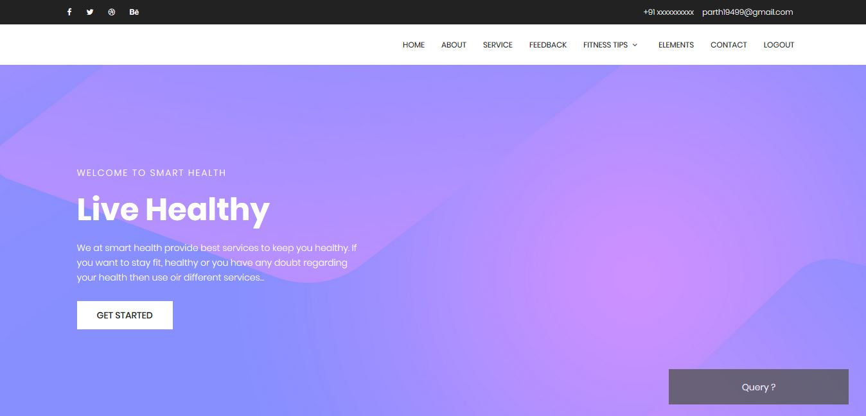

As you can see here on our homepage a query popup is also provided which will send this query with the subject to the admin of the page.

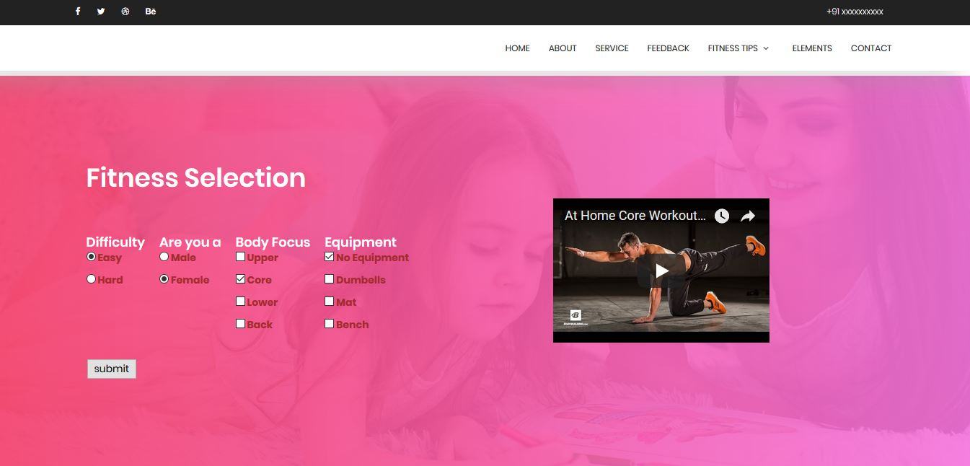

This is the fitness guide which will according to your choice provide you with workout videos and tips and guides.

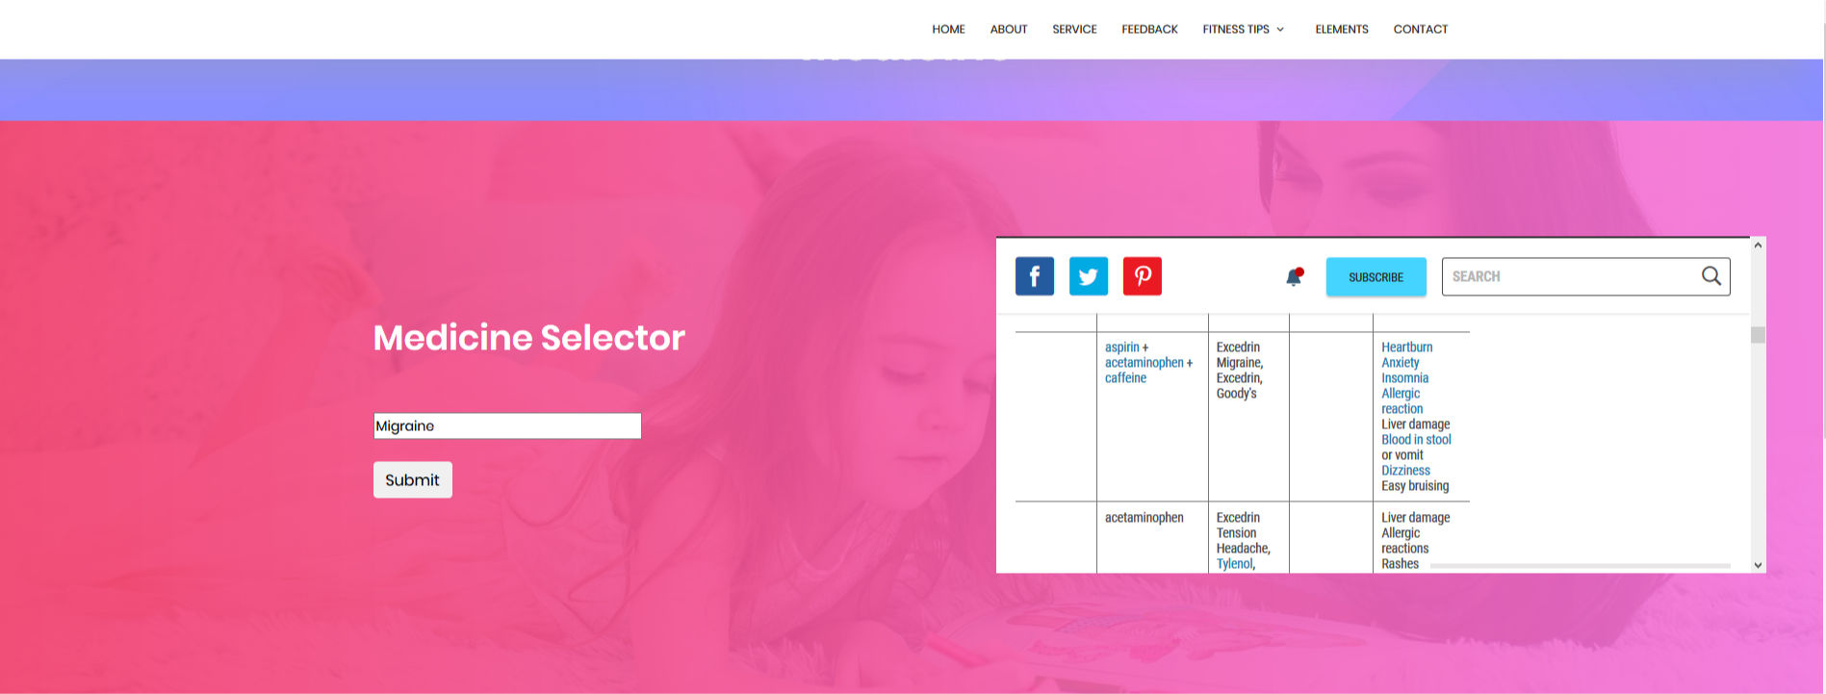

# Conclusion

We have created a web app to provide health services to every person.

After having worked on this project we have learned how to use css and html for frontend development and also use php, JavaScript for backend development