**WebApp for Smart Healthcare**

**By**

**Parthkumar Panchal**

**16BCE115**

**&**

**Manan Charania**

**16BCe100**



**DEPARTMENT OF COMPUTER SCIENCE & ENGINEERING**

**Ahmedabad 382481**

**WebApp for Smart Healthcare**

**Mini Project – II**

Submitted in fulfillment of the requirements

For the degree of

**Bachelor of Technology in Information Technology**

By

**Parthkumar Panchal**

**16BCE115**

**&**

**Manan Charania**

**16BCE100**

Guided By

**Dr. Sudeep Tanwar**

**[DEPARTMENT OF COMPUTER SCIENCE & ENGINEERING]**



**DEPARTMENT OF COMPUTER SCIENCE & ENGINEERING**

**Ahmedabad 382481**

CERTIFICATE

This is to certify that the Mini Project -II entitled “WebApp for Smart Healthcare” submitted by Parthkumar Panchal (16BCE115) and Manan Charania (16BCE100), towards the partial fulfillment of the requirements for the degree of Bachelor of Technology inInformation Technology of Nirma University is the record of work carried out by him/her under my supervision and guidance. In my opinion, the submitted work has reached a level required for being accepted for examination.

Dr. Sudeep Tanwar Dr. Madhuri Bhavsar

Associate Professor Dept. of Computer Science & Engineering,

Department of Computer Science & Engg., Institute of Technology,

Institute of Technology, Nirma University,

Nirma University, Ahmedabad

Ahmedabad

**ACKNOWLEDGEMENT**

We would like to express our utmost gratitude to our mentor during this Mini-Project II, as Dr. Sudeep Tanwar well as our Head of Department, Dr. Madhuri Bhavsar who gave us the wonderful opportunity to research on the topic “Healthcare System”. Working with our guide and researching this fascinating topic helped us improve in a lot of ways. It has helped us improve our people skills, learn how to do proper research, how to properly write a research paper and has given us a lot of valuable experience. The knowledge we gained from completing this project is just another bonus.

I would also like to thank our families and friends who helped us complete this project before the deadline. They would encourage us to do my very best and helped us out when we were stuck. Without them, this project would not have been as good as it is now

**ABSTRACT/ Outline**

Web development is one of the most important profession today. The objective of Mini-Project 2 is to put our theoretical knowledge of HTML, CSS, JavaScript to the test by making a Web application.

Through such a project, we can experience the development process with all the problems that come with it.

Here, we are going to use PHP, HTML, JavaScript to make a HealthCare System Web application. We are using MySQL for Database Management.

We have implemented Authentication, Database Editing, also tried to implement an NLP code to find symptom disease relation.

**CONTENTS**

CERTIFICATE 3

ACKNOWLEDGEMENT 4

ABSTRACT 5

Introduction 7

What are we building? 7

Timeline 7

Progress 7

Comparative Study 8

Diagrams 9

Class Diagram 10

Project Overview 11

Conclusion 11

Future Work 11

Appendix – A List of Useful Websites 11

**Introduction**

Our project is a Smart Healthcare System webapp. We have analyzed different Healthcare apps and tried to integrate their functions in our app, and also tried to add some new features.

**What we are building?**

* We are building a WebApp which facilitate users in making better health decisions.
* It helps patients maintain their regular medication.
* It helps users to maintain their diet and fitness.
* It brings medical advice to the rural areas where there is a lack of doctors.
* It will help you to find information about different medications.

**Progress**

* Authentication module – Login, Sign up, change password, OTP, Hashing.
* Fitness Guidance module
* Medicine info module

**Comparative Study**

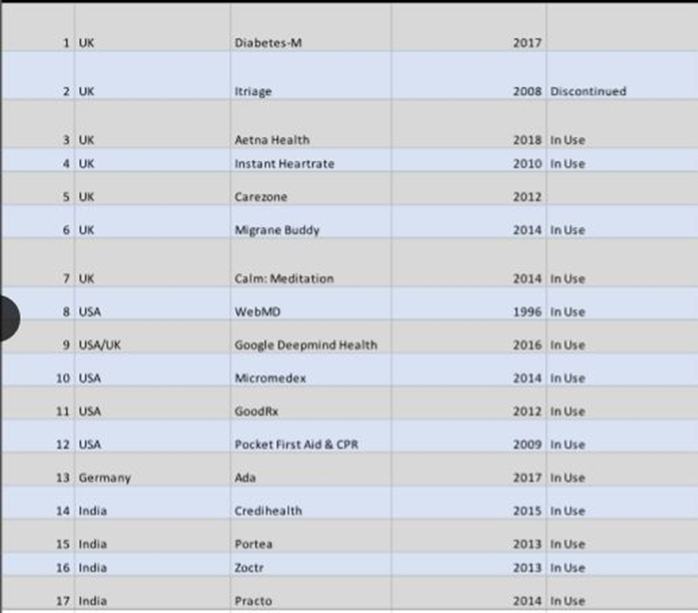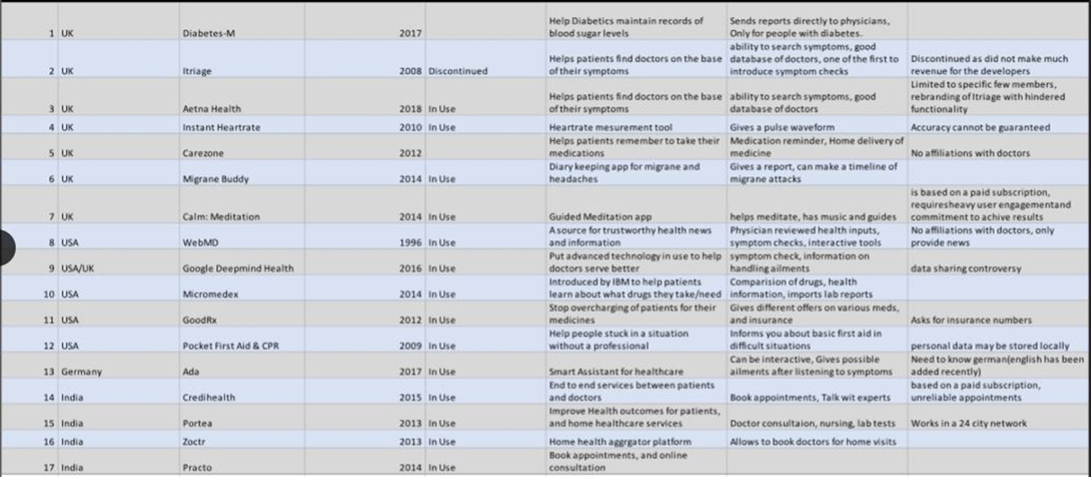

**Diagrams**

We have created a class diagram to help with the development of this project

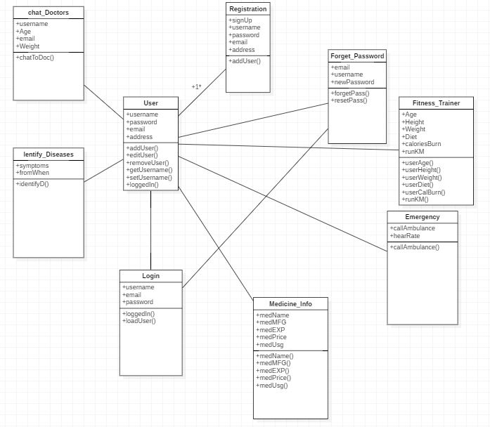

**Project Overview**

Now we shall be seeing the screens of the application and describing them

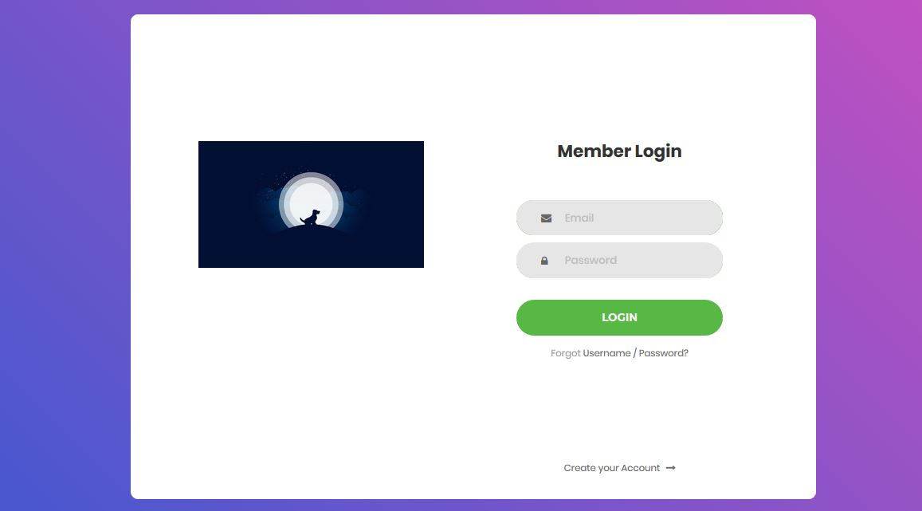

* This is the login page , it is the first page that will be shown.
* Create account and forgot password options are also given here

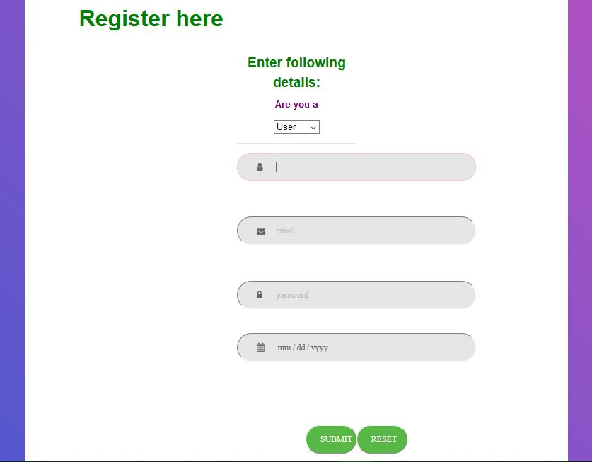

* This is the registration page , registration for user and doctors are available
* Password will be hashed and then stored in a database.
* Password and email fields also have JavaScript validation applied

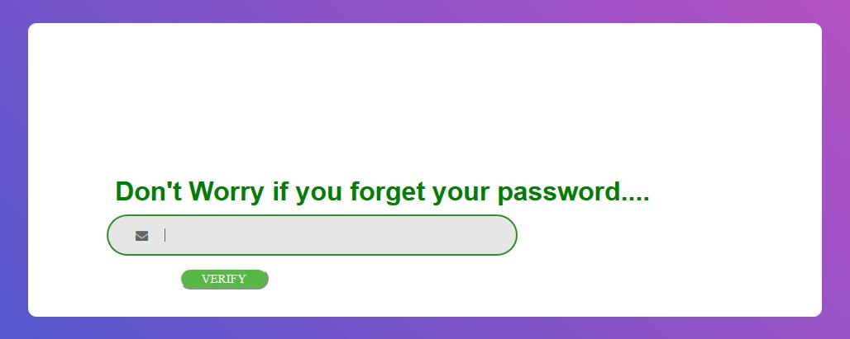

* Forget password page asks for an email Id checks if it is present on the database and then sends an email with an OTP.
* 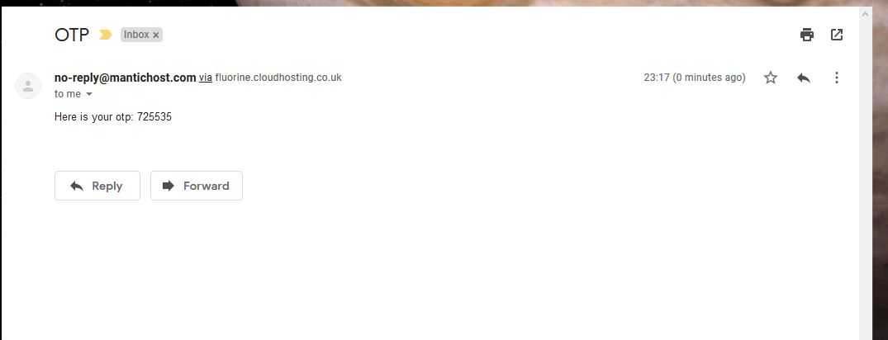
* 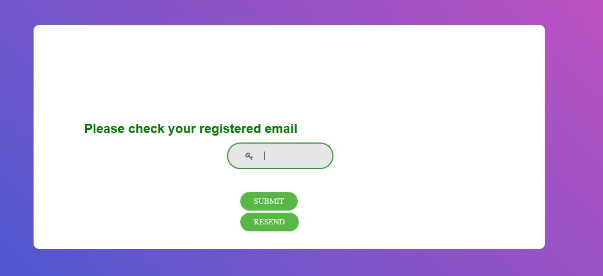
* After OTP is entered you will be asked for a new password.
* 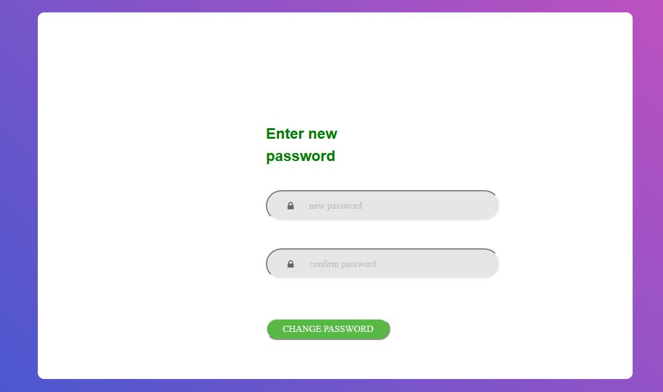

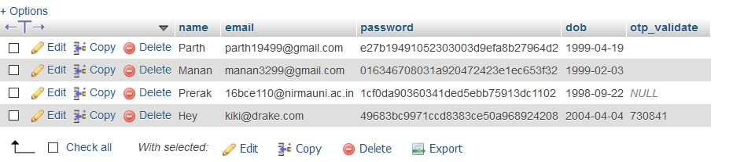

Example of primary database of users.

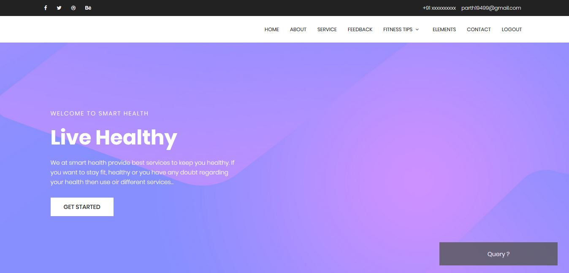

As you can see here on our homepage a query popup is also provided which will send this query with the subject to the admin of the page.

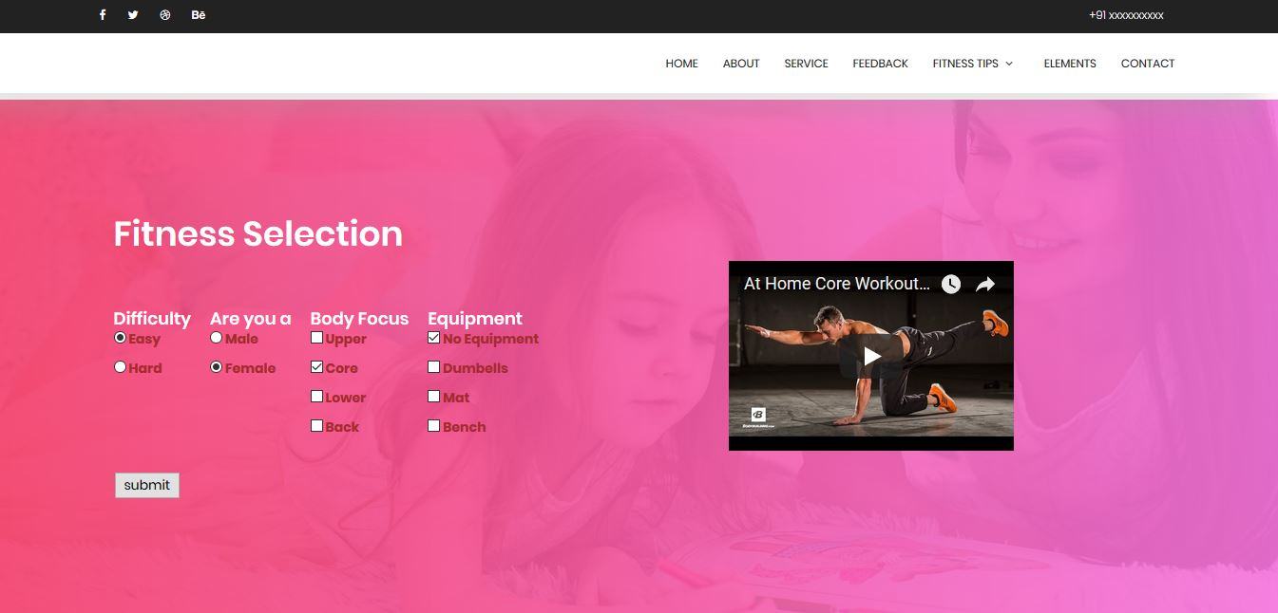

This is the fitness guide which will according to your choice provide you with workout videos and tips and guides.

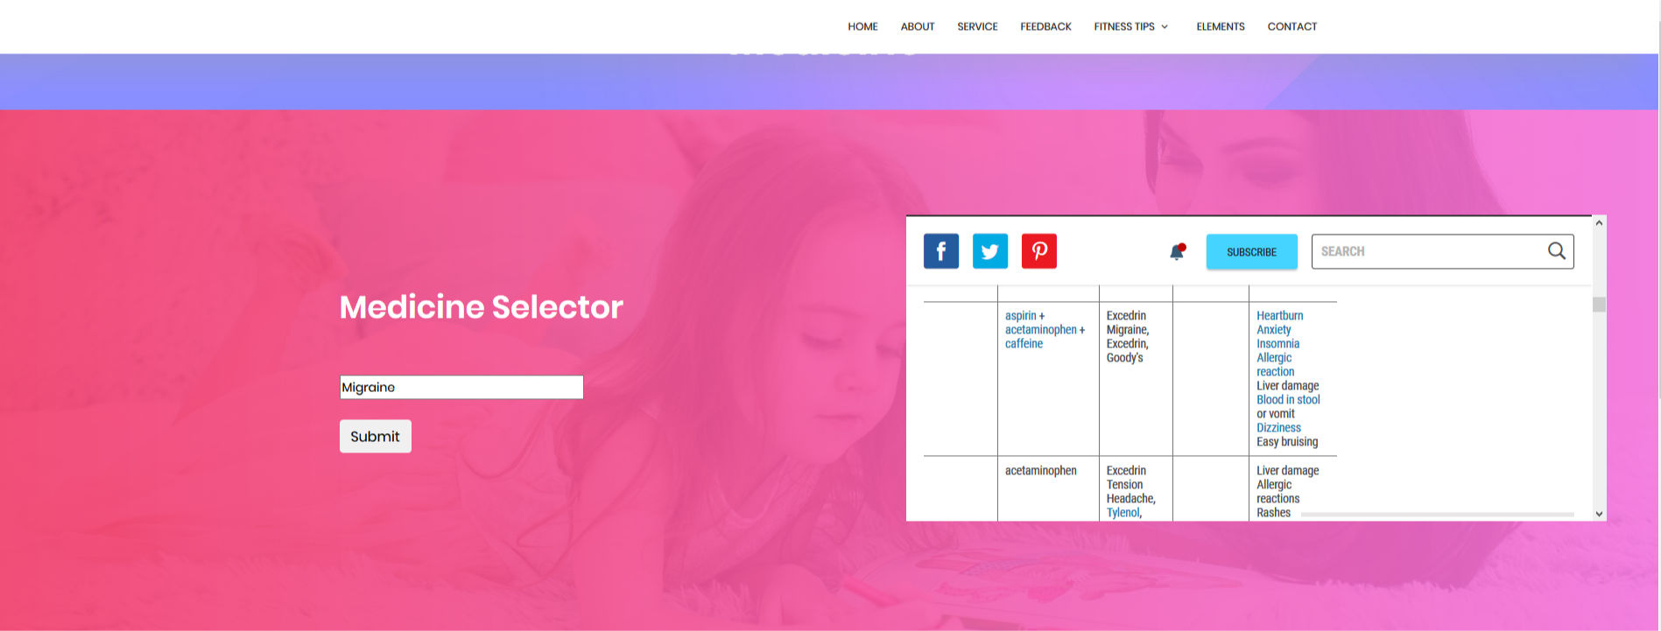

Medicine Information page which will give you medicine info on various ailments.