Internship
At
Enlighten Infosystems

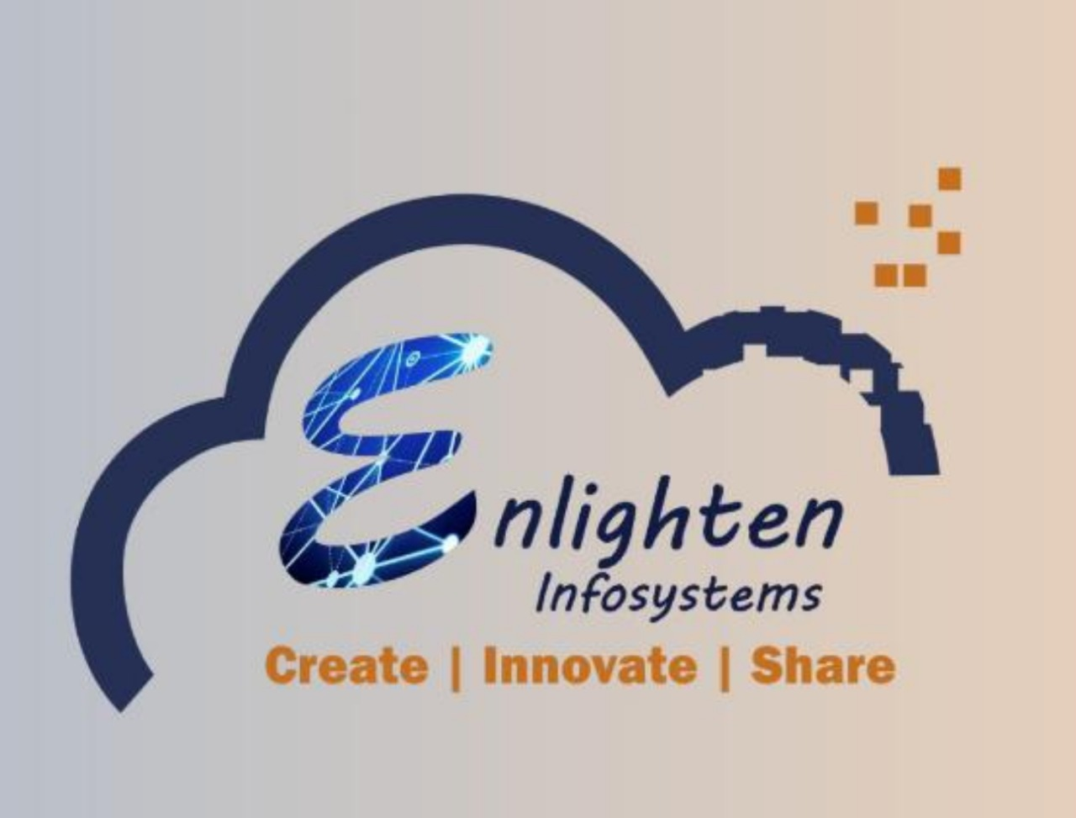

Internship Report

Submitted To
Parul University
Computer Engineering
2024-25 (Semester - 4)
Enrollment No: 2303396160011

Prepared By: Shadakwala Mahirabanu
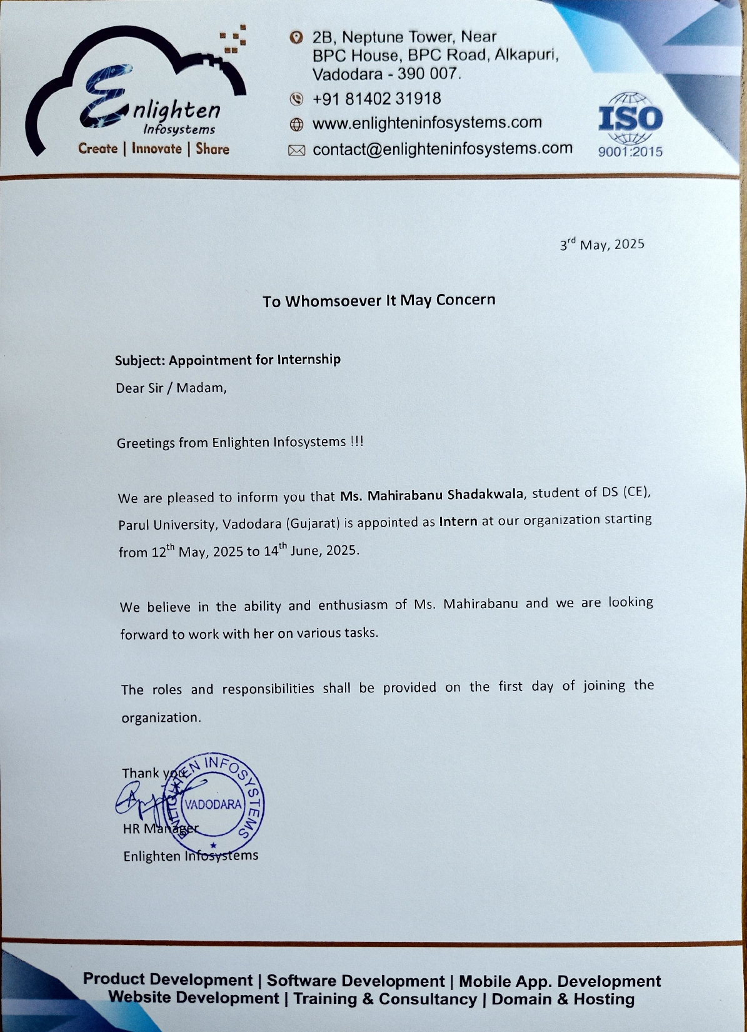
Index
Sr. No | Description | Page No
1 | Acknowledgement | 4
2 | Abstract | 5
3 | Learning Internship | 6
4 | Weekly Overview of Task | 7
5 | Conclusion | 8

Acknowledgement
The successful completion of a short-term internship is generally not an individual effort. It is an outcome of cumulative efforts of a number of persons, each having its own importance to the objective. This section is a value of thanks and gratitude towards all those persons who have directly or indirectly contributed in their own special way towards the completion of the internship. For their invaluable comments and suggestions, I wish to thank them all.
No word will suffice to thank my Internship guide Ms. Jagruti Parmar for their cooperation, invaluable guidance, and encouragement, which extended us for completion of our internship, both in knowledge and morale.
I am immensely thankful to Prof. HETAL BHAIDASNA (HOD of Computer Dept.) for their incessant and perpetual cooperation and encouragement for their guidance and inspiration.
I am also immensely thankful to Ms. Jagruti Parmar, our Guide at Enlighten Infosystems, Vadodara, for their guidance and enhancing IT knowledge.
I am also thankful to the Management of Enlighten Infosystems, Vadodara for their guidance and encouragement for the successful completion of the Internship.
In the end, I am grateful to my Parents who inspired and gave me all kinds of moral help and support for doing this internship.
Date: 14/06/2025
Place: Vadodara
Shadakwala Mahirabanu
Abstract
This report presents a summary of my 1 Month internship at Enlighten Infosystems, where I gained hands-on experience in key areas of information technology, including cyber security fundamentals, SQL database management, and web development. The internship was designed to help bridge the gap between academic knowledge and its real-world application in a dynamic IT environment.
Throughout the internship, I was actively involved in working with MySQL databases, developing and connecting web forms using HTML and PHP, and using XAMPP as a local server environment for backend testing. I also explored basic cyber security concepts, such as data protection, secure coding practices, and understanding potential threats in web applications.
The overall experience enhanced both my technical and soft skills, offering insights into practical problem-solving, teamwork, and project execution. This internship has strengthened my interest in the field of software and cyber security, and has prepared me for future roles in IT development and secure application design.

Learning for Internship
- What is Cyber Security?
- How many types of Threats?
- What is SQLIjection?
- What is MySQL?
- What is XAMPP?
- Types of Cyber Attacks
- Form Validation
- Creating tables in XAMPP Control Panel
- Mail verification using OTP
- Role Based Permissions
- Coding in HTML, CSS & JAVASCRIPT
- CSRF Token
- PHP Language
- Connecting XAMPP to HTML

Weekly Overview to Task

Date | Day | Topic
12-05-2025 | Monday | List out cyber security concepts and cyber attacks
14-05-2025 | Wednesday | Types of Attacks
15-05-2025 | Thursday | Making registration and login form using HTML & CSS
16-05-2025 | Friday | Add validation in forms
17-05-2025 | Saturday | Holiday
18-05-2025 | Sunday | Holiday
19-05-2025 | Monday | Creating Database using PHPMyadmin
20-05-2025 | Tuesday | Connect forms with database using PHP
21-05-2025 | Wednesday | Brute Force Attack
23-05-2025 | Friday | Session based HTML From
24-05-2025 | Saturday | Holiday
25-05-2025 | Sunday | Holiday
26-05-2025 | Monday | In case of Inactivity Session Expire
27-05-2025 | Tuesday | CSRF Token
29-05-2025 | Thursday | SQL Injection
31-05-2025 | Saturday | Holiday
01-06-2025 | Sunday | Holiday
02-06-2025 | Monday | OTP based Two-step Verification
03-06-2025 | Tuesday | Expiring OTP in 1 min
04-06-2025 | Wednesday | Adding CAPTCHA in registration form
05-06-2025 | Thursday | Role based Registration & Login Form
07-06-2025 | Saturday | Holiday
08-06-2025 | Sunday | Holiday
09-06-2025 | Monday | Sending Email to User account
10-06-2025 | Tuesday | User Login Tracking with IP, Browser & Timestamp
11-06-2025 | Wednesday | Role based Permissions
13-06-2025 | Friday | Report Making & Documentation

Conclusion
My 1 Month internship at Enlighten Infosystems proved to be a valuable learning experience, allowing me to apply classroom knowledge to real-world scenarios. I gained practical exposure to web development using HTML, PHP, and XAMPP, enhanced my skills in SQL database management, and developed a foundational understanding of cyber security principles. The tasks and responsibilities assigned to me not only strengthened my technical abilities but also improved my communication and problem-solving skills. This internship has inspired me to continue exploring opportunities in software development and cyber security, and has given me greater confidence in pursuing a career in the IT industry.

