PRACTICAL-5

Name: Parth Kharwade
Subject: BDA-Lab
Section: CSE-B
Roll No: B3-48

Aim: To implement a Hadoop MapReduce program to count the number of even and odd numbers in a dataset stored in HDFS.
Details:
The aim of this experiment is to develop a Java-based Hadoop MapReduce application that reads a set of integers stored in the Hadoop Distributed File System (HDFS), classifies each number as even or odd, and computes the total count of even and odd numbers. The experiment demonstrates the working of Mapper and Reducer classes in processing numerical data in a distributed manner and producing aggregated results.
ALGORITHM: EVEN AND ODD COUNT USING MAPREDUCE
- Start HDFS and YARN services to ensure Hadoop is running.
- Upload the input file containing integers into an HDFS directory.
- Mapper reads each number from the input file line by line.
- Check if the number is even or odd:
  - If divisible by 2 → key = "EVEN"
  - Else → key = "ODD"
- Emit key-value pairs: (EVEN, 1) or (ODD, 1) for each number.
- Shuffle and sort step groups all values for the same key.
- Reducer receives all values for each key ("EVEN" or "ODD").
- Sum all the values for each key to get total counts.
- Write the output in HDFS as <key> <count> (EVEN 3, ODD 2).
- Stop Hadoop services after the job completes.

INPUTS:
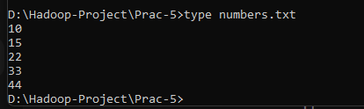

COMMANDS:
- mkdir classes
- javac -classpath %HADOOP_HOME%\share\hadoop\common\*;%HADOOP_HOME%\share\hadoop\common\lib\*;%HADOOP_HOME%\share\hadoop\mapreduce\*;%HADOOP_HOME%\share\hadoop\mapreduce\lib\*;%HADOOP_HOME%\share\hadoop\yarn\*;%HADOOP_HOME%\share\hadoop\yarn\lib\* -d classes EvenOddMapper.java EvenOddReducer.java EvenOddDriver.java
- jar cvf evenodd.jar -C classes .
- jar tf evenodd.jar
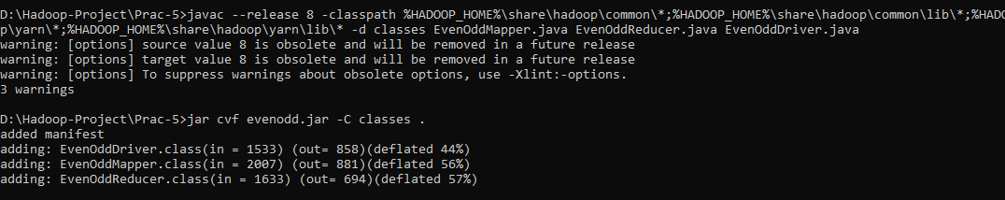

- start-dfs.cmd
- start-yarn.cmd
- JPS
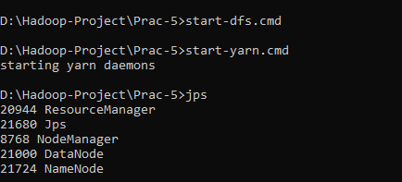

- hdfs dfs -mkdir /evenoddinput
- hdfs dfs -put D:\Hadoop-Project\Prac-4\numbers.txt /evenoddinput
- hadoop jar D:\Hadoop-Project\Prac-4\evenodd.jar EvenOddDriver /evenoddinput /evenoddoutput
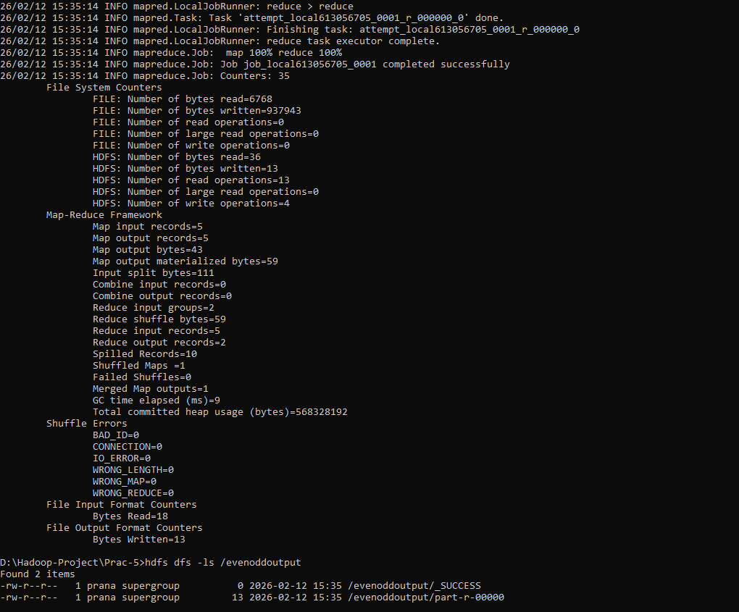

- hdfs dfs -ls /evenoddoutput
- hdfs dfs -cat /evenoddoutput/part-r-00000
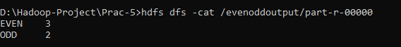

- stop-dfs.cmd
- stop-yarn.cmd
