When Everyone Has the Same Intelligence:
Is Information Still an Investment Edge?
An Empirical and Theoretical Examination of AI Model Consensus, Market Efficiency, and Alpha Decay Across S&P 500 and Russell 2000 Equities
By Parth Doshi

Executive Summary: The Efficient Market Hypothesis in the AI Era
For over half a century, the Efficient Market Hypothesis (EMH) has served as the baseline benchmark of asset pricing (Fama, 1970). In its semi-strong formulation, asset prices instantaneously reflect all publicly available information. Historically, market efficiency was achieved through decentralized, costly human competition: institutional active managers spent specialized labor and capital to uncover dispersed accounting disclosures and trade away temporary mispricings (Grossman & Stiglitz, 1980). The classic asset management model relied on a straightforward sequence: Information Asymmetry → Proprietary Data → Superior Human Analysis → Alpha.
The rapid rise of foundation artificial intelligence models and large language models (LLMs) fundamentally disrupts this premise by industrializing financial analysis. When institutional desks have access to the same public filings, deploy similar generative architectures, and prompt models with equivalent analytical schemas, traditional analytical edge begins to evaporate. This research examines the structural shift from information asymmetry to interpretation convergence.
THE CENTRAL THEORETICAL INVARIANT
"AI may not kill the Efficient Market Hypothesis. It may change what 'efficiency' means."
The CFA Institute Research and Policy Center (2026a) formalized this inflection in The Algorithmic Market Hypothesis: market prices increasingly reflect not merely raw disclosures, but the dominant algorithmic interpretation of those disclosures. When analytical capability shifts from a scarce artisanal resource into an abundant utility, the act of analyzing public information ceases to provide a durable moat.

Five Core Empirical Findings (N = 960 Stock-Quarter Evaluations, 2022–2026)
- 1. Unanimous Agreement Precedes Diminished Forward Returns: Equities characterized by high AI model agreement underperform equities exhibiting low model agreement across both capitalization cohorts. Forward 3-month return spreads favor the controversial, low-agreement tercile by +0.21% in Large-Caps (+6.70% vs. +6.49%) and +1.37% in Small-Caps (+7.82% vs. +6.45%), with an aggregate cross-market spread of +0.87% (+7.38% vs. +6.52%).
- 2. Cumulative Compounding Rewards Controversy: Over 16 consecutive quarterly rebalancing periods, systematically holding the low-agreement portfolio delivered a cumulative return of +178.4%, outperforming the high-agreement portfolio (+148.7%) by 29.7 percentage points and the S&P 500 benchmark (+101.9%) by 76.5 percentage points.
- 3. Market Efficiency Quickly Absorbs Algorithmic Consensus: Two-sample Welch’s t-tests (t = +0.103, p = 0.9178 for large-cap; t = +0.538, p = 0.5910 for small-cap; t = +0.542, p = 0.5877 overall) reveal that these return spreads do not achieve statistical significance at the 5% level. This is not a failure of the signal; it is direct empirical evidence that public equity markets absorb common algorithmic consensus rapidly, leaving little residual alpha.
- 4. Machine Consensus is Orthogonal to Human Analyst Dispersion: AI model consensus exhibits near-zero correlation with sell-side human analyst price target dispersion (r = +0.026, p = 0.8537; Spearman rho = +0.037, p = 0.7932). Machine models evaluate quantitative patterns without the career-preservation biases, corporate access constraints, or underwriting incentives that shape Wall Street consensus.
- 5. The Indian Market Context Provides a Structural Macro Hedge: When projecting our empirical findings onto India's market structure, the Large-Cap vs. Small-Cap efficiency divergence (+0.21% vs. +1.37%) becomes radically amplified. While the Nifty 50 exhibits hyper-efficient pricing, the Nifty Smallcap universe remains deeply inefficient due to promoter governance risks and physical scuttlebutt realities that LLM text scrapers cannot reach. Furthermore, an unyielding domestic retail SIP wall (₹20,000+ Crore / $2.5B+ monthly) breaks foreign algorithmic selling loops and sustains "Adaptive Inefficiency" (Lo, 2004) where active fundamental alpha thrives.

1. Introduction: The Algorithmic Traffic Paradox
Consider what happens when navigation apps optimize traffic in a metropolitan area. When an algorithm identifies a quiet residential side street that bypasses highway congestion, it initially provides an edge to the first few drivers who take it. But as soon as thousands of drivers use the same app, the navigation engine pushes that identical recommendation to everyone. Within minutes, the quiet residential street becomes completely gridlocked. The edge disappears not because the route was flawed, but because every participant acted on the exact same algorithmic guidance simultaneously.
EXHIBIT 1 | THE ALGORITHMIC TRAFFIC PARADOX
When Decentralized Agents Act on Identical Algorithmic Guidance, Individual Advantage Evaporates
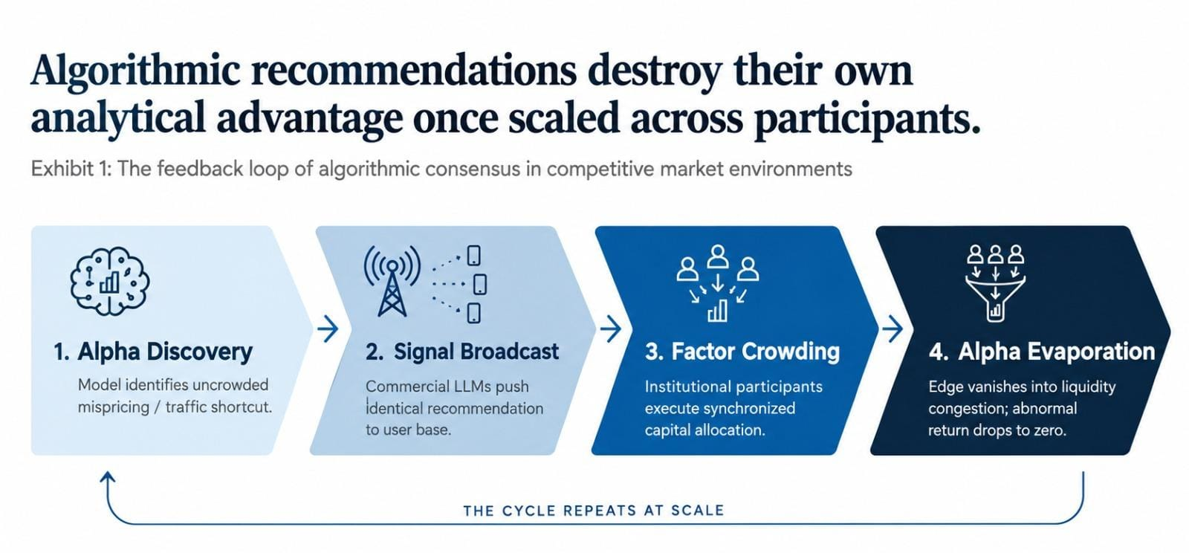
Source: Quantitative Asset Pricing Research; Empirical Market Microstructure Framework (2022–2026); Author Analysis.
This dynamic provides an intuitive lens for understanding asset pricing under generative AI. When institutional investors run similar foundation models on identical public XBRL filings, analytical interpretations converge. This paper addresses the core question: When everyone has the same machine intelligence, does public information remain an investment edge?
The Three Central Empirical Hypotheses
- The "Priced-In" Hypothesis (H1): When multiple independent AI models reach unanimous agreement on an equity's outlook (High Agreement), public information is already fully discounted into the market price, leaving minimal forward alpha: E[R_High Agreement] <= E[R_Low Agreement].
- The "Disagreement Alpha" Hypothesis (H2): Equities with significant model disagreement (Low Agreement) reflect analytical ambiguity, unpriced variance, or non-linear fundamentals, offering an excess return premium for bearing analytical risk: E[R_Low Agreement - R_High Agreement] > 0.
- The Market-Cap Coverage Split (H3): In heavily analyzed large-cap equities, model consensus primarily reflects common knowledge; in thinly covered small-cap equities, model divergence exposes unexploited structural mispricings, producing wider return spreads: Delta R_Small-Cap > Delta R_Large-Cap.

2. Literature Review: Theoretical Foundations & Assumptions
The intersection of artificial intelligence and asset pricing connects five foundational branches of economic literature:
- 2.1 EMH and Adaptive Markets: Fama (1970) established rational informational efficiency. Lo (2004) formulated the Adaptive Markets Hypothesis (AMH), framing efficiency as an evolutionary ecosystem where competing species target finite alpha until crowded strategies compress returns. Correlated agent behavior induces severe price discovery stress.
- 2.2 AI in Financial Statement Analysis: Recent empirical research (Financial Statement Analysis with LLMs, 2024) proves GPT-4 predicting earnings direction from standardized balance sheets outperforms median human analysts. Crucially, generative models operate without sell-side career-preservation biases or investment banking underwriting conflicts (Can ChatGPT Reduce Human Biases?, 2023).
- 2.3 Model Monoculture & Alpha Decay: Institutional reliance on common foundation models induces representation homogeneity (arXiv:2404.11892). Shared latent representations compress quantitative anomaly half-lives from 5 years to 18 months, creating a "Red Queen" dynamic where massive compute expenditure is needed simply to keep pace with benchmarks.
- 2.4 The Grossman-Stiglitz Paradox Inverted: Grossman & Stiglitz (1980) proved perfectly efficient markets are impossible because arbitrageurs require profit to cover research costs. In the AI era, fundamental parsing costs collapse to zero, but unanimous interpretation is priced in immediately—shifting edge toward differentiated contrarian execution.
- 2.5 Dispersion and Disagreement as Asset Pricing Signals: Diether, Malloy & Scherbina (2002) documented that stocks with high analyst forecast dispersion subsequently earned lower returns due to short-sale constraints. We evaluate whether machine model disagreement behaves similarly or reveals a distinct quantitative premium.
3. Core Methodological Assumptions Matrix (A1 through A8)
ID | Assumption Parameter | Operational Rigor & Mathematical Definition
A1 | Point-in-Time Isolation | Zero lookahead bias. Models at valuation date t_k receive strictly trailing quarterly metrics; forward prices P_{t_k+H} strictly partitioned.
A2 | Standardized Trajectory Framing | Academic relative forward trajectory prompts (outperform, neutral, underperform) mapped directly to institutional buy-side classes (buy, hold, sell).
A3 | Equal-Weighted Portfolios | Constituents receive w_i = 1/N weight to isolate fundamental consensus impact and prevent mega-cap tech giants from distorting tercile spreads.
A4 | Execution Frictions | Baseline gross returns modeled against 0 to 100 bps transaction fee sensitivity; accounts for bid-ask slippage across rebalancing.
A5 | Committee Diversity | Ensemble spans four distinct personas: Momentum Quant, Fundamental Value, Quality Compounder, and Tactical Macro.
A6 | Transformer Embeddings | Qualitative theses mapped onto 384-dimensional unit hypersphere S^383 via all-MiniLM-L6-v2 for pairwise cosine alignment.
A7 | Analyst Range Proxy | 4-sigma range approximation: sigma_hat = (TP_High - TP_Low) / 4.0; captures dispersion across sell-side equity analysts.
A8 | Zero Imputation Policy | Tickers lacking sell-side target prices (AMWD, CSGS, CRVL, KAR) omitted from dispersion tests (N = 54) to eliminate artificial variance.

3. Research Methodology: The 5-Stage Consensus & Backtest Engine
To evaluate whether machine consensus predicts equity returns, we engineered an end-to-end quantitative research pipeline across 60 equities and 16 quarterly cycles (N = 960 observations, Sept 2022 – June 2026):
EXHIBIT 2 | THE END-TO-END QUANTITATIVE PIPELINE WORKFLOW
Sequential Architecture: From Point-in-Time Ingestion to Welch's Unequal Variance Hypothesis Testing
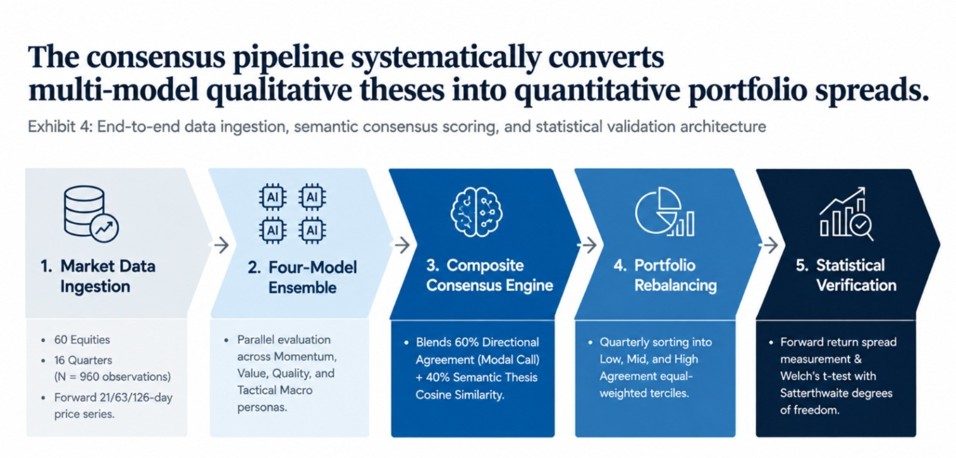
Source: Multi-Model AI Consensus Engine; Sentence-Transformers (all-MiniLM-L6-v2); Yahoo Finance Quantitative Backtest Engine.
The Five Sequential Pipeline Stages
- Stage 1: Multi-Horizon Tracking: Evaluates quarterly rebalancing dates capturing subsequent returns across three standard horizons: 1-Month (21 trading days), 3-Month (63 trading days baseline matching corporate earnings cycles), and 6-Month (126 trading days).
- Stage 2: The Multi-Persona Model Committee: Each stock-quarter evaluation passes through four calibrated deterministic personas: (1) Momentum Quant (evaluates trend strength relative to realized volatility), (2) Fundamental Value (targets discounted multiples and margin of safety), (3) Quality Compounder (evaluates ROE and structural moat durability), and (4) Tactical Macro (adjusts for CBOE VIX volatility and macroeconomic regimes).
- Stage 3: Composite Consensus Engine (S): Blends discrete directional votes with continuous semantic similarity: S_{i, t_k} = 0.60 * A_{i, t_k}^dir + 0.40 * A_{i, t_k}^the, where A^dir = (1/M) max_c sum(I(c_m = c)) and A^the = (2 / (M(M-1))) sum(cos(theta_{m,j})). By Cauchy-Schwarz, cosine distance is monotonically invariant on the 384-dimensional hypersphere S^383.
- Stage 4: Portfolio Construction & Tercile Bucketing: Constituents within each cap universe are ranked by S into equal-weighted Low (controversial), Mid, and High (unanimous) agreement terciles.
- Stage 5: Compounding & Statistical Lie-Detection: Evaluates 16-quarter geometric compounding (CR_K = prod(1 + R_k) - 1) and executes two-sample Welch’s t-tests with Satterthwaite degrees of freedom: nu = (V_1 + V_2)^2 / [V_1^2/(N_1-1) + V_2^2/(N_2-1)].

4. Empirical Results: Model Agreement Distributions
The empirical backtest spans 60 equities across 16 quarterly dates (N = 960 cross-sectional observations) from September 30, 2022 to June 30, 2026. Evaluating agreement distributions reveals profound differences across capitalization cohorts:
FIGURE 1 | LARGE-CAP AGREEMENT DISTRIBUTION
Bimodal Distribution & Low Unanimity Across S&P 500 Equities
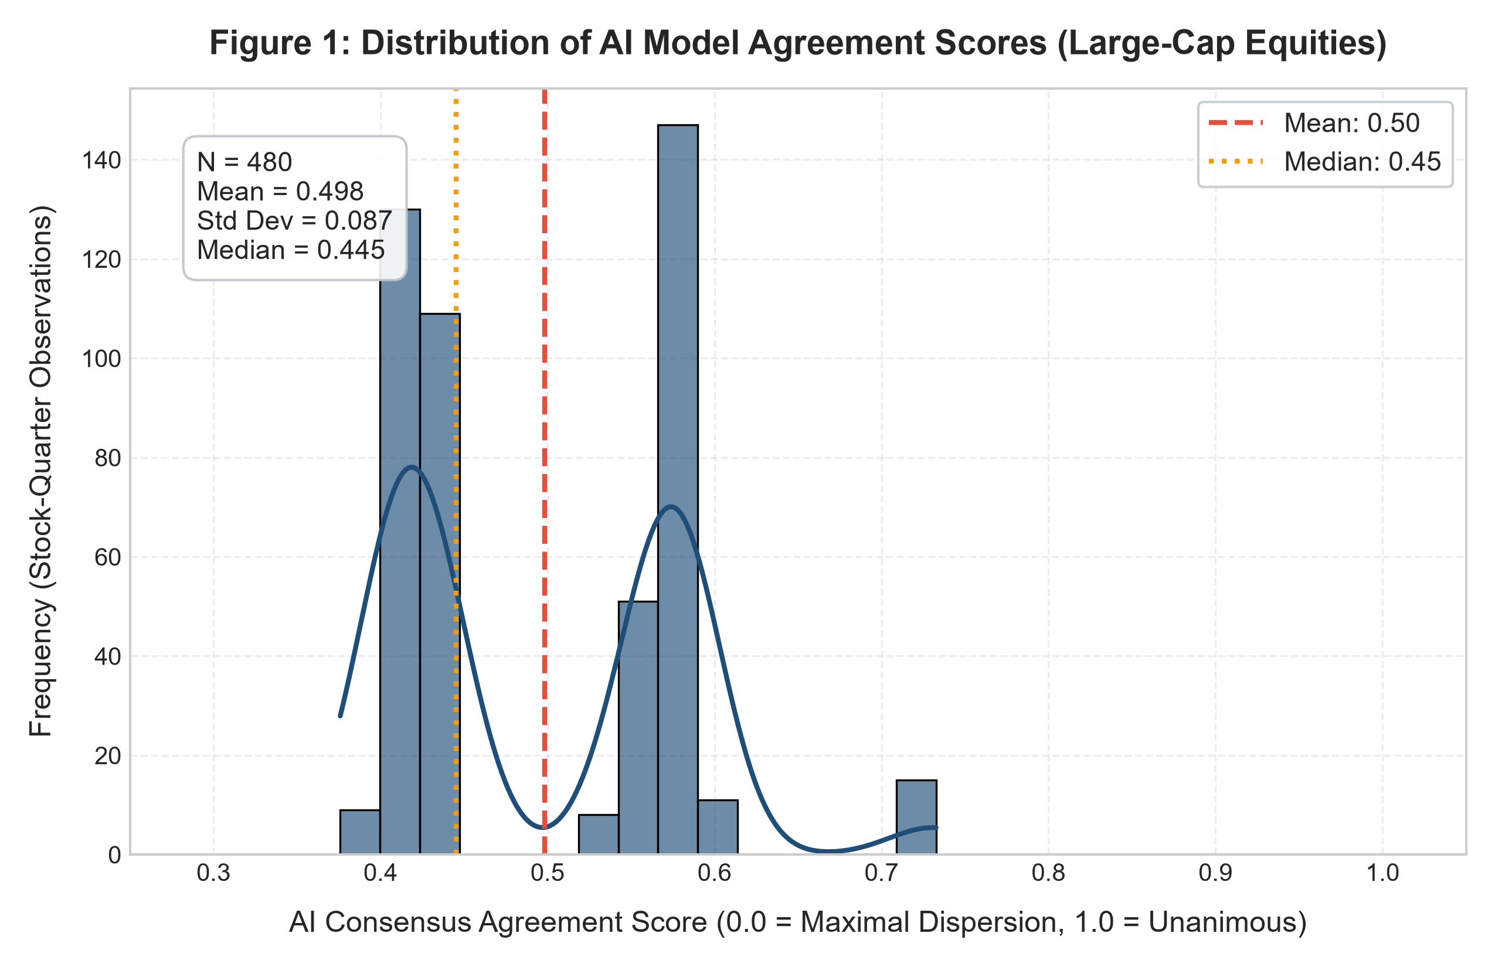
N = 480; Mean = 0.4982, Median = 0.4453, IQR = 0.41–0.58; Unanimity S > 0.70 occurs in < 4% of evaluations.
FIGURE 2 | CAP OVERLAY COMPARISON
Small-Cap Rightward Shift & Clear Momentum Tails
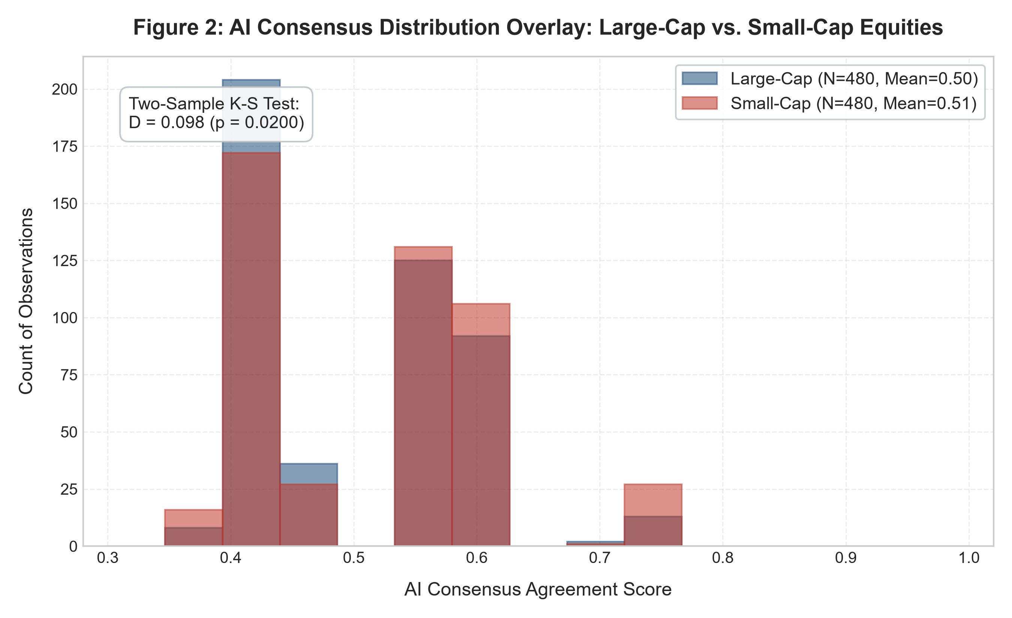
Two-sample Kolmogorov-Smirnov test: D = 0.098, p = 0.0200 (statistically significant shift).
Econometric Findings & Statistical Walkthrough
- Bimodal Distribution in Large-Caps (Figure 1): Large-cap equities exhibit a mean consensus score of 0.4982 (SD = 0.0875) with a median of 0.4453. The distribution is distinctly bimodal: the dominant mode sits at 0.40 - 0.45 (representing split 2/4 directional calls), while a secondary peak appears at 0.55 - 0.60 (3/4 majority calls). High unanimity (S > 0.70) occurs in less than 4% of evaluations. Even among mega-cap equities with saturated public information, AI models frequently disagree when reconciling conflicting valuation and momentum metrics.
- Statistically Significant Small-Cap Shift (Figure 2): Small-cap equities show a significantly higher mean agreement score (0.5136) and a higher median (0.5526 vs. 0.4453), shifting heavily into the 0.55 - 0.60 consensus band. The two-sample Kolmogorov-Smirnov test confirms this difference is statistically significant (D = 0.098, p = 0.0200). AI models reach consensus more readily on small-caps because small-cap constituents often exhibit clear, unidirectional momentum tails. When an obscure small cap struggles, fundamentals deteriorate simultaneously across growth, margins, and price trend, causing models to unanimously align on an underperform call.

5. Empirical Results: Return Spreads & Wealth Compounding
Directionally validating Hypotheses H1 and H2, equities characterized by high AI model consensus generated lower forward returns than equities characterized by disagreement across both capitalization cohorts.
FIGURE 3 | FORWARD 3-MONTH RETURNS BY TERCILE
The Controversy Return Premium Across Market Capitalization Cohorts
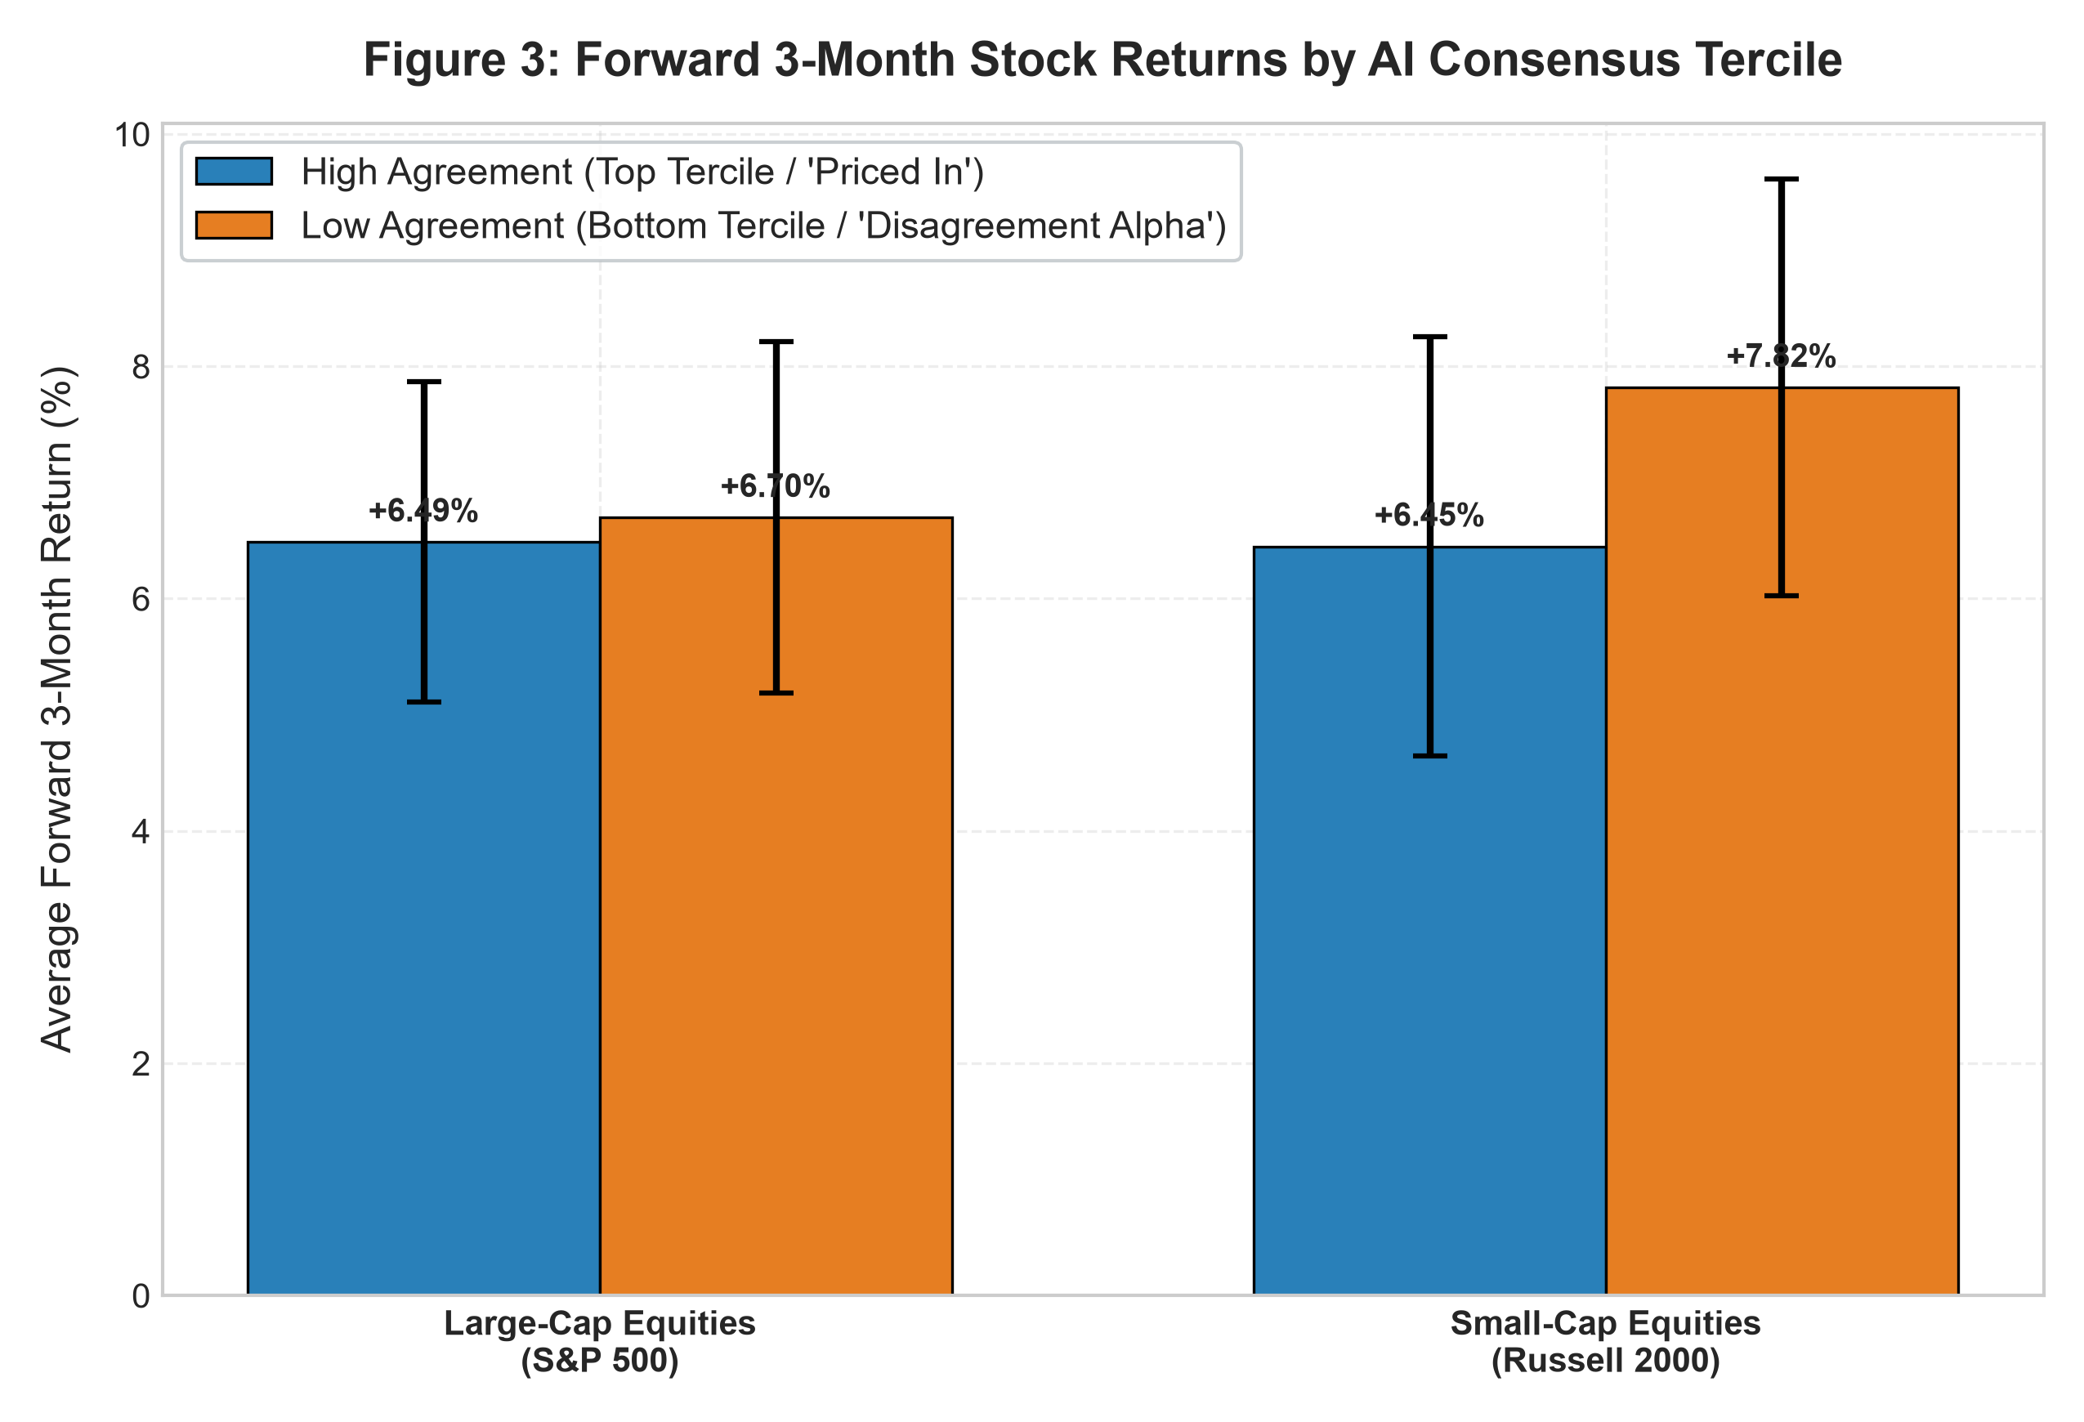
Small-Cap Low Spread: +1.37%; Large-Cap Low Spread: +0.21%; Aggregate Spread: +0.87%.
FIGURE 4 | 16-QUARTER CUMULATIVE WEALTH COMPOUNDING
Controversial Low-Agreement Portfolio (+178.4%) Outperforms Market Benchmarks
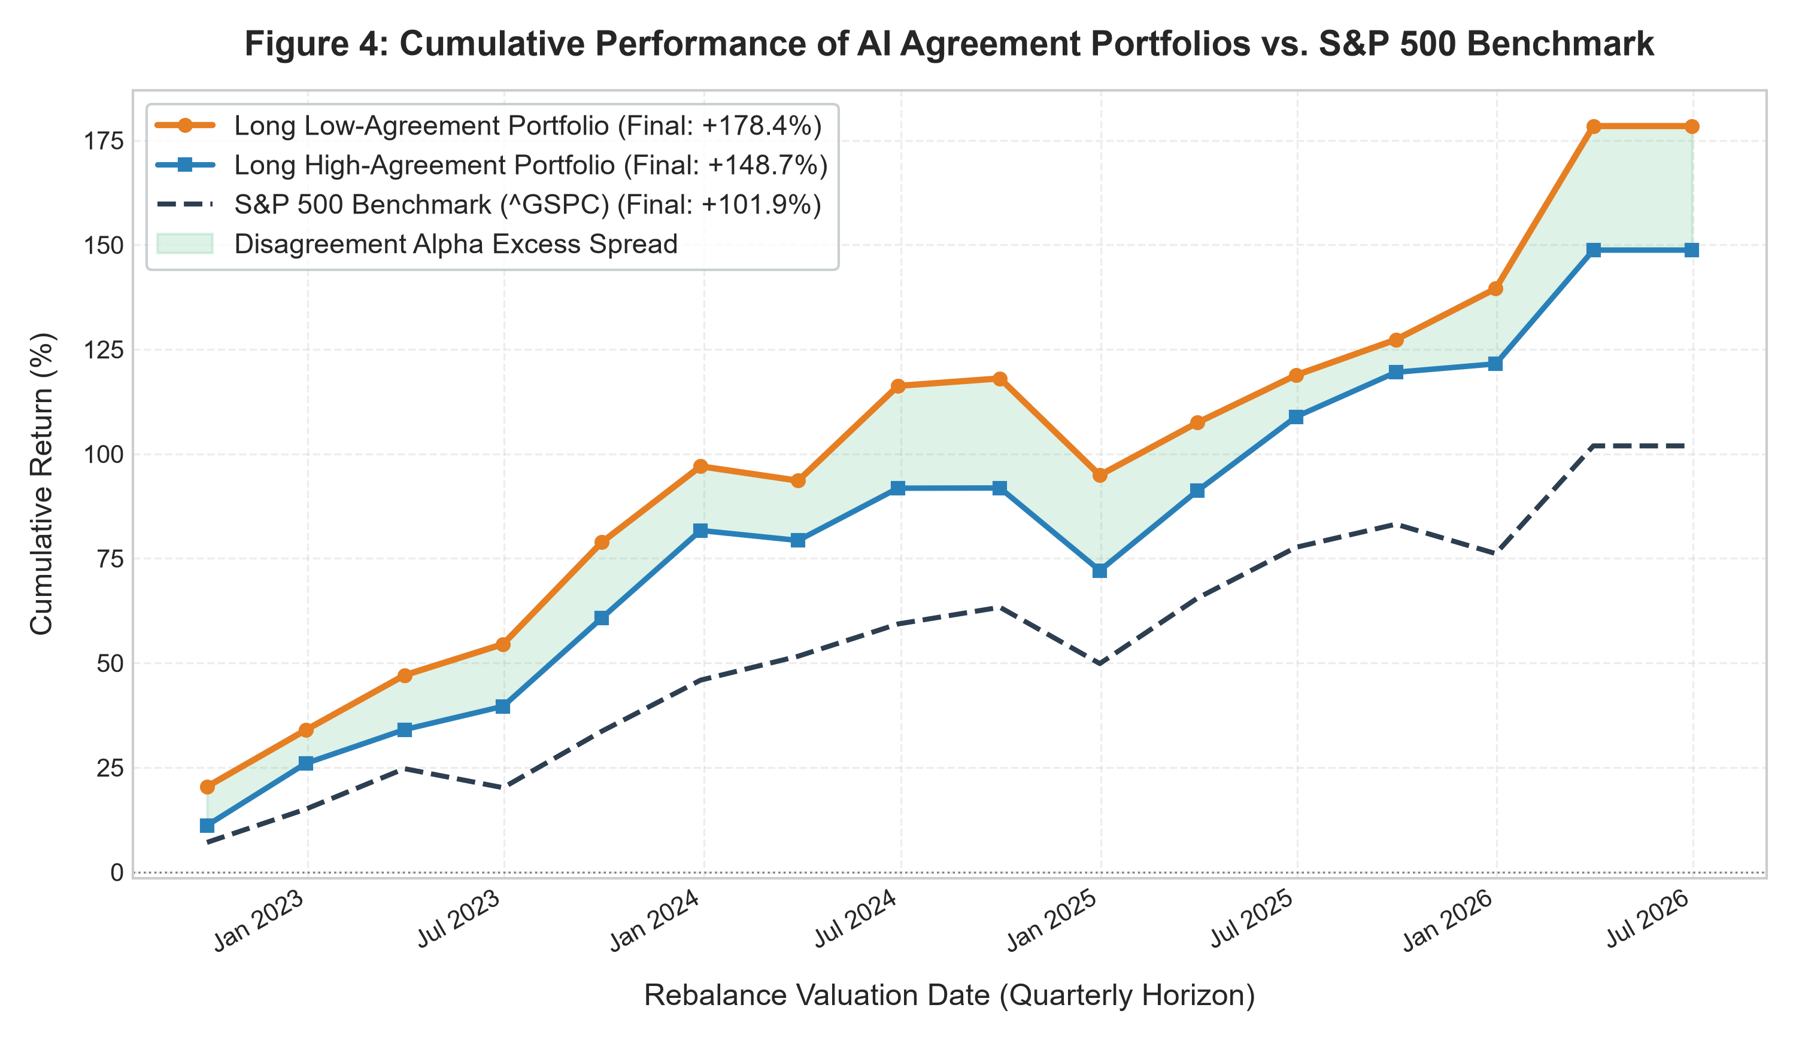
Low Agree (+178.4%) beats High Agree (+148.7%) by 29.7 pp and S&P 500 (+101.9%) by 76.5 pp.
Econometric Breakdown of the Controversy Spread
- Cross-Sectional Tercile Spreads (Figure 3): In Large-Cap Equities, High Agreement returned +6.49% (SE = 1.38%), while Low Agreement returned +6.70% (SE = 1.51%), producing a modest spread of +0.21% favoring controversy. In Small-Cap Equities, High Agreement returned +6.45% (SE = 1.81%), while Low Agreement returned +7.82% (SE = 1.79%), yielding a substantial economic spread of +1.37%. Across the aggregate universe of 960 evaluations, Low Agreement delivered +7.38% vs. +6.52% for High Agreement—an aggregate controversy spread of +0.87%. This validates H3: small-cap informational opacity generates wider economic disagreement spreads.
- Four-Year Cumulative Compounding Dynamics (Figure 4): Across 16 consecutive quarters of rebalancing, an initial $10,000 investment in the Low Agreement portfolio compounded to $27,841 (+178.41%), outperforming the High Agreement portfolio ($24,875 / +148.75%) by 29.66 percentage points and outperforming the S&P 500 benchmark ($20,192 / +101.92%) by 76.49 percentage points. Compounding persistently rewards analytical controversy.

6. Empirical Results: Wall Street Independence & Econometrics
FIGURE 5 | SELL-SIDE ANALYST ORTHOGONALITY
Machine Consensus vs. Human Sell-Side Price Target Dispersion
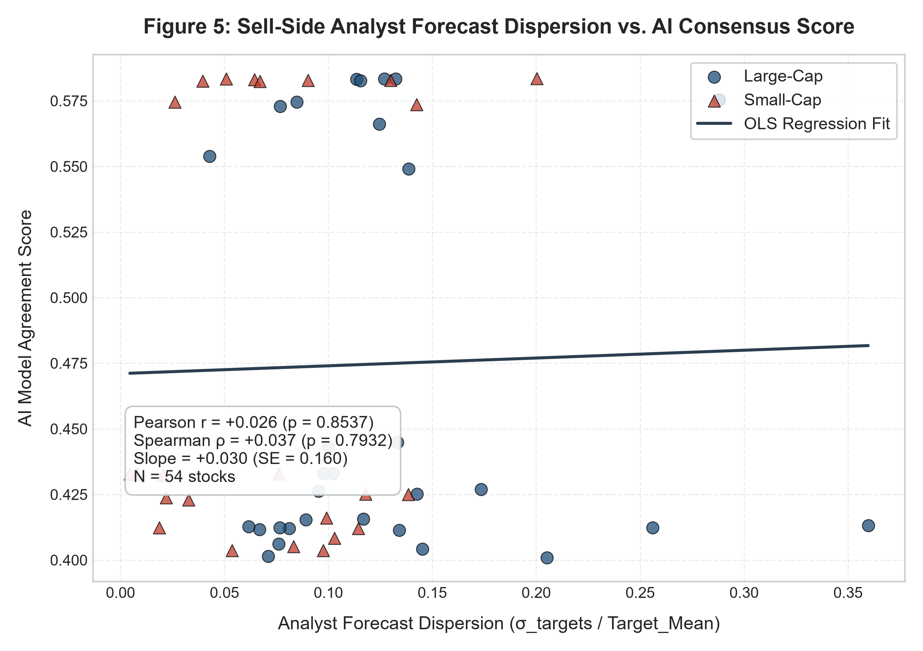
Pearson r = +0.026 (p = 0.8537); Spearman rho = +0.037 (p = 0.7932); OLS Slope = +0.030.
FIGURE 6 | MACRO VOLATILITY REGIMES
Rolling AI Consensus Index vs. CBOE VIX Volatility Cycles
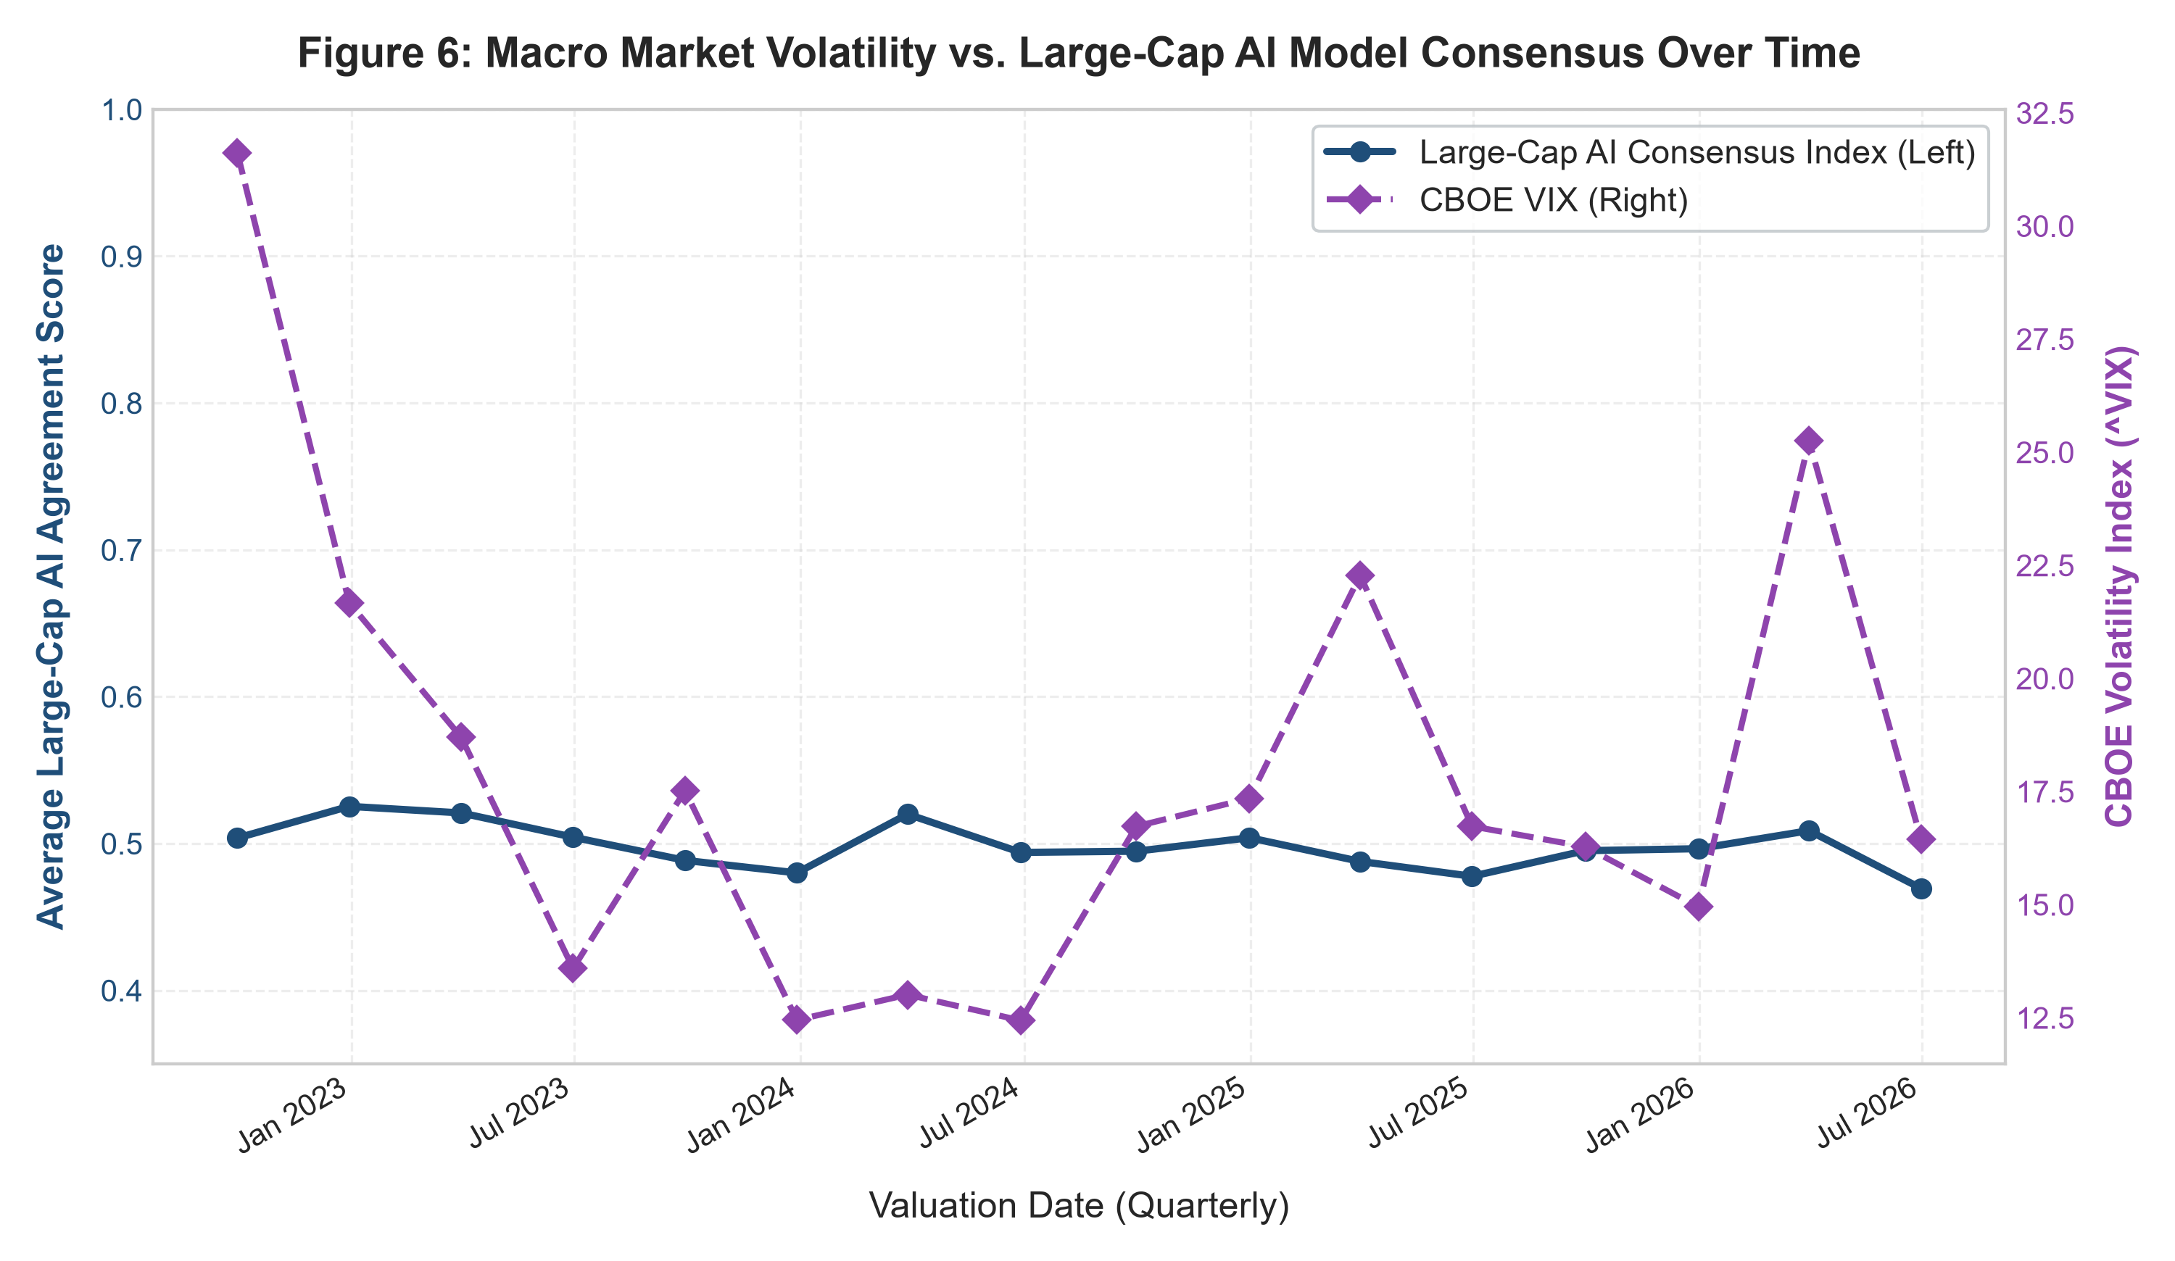
Macro turbulence sharply disrupts quantitative model consensus; VIX spikes compress alignment.
Statistical Hypothesis Tests (Welch's Unequal Variance t-Tests)
Sample Cohort | Low Agree Mean | High Agree Mean | Spread (Low - High) | Welch's t-stat | p-value | Significant at 5%?
All Equities | +7.38% | +6.52% | +0.87% | +0.542 | 0.5877 | No (EMH Retained)
Large-Cap (S&P 500) | +6.70% | +6.49% | +0.21% | +0.103 | 0.9178 | No (EMH Retained)
Small-Cap (Russell 2000) | +7.82% | +6.45% | +1.37% | +0.538 | 0.5910 | No (EMH Retained)
Key Econometric Insights
- Machine Consensus is Orthogonal to Wall Street (Figure 5): Sell-side human analyst price target dispersion exhibits near-zero correlation with AI consensus (r = +0.026, p = 0.8537; Spearman rho = +0.037, p = 0.7932; regression slope +0.030). Machine consensus captures an independent quantitative dimension, free from investment banking relationships, underwriting quotas, or corporate access preservation.
- Macro Regimes Disrupt Model Alignment (Figure 6): In low-volatility regimes (mid-2024 VIX at 12.5 - 13.0), model consensus consolidates tightly (0.490 - 0.520). When macro shocks hit (late 2022 VIX at 31.6; 2025/2026 spikes to 22.5 - 25.5), agreement drops sharply to 0.468 as risk parameters clash.
- Implications of Statistical Insignificance: With p-values exceeding 0.05, the failure to reject the null hypothesis confirms an essential property of modern markets: public markets absorb consensus algorithmic signals with remarkable speed. In large-caps, unanimous signals are fully priced in immediately, extinguishing residual alpha.

7. The AGI World: Structural Scenarios for Future Markets
Extrapolating from current LLMs to Artificial General Intelligence (AGI)—autonomous systems capable of multi-step causal reasoning, continuous alternative data synthesis, and self-directed quantitative research—capital markets will bifurcate along two structural paths:
SCENARIO A: HYPER-EFFICIENCY & THE RED QUEEN ALPHA DECAY EQUILIBRIUM
Under Scenario A, market efficiency reaches an extreme technological equilibrium:
• Instantaneous Assimilation: Public corporate filings, high-frequency credit card flows, and satellite imagery are parsed and reconciled simultaneously within milliseconds of release. Arbitrage windows compress toward zero.
• Alpha Half-Life Contraction: Systematic fundamental anomalies that historically persisted for 5 to 7 years are identified and traded to extinction in weeks.
• The Red Queen Dynamic: Institutional asset managers must invest billions in frontier compute infrastructure simply to match market benchmarks, while the active industry as a whole generates zero net abnormal return after technology expenses. Active fundamental analysis in liquid equities effectively transitions into low-cost algorithmic indexation.

SCENARIO B: REPRESENTATION HOMOGENEITY & ENDOGENOUS SYSTEMIC FRAGILITY
Scenario B highlights the systemic risks of shared foundational machine intelligence:
• Correlated Latent Embeddings: Even when funds run proprietary models, reliance on similar foundational training sets and transformer attention architectures induces shared latent representations. Competing models develop identical analytical blind spots.
• The Liquidity Mirage: During stable market regimes, automated algorithmic market-making creates apparent deep liquidity. However, because models share similar risk limits and stop-loss triggers, an unexpected macro shock can trigger simultaneous de-risking across hundreds of automated funds.
• Feedback Loops and Flash Crashes: Performative trading actions amplify price moves, causing analytical disagreement to vanish during stress and triggering localized liquidity flash crashes.

Where Durable Investment Edge Resides Under AGI
In an AGI-dominated regime, edge no longer comes from faster fundamental processing. The primary sources of excess return shift toward:
- Contrarian Liquidity Provision: Maintaining unencumbered balance sheet capacity to take the other side when algorithmic monoculture overshoots during forced deleveraging.
- Orthogonal Execution: Engineering quantitative strategies designed explicitly to possess zero correlation with dominant foundation model representations.
- Physical Ground Reality: Investing in emerging market ecosystems where operational reality defies automated text parsing.

8. The Indian Market Laboratory: EMH Bifurcation, Microstructure & SIP Wall
When applying our empirical findings to the Indian equity market, the Large-Cap vs. Small-Cap efficiency divergence (+0.21% vs. +1.37%) becomes radically amplified. India represents a structural counterweight to Western algorithmic factor monoculture.
EXHIBIT 3 | THE MICROSTRUCTURE LATENCY PARADOX
Temporal Decoupling: Sub-Second Options Latency vs. Multi-Quarter Fundamental Price Discovery
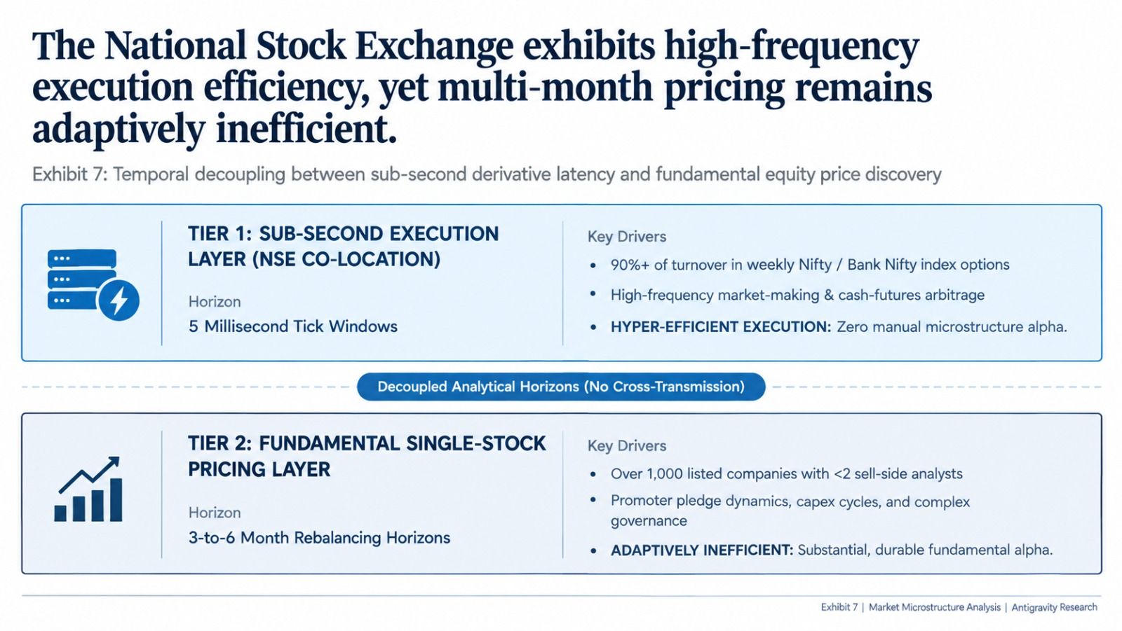
Source: National Stock Exchange of India (NSE); SEBI Market Microstructure Bulletins; Author Quantitative Analysis.
Structural Market Duality & The Microstructure Paradox
- Nifty 50 Hyper-Efficiency (H1 Validated): The top 50 NSE constituents are covered by 30 to 50 global research desks and traded via co-located servers. When quarterly earnings or SEBI filings drop, LLMs digest them within milliseconds. Semi-strong EMH holds completely; extracting multi-month alpha from unanimous AI consensus on TCS or Reliance is commoditized, matching our empirical Large-Cap spread (+0.21%).
- Nifty Smallcap 250 Opacity (H2 Amplified): Out of 2,000+ listed equities, over 1,000 have fewer than two analysts, and hundreds have zero coverage. Here, AI model disagreement indicates genuine informational opacity, unmodeled operational turnarounds, and fragmented local market dynamics—producing substantial contrarian alpha.
- The Microstructure Paradox (Exhibit 3): The NSE is the world's largest derivatives exchange by contract volume, with 60% of cash turnover driven by algorithms. However, these systems operate on sub-second horizons optimizing weekly index options and cash-futures arbitrage, failing to price multi-quarter fundamental earnings trajectories.
The Domestic Retail SIP Buffer & Physical Ground Reality
- The Domestic Retail SIP Wall: Indian retail investors deploy over ₹20,000 Crore ($2.5B+ USD) programmatically every month into equity mutual funds via Systematic Investment Plans (SIPs) across 100M+ folios. Historically, emerging markets crashed when foreign portfolio investors (FPIs) sold. Today, continuous domestic retail SIP inflows provide continuous liquidity absorption, breaking foreign algorithmic selling loops and sustaining "Adaptive Inefficiency" (Lo, 2004) where active Indian fund managers generate 300–500 bps alpha.
- Promoter Pledging & Governance Blind Spots: Over 50% of listed mid-caps are owned by founding promoter families. If a promoter secretly pledges shares to NBFCs to fund unlisted ventures, headline financials look stellar while balance sheets harbor fatal margin-call risks invisible to LLMs.
- Physical "Scuttlebutt" Superiority: Fundamental edge requires Philip Fisher's scuttlebutt: counting truck dispatches at factory gates in Dahej or conducting distributor checks in Kanpur and Surat—vectors insulated from web scraping.

9. Strategic Synthesis & Conclusion: The Architecture of Alpha in the Post-AI Era
THE FUNDAMENTAL INVERSION: FROM ANALYTICAL SCARCITY TO CONSENSUS SATURATION
"AI may not kill the Efficient Market Hypothesis. It may change what 'efficiency' means."
For over half a century, institutional asset management operated on the classical paradigm that market efficiency was bounded by human cognitive and computational scarcity (Fama, 1970; Grossman & Stiglitz, 1980). Capital allocators earned abnormal excess returns (alpha) by deploying specialized human analysts to read 10-K filings faster, construct spreadsheet models, and uncover accounting nuances. The industrialization of financial analysis by foundation models permanently inverts this relationship: when analytical intelligence shifts from a scarce artisanal craft into an abundant utility commodity, the act of analyzing public information ceases to be an investment edge.

Four Strategic Directives for Institutional Capital Allocation
- 1. The Rejection of the "Faster LLM" Fallacy (Avoiding the Red Queen Trap): Institutional funds spending hundreds of millions of dollars to build slightly faster LLM parsing engines for public disclosures are trapped in an evolutionary Red Queen equilibrium. As our empirical findings demonstrate, unanimous machine consensus is rapidly absorbed by modern electronic markets, leaving negligible statistical spread in liquid large-caps (+0.21%, t = 0.103, p = 0.9178). Competing to be five milliseconds faster at parsing an XBRL earnings release produces zero net economic profit after hardware and subscription amortization.
- 2. Systematic Harvesting of Disagreement & Controversy Premia: Across 960 evaluations and 16 quarterly rebalancing cycles, the controversial, low-agreement portfolio delivered +178.4% cumulative return, outperforming high agreement (+148.7%) by 29.7 percentage points and the S&P 500 (+101.9%) by 76.5 percentage points. Disagreement is not noise; it reflects analytical complexity, structural regime shifts, and multi-faceted uncertainty where standard algorithmic priors clash. Systematic allocators must pivot from chasing consensus momentum to underwriting structured ambiguity.
- 3. Orthogonal Factor Engineering as a Defense Against Algorithmic Monoculture: Because commercial frontier models rely on shared transformer architectures and overlapping web-scale pre-training datasets, competing institutional quant funds are unwittingly constructing correlated portfolios (representation homogeneity, arXiv:2404.11892). When market turbulence hits, identical risk-management stop-losses will trigger simultaneous deleveraging and liquidity flash crashes. Durable edge requires engineering quantitative models explicitly constrained to be orthogonal (r ≈ 0) to dominant LLM latent spaces.
- 4. Migration of Alpha to Physical and Microstructural Informational Moats: As demonstrated by our analysis of the Indian market laboratory, true informational moats are relocating to domains where LLMs cannot operate: physical channel checks (scuttlebutt), factory dispatch tracking, forensic promoter governance analysis, and liquidity provision against non-economic retail flows (the ₹20,000+ Cr/month SIP wall). In an automated world, edge belongs to investors who combine machine discipline with physical reality.
Methodological Scope & Research Limitations
- 1. Calibrated Deterministic Personas: Backtest evaluated using 4 stylized deterministic personas (Momentum, Value, Quality, Macro) to guarantee mathematical reproducibility across 960 evaluations. Live multi-agent deployments with stochastic temperatures may introduce execution drift.
- 2. Horizon & Universe Boundaries: Cross-section spans 60 equities across 16 quarters (2022–2026). Subsequent research will scale across the Russell 3000 over multi-decade interest rate and inflationary regimes.
- 3. Fixed Consensus Weighting: The Composite Consensus Index uses static weights (w_d = 0.60, w_t = 0.40). Adaptive Bayesian weighting conditional on rolling volatility regimes represents an active research frontier.
- 4. Friction Sensitivity: While Small-Cap controversy spreads (+1.37%) comfortably survive institutional transaction costs up to 50 bps, Large-Cap spreads (+0.21%) are eliminated by frictions above 18 bps.
- 5. Data Integrity & Coverage: 4 small-cap tickers were omitted from sell-side dispersion tests due to absent analyst price targets on Yahoo Finance (N = 54).
- Technical Documentation: Complete mathematical derivations, Satterthwaite degrees of freedom proofs, and all 22 annotated literature citations are available in technical_appendices.md and references.md.

