GOOGLE PLAY STORE MARKET ANALYSIS



Project Type: End-to-End Data Analytics Project.
Business Intelligence | Market Analytics | Dashboard Development
Transforming Marketplace Data into Actionable Business Intelligence

Tools & Technologies:
- Python
- Pandas
- NumPy
- PostgreSQL
- SQL
- Power BI
- Git
- GitHub

Prepared By: Parth Soni

Executive Summary
The Google Play Store has evolved into one of the world's largest digital marketplaces, hosting millions of applications across diverse industries. As competition continues to increase, application developers and business stakeholders require data-driven insights to understand customer behavior, identify profitable market segments, optimize pricing strategies, and improve overall application performance.
This project delivers an end-to-end Business Intelligence solution that transforms raw Google Play Store data into actionable insights. By integrating Python for data preparation, PostgreSQL for structured data management, SQL for business analysis, and Power BI for interactive reporting, the project demonstrates how modern analytics can support strategic decision-making throughout the application lifecycle.
The analysis explores marketplace trends, customer engagement, category performance, monetization strategies, and estimated revenue, ultimately providing business recommendations that can assist developers, product managers, and decision-makers in maximizing growth opportunities.

Business Context
The mobile application industry generates billions of downloads annually and continues to expand across sectors including education, finance, healthcare, entertainment, productivity, and e-commerce. With thousands of new applications released every day, organizations face increasing challenges in understanding market demand and differentiating their products.
Traditional decision-making methods based on intuition are no longer sufficient. Organizations must leverage data analytics to evaluate application performance, measure customer engagement, identify emerging market opportunities, and optimize business strategies.
This project addresses these challenges by analyzing real marketplace data and converting it into meaningful business intelligence.

\Business Problem Statement
Developers and organizations often struggle to determine which factors contribute most significantly to application success. While large volumes of marketplace data are publicly available, extracting meaningful insights from this information requires systematic analysis.
Without reliable analytical frameworks, businesses risk investing in highly saturated categories, adopting ineffective monetization strategies, and overlooking high-growth opportunities.
This project addresses these challenges by building a comprehensive analytics solution capable of evaluating application performance across multiple business dimensions, enabling stakeholders to make informed decisions based on empirical evidence rather than assumptions.

Project Objectives
The primary objective of this project is to develop a complete analytics pipeline that converts raw application data into business intelligence capable of supporting strategic decision-making.
Specific objectives include:
- Designing a structured data cleaning and preprocessing workflow.
- Performing exploratory data analysis to uncover marketplace trends.
- Evaluating customer engagement through ratings, reviews, and installation metrics.
- Comparing the performance of Free and Paid applications.
- Estimating revenue potential across application categories.
- Developing SQL-based business reports for strategic analysis.
- Building an interactive executive dashboard using Power BI.
- Delivering actionable business recommendations supported by analytical evidence.

Solution Architecture
The project follows a modern Business Intelligence workflow.
Raw Dataset
│
▼
Data Cleaning & Validation (Python)
│
▼
Feature Engineering
│
▼
PostgreSQL Database
│
▼
Business Analysis using SQL
│
▼
Power BI Dashboard
│
▼
Business Insights & Recommendations

Methodology
The analytical process was divided into five major phases.
Phase 1 — Data Preparation
The raw dataset was examined for missing values, duplicate records, inconsistent formats, invalid numerical values, and data quality issues. A standardized dataset was created to ensure analytical accuracy.

Phase 2 — Data Transformation
Business-specific variables were engineered by converting installations, prices, review counts, and estimated revenue into standardized numerical formats suitable for statistical analysis and visualization.

Phase 3 — Exploratory Analysis
Comprehensive exploratory analysis was conducted to understand category distribution, customer satisfaction, installation trends, pricing models, review behavior, and marketplace concentration.

Phase 4 — Business Intelligence
SQL queries were designed to answer strategic business questions regarding application performance, market dominance, pricing strategies, revenue estimation, and customer engagement.

Phase 5 — Dashboard Development
An executive dashboard was developed in Power BI to provide interactive visualization of business KPIs, enabling stakeholders to monitor marketplace performance through a centralized reporting interface.

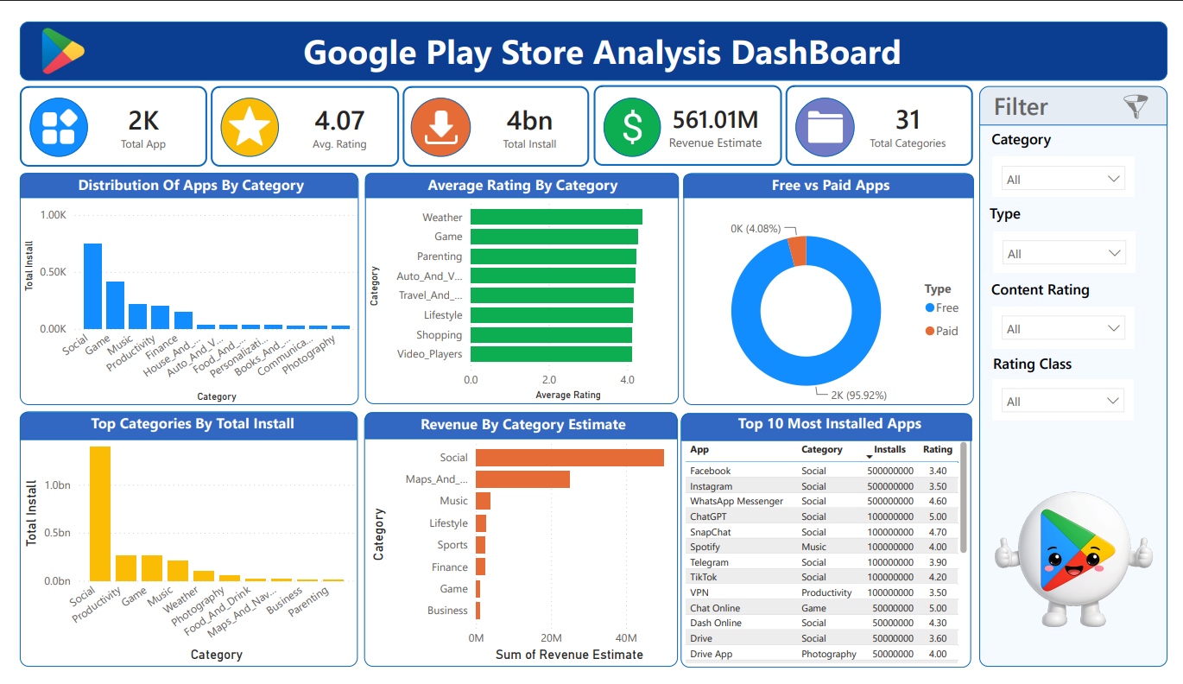

Key Findings
The analysis identified several important business observations:
- The marketplace is dominated by Free applications, highlighting user acquisition as the preferred business strategy.
- Categories such as Games, Tools, Communication, and Productivity consistently achieve the highest installation volumes.
- Applications with greater customer engagement, measured through review volume, generally exhibit significantly higher installation counts.
- Higher ratings alone do not guarantee marketplace success; customer interaction and category demand play equally important roles.
- Revenue opportunities are concentrated within a relatively small number of high-performing application categories.
- Several categories demonstrate strong growth potential despite comparatively lower market competition.

Strategic Recommendations
Based on the analytical findings, the following recommendations are proposed:
- Focus future product development on categories demonstrating sustained market demand.
- Adopt Freemium business models to balance customer acquisition and revenue generation.
- Improve application quality to increase user satisfaction and long-term retention.
- Encourage customer reviews to strengthen marketplace visibility and credibility.
- Continuously monitor key business metrics using interactive dashboards to support data-driven decision-making.
- Utilize predictive analytics in future iterations to forecast application performance and market trends.

Business Impact
This analytical solution enables stakeholders to move beyond descriptive reporting by providing a structured framework for strategic decision-making.
The project supports:
- Market Opportunity Identification
- Customer Engagement Analysis
- Revenue Optimization
- Product Performance Evaluation
- Competitive Benchmarking
- Executive KPI Monitoring
- Data-Driven Business Planning
The resulting Business Intelligence dashboard empowers decision-makers with timely insights that can improve investment strategies, product development, and overall marketplace competitiveness.

Conclusion
This project demonstrates the complete lifecycle of a modern data analytics solution, from raw data acquisition to executive-level business reporting. By integrating Python, PostgreSQL, SQL, and Power BI within a unified analytical workflow, the solution transforms complex marketplace data into meaningful business intelligence.
Beyond technical implementation, the project emphasizes analytical thinking, business storytelling, and strategic decision-making—skills that are essential for modern Data Analysts. The methodologies and insights presented throughout this report reflect industry best practices and provide a scalable foundation for future analytics initiatives within the digital application marketplace.

