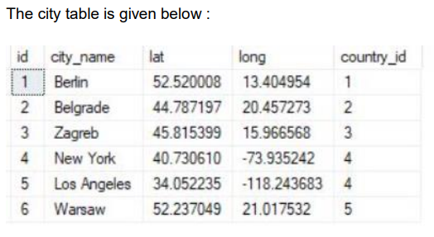

1. CREATE TABLE `city` (

`id` int(11) NOT NULL,

`city_name` varchar(30) DEFAULT NULL,

`lat` varchar(20) DEFAULT NULL,

`logn` varchar(30) DEFAULT NULL,

`country_id` varchar(30) DEFAULT NULL

)

* INSERT INTO `city` (`id`, `city_name`, `lat`, `logn`, `country_id`) VALUES

(1, 'Berlin', '52.520008', '13.404954', '1');

* INSERT INTO `city` (`id`, `city_name`, `lat`, `logn`, `country_id`) VALUES

(2, 'Belgrade', '44.787197', '20.457273', '2');

* INSERT INTO `city` (`id`, `city_name`, `lat`, `logn`, `country_id`) VALUES

(3, 'Zagred', '45.815399', '15.966568', '3');

* INSERT INTO `city` (`id`, `city_name`, `lat`, `logn`, `country_id`) VALUES

(4, 'New York', '40.730610', '-73.935254', '4');

* INSERT INTO `city` (`id`, `city_name`, `lat`, `logn`, `country_id`) VALUES

(5, 'Los Angeles', '34.0522235', '-118.243683', '4');

* INSERT INTO `city` (`id`, `city_name`, `lat`, `logn`, `country_id`) VALUES

(6, 'Warsaw', '52.237049', '21.017532', '5');

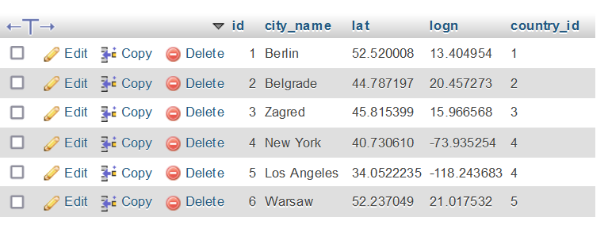

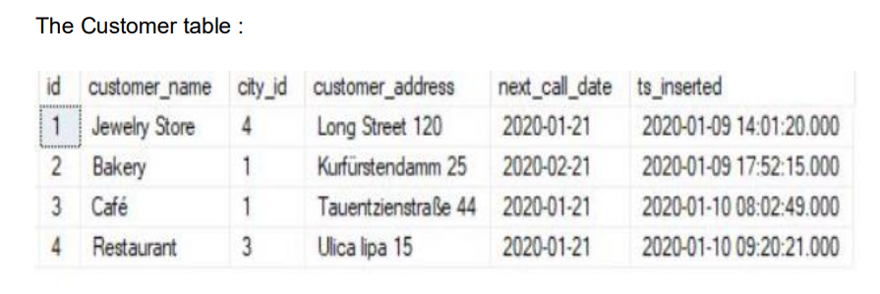

1. CREATE TABLE `new_customer` (

`id` int(11) DEFAULT NULL,

`customer_name` varchar(30) DEFAULT NULL,

`city_id` int(11) DEFAULT NULL,

`customer_address` varchar(50) DEFAULT NULL,

`next_call_date` varchar(30) DEFAULT NULL,

`ts_inserted` varchar(30) DEFAULT NULL

)

* INSERT INTO `new_customer` (`customer_name`, `city_id`, `customer_address`, `next_call_date`, `ts_inserted`) VALUES

(1, 'Jewelry Store', 4, 'Long Street 120', '2020-01-21', '2020-01-09 14:01:20.000');

* INSERT INTO `new_customer` (`customer_name`, `city_id`, `customer_address`, `next_call_date`, `ts_inserted`) VALUES

(2, 'Bakery', 1, 'Kurfurstendamm 25', '2020-02-21', '2020-01-09 17:52:15.000');

* INSERT INTO `new_customer` (`customer_name`, `city_id`, `customer_address`, `next_call_date`, `ts_inserted`) VALUES

(3, 'Cafe', 1, 'TauentzienstraBe 44', '2020-01-21', '2020-01-10 08:02:49.000');

* INSERT INTO `new_customer` (`customer_name`, `city_id`, `customer_address`, `next_call_date`, `ts_inserted`) VALUES

(4, 'Restaurant', 3, 'Ulica lipa 15', '2020-01-21', '2020-01-10 09:20:21.000');

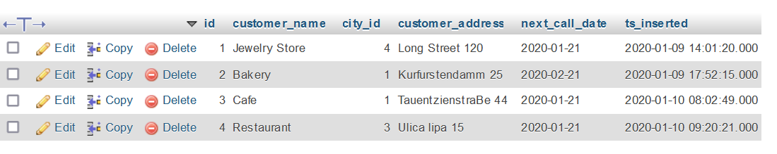

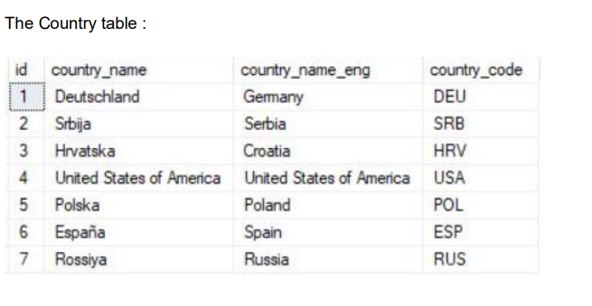

1. CREATE TABLE `country` (

`id` int(11) AUTO_INCREMENT PRIMARY KEY,

`country_name` char(30) NOT NULL,

`Country_name_eng` varchar(30) NOT NULL,

`country_code` varchar(20) NOT NULL

)

* INSERT INTO country (`country_name`,`Country_name_eng`,`country_code`) VALUES

('Deutschland','Germany','DEU');

* INSERT INTO country (`country_name`,`Country_name_eng`,`country_code`) VALUES

('Srbija','Serbia','SRB');

* INSERT INTO country (`country_name`,`Country_name_eng`,`country_code`) VALUES

('Hrvatska','Croatia','HRV');

* INSERT INTO country (`country_name`,`Country_name_eng`,`country_code`) VALUES

('United States of America','United States of America','USA');

* INSERT INTO country (`country_name`,`Country_name_eng`,`country_code`) VALUES

('Polska','Poland','POL');

* INSERT INTO country (`country_name`,`Country_name_eng`,`country_code`) VALUES

('Espana','Spain','ESP');

* INSERT INTO country (`country_name`,`Country_name_eng`,`country_code`) VALUES

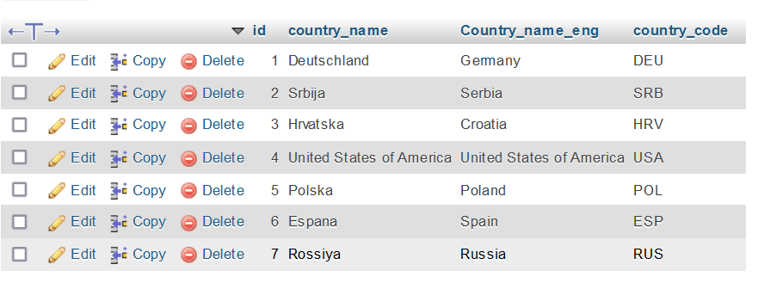('Rossiya','Russia','RUS')

* Task 1

SELECT `customer`.*, `city`.* FROM `customer` LEFT JOIN `city` ON `customer`.`city_id`=`city`.`id`

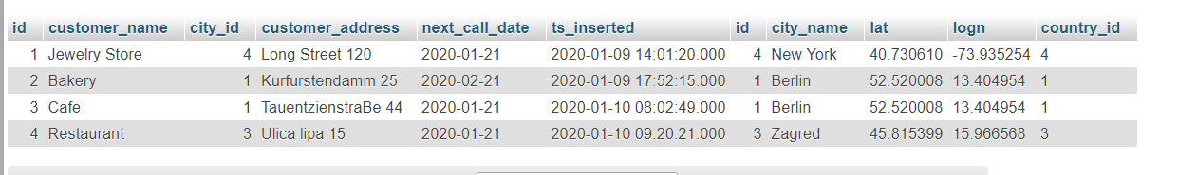

* Task 2

SELECT *

FROM country

INNER JOIN customer ON country.id = customer.city_id;

