COMPUTER NETWORK LAB PROJECT
For
Implementing a secure network architecture
For a large enterprise

Introduction:
This project entails the design and configuration of a comprehensive network infrastructure tailored for a considering the enterprise's multiple locations and remote offices, utilizing Cisco Packet Tracer. The network setup encompasses various elements including Perimeter Security, Secure Remote Access, Endpoint Security, Identity and Access Management (IAM), Data Encryption, Monitoring and Logging, Network Segmentation, serial router configurations, password security measures.

Objective:
The primary aim of this project is to develop a robust and efficient network infrastructure customized to meet the specific demands of company infrastructure setting. This involves the creation of segmented VLANs to manage traffic effectively, configuring routers to enable inter-VLAN communication, implementing security measures such as password protection, login monitoring, deploying an endpoint security, and integrating DHCP services for simplified IP address allocation.

Description of System:
Router 1: IP 10.10.10.1
Head quarter: Located on the first Router 1 serves as the gate way for this area. It is responsible for managing network traffic and providing internet access to administrative devices.
VLANS for segment network traffic
2 VLAN:
Vlan10: IT team assign IP 192.168.10.0
Vlan20: Admin team assign IP 192.168.20.0

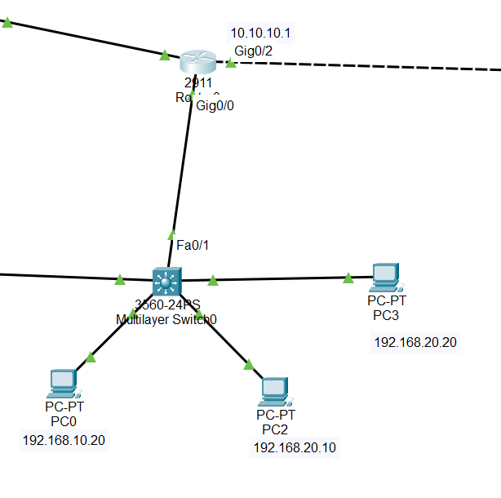

Router 2: IP 10.10.20.1
Branch office: Located on the Second Router 2 serves as the gate way for this area. It is responsible for managing network traffic and providing internet access to devices.
VLANS for segment network traffic
2 VLAN:
Vlan30: IT team assign IP 192.168.30.0
Vlan40: Admin team assign IP 192.168.40.0
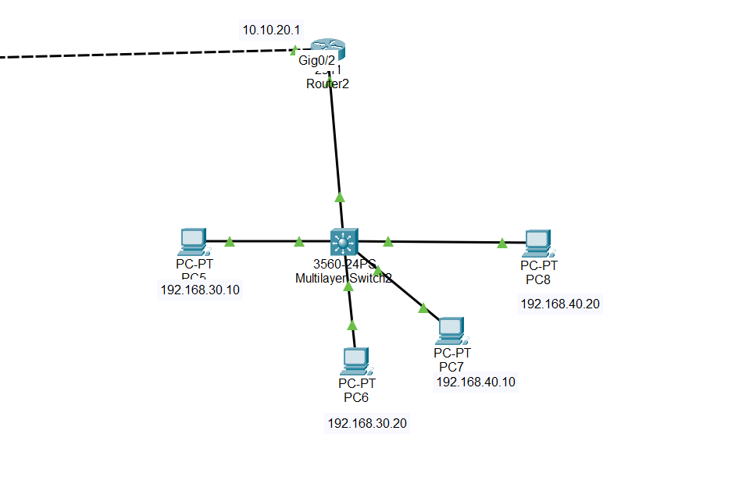

Router 3: IP 10.10.30.1
Remote office: Located on the Third Router 3 serves as the gate way for this area.
I network remotely connect IP 192.168.60.10
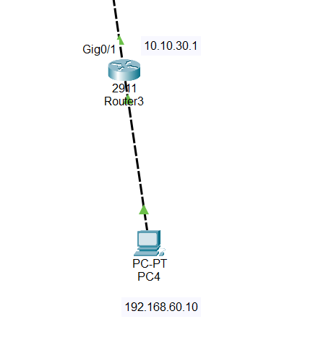
Virtual Private Network (VPN) Remote VPN
Configuration is done in Router.
Build VPN tunnel from Router 1 (Headquarter) to Router 3 (Remote office)
Connect router 1 IP 10.10.10.1 and router 3 IP 10.10.30.1
Packet transfer from 192.168.20.10 to 192.168.60.10
Packets are encrypted in form of sha256
Password is Ciscovpn
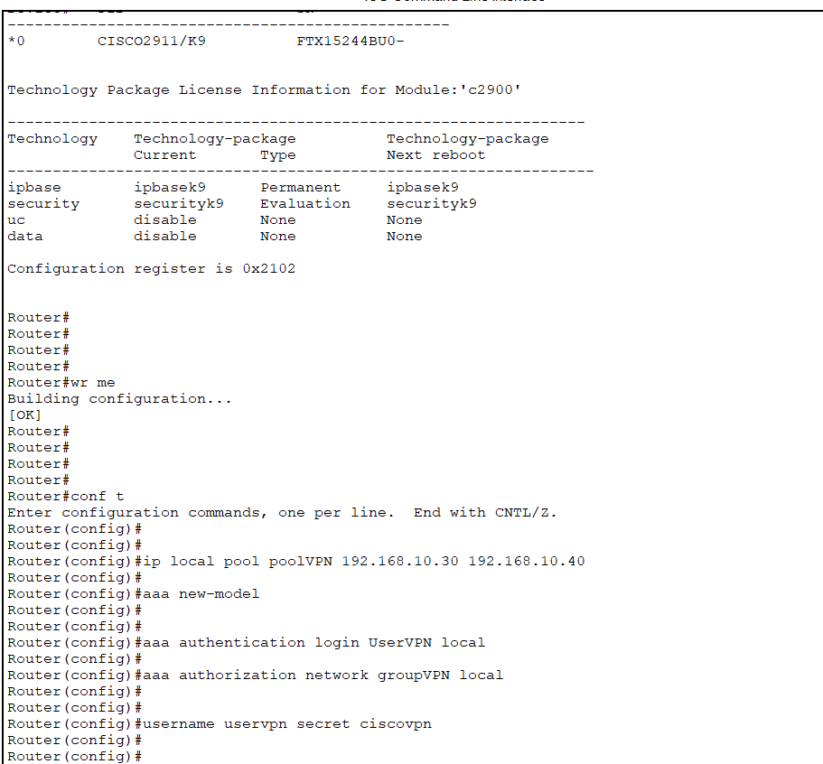

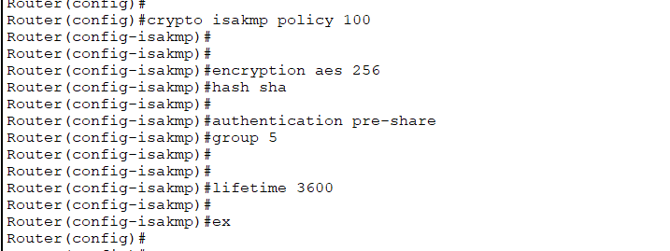

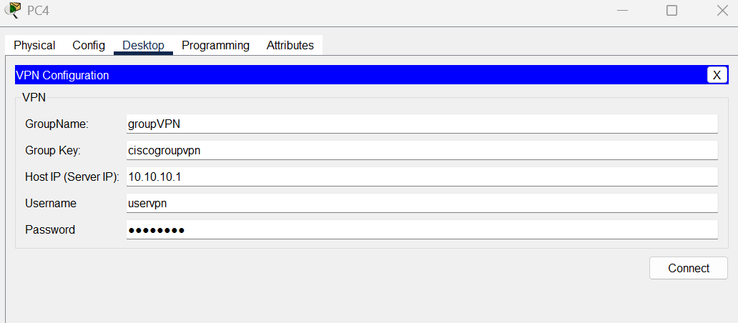
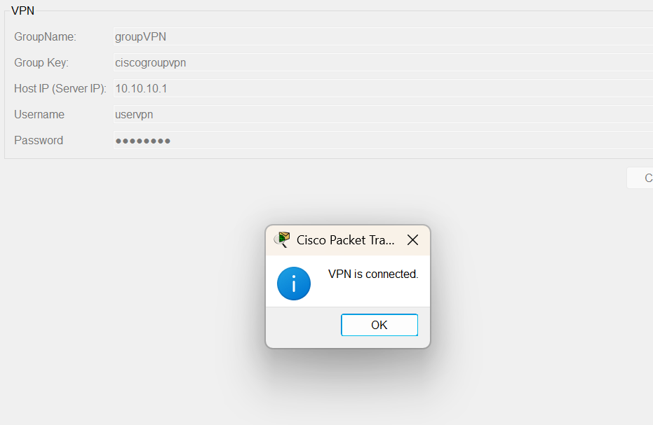

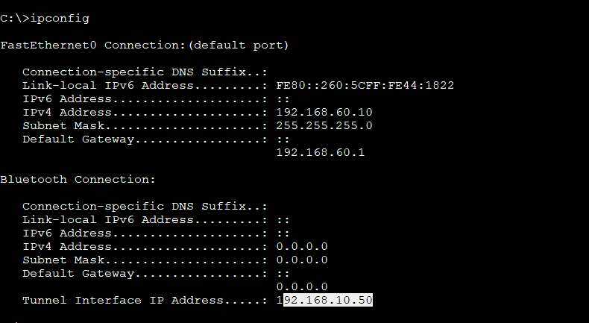

Secure Remote Access Strategy
Virtual Private Network (VPN) Setup
Planning and Preparation
Identify the type of VPN required:
Remote Access VPN – For individual users connecting securely to the corporate network.
Site-to-Site VPN – For secure communication between office locations.
Choose a VPN protocol:
OpenVPN – Secure, open-source, supports strong encryption.
IPSec – Ideal for site-to-site connections, widely supported.
Wire Guard – Modern, lightweight, high-speed VPN solution.
Ensure multi-factor authentication (MFA) is enabled for VPN access.
VPN Configuration
Deploy VPN servers in a DMZ network to isolate external access.
Configure strong encryption (AES-256, SHA-2 for hashing) and secure tunnelling protocols.
Implement role-based access control (RBAC) to limit VPN access based on user roles.
Enable split tunnelling (if necessary) to balance security and performance.
Set up logging and monitoring to track VPN access attempts and potential threats.
VPN Management and Security
Enforce automatic disconnection after inactivity to prevent session hijacking.
Regularly patch and update VPN software and firmware.
Conduct penetration testing to identify vulnerabilities.
Implement geofencing to restrict VPN access from unauthorized locations.

ACLs (Access Control Lists)
Give OUTSIDE Server to access DMZ Server
Allow icmp packets for travel traffic through ASA Firewall to server
Defined two security zone:
Outside network as 10.10.10.1
DMZ server 192.168.100.10
Outside zone have security-level 0 least untrusted network
DMZ have security-level 80 it’s a server

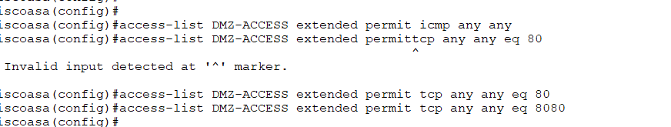

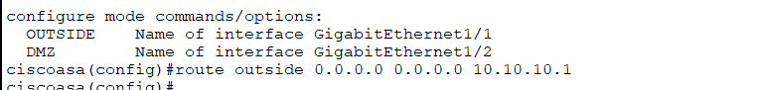

Multi-Factor Authentication (MFA)
Enhancing security by requiring multiple verification methods.
MFA prevents unauthorized access by requiring an additional layer of authentication, such as:

Password + OTP (One-Time Password)
Password + Biometrics
Role-Based Access Control (RBAC)
RBAC configuration done by AAA in Router 4
Two different role
Net IT which has less privileges
Net Admin which has more privileges
User id: RBAC
Password: cisco
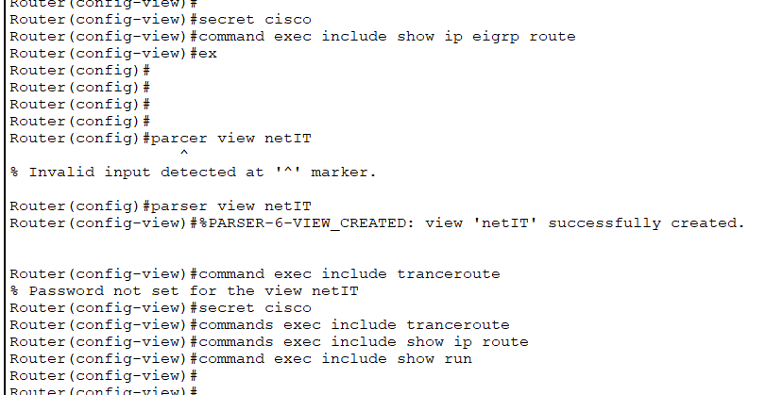
In pc 4
Telnet is connect
After id & pass you run command
AAA authentication and command authorization to enforce RBAC
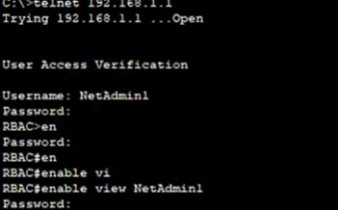

ENDPOINT SECURITY

Firewall Security
Use a Cisco ASA Firewall or configure ACLs (Access Control Lists) on routers to filter traffic.
Block access to malicious websites or unauthorized connections to simulate endpoint protection.
Implement Firewall Security
Use a Cisco ASA Firewall or configure ACLs (Access Control Lists) on routers to filter traffic.
Block access to malicious websites or unauthorized connections to simulate endpoint protection.
Antivirus
Use a Syslog Server to monitor network traffic for suspicious activity.
Configure an Intrusion Detection System (IDS) or Intrusion Prevention System (IPS) on routers or firewalls to detect and mitigate threats.
VLAN
Create VLANs to separate endpoints from critical systems.
Use port security on switches to prevent unauthorized devices from connecting.
Configure security policies
Use AAA (Authentication, Authorization, and Accounting) for user access control.
Implement SNMP (Simple Network Management Protocol) to monitor endpoint activities.
Multi-Factor Authentication (MFA)
Configuration is done in ASA Firewall.
Simulate MFA using AAA (Authentication, Authorization, and Accounting)
Enable AAA (for authentication control) and configure a RADIUS server.
Data Encryption:
Configuration is done in Router.
TLS and SSH also use VPN for encryption
This enables TLS encryption for secure web management.
SSH encrypts remote administration traffic.

Network Monitoring
Configuration is done in ASA Firewall and Router.
Network Monitoring Setup
Network monitoring ensures real-time visibility into traffic, performance, and security threats
To monitor network activity
Logging
A centralized logging system aggregates logs from network devices, servers, and applications for analysis.
Syslog Server
On syslog on server to see logs
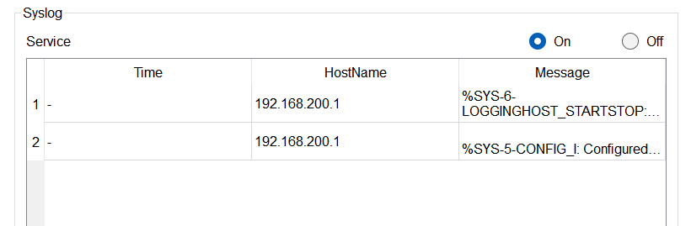

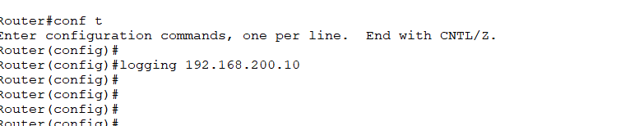

Policy and compliance

Security Policies
Develop and enforce comprehensive security policies to govern network access, data handling, and system protection.
Implement role-based access controls (RBAC) to restrict unauthorized access.
Define incident response procedures for handling security breaches and cyber threats.
Ensure data encryption for both stored and transmitted data.
Regularly review and update security policies to address emerging threats.
Regulatory Compliance
Ensure that the network architecture adheres to industry regulations such as:
GDPR (General Data Protection Regulation) – for data privacy and protection.
HIPAA (Health Insurance Portability and Accountability Act) – for safeguarding healthcare-related information.
ISO 27001 – for establishing an information security management system (ISMS).
Conduct regular audits to assess compliance and identify potential gaps.
Implement data retention and deletion policies in accordance with legal requirements.
Train employees on compliance best practices to reduce human error-related security risks.

Zero Trust Architecture (ZTA) Implementation

Core Principles of Zero Trust
Never trust, always verify – Authenticate every access request.
Least privilege access – Users and devices get only the necessary access.
Micro-segmentation – Network divided into smaller, secure zones.
Continuous monitoring – Real-time threat detection and response.
Defined two security zone:
Outside network 10.10.10.1
DMZ server 192.168.100.10
Outside zone we have zero trust so we give him security-level 0 mean low trust
DMZ zone have inner server so I give him security-level 70


Data Encryption Strategy

Encryption is critical for securing sensitive data from unauthorized access
Data Encryption in Transit by using Protocols for Secure Communication
TLS (Transport Layer Security) – Encrypts web traffic (HTTPS), emails (SMTPS), and VPNs
IPSec (Internet Protocol Security) – Encrypts network traffic at Layer 3 (VPNs, site-to-site encryption).
SSH (Secure Shell) – Encrypts remote administrative access to systems
SFTP (Secure File Transfer Protocol) – Encrypts file transfers.
WPA3 (Wi-Fi Protected Access 3) – Encrypts wireless networks
Use strong VPN encryption (AES-256 with IPSec).
Enable HTTPS & TLS 1.2/1.3 for web applications
Configure SSH instead of Telnet for remote access
Data Encryption at Rest
Data at rest refers to data stored on disks, databases, or backups. Encryption prevents unauthorized access even if the storage device is stolen.
Encryption Techniques-
AES-256 (Advanced Encryption Standard) – Used for databases, files, and full-disk encryption.
BitLocker & File Vault – Encrypts entire drives.
Transparent Data Encryption (TDE) – Encrypts SQL databases without modifying applications.
Implementation step
Encrypt database columns containing sensitive data
Use hardware security modules (HSMs) to store encryption keys securely
Always store data in encrypted form
Implement access controls to restrict decryption permissions.
Secure backups with encryption before transferring off-site

Incident Response and Management

Incident Response Plan
Develop and implement a comprehensive incident response plan (IRP) to handle security incidents effectively.
Define clear roles and responsibilities for the incident response team (IRT).
Establish an incident classification system to categorize threats based on severity and impact.
Create detailed response procedures for different types of incidents, including:
Data breaches
Malware infections
DDoS attacks
Unauthorized access attempts
Insider threats
Ensure real-time monitoring and logging of network activities to detect incidents early.
Implement communication protocols to notify stakeholders, regulatory bodies, and affected users as required.
Develop post-incident review processes to analyse root causes and improve response strategies.
Training and Drills
Conduct regular training sessions for the incident response team to stay updated on best practices.
Perform table top exercises and simulated attack drills (e.g., phishing tests, ransomware simulations) to test readiness.
Ensure all employees receive cybersecurity awareness training to recognize and report security incidents.
Maintain detailed documentation of training sessions and drills for compliance and continuous improvement.
Regularly update and refine the incident response plan based on lessons learned from past incidents and new emerging threats.
1 Preparation
Define roles, tools, and policies. Conduct training.
2 Detection & Analysis
Identify and verify the breach, assess impact.
3 Containment
Limit the spread of the attack, isolate affected systems.
4 Eradication
Remove threats (e.g., malware, compromised accounts)
5 Recovery
Restore systems, verify security, and resume normal operations.
Conduct the Drill
Initial Alert
Security monitoring tools (SIEM, IDS/IPS) detect suspicious activity.
Investigation & Containment
SOC team analyses logs & identifies affected systems.
IT team isolates compromised machines.

