Developing a Secure Firmware Update Mechanism for IoT Devices

IoT devices
The Internet of Things (IoT) is regarded as a technology and economic wave in the global information industry after the Internet. The IoT is an intelligent network which connects all things to the Internet for exchanging information and communicating through the information sensing devices in accordance with agreed protocols. It achieves the goal of intelligent identifying, locating, tracking, monitoring, and managing things. It is an extension and expansion of an Internet-based network, which expands the communication from human and human to human and things or things and things. In the IoT paradigm, many objects surrounding us will be connected into networks in one form or another. RF identification (RFID), sensor technology, and other smart technologies will be embedded into a variety of applications. Wearable Technology (WT) or called wearable is a computing technology device that can be worn on the human body, either a computer that is incorporated as an accessory or as part of material used in clothing. These devices come in many different forms such as watches, glasses, wristbands or even jewellery items. Wearable devices are defined by six main characteristics which are un-monopolizing, unrestrictive, observable, controllable, attentive and communicative. The development of the applications that can work with WT cover a broad field from those focused-on healthcare and fitness, to industrial applications, and even entertainment and arts. The scope of wearable technologies is very broad and amorphous, and determining the characteristics and specifications of wearable technologies is very difficult. Therefore, to understand the classification of wearable technologies based on the basic characteristics will be very beneficial. According to the literature, wearable technologies may be divided into three main categories. These categories can be called wearable health technologies, wearable textile technologies and wearable consumer electronics


vulnarabilities in IoT
As the use of wearable services increases, the concern about their security becomes critical. According to HP research, most smartwatches are vulnerable to security attacks, having a risk of leaking personal data. Several studies demonstrate that firmware update vulnerability in wearable devices allows attackers to inject malicious codes. As smartphone apps and web services make use of open interfaces for interoperability, they are susceptible to attack, becoming a weak point for a security threat. For instance, web services suffer from the notorious vulnerabilities such as SQL injection and XSS (Cross-Site Scripting) attacks.

Easy Physical Access to Data
The fact that many wearables store data on the local device without encryption is a real issue. There’s often no PIN or password protection, no biometric security and no user authentication required to access data on a wearable. If it falls into the wrong hands, there’s a risk that sensitive data could be accessed very easily.

Insecure Wireless Connectivity
The fact that the wearable devices tend to connect to one’s smartphone or tablet wirelessly using protocols such as Bluetooth, NFC and Wi-Fi, create another potential point of entry. One may have features like Bluetooth, hotspot connectivity turned ON 24/7 for the need to synchronize with the device. Many of these wireless communications are insufficiently secure to guard against a determined brute-force attack. The data transmission is sometimes not encrypted, which leads to a lot of malicious attacks like eavesdropping, evil twin etc.

Lack of Encryption
Many research work report the lack of encryption on many wearable devices, but there are also serious issues with data in transit when it’s being synced and with data being stored on manufacturer’s or service provider’s cloud servers. Some third-party apps neglect basic security standards and send or store information that’s not encrypted. The kind of data that’s automatically being collected by wearables is very valuable to the right people.

Scope and Objectives of Secure Boot, Code Signing, and Update Verification in System Design and Architecture

Scope:
The scope of this system design and architecture focuses on ensuring the security and integrity of firmware and software execution on a device. It covers the following key areas:
Secure Boot:
- Implements a cryptographic-based boot process to prevent unauthorized firmware execution.
- Ensures only trusted and signed firmware is loaded during the boot process.
- Protects against boot-time attacks and unauthorized firmware modifications.
Code Signing:
- Uses digital signatures to verify the authenticity of firmware and software updates.
- Prevents execution of tampered or untrusted code.
- Ensures the firmware comes from a legitimate source.
Update Verification:
- Checks the integrity and authenticity of firmware updates before and after installation.
- Prevents unauthorized or malicious updates from being installed on the device.
- Ensures rollback protection to prevent downgrading to vulnerable versions.

Objectives:
- Enhance Security:
Protect devices from unauthorized modifications and malicious firmware.
- Prevent rootkits, bootkits, and other malware from compromising the system.
Ensure Integrity and Authenticity:
- Verify firmware and software authenticity at boot and during updates.
- Use cryptographic techniques to detect unauthorized modifications.
Regulatory and Compliance Adherence:
- Comply with security standards like NIST, ISO 27001, and industry best practices.
- Meet cybersecurity requirements in critical industries like automotive, healthcare, and IoT.
Reliability and Stability:
- Prevent bricking of devices due to corrupt or malicious firmware updates.
- Enable rollback and recovery mechanisms in case of update failures.
Scalability and Future-Proofing:
- Design the system to support future firmware security enhancements.
- Ensure compatibility with evolving security threats and cryptographic standards.

Scope and Objectives of Core Security Features in System Design

Scope:
The core security features focus on safeguarding firmware integrity, authenticity, and confidentiality through cryptographic mechanisms. The scope includes:
Cryptographic Algorithms:
- Implementation of strong cryptographic algorithms like RSA or ECC for digital signing.
- Use of SHA-256 or stronger hashing algorithms for integrity verification.
- Ensuring compliance with modern security standards (e.g., NIST, FIPS).
Firmware Encryption:
- Encrypting firmware updates to prevent unauthorized access or tampering.
- Protecting sensitive firmware components from reverse engineering and attacks.
- Implementing secure key management for encryption and decryption processes.
Rollback Protection:
- Preventing downgrades to outdated or vulnerable firmware versions.
- Implementing secure version control and anti-replay mechanisms.
- Ensuring that only newer and verified firmware can be installed.

Objectives:
Ensure Data Integrity and Authenticity:
- Use cryptographic signatures to validate firmware origin.
- Prevent execution of modified or untrusted firmware.
Enhance Firmware Confidentiality:
- Encrypt firmware updates to protect sensitive information.
- Restrict unauthorized access to firmware during transmission and storage.
Mitigate Security Risks:
- Prevent rollback attacks that exploit older, insecure firmware versions.
- Reduce the risk of firmware-based exploits and unauthorized modifications.
Compliance with Security Standards:
- Adhere to industry regulations (e.g., ISO 27001, NIST, FIPS 140-2).
- Meet security requirements for IoT, embedded systems, and critical infrastructures.
Long-Term Security and Maintainability:
- Ensure cryptographic agility to adapt to evolving security threats.
- Support secure update mechanisms for future enhancements.
Secure firmware:
Firmware updates are essential for maintaining device security and functionality. However, vulnerabilities in the firmware update process can expose systems to significant risks. Understanding the literature, security standards, and real-world vulnerabilities associated with firmware updates is crucial for enhancing cybersecurity measures.
Security Standards for Firmware Updates
Adhering to established security standards is vital to ensure the integrity and authenticity of firmware updates. Key standards include:
- NIST SP 800-147: Provides guidelines for BIOS protection, emphasizing the need for authenticated updates to prevent unauthorized firmware modifications.
- NIST SP 800-193: Focuses on platform firmware resiliency, outlining mechanisms to protect, detect, and recover from firmware attacks.
- Trusted Platform Module (TPM) 2.0: A hardware-based security standard that ensures cryptographic processes, such as data encryption and hardware authentication, are securely managed. TPM 2.0 is integral to modern operating systems like Windows 11, which require it for enhanced security feature
Real-World Vulnerabilities in Firmware Updates
Several notable vulnerabilities have been identified in firmware update mechanisms:
- UEFI Firmware Vulnerabilities: Researchers discovered critical flaws in the InsydeH2O UEFI firmware used by over 25 vendors, including Fujitsu, Intel, and Dell. These vulnerabilities could allow attackers to install persistent, undetectable malware, compromising the system's security at a fundamental level.
ASUS Router Firmware Update Flaw: A vulnerability in ASUS RT series routers allowed attackers to perform man-in-the-middle attacks during the firmware update process. By exploiting the lack of encryption in the update mechanism, attackers could trick routers into installing malicious firmware versions
Dell Firmware Update Driver Vulnerability: A 12-year-old flaw in Dell's firmware updater, DBUtil 2.3, was found to allow local privilege escalation. This vulnerability could enable attackers to gain kernel-level access, posing severe security risks.
RAUC Embedded Firmware Update Framework Vulnerability: A significant vulnerability in the RAUC framework, used for firmware updates in embedded Linux devices, was discovered. This flaw could allow attackers to bypass cryptographic signature checks, leading to the installation of unauthorized firmware.
Mitigation Strategies
To mitigate risks associated with firmware updates:
- Implement Secure Update Mechanisms: Ensure firmware updates are delivered over secure channels (e.g., HTTPS) and are cryptographically signed to verify authenticity.
- Regularly Update Firmware: Keep firmware up to date to patch known vulnerabilities. For example, Apple released iOS 18.3 to address significant security flaws, highlighting the importance of timely updates
Adopt Hardware Security Modules: Utilize hardware-based security features, such as TPM 2.0, to enhance the security of the firmware update process

Update mechanisms Flowchart Explanation

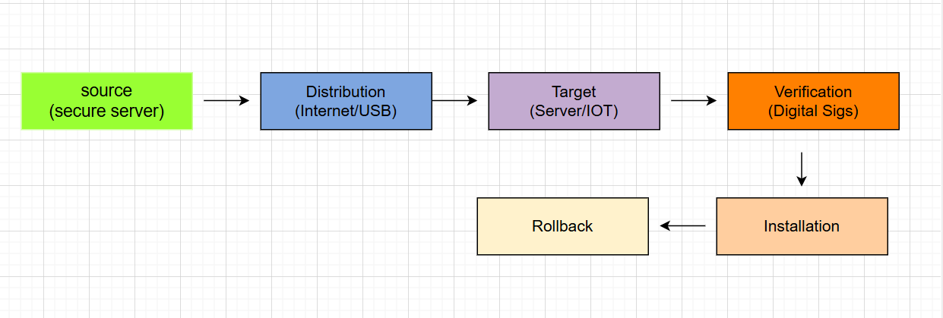

Source (Secure Server):

- Purpose: This is the origin of the update. It could be a secure server or a trusted repository where updates are stored.
- Role: Ensures that the update is authentic and has not been tampered with. It acts as the trusted source from which updates are distributed.

Distribution (Internet/USB):

- Purpose: This is the method by which the update is delivered to the target systems.
- Role: Can be over the internet, via USB, or any other secure method. The distribution method must ensure that the update reaches the target systems securely and efficiently.

Target (Servers/IoT):

- Purpose: These are the systems or devices that will receive and apply the update.
- Role: Can include servers, IoT devices, mobile apps, or any other systems that need to be updated. The target systems must be capable of receiving, verifying, and installing the update.

Verification (Digital Signs):

- Purpose: This step ensures the integrity and authenticity of the update.
- Role: Uses digital signatures, checksums, or other verification methods to confirm that the update has not been altered and comes from a trusted source. This is a critical step to prevent malicious updates.

Installation:

- Purpose: This is the process of applying the update to the target systems.
- Role: Involves installing the update and ensuring that it is correctly applied. This step may include restarting the system, updating configuration files, or other necessary actions.

Rollback:

- Purpose: This is the mechanism for reverting to a previous state if the update fails.
- Role: Ensures that the system can return to a stable state if the update process encounters issues. This is crucial for maintaining system availability and reliability.

Secure Boot Flowchart Explanation

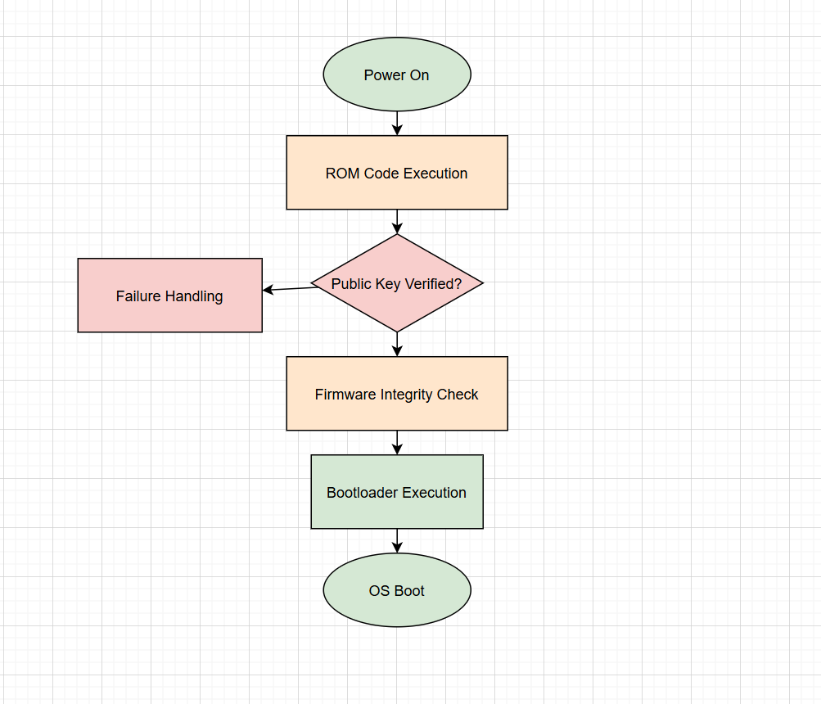
This Secure Boot process ensures that only trusted, signed firmware is loaded onto a device, preventing unauthorized or malicious code from executing. Below is a step-by-step breakdown of the flowchart:

Power On (Start Node)
- The device is powered on, initializing hardware components.
- Execution starts from Read-Only Memory (ROM), which contains the first-stage bootloader.

ROM Code Execution
- The device executes firmware stored in ROM, which is immutable and contains the secure boot logic.
- The ROM bootloader is responsible for verifying the authenticity of the next stage bootloader or firmware.

Public Key Verification (Decision Node)
- The bootloader checks the digital signature of the firmware using a public key stored in hardware (e.g., TPM, fuses, or secure storage).
- This ensures that only firmware signed by a trusted source (e.g., the manufacturer) is allowed to execute.
- Two possible outcomes:
  - Verification Success → Proceed to Firmware Integrity Check.
  - Verification Failure → The system enters Failure Handling mode (explained below).

Firmware Integrity Check
- The device verifies that the firmware has not been tampered with using cryptographic hash functions (e.g., SHA-256).
- The firmware's hash value is compared with a precomputed, signed hash.
- Two possible outcomes:
  - Integrity Check Passed → Proceed to Bootloader Execution.
  - Integrity Check Failed → The system enters Failure Handling mode.

Bootloader Execution
- Once the firmware is verified, the bootloader is executed.
- The bootloader loads the operating system (OS) kernel into memory.

OS Boot (End Node)
- The bootloader successfully loads and executes the OS.
- The device is now operational and running a trusted system.

Failure Handling (If Verification Fails)
- If the signature verification or integrity check fails, the device takes one of the following actions:
- Rollback to a previous trusted firmware version (if rollback protection allows).
- Enter recovery mode for manual firmware reinstallation.
- Halt the boot process and display an error message.

Cryptographic Implementations
RSA (Rivest-Shamir-Adleman)RSA is a widely used asymmetric encryption algorithm that relies on the difficulty of factoring large prime numbers. It provides strong security for data encryption and digital signatures.
Key Features:Key Pair: Uses a public key for encryption and a private key for decryption.
Security Basis: Relies on the prime factorization problem, which is computationally difficult to reverse-engineer.
Use Cases: Secure communication (e.g., SSL/TLS), digital signatures, key exchange, and email encryption (e.g., PGP).
Process:Generate two large prime numbers, p and q, and compute n = p × q.
Compute Euler’s totient function: φ(n) = (p - 1) × (q - 1).
Select a public exponent e (commonly 65537) that is relatively prime to φ(n).
Compute the private exponent d, where d × e ≡ 1 (mod φ(n)).
Encryption: Ciphertext (C) = Plaintext^e mod n.
Decryption: Plaintext (P) = Ciphertext^d mod n.
ECDSA (Elliptic Curve Digital Signature Algorithm)ECDSA is an asymmetric cryptographic algorithm used for digital signatures, offering strong security with shorter key lengths compared to RSA.
Key Features:Based on Elliptic Curve Cryptography (ECC), providing strong security with smaller key sizes.
Efficient and faster than RSA for digital signatures.
Common Uses: Blockchain (e.g., Bitcoin, Ethereum), secure authentication, digital certificates, and identity verification.
Process:Generate a private key (a random number) and compute the corresponding public key using elliptic curve operations.
Compute a cryptographic hash (e.g., SHA-256) of the message.
Use the private key to generate a unique signature.
The recipient verifies the signature using the sender’s public key.
SHA-256 (Secure Hash Algorithm 256-bit)SHA-256 is a cryptographic hash function that produces a 256-bit fixed-length output from any input data.
Key Features:One-way function: It is infeasible to reverse-engineer the original data from the hash.
Collision-resistant: It is extremely difficult to find two different inputs producing the same hash.
Deterministic: The same input always produces the same hash output.
Common Uses: Digital signatures, password hashing, blockchain transactions, file integrity verification, and certificate generation.
Process:The input message is padded and divided into 512-bit blocks.
A series of bitwise operations (AND, XOR, shifts, modular additions) are applied using predefined constants and functions.
The final output is a 256-bit hash value unique to the input data.
Key ManagementKey management is essential for maintaining the confidentiality, integrity, and availability of cryptographic keys. Without proper key management, even the strongest encryption can be compromised.
Best Practices:Key Generation: Use a strong, secure random number generator to create cryptographic keys.
Key Storage: Secure keys using hardware security modules (HSMs), secure key vaults, or trusted platform modules (TPM).
Key Rotation: Periodically change encryption keys to mitigate risks of compromise.
Key Access Control: Implement role-based access control (RBAC) to restrict key access to authorized users only.
Key Expiry and Revocation: Define expiration dates and have a mechanism to revoke compromised keys.
Secure Key Exchange: Use secure protocols (e.g., Diffie-Hellman, RSA) to transmit keys safely over networks.
Audit and Monitoring: Regularly review logs and monitor access to cryptographic keys to detect potential breaches.
Secure Storage SolutionsStoring cryptographic keys and sensitive data securely is critical to prevent unauthorized access or theft. Various solutions are available to ensure secure storage.
Common Secure Storage Methods:Hardware Security Modules (HSMs): Physical devices that store and manage cryptographic keys securely, protecting them from unauthorized access and tampering.
Trusted Platform Module (TPM): A dedicated microcontroller that protects cryptographic operations and keys, typically used in secure boot processes and disk encryption.
Secure Enclaves: Isolated execution environments, such as Intel SGX and ARM TrustZone, which allow secure computation without exposing data to the operating system.
Cloud Key Management Services (KMS): Managed services from cloud providers (e.g., AWS KMS, Azure Key Vault, Google Cloud KMS) that securely store and manage cryptographic keys.
Encrypted Databases: Use database encryption techniques such as Transparent Data Encryption (TDE) to protect stored data from unauthorized access.
Secure USB Tokens & Smart Cards: Physical devices that store encryption keys and require authentication before use, adding an additional layer of security.

Architecture and Implementation Details for Secure Update Distribution

System Architecture
A secure and efficient firmware update distribution system consists of the following key components:

High-Level Architecture
Secure Update Server (Centralized or Cloud-based)
- Stores and distributes firmware updates securely.
- Implements access control, authentication, and cryptographic verification.
Communication Layer
- Uses secure communication protocols (e.g., TLS 1.3, HTTPS, or MQTT with TLS) to prevent data interception.
- Implements authentication using certificates, OAuth, or API keys.
IoT Device/Client-Side Agent
- A lightweight client that regularly checks for firmware updates.
- Verifies the authenticity and integrity of received updates.
- Supports rollback protection and delta update processing.
Bandwidth Optimization Layer
- Uses delta updates to minimize data transfer.
- Implements CDN (Content Delivery Network) for scalable update distribution.
- Supports update scheduling to balance network load.

Implementation Details

Secure Update Server Implementation
Server Security:
- Deploy the update server on a secure cloud or on-premise infrastructure (e.g., AWS, Azure, Google Cloud).
- Use firewalls (WAFs) and DDoS protection to prevent attacks.
- Implement role-based access control (RBAC) and multi-factor authentication (MFA) for administrators.
Update Verification:
- Sign firmware updates using RSA-2048/ECC and verify signatures before installation.
- Store firmware hashes using SHA-256 or SHA-3 to check integrity.
API and Access Control:
- Use OAuth 2.0, JWT (JSON Web Tokens), or API keys for device authentication.
- Restrict unauthorized access to firmware download endpoints.
Storage & Distribution:
- Host firmware securely using S3 with access control, a private repository, or a CDN.
- Implement version control and allow only newer versions to be installed.

Communication Security Implementation
Secure Protocols:
- Enforce TLS 1.3 or HTTPS for all update communications.
- Use mutual TLS (mTLS) where both the server and IoT device authenticate each other.
Authentication & Authorization:
- Each IoT device should have a unique device certificate (X.509) issued by a trusted CA.
- Use a Zero Trust model, requiring re-authentication before each update.
Data Encryption:
- Encrypt firmware updates using AES-256 to prevent unauthorized access.
- Use HMAC (Hash-based Message Authentication Code) for integrity verification.

Bandwidth Optimization Implementation
Delta Updates:
- Use binary diffing tools like bsdiff, Courgette (Google), or xdelta3 to generate only the changes instead of full firmware updates.
- The IoT device should apply the delta update to the existing firmware and verify integrity.
Compression:
- Use gzip or Brotli compression to reduce update size.
Update Scheduling & Load Balancing:
- Stagger update rollouts to prevent overload.
- Use CDN-based distribution for global scalability.
- Implement an update priority mechanism (e.g., critical security patches get priority).

Update Process Flow
Update Preparation:
- The developer signs the firmware using RSA/ECC.
- The update server stores the firmware securely and creates metadata (version, hash).
Device Check & Authentication:
- The IoT device periodically checks the update server via a secure API.
- Device authenticates using a certificate or token.
Update Download & Verification:
- Device downloads the update over TLS.
- Verifies the digital signature and checks the hash.
Installation & Rollback Protection:
- If verification succeeds, the update is installed.
- If an issue occurs, a rollback mechanism prevents bricking.

Implementation Architecture and Security Best Practices for User Authentication and Authorization in Firmware Updates

System Architecture
A secure user authentication and authorization system for firmware updates includes the following components:

High-Level Architecture
Authentication System
- Verifies user identity before granting access to firmware update services.
- Uses OAuth 2.0, JWT (JSON Web Tokens), X.509 Certificates, or Multi-Factor Authentication (MFA).
Authorization & Access Control
- Determines who can perform firmware updates based on their role.
- Uses Role-Based Access Control (RBAC) or Attribute-Based Access Control (ABAC) to enforce permissions.
Audit Logging & Monitoring System
- Records all update activities, authentication attempts, and security events.
- Integrates with SIEM (Security Information and Event Management) systems for real-time threat detection.
Firmware Update Management Server
- Controls firmware distribution and ensures only authorized updates are applied.
- Securely stores firmware images, cryptographic signatures, and update policies.
IoT/Embedded Devices
- Authenticate with the server before receiving updates.
- Verify update integrity using digital signatures.

Implementation Details

Authentication System Implementation
Secure Authentication Methods:
- OAuth 2.0 + JWT:
- Users authenticate via OAuth 2.0 and receive a JWT token for secure API access.
- The server validates the token before allowing firmware updates.
- X.509 Certificates:
- Devices authenticate using TLS with mutual authentication (mTLS).
- Each IoT device has a unique certificate issued by a trusted CA.
- Multi-Factor Authentication (MFA):
- Requires an additional verification step (e.g., TOTP, SMS, biometric authentication).
Implementation Example (OAuth 2.0 + JWT):
- User logs in and requests an access token from the authentication server.
- Authentication server verifies credentials and issues a JWT token.
- User includes the JWT token in the firmware update API request.
- Firmware update server validates the JWT token before authorizing the update.

Authorization & Access Control Implementation
Role-Based Access Control (RBAC):
- Defines roles and permissions (e.g., Admins, Developers, Support Engineers).
- Ensures only authorized users can perform updates.
Role | Permissions
Administrator | Full access: Can approve and deploy updates.
Developer | Can create updates but not deploy.
Support Engineer | Can view update logs but not modify firmware.
Attribute-Based Access Control (ABAC) (For Advanced Use Cases):
- Access is granted based on user/device attributes (e.g., location, device type, update priority).
- Example: A device in a high-security zone requires additional verification before applying updates.
Implementation Example (RBAC with API Gateway):
- Use an API Gateway (e.g., AWS API Gateway, Kong, Nginx) to enforce access control.
- Attach IAM policies or RBAC rules to determine which users can call firmware update APIs.

Audit Logging & Monitoring Implementation
Logging Update Activities:
- Capture key events such as:
  - Who initiated the update?
  - Which device received the update?
  - Was the update successful or failed?
- Logs should include:
  - User ID / Device ID
  - Timestamp
  - Action performed (e.g., Update Started, Update Completed, Update Rejected)
  - IP Address / Geo-location
Secure Log Storage:
- Store logs in immutable databases (e.g., AWS CloudTrail, Elasticsearch, PostgreSQL with WORM policies).
- Encrypt logs using AES-256 for confidentiality.
Real-Time Monitoring & Alerting:
- Integrate with SIEM tools like Splunk, Graylog, or ELK (Elasticsearch, Logstash, Kibana).
- Set up alerts for suspicious activities (e.g., multiple failed login attempts).

Firmware Update Management Server Implementation
Secure Update Deployment:
- Only signed firmware can be deployed (signed using RSA-2048/ECC).
- Update server enforces version control to prevent rollback attacks.
API Security for Update Requests:
- Use OAuth 2.0 tokens or mTLS certificates to authenticate update requests.
- Limit API requests using rate limiting to prevent abuse.
Secure Firmware Storage:
- Store firmware images in a secure cloud storage (e.g., AWS S3 with encryption).
- Enforce access control policies to prevent unauthorized downloads.

Usability and Management in Firmware Update Systems

Scope
The usability and management aspect of a firmware update system focuses on ensuring that users can efficiently manage, deploy, and monitor firmware updates with minimal friction. It includes:

User Interface (UI):
- A web-based dashboard or mobile app for managing firmware updates.
- Intuitive UI elements for update scheduling, tracking, and rollback management.
- Role-based access control (RBAC) for different user types (Admins, Engineers, Operators).

Automated Updates:
- Scheduled updates to deploy firmware at predefined times.
- Auto-retry mechanisms for failed updates.
- Manual override option for administrators to control critical updates.

Notifications & Alerts:
- Real-time email, SMS, or push notifications for update availability and status.
- Alerts for failures, retries, and security patches.
- Update progress tracking via logging and audit trails.

Objectives

Improve User Experience & Accessibility
Provide a simple, interactive dashboard for firmware management.
Allow easy update scheduling, monitoring, and rollback.

Reduce Manual Effort with Automation
Automate update deployment while ensuring manual control when needed.
Minimize human intervention in recurring updates and patching cycles.

Enhance Monitoring & Communication
Ensure users are informed of firmware updates via notifications.
Provide real-time tracking for update failures and retries.

Implementation Architecture

High-Level System Components

User Interface (UI) Layer
- Web-based dashboard (React.js, Angular, Vue.js) or mobile app.
- API-driven communication with backend services.

Update Management & Automation Layer
- Scheduler for automated update deployment (e.g., cron jobs, Kubernetes Jobs).
- Policy engine to allow manual override of automatic updates.

Notification & Monitoring System
- Webhooks, SMTP, SMS, or push notifications for update alerts.
- Logging and monitoring for real-time update tracking

Firmware Update Server
- Stores and delivers firmware updates securely.
- Implements role-based access control (RBAC) and audit logging.

Implementation Details

User Interface (UI) for Firmware Management
Features:
Dashboard with update history, status tracking, and device management.
Interactive UI for manual update triggering and rollback control.
Role-based access (RBAC): Admins, Operators, and Viewers.
Technologies:
- Frontend: React.js, Angular, Vue.js.
- Backend: Node.js, Python (FastAPI, Flask), Golang.
- Database: PostgreSQL, MongoDB, Firebase.
Example UI Components:
- "Check for Updates" Button: Manually trigger updates.
- "Schedule Update" Panel: Select date/time for automated updates.
- "Update Status Log" Table: View firmware version, deployment time, and errors.

Testing and Validation of Firmware Updates

Scope
The Testing and Validation phase ensures that firmware updates are reliable, secure, and fail-safe before deployment. It includes:

Firmware Validation
- Testing firmware in a controlled lab environment before releasing it.
- Verifying functionality, security, and performance under different conditions.
- Running tests on real hardware and virtualized test environments (e.g., QEMU, Docker).

Failure Recovery
- Implementing recovery mechanisms for failed updates.
- Ensuring devices can roll back to a stable firmware version if an update fails.
- Using redundant partitions, watchdog timers, and safe rollback strategies.

Objectives

Ensure Firmware Quality & Security
- Verify firmware integrity, performance, and compatibility.
Identify and fix vulnerabilities before deployment.

Minimize Downtime & Failures
- Detect and recover from update failures automatically.
Enable rollback mechanisms to prevent device bricking.

Improve Reliability in Real-World Scenarios
- Test updates in various network conditions, power failures, and hardware failures.
Validate OTA (Over-the-Air) update mechanisms in distributed environments.

Implementation Architecture

High-Level Testing & Validation Workflow
Pre-Deployment Testing
- Validate firmware in a sandbox environment before release.
- Run automated unit, integration, and security tests.
- Perform compatibility tests across different devices.
Update Simulation & Staging
- Deploy updates to a test group of devices before mass deployment.
- Monitor update success rate and error reports.
Failure Handling & Recovery
- Implement automatic rollback if an update fails.
- Use dual-bank (A/B) firmware partitions to store previous versions.

Firmware Validation Implementation

Pre-Deployment Testing
Unit Testing (Code-Level Tests)
- Test individual firmware components (e.g., bootloader, drivers, cryptographic modules).
- Use Google Test (C++), Unity Test Framework (C), PyTest (Python).
Integration Testing (System-Wide Tests)
Verify interactions between different firmware modules.
Ensure secure boot, code signing, and rollback protection work together.
Test update application process on actual hardware.
Tools:
- Hardware-in-the-loop (HIL) testing using Raspberry Pi, STM32, ESP32.
- Virtualized testing using QEMU, Docker, Zephyr Emulator.

Functional Testing (User Experience & Performance Tests)
Simulate real-world scenarios (e.g., power failure, network failure during updates).
Measure update time, CPU usage, memory footprint.
Check logs for anomalies, unexpected reboots, or security issues.
Example: Power Failure Simulation During Update
- Update device while cutting power to test recovery.
- Use watchdog timers to detect failures and trigger a rollback.

Compliance and Standards for Firmware Updates

Scope
The Compliance and Standards phase ensures that firmware update systems comply with security best practices, legal regulations, and industry-specific requirements. The primary focus areas include:

Security Standards
Aligning with recognized security frameworks such as:
- NIST Cybersecurity Framework (National Institute of Standards and Technology).
- IoT Security Foundation (IoTSF) Guidelines for IoT device security.
- OWASP IoT Top 10 security best practices.
Implementing secure boot, encrypted firmware, and code signing.
Using cryptographic best practices for authentication, encryption, and integrity checks.

Regulatory Compliance
Ensuring firmware update mechanisms comply with:
- GDPR (General Data Protection Regulation) – for data protection.
- HIPAA (Health Insurance Portability and Accountability Act) – for medical device security.
- ISO/IEC 27001 – for information security management.
- Federal Information Processing Standards (FIPS 140-2/140-3) for cryptographic security.
Implementing audit logs, access controls, and secure communication.
Following data retention and privacy policies in firmware management.
Objectives

1. Strengthen Security & Reduce Risks
Follow recognized security standards to mitigate vulnerabilities.
Ensure firmware integrity, authentication, and encryption.

2. Meet Legal & Regulatory Requirements
Ensure compliance with GDPR, HIPAA, ISO 27001, and FIPS 140-3.
Implement user data protection measures in firmware updates.

3. Enhance Trust & Reliability
Provide audit trails for compliance verification.
Enable transparency and accountability in firmware updates.
Regulatory Compliance Implementation

1. GDPR Compliance (Data Protection in Firmware Updates)
Data Minimization: Ensure firmware updates do not collect unnecessary personal data.
Encryption: Protect user information in transit and at rest using AES-256.
Consent Management: If personal data is collected, obtain user consent before firmware updates.
Right to Erasure: Implement data deletion mechanisms upon user request.
Example: GDPR-Compliant Firmware Update Process
1 ️ Device requests an update securely using an encrypted channel.
2️ The server authenticates and verifies user consent before updating.
3 ️ Update logs anonymize device-specific information.

2. HIPAA Compliance (Medical Device Security)
Encryption & Authentication: Ensure firmware updates for medical devices are encrypted and verified.
Access Controls: Restrict update permissions using role-based access control (RBAC).
Audit Logging: Maintain tamper-proof logs for compliance audits.
Integrity Checks: Use cryptographic hashing (SHA-256, SHA-3) to verify firmware authenticity.
Example: HIPAA-Compliant Firmware Update Flow
- Authentication: Device securely authenticates with the firmware update server.
- Data Encryption: Update files are encrypted using AES-256 to prevent unauthorized access.
- Audit Logs: A detailed record of the update is stored, ensuring traceability.

3. ISO/IEC 27001 Compliance (Information Security Management)
Secure Access Management: Implement multi-factor authentication (MFA) for firmware update access.
Security Risk Assessment: Regularly test firmware update systems for vulnerabilities and misconfigurations.
Incident Response Plan: Define procedures for responding to firmware update failures or security breaches.

Security Best Practices & Implementation

Secure Boot & Code Signing
Ensure only trusted firmware is executed by verifying digital signatures.
Use RSA-4096/ECC (Elliptic Curve Cryptography) for signing updates.

Audit Logging & Compliance Monitoring
Store firmware update logs securely and tamper-proof.
Use immutable storage (e.g., blockchain-based logs).
Monitor logs for anomalies and security incidents.

TLS Secure Communication for Update Delivery
Use TLS 1.3 with perfect forward secrecy (PFS) to encrypt update transmissions.
Implement certificate pinning to prevent MITM attacks.
NIST 800-193: Guidelines for Securing Control Systems
Purpose: To provide guidelines for securing control systems, including Industrial Control Systems (ICS) and Supervisory Control and Data Acquisition (SCADA) systems.
Checklist:
Risk Management:
- Conduct a risk assessment to identify potential threats and vulnerabilities.
- Develop a risk management plan to mitigate identified risks.
- Implement a risk management framework (e.g., NIST RMF).
Security Controls: Implement access controls to restrict unauthorized access.
- Use encryption for data at rest and in transit.
- Implement network segmentation to isolate control systems.
- Regularly update and patch systems to address known vulnerabilities.
Incident Response:
- Develop and maintain an incident response plan.
- Conduct regular incident response drills and exercises.
- Implement monitoring and logging to detect and respond to incidents.
Training and Awareness:

- Provide regular security training for personnel.
- Conduct awareness programs to educate personnel about security risks and best practices.

Compliance and Documentation :

- Document all security policies, procedures, and controls.
- Conduct regular audits and assessments to ensure compliance with NIST 800-193.

FIPS 140-2: Security Requirements for Cryptographic Modules
Purpose: To specify security requirements for cryptographic modules, including both hardware and software components.

Checklist:

Cryptographic Module Specification:

- Define the cryptographic boundary of the module.
- Specify the cryptographic algorithms and key management procedures.

Cryptographic Module Ports and Interfaces:

- Define the interfaces and ports for input and output.
- Implement tamper-evident and tamper-resistant mechanisms.

Roles, Services, and Authentication:

- Define roles and services within the cryptographic module.
- Implement authentication mechanisms to ensure authorized access.

Finite State Model:

- Define the finite state model for the cryptographic module.
- Implement state transitions and error handling.

Physical Security:

- Implement physical security measures to protect the cryptographic module.
- Conduct physical security testing to ensure compliance.

Operational Environment:

- Define the operational environment for the cryptographic module.
- Implement environmental monitoring and control.

Cryptographic Module Specification:

- Document all security policies, procedures, and controls.
- Conduct regular audits and assessments to ensure compliance with FIPS 140-2.

ISO 27001: Information
Security Management System (ISMS)Purpose: To provide a framework for establishing, implementing, maintaining, and continually improving an information security management system (ISMS).

Checklist:

Context of the Organization:

- Understand the organization's context and determine the scope of the ISMS.
- Identify interested parties and their requirements.

Leadership:

- Establish an information security policy.
- Ensure top management commitment and support

Planning:

- Conduct a risk assessment to identify risks and opportunities.
- Develop an information security risk treatment plan.

Support:

- Provide resources and training to support the ISMS.
- Implement communication and documentation processes.

Operation:

- Implement risk treatment plans and controls.
- Conduct regular monitoring and measurement activities.

Performance Evaluation:

- Conduct internal audits and management reviews.
- Implement a process for continual improvement.

Improvement:

- Address nonconformities and take corrective actions.
- Implement a process for continual improvement.

Regulatory Compliance Documentation
Purpose: To document the organization's compliance with the specified standards and regulations.

Components:

Policy and Procedure Documentation:

- Develop and document security policies, procedures, and guidelines that align with the requirements of NIST 800-193, FIPS 140-2, and ISO 27001.
- Ensure that all documentation is up-to-date and accessible to relevant personnel.

Risk Assessment and Management:

- Document the risk assessment process, including identified risks, risk treatment plans, and mitigation strategies.
- Maintain records of risk assessments and updates..

Control Implementation:

- Document the implementation of security controls, including access controls, encryption, network segmentation, and incident response.
- Maintain records of control implementation and updates.

Training and Awareness:

- Document training programs, awareness campaigns, and personnel training records.
- Maintain records of training attendance and completion.

Incident Response:

- Document the incident response plan, including procedures for detection, response, and recovery.
- Maintain records of incidents, responses, and lessons learned.

Audits and Assessments:

- Document the audit and assessment process, including audit plans, findings, and corrective actions.
- Maintain records of audit reports and follow-up actions.

Compliance Reporting:

- Develop and maintain compliance reports that demonstrate adherence to the specified standards and regulations.
- Provide regular updates to stakeholders on compliance status and any identified issues.

Incident Response & Recovery Strategies for Firmware Compromise & Post-Update Failures
Firmware is the foundational software embedded in hardware components, and it's compromise can lead to severe security risks. A structured response and recovery strategy is essential for mitigating threats and restoring system integrity.

Incident Response for Firmware Compromise

Detection & Identification
- Monitor for Anomalous Behavior: Look for unexpected device reboots, degraded performance, unauthorized network traffic, or persistent malware infections.
- Use Firmware Integrity Verification: Compare firmware hashes with manufacturer-provided checksums using tools like Trusted Platform Module (TPM) or Hardware Root of Trust.
- Check System Logs & Security Alerts: Look for unusual access attempts or modifications in firmware update logs.
- Utilize Endpoint Detection & Response (EDR) Tools: Solutions like Microsoft Defender for Endpoint or CrowdStrike can help detect firmware-level attacks.

Containment & Mitigation
- Isolate Affected Systems: Disconnect compromised devices from networks to prevent lateral movement of malware.
- Disable Affected Components: If possible, disable affected hardware modules to prevent further exploitation.
- Revoke Compromised Credentials: If attackers gained access via firmware vulnerabilities, reset credentials and reissue certificates.

Eradication & Remediation
- Flash Trusted Firmware: Use a verified copy from the manufacturer to reflash the firmware. Ensure the update is performed via secure boot mechanisms.
- Restore Secure Boot & TPM Configurations: Re-enable these features to prevent unauthorized firmware modifications in the future.
- Implement Hardware Security Modules (HSM): These modules provide cryptographic verification of firmware integrity.
- Conduct a Full System Audit: Ensure no persistence mechanisms (e.g., rootkits) remain by using forensic analysis tools.

Recovery & Reinforcement
- Rebuild Systems as Needed: If integrity cannot be assured, a complete reinstallation of firmware, operating system, and applications may be required.
- Apply Vendor Patches & Security Updates: Ensure all firmware is up to date to address known vulnerabilities.
- Monitor for Residual Threats: Use continuous monitoring tools to detect any signs of reinfection.
- Enhance Security Policies: Implement stricter firmware update policies and enforce digital signatures for firmware updates.

Post-Update Failures & Remediation

Failure Categories & Diagnosis
System Boot Failure
- Possible Causes: Corrupt firmware image, incompatibility, Secure Boot failure.
Remediation:
- Boot into recovery mode and roll back firmware.
- Reflash a known good firmware image from a trusted source.
- Reset BIOS/UEFI settings to default.
Bricked Device (No Response)
- Possible Causes: Incomplete update, incorrect firmware file, power loss during update.
Remediation:
- Perform a hard reset and try reloading firmware via a bootable USB or vendor recovery tool.
- If available, use a JTAG or ISP programmer to directly write firmware to the chip.
Peripheral Malfunctions
- Possible Causes: Driver conflicts, missing firmware components.
Remediation:
- Reinstall affected drivers.
- Roll back to a previous firmware version if issues persist.
Network & Connectivity Issues
- Possible Causes: Corrupt network stack, firmware bug.
Remediation:
- Reset network settings.
- Apply any vendor-provided hotfixes or patches.
Performance Degradation
- Possible Causes: Incompatible firmware, incorrect settings applied.
Remediation:
- Downgrade firmware if performance issues are critical.
- Optimize system settings and ensure all drivers are updated.

Best Practices for Prevention
- Enable Secure Firmware Updates: Use digitally signed updates from trusted vendors.
- Use Redundant Firmware Storage: Dual BIOS/UEFI setups can help recover from failed updates.
- Conduct Firmware Testing in a Staging Environment: Test updates on non-production systems before deployment.
- Automate Update Rollbacks: Configure rollback policies to revert to a previous firmware version if an update fails.
- Regularly Back Up Critical Configurations: Keep copies of firmware configurations and system settings for quick recovery.
Secure Firmware Validation Flow

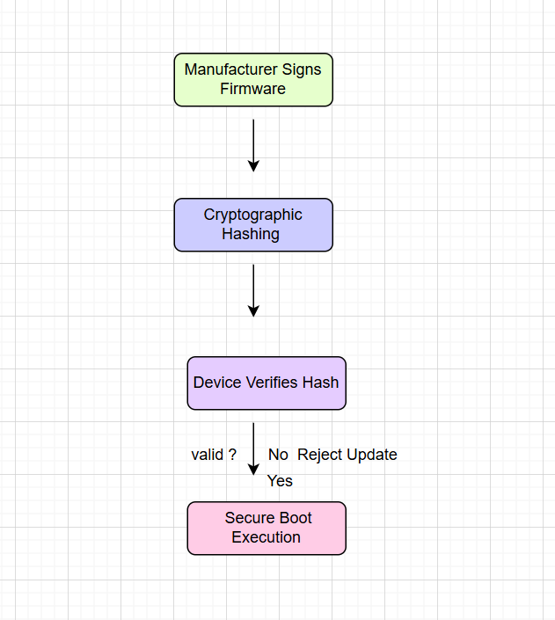
This diagram represents the process of verifying the authenticity and integrity of firmware before execution, ensuring that only trusted firmware runs on a device.

Manufacturer Signs Firmware
Before distributing firmware, the manufacturer digitally signs it using cryptographic techniques (e.g., RSA or ECC signatures). This ensures that the firmware has not been tampered with and originates from a trusted source.

Cryptographic Hashing
A hash value (e.g., SHA-256) is generated from the firmware binary. This hash acts as a unique fingerprint of the firmware. If the firmware is altered in any way, its hash will change, alerting the system to possible tampering.

Device Verifies Hash
When the firmware is installed, the system compares the firmware's cryptographic hash with the expected hash from the manufacturer. This verification can be performed using a Trusted Platform Module (TPM) or a Hardware Root of Trust.

Validity Check
- If the hash matches: The firmware is considered legitimate, and the system proceeds with execution.
- If the hash does NOT match: The firmware is rejected, and the system prevents it from running, protecting against potential malware infections.

Secure Boot Execution
If the firmware is verified successfully, Secure Boot ensures that only trusted code runs during system startup. Secure Boot checks each component in the boot process, ensuring they are signed and unmodified.

Why Is This Process Critical?
Prevents Unauthorized Modifications: Attackers cannot inject malicious code into firmware.
Ensures Authenticity: Only firmware from trusted vendors is allowed.
Protects Against Firmware-Based Malware: Malicious firmware cannot execute, reducing attack risks like rootkits and persistent threats.

Firmware Compromise Response Workflow

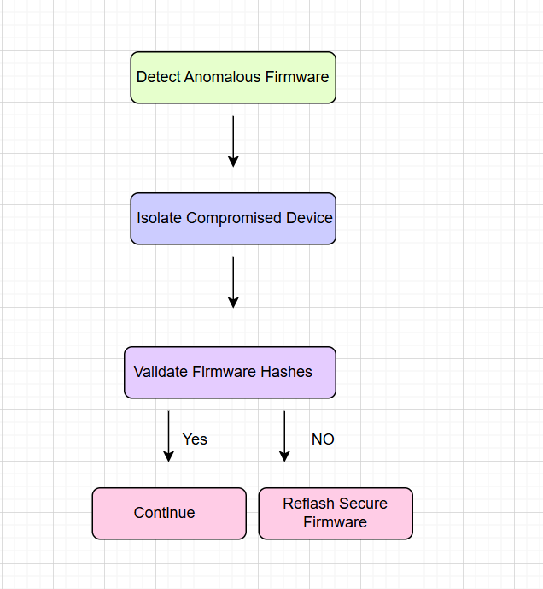
This diagram illustrates a structured approach to responding to a firmware compromise, ensuring quick detection, containment, and remediation. The goal is to minimize damage, restore system integrity, and prevent future attacks.

Detect Anomalous Firmware
Indicators of Compromise (IoC):
- Unexpected reboots or crashes
- Degraded system performance
- Unusual network activity (firmware communicating with unknown IPs)
- Security logs showing unauthorized firmware modifications
- Antivirus or endpoint detection alerts
Detection Tools:
Trusted Platform Module (TPM) Integrity Check
Firmware Hash Comparison (against manufacturer hashes)
Endpoint Detection & Response (EDR) Solutions

Isolate Compromised Device
Why? If firmware is compromised, malware could spread across the network.
Actions to Take:
Disconnect the affected system from the corporate network.
Disable remote access to prevent further exploitation.
If possible, disable the affected hardware module (e.g., network controller, USB controller).

Validate Firmware Hashes
- Compare the installed firmware with a known-good version from the manufacturer.
- If the hashes match: The firmware is likely intact, and further investigation is needed.
- If the hashes do not match: The firmware is compromised and must be replaced.

Reflash Secure Firmware (If Compromised)
Steps to Restore Firmware Integrity:
Download the latest signed firmware from the vendor.
Boot into firmware recovery mode or use a hardware programming tool (JTAG/ISP) to rewrite the firmware.
Reset BIOS/UEFI settings to default secure configurations.
Re-enable Secure Boot & TPM if disabled.

System Recovery & Monitoring
Once the system is operational:
- Apply the latest security patches to prevent reinfection.
- Monitor logs for unusual activity post-recovery.
- Enhance security policies, enforcing signed firmware updates and better network segmentation.

Why This Process is Important?
Prevents Further Damage – By isolating infected systems, we stop malware from spreading.
Restores System Integrity – Ensures firmware is secure and not altered by attackers.
Strengthens Future Defenses – Enforces security controls like firmware validation, Secure Boot, and TPM to prevent repeat attacks.

Secure Firmware Update Process

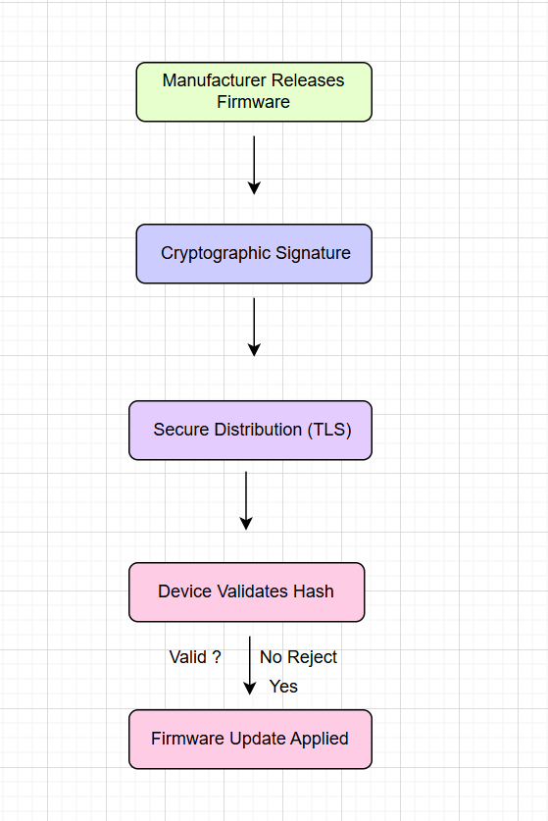
This diagram outlines the end-to-end process of securely updating firmware, ensuring that only authenticated and verified updates are installed on a device. This is crucial for protecting against malicious firmware tampering, unauthorized updates, and supply chain attacks.

Manufacturer Releases Firmware
The firmware vendor (e.g., Intel, Dell, Cisco) creates a firmware update and signs it cryptographically using a private key. This ensures that the update is authentic and has not been tampered with.
Security Measures:
Digital signatures using RSA or ECC
Secure version control to prevent rollback attacks
Code signing policies to verify integrity

Cryptographic Signature Verification
Before distributing the update, the manufacturer generates a cryptographic hash (e.g., SHA-256) and signs it with their private key. This ensures:
- Authenticity: The firmware is truly from the vendor.
- Integrity: The firmware has not been modified or corrupted in transit.
Verification Process:
Hashing → Digital Signing → Hash Stored for Future Verification

Secure Distribution (TLS Encryption)
The firmware update is transmitted securely using:
TLS (Transport Layer Security) encryption to prevent Man-in-the-Middle (MITM) attacks.
Code repositories or update servers with access control to prevent unauthorized modifications.
Common Secure Distribution Methods:
- Vendor update servers (e.g., Microsoft Update, Lenovo Vantage)
- Enterprise deployment tools (e.g., SCCM, WSUS)
- Secure USB or air-gapped installations for critical systems

Device Verifies Hash & Signature
Before installation, the device checks the integrity and authenticity of the downloaded firmware:
Hash Validation: Compares the firmware’s computed hash with the vendor’s signed hash.
Signature Validation: Uses the manufacturer’s public key to verify the signature.
If verification fails (mismatch or invalid signature): The update is rejected to prevent unauthorized modifications.

Firmware Update is Applied
If verification is successful , the firmware update is safely applied.
Final Steps:
- The firmware is written to flash memory or a TPM-protected storage.
- Secure Boot ensures that only signed firmware runs.
- The system logs the update event for auditing.

Why Is This Process Critical?
Prevents Supply Chain Attacks – Ensures firmware is from an authentic vendor.
Protects Against Malware – Stops unauthorized firmware modifications.
Ensures Update Integrity – Prevents corrupt or malicious firmware from bricking devices.

Attack Mitigation Strategy

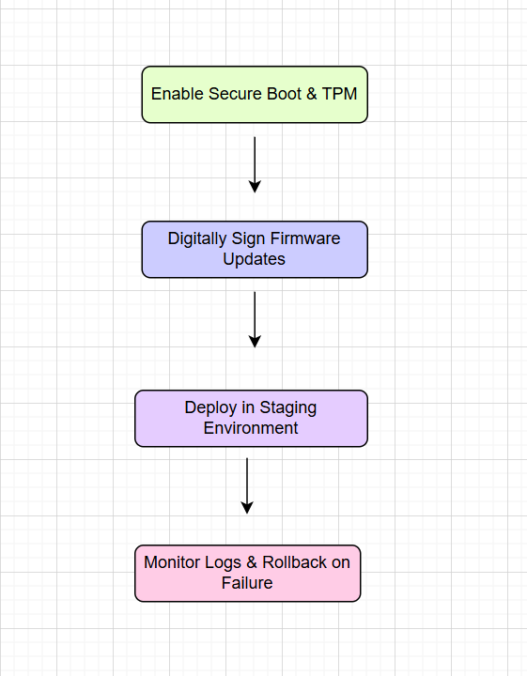
This diagram illustrates a multi-layered security approach to mitigate firmware attacks, ensuring that only trusted firmware is executed while preventing unauthorized modifications. By implementing these strategies, organizations can reduce the risk of firmware-based malware, rootkits, and persistent threats.

Enable Secure Boot & TPM
Goal: Prevent unauthorized firmware from executing during system startup.
Secure Boot:
- Ensures only digitally signed firmware and OS components load at boot.
- Uses a UEFI-based validation process to block unsigned or tampered firmware.
Trusted Platform Module (TPM):
- Stores cryptographic keys for verifying firmware integrity.
- Provides hardware-based protection against rootkits and boot-level malware.
If firmware validation fails → System halts boot process to prevent infection.

Digitally Sign Firmware Updates
Goal: Ensure that only authentic firmware updates from the manufacturer are installed.
How It Works:
- Manufacturers sign firmware updates using public-key cryptography (RSA/ECC).
- Before installation, the device checks the update’s signature and hash to verify authenticity.
- If the signature is invalid → The update is rejected.
Prevents:
Supply chain attacks (e.g., fake firmware updates)
Unauthorized modifications by attackers

Deploy Updates in a Staging Environment
Goal: Test firmware updates before deployment to detect potential failures or vulnerabilities.
Process:
- Deploy firmware updates in an isolated testing environment (e.g., virtual sandbox).
- Monitor system behavior for errors, crashes, or performance issues.
- Validate compatibility with existing hardware and software configurations.
- Deploy updates to production systems only after successful testing.
Prevents:
System downtime due to failed firmware updates
Incompatibility issues with hardware

Monitor Logs & Rollback on Failure
Goal: Detect unauthorized firmware changes and enable quick rollback in case of failure.
Continuous Monitoring:
- Use SIEM (Security Information and Event Management) tools to analyze firmware logs.
- Set up alerts for unexpected firmware modifications or boot failures.
Automated Rollback:
- If an update causes system instability, rollback to the previous stable firmware version.
- Utilize Dual BIOS/UEFI chips to restore a secure backup version if the primary firmware is corrupted.
Prevents:
Persistent threats hiding in firmware
Firmware corruption leading to system bricking

Why Is This Strategy Critical?
Reduces Attack Surface – By enforcing firmware signing and Secure Boot, attackers cannot execute rogue firmware.
Minimizes Downtime – Staged deployment and rollback features prevent system failures.
Enhances Threat Detection – Continuous monitoring ensures any unauthorized firmware changes are detected in real-time.

