Implementing Security Measures within a Threat Intelligence Sharing Platform
MISP
What is MISP?
MISP stands for:
Malware Information Sharing Platform & Threat Intelligence Platform
It is an open-source threat intelligence platform designed to:
- Collect,
- Store,
- Analyse, and
- Share cybersecurity threat intelligence (CTI).
MISP is widely used by:
- Governments and CERTs (Computer Emergency Response Teams),
- Security Operation Centres (SOCs),
- Private sector companies, and
- Research communities
to improve detection, prevention, and response to cyber threats.
Why MISP Exists?
Cyber threats are evolving fast. No single organization can detect all threats on its own. MISP helps organizations collaborate and share threat information, so they can:
- React faster to incidents,
- Detect attacks proactively,
- Strengthen collective cybersecurity defences.
What Does MISP Do?
MISP helps users to:
1. Create and Manage Threat Intelligence
Users can input information about cyber incidents and threats (like phishing, ransomware, APT activity). This is done by creating Events, which are structured threat records.
2. Add and Share IOCs (Indicators of Compromise)
IOCs include:
- IP addresses,
- Domains and URLs,
- File hashes (MD5, SHA1, SHA256),
- Email addresses,
- YARA rules,
- Malware names,
- Vulnerabilities (CVEs),
- MITRE ATT&CK techniques.
These can be enriched and exported in machine-readable formats.
3. Correlate Threat Data
MISP automatically links related data. For example, if two threat events share the same IP address or file hash, MISP will show that correlation. This helps uncover larger attack campaigns.
4. Collaborate with Trusted Communities
MISP allows you to:
- Sync with other MISP instances,
- Share data with custom visibility settings, and
- Define sharing groups (private, community, sector-specific, national, etc.)
This means you can share only with trusted partners while keeping sensitive data private.
5. Automate via API and Integrations
MISP is built for automation:
- It offers a full-featured RESTful API.
- Supports STIX 2, TAXII, OpenIOC, and other standards.
- Can integrate with SIEMs (like Splunk), IDS/IPS (like Suricata), EDRs, SOAR platforms, and others.
Core Features of MISP (Malware Information Sharing Platform)
- Threat Intelligence Sharing
MISP allows organizations to securely share cyber threat intelligence, such as indicators of compromise (IOCs), malware signatures, and tactics, techniques, and procedures (TTPs). It supports both private and community-level sharing to enhance collaborative defences.
- Automation and Integration
MISP provides robust RESTful APIs and supports threat data formats like STIX, TAXII, and OpenIOC. These features enable integration with security tools (SIEMs, IDS/IPS, and SOAR) and automate data ingestion, export, and correlation.
- Data Correlation
One of MISP’s powerful features is automatic correlation. It links related indicators and events across the database, helping analysts identify patterns, uncover threat campaigns, or detect reused infrastructure.
- Structured Event Management
MISP allows users to create "events" where attributes such as IP addresses, URLs, file hashes, and CVEs can be added and categorized. Events are structured to follow incident response workflows and can include contextual data, such as attack patterns or targeted sectors.
- Tagging and Taxonomies
Users can organize and classify data using standardized tags and taxonomies. MISP supports frameworks like MITRE ATT&CK, TLP (Traffic Light Protocol), OSINT levels, and confidence scores. This enhances search ability and context.
- Synchronization with Other MISP Instances
MISP supports syncing with other trusted MISP servers. This enables cross-organization collaboration and threat information exchange while maintaining control over what is shared and with whom.
- Role-Based Access Control (RBAC)
MISP offers fine-grained access control by using user roles and organization-based permissions. Admins can assign specific roles to users, limiting what they can see, edit, or share.
- Dashboards and Logging
MISP includes visual dashboards to provide insights into recent activity, types of threats, and data volume. It also logs all actions, enabling audits, usage analysis, and security monitoring.
- Flexible Data Format Support
it handles a wide variety of threat intelligence data types, including file hashes (MD5, SHA1, and SHA256), domains, URLs, IPs, YARA rules, malware families, and even custom attributes defined by users.
Why MISP Matters in Cybersecurity?
- Promotes cyber threat sharing and collaboration
- Speeds up detection and response
- Breaks silos between organizations
- Supports structured, actionable intelligence
- Helps organizations transition from reactive to proactive defence
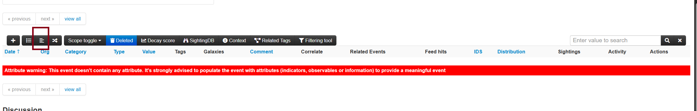
Click on this to add IOCs
Red Warning Banner
Attribute warning: This event doesn't contain any attribute. It’s strongly advised to populate the event with attributes (indicators, observables or information) to provide a meaningful event.
- Meaning: You created or are viewing a MISP event that currently has no data inside it—no indicators of compromise (IOCs), observables, or other threat intelligence.
- Impact: Such an event is considered incomplete or meaningless because MISP relies on attributes (like IPs, hashes, domains, emails, etc.) to share intelligence.
- Action Needed: You must add attributes to this event.
Menu Icon Highlighted (Left Sidebar)
The highlighted (hamburger icon) is the main event action menu. Clicking this will open a dropdown with options like:
- Add Attribute
- Add Object
- Edit Event
- Export
- Delete
- Publish
This is where you should go next to add meaningful data to the event.
Table Headers above the Warning
This section lists attributes when they exist. Current columns include:
- Date, Org, Category, Type, Value, Tags, Comment, etc.
Since your event has no attributes yet, the table is empty.
What You Should Do Next:
- Click the icon (menu on the left).
- Choose “Add Attribute” or “Add Object”.
- Add relevant threat intelligence, such as
  - IP address
  - File hash
  - Domain name
  - Email address
  - Malware sample
  - URLs
- Save the attributes and optionally publish the event.

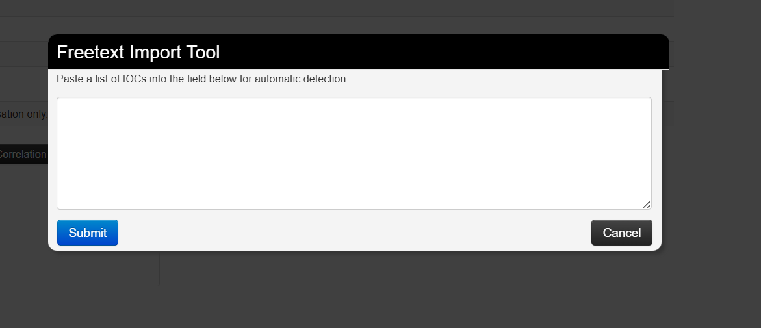
Paste your IOCs list here to add and click on Submit to submit attribute

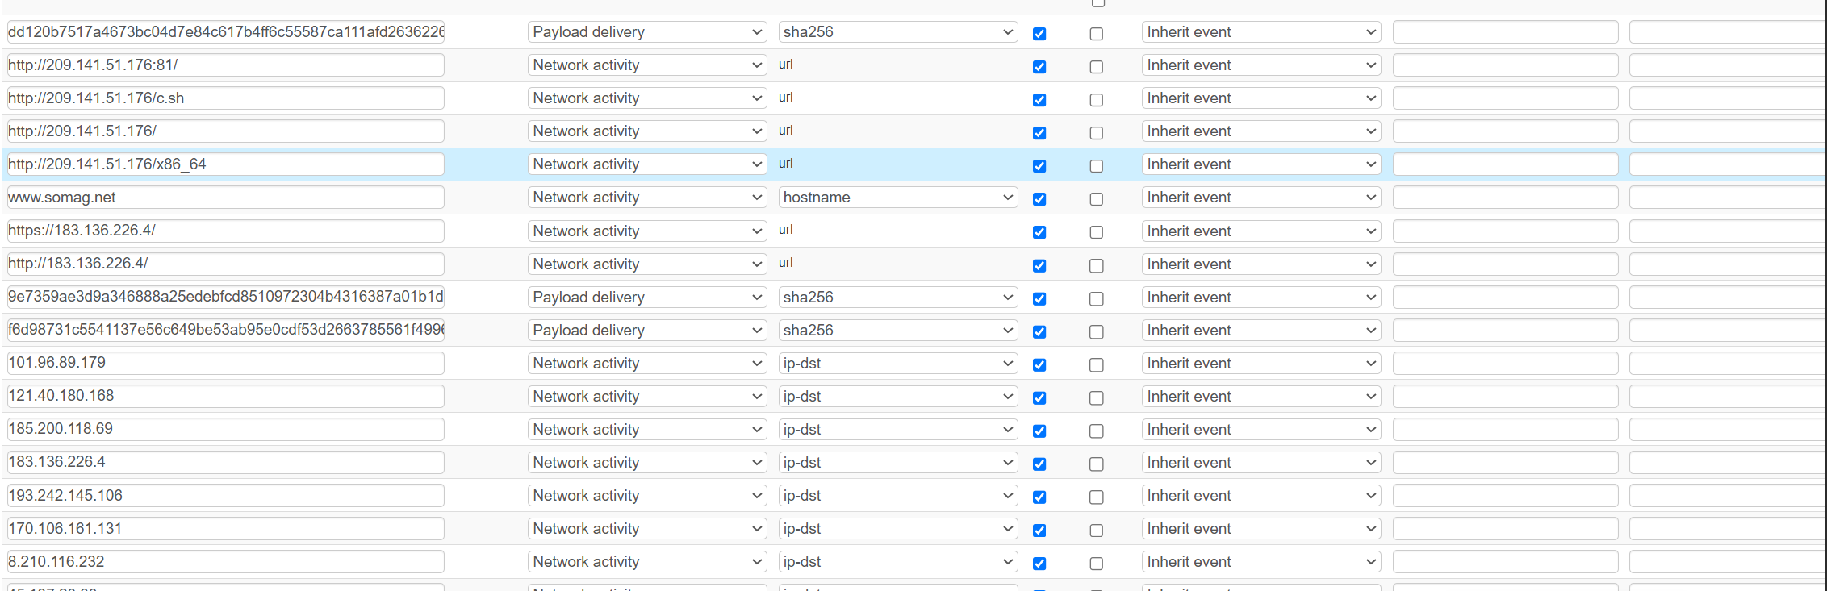

After submit you see your attributes here
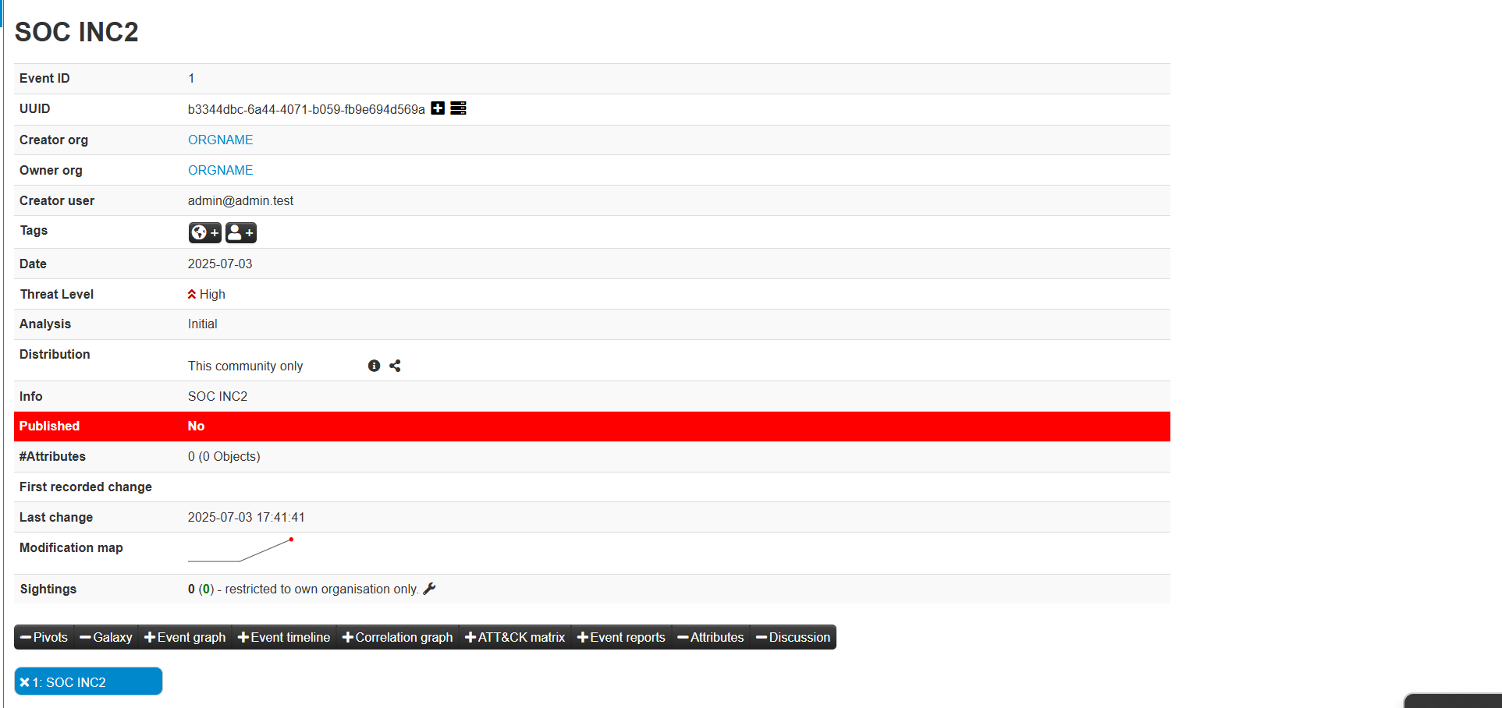

BROKEN AUTHENTICATION
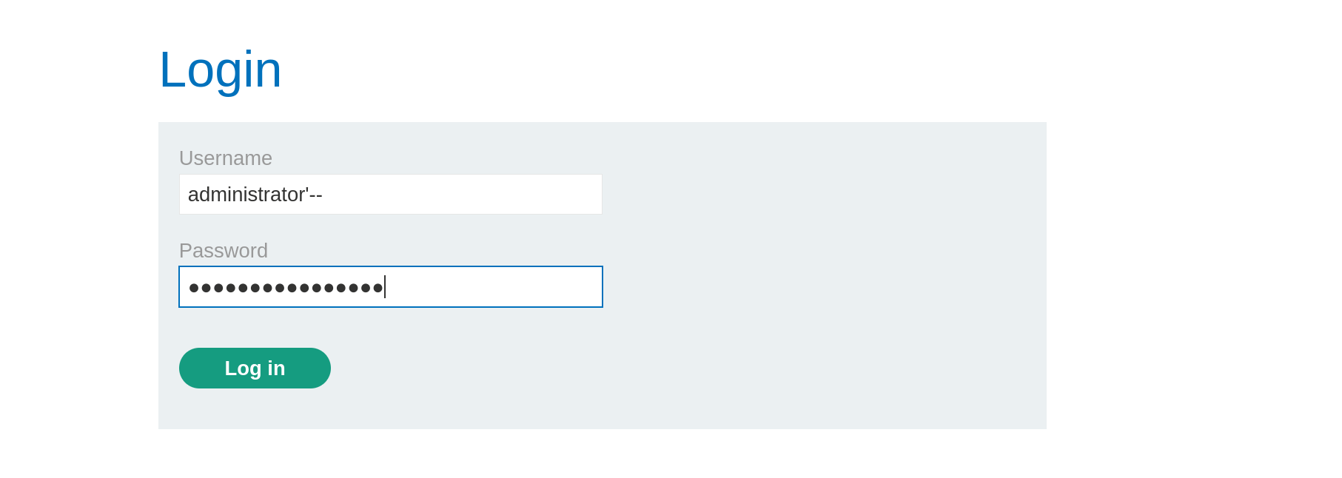
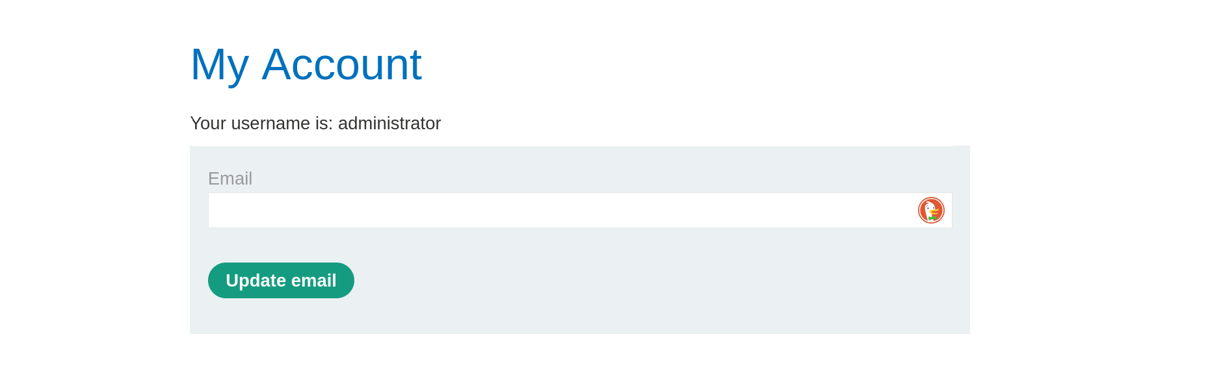 What Is Broken Authentication?
Broken Authentication occurs when an application incorrectly implements user authentication and session management, allowing attackers to compromise user credentials, sessions, or bypass login mechanisms.
It is listed as one of the OWASP Top 10 Web Security Risks.
1. SQL Injection in Login Forms
One of the most critical issues is when user input is directly included in SQL queries without proper validation or sanitization. This allows attackers to inject malicious SQL code, such as '--, to bypass password verification or gain unauthorized access. For example, entering administration'-- as a username can trick the system into logging in without checking the password.
2. Lack of Rate Limiting
If the login form allows unlimited login attempts, attackers can perform brute-force or credential stuffing attacks. They can use automated tools to try thousands of username-password combinations rapidly. Without limits on login attempts or IP blocks, this becomes a serious risk.
3. Weak or Predictable Credentials
Using default usernames like "admin" and weak or reused passwords makes it easy for attackers to guess credentials. Some systems do not enforce strong password policies, making them vulnerable to guessing attacks.
4. Poor Session Management
Even after successful login, improperly handled session IDs can allow attackers to hijack sessions. Common issues include:
- Not rotating session IDs after login.
- Storing session tokens in URLs.
- Failing to set expiration times.
- Not using Https only or secure flags in cookies.
These flaws make it easier for attackers to steal or reuse session tokens and impersonate users.
5. Missing or Weak Multi-Factor Authentication (MFA)
Without MFA, all an attacker needs is a username and password to gain full access. Even if credentials are stolen or guessed, MFA adds an additional verification step (e.g., OTP, email code, authenticator app) that greatly reduces the risk of unauthorized access.
6. User Enumeration
When login forms return specific error messages like "User does not exist" or "Wrong password," attackers can use this to find out which usernames are valid. This information helps them narrow down their targets for brute-force or phishing attacks.
7. Insecure Password Recovery Mechanisms
Sometimes, the “Forgot Password” feature is poorly implemented. If it allows guessing or brute-forcing security questions, or sending reset links without proper validation, attackers can use it to reset passwords and take over accounts.
8. Unencrypted or Poorly Protected Credentials
Storing passwords in plain text or using weak hashing algorithms like MD5 or SHA1 means that if the database is breached, all passwords are exposed. Secure systems should use strong, salted hashing algorithms like bcrypt or Argon2.
To prevent broken authentication
It’s important to secure every part of the login and session management process. First and foremost, applications must avoid trusting user input. This means never building SQL queries using string concatenation with input data—instead, developers should always use parameterized queries or prepared statements to protect against SQL injection attacks.
Implementing multi-factor authentication (MFA) is another crucial step. With MFA, even if an attacker manages to steal a user’s credentials, they won’t be able to log in without access to the second factor, such as an OTP or authenticator app.
Password security is also essential. Passwords should be stored using strong hashing algorithms like bcrypt, with a unique salt for each user. The application should enforce strong password policies requiring a mix of characters and minimum length to reduce the chance of guessing or brute-force attacks.
Rate limiting is another defense mechanism that helps stop attackers from attempting too many login attempts in a short period. If a user tries to log in repeatedly with incorrect credentials, the system should temporarily lock the account or show a CAPTCHA.
Session security must not be overlooked. After a successful login, a new session token should be generated, and tokens should expire after a certain time or logout. Session cookies must be protected with the Http only and Secure flags to reduce the risk of theft via cross-site scripting or unsecured connections.
The application should also avoid revealing whether a username exists during login or password reset. Using generic error messages like “Invalid login credentials” helps prevent user enumeration, where an attacker can test which usernames are valid.
Lastly, all authentication-related code should be regularly reviewed, penetration tested, and monitored. Logging and alerting unusual behaviour—such as logins from new locations or multiple failed attempts—can help detect and respond to potential breaches early. Keeping frameworks and libraries up to date also helps prevent known security flaws from being exploited.
Cross-Site Scripting (XSS)
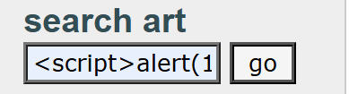
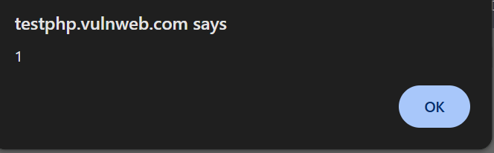
In the search input box, the user has entered the following:
<script>alert(1)</script>
When the "go" button is clicked, if the application is vulnerable, this JavaScript code will be executed in the browser instead of being treated as plain text. In this case, the browser will pop up a small alert window displaying the number 1.
This is a classic payload used by security testers and attackers to check for XSS vulnerabilities.
What is Cross-Site Scripting (XSS)?
XSS is a type of injection attack where malicious scripts are injected into otherwise trusted websites. When a site improperly handles user input, an attacker can insert and execute arbitrary JavaScript in the context of a victim's session.
XSS can be used to:
- Steal cookies or session tokens
- Deface websites
- Redirect users to malicious websites
- Log keystrokes or spy on users
- Bypass security controls

Types of XSS (Simplified)
- Reflected XSS
  - Payload is part of the request (like a URL or form input).
  - Executed immediately if the input is reflected back in the response.
  - Example: Searching and seeing an alert immediately.
- Stored XSS
  - Malicious script is stored on the server (e.g., in comments, posts).
  - Every time someone loads the page, the script runs.
- DOM-based XSS
  - Script executes based on client-side JavaScript behaviour.
  - Often found in JS-heavy SPAs (Single Page Applications).
How to Prevent XSS
- Escape Output Properly
  - Encode user input before rendering it on the page.
  - Use functions that escape <, >, &, ", ' depending on the context (HTML, JavaScript, URL, etc.).
- Sanitize User Input
  - Use libraries like DOM Purify (JavaScript) or Bleach (Python) to strip dangerous tags.
- Use Content Security Policy (CSP)
  - Adds a layer of protection by restricting what scripts can run.
- Avoid Inline JavaScript
  - Don’t include user-generated content directly in scripts or event handlers.
- Framework Security Best Practices
  - Use built-in protections provided by frameworks (e.g., Django, React, Angular auto-escape data by default).
NMAP SCAN
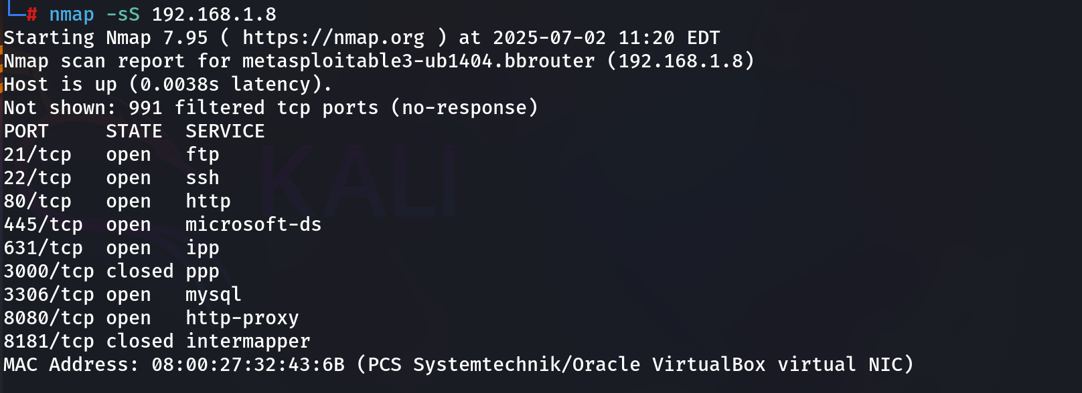
What is Nmap?
Nmap (Network Mapper) is an open-source tool used for network discovery, security auditing, and vulnerability scanning.
It helps system administrators and cybersecurity professionals to:
- Discover devices on a network.
- Identify open ports and running services.
- Detect operating systems and service versions.
- Assess security risks.
nmap -sS 192.168.1.8
nmap: Network Mapper tool used to discover hosts and services.
-sS: SYN scan (stealth scan). Sends SYN packets and waits for SYN-ACK to detect open ports without completing the TCP handshake.
192.168.1.8: The target IP address (your Metasploitable3 VM in local network).
Port 21 (FTP - File Transfer Protocol)
This port is used for transferring files between systems. It's commonly exploited if anonymous login is enabled or if weak/default credentials are used. Metasploitable3 may have a vulnerable FTP server that allows anonymous access or has directory traversal issues.
Port 22 (SSH - Secure Shell)
This port is used for secure remote login and command execution. On vulnerable systems, it may allow brute-force attacks or be misconfigured to accept weak credentials. Tools like Hydra can be used to attempt SSH login.
Port 80 (HTTP - Web Server)
This is the standard port for websites. On Metasploitable3, it typically hosts insecure web applications like DVWA, WebDAV, or vulnerable CMS platforms. These can be tested for SQL injection, XSS, and file upload vulnerabilities.
Port 445 (Microsoft-DS - SMB)
This port is used for Windows file sharing (SMB protocol). It's commonly targeted by exploits like EternalBlue (used in WannaCry). Metasploitable may run vulnerable versions of SMB that can be attacked with tools like Metasploit or smbc clint.
Port 631 (IPP - Internet Printing Protocol)
This port is used for network printing. While less commonly targeted, misconfigured IPP services could reveal internal info or be abused for DoS attacks. It’s often used by CUPS (Common UNIX Printing System).
Port 3306 (MySQL Database)
This is the default port for MySQL databases. If root access is allowed without a password (which is common in Metasploitable), it can be exploited to access or modify the database directly, or be used for SQL injection testing.
Port 8080 (HTTP Proxy / Alternate Web Server)
Often used for web services running on alternative ports (like Apache Tomcat, Jenkins, or proxy servers). On Metasploitable3, this might host an application vulnerable to remote code execution or weak authentication.
TLS Configuration (Transport Layer Security)
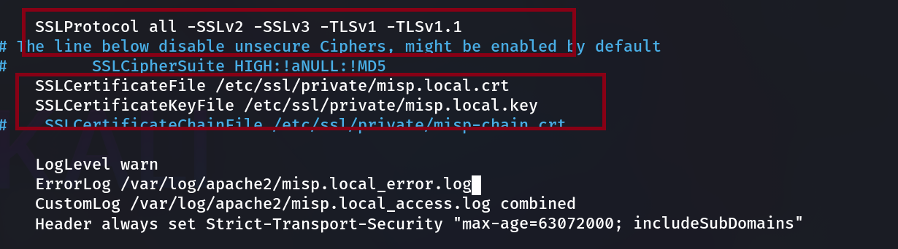
SSLProtocol all -SSLv2 -SSLv3 -TLSv1 -TLSv1.1
This line enables all protocols except:
- SSLv2 and SSLv3: Very old and insecure. Vulnerable to multiple attacks like POODLE.
- TLSv1 and TLSv1.1: Deprecated by most modern browsers as of 2020.
Result: Only TLSv1.2 and TLSv1.3 are enabled, which are secure and recommended.
SSLCipherSuite HIGH:! aNULL:!MD5
This sets which cipher suites Apache is allowed to use when establishing TLS connections.
- HIGH: Allows strong encryption algorithms (e.g., AES, ECDHE).
- !aNULL: Excludes ciphers with no authentication (anonymous).
- !MD5: Excludes MD5-based ciphers, which are insecure due to collision vulnerabilities.
Purpose: Prevent weak encryption algorithms and enforce strong security.
TLS Certificate Configuration:
These lines define the TLS/SSL certificate and key files used by Apache to serve secure HTTPS connections:
- SSLCertificateFile /etc/ssl/private/misp.local.crt:
This is the public certificate file. It identifies your server and is shared with clients during the TLS handshake.
- SSLCertificateKeyFile /etc/ssl/private/misp.local.key:
This is the private key corresponding to the certificate above. It must be kept secret and secure, as it's used to establish encrypted connections.
- SSLCertificateChainFile /etc/ssl/private/misp-chain.crt:
This line is currently commented out. It would normally be used to provide intermediate certificates that help the client trust the public certificate (especially with commercial or CA-issued certs). It's optional but recommended for public-facing servers.
Together, these files enable the server to authenticate itself and encrypt traffic using HTTPS.
Logging Configuration:
These lines configure how Apache logs activity and errors for this virtual host:
- LogLevel warn:
Sets the logging level to "warn", meaning only warnings, errors, and critical issues will be logged. Lower-level info and debug logs are ignored.
- ErrorLog /var/log/apache2/misp.local_error.log:
This defines the file where Apache will store error messages related to this site—useful for troubleshooting issues like failed connections or misconfigurations.
- CustomLog /var/log/apache2/misp.local_access.log combined:
This sets the path and format for access logs. It logs every incoming HTTP(S) request, including client IPs, requested URLs, user agents, and response codes. The combined format includes all standard fields used in web server access logs.
These logs are important for monitoring the health of the web server, identifying security incidents, and analysing usage patterns.

Enables password complexity
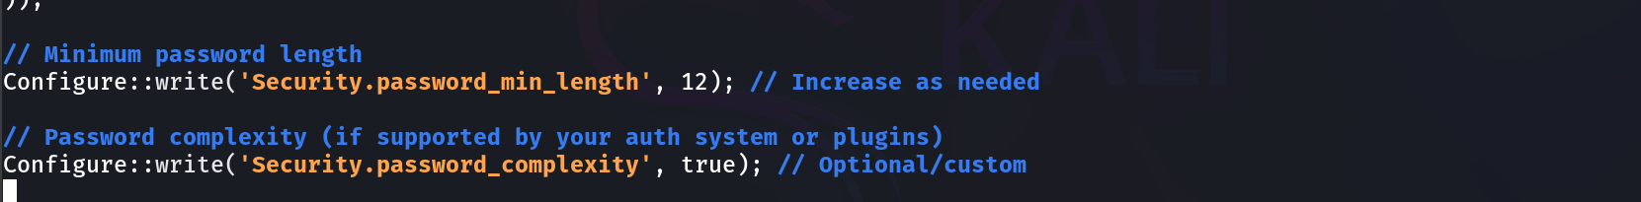
What It Does:
This sets the minimum number of characters required for user passwords in MISP to 12.
Why It Matters:
- Longer passwords are harder to brute-force or guess.
- A minimum of 12 characters is considered a strong baseline in modern security practices.
- By default, MISP may have a lower value (like 8), so raising it improves resilience against password attacks.
You can increase this value further based on your organization's security policies.
Configure::write ('Security.password_complexity', true);
What It Does:
This enables password complexity enforcement—meaning users will be required to create passwords that are not just long but also diverse in content.
When set to true, MISP typically enforces:
- At least one uppercase letter (A–Z)
- At least one lowercase letter (a–z)
- At least one digit (0–9)
- At least one special character (e.g., @#$%^&*())
Why It Matters:
- Passwords like password1234 are easy to guess.
- Complex passwords like S3cur3! Acc3ss2025 are much stronger.
- This helps defend against dictionary attacks and credential stuffing.

What is GPG?
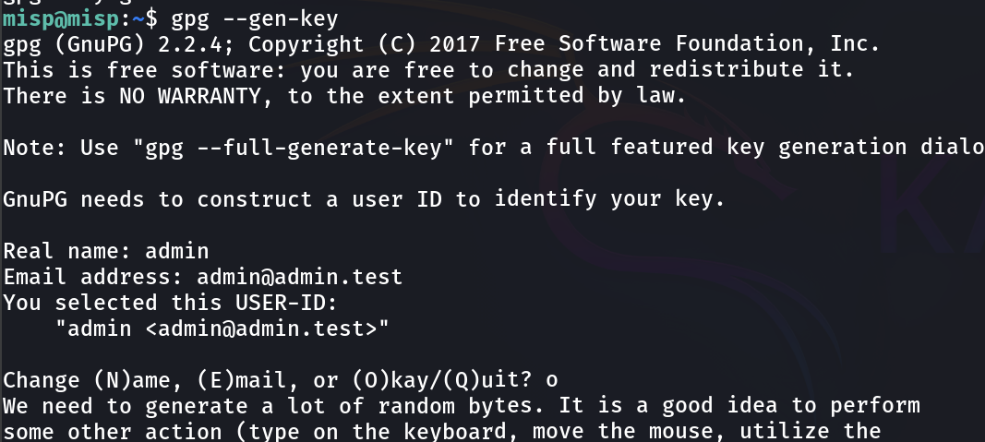
GPG (GNU Privacy Guard) is an open-source implementation of the OpenPGP standard. It allows you to:
- Encrypt and decrypt data (emails, files, etc.)
- Sign content to verify authenticity
- Use public/private key cryptography
In MISP, GPG is used for securely sharing threat intelligence, signing emails, and verifying communication.
Command Used
gpg --gen-key
This command starts the process of generating a new GPG key pair, which includes:
- A public key (shared with others to encrypt data for you)
- A private key (kept secret; used to decrypt and sign data)
Step-by-Step Explanation from the Screenshot
1. GPG Version Info
gpg (GnuPG) 2.2.4
This tells you the version of GnuPG in use. Version 2.x is the modern and recommended version.
2. Identity Setup
GnuPG needs to construct a user ID to identify your key.
This means GPG needs a name and email to associate with your key. This User ID is used when others refer to or search for your key.
You entered:
- Real name: admin
- Email address: admin@admin.test
GPG then creates this identity string:
"Admin <admin@admin.test>"
This is how the key will be identified in keyrings or when shared.
3. Confirmation Prompt
Change (N)ame, (E)mail, or (O)kay/(Q)uit? o
You're asked to:
- N: Change name
- E: Change email
- O: Accept and continue
- Q: Cancel the key generation
You chose o, meaning "Okay" — proceed to generate the key.
4. Entropy Collection for Key Generation
We need to generate a lot of random bytes...
This step collects entropy (randomness) from system activity to generate secure cryptographic keys. It suggests you:
- Type on the keyboard
- Move the mouse
- Use the system actively
This helps GPG gather enough randomness to generate strong keys that are unpredictable and secure.
Enforces user authentication configure
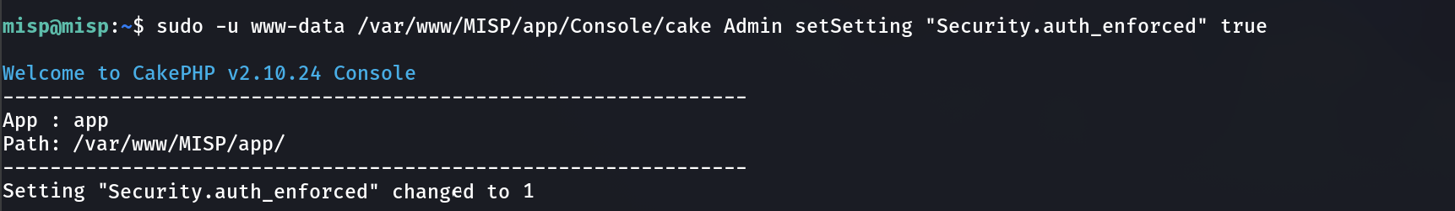
Command Executed:
sudo -u www-data /var/www/MISP/app/Console/cake Admin setSetting "Security.auth_enforced" true

Explanation:
- sudo -u www-data:
Runs the command as the www-data user, which is the default web server user on Debian-based systems (used by Apache). MISP must run commands as this user to modify application settings correctly.
- /var/www/MISP/app/Console/cake:
This is the path to CakePHP’s CLI utility used in MISP. Cake is a command-line interface provided by the CakePHP framework, which MISP is built on.
- Admin set Setting:
This is telling the CLI to invoke the Admin shell and run the setSetting method, which updates a configuration setting in MISP.
- "Security.auth_enforced":
This is the specific setting being changed. It enforces user authentication, meaning anonymous access to the MISP web interface is no longer allowed.
- True:
This sets the setting to true (internally shown as 1), enabling the authentication enforcement.
What is Security.auth_enforced?
This setting in MISP ensures that no one can access any part of the platform without logging in.
When it's enabled (true):
- All access requires a valid MISP user account.
- Even the homepage or event preview can't be accessed by unauthenticated users.
- Protects the platform from information leakage and anonymous reconnaissance.
When it's disabled (false):
- Some information might be visible without logging in.
- Risk of exposing metadata or instance versioning to attackers.
You can open this page In Administration setting
What Are Roles in MISP?
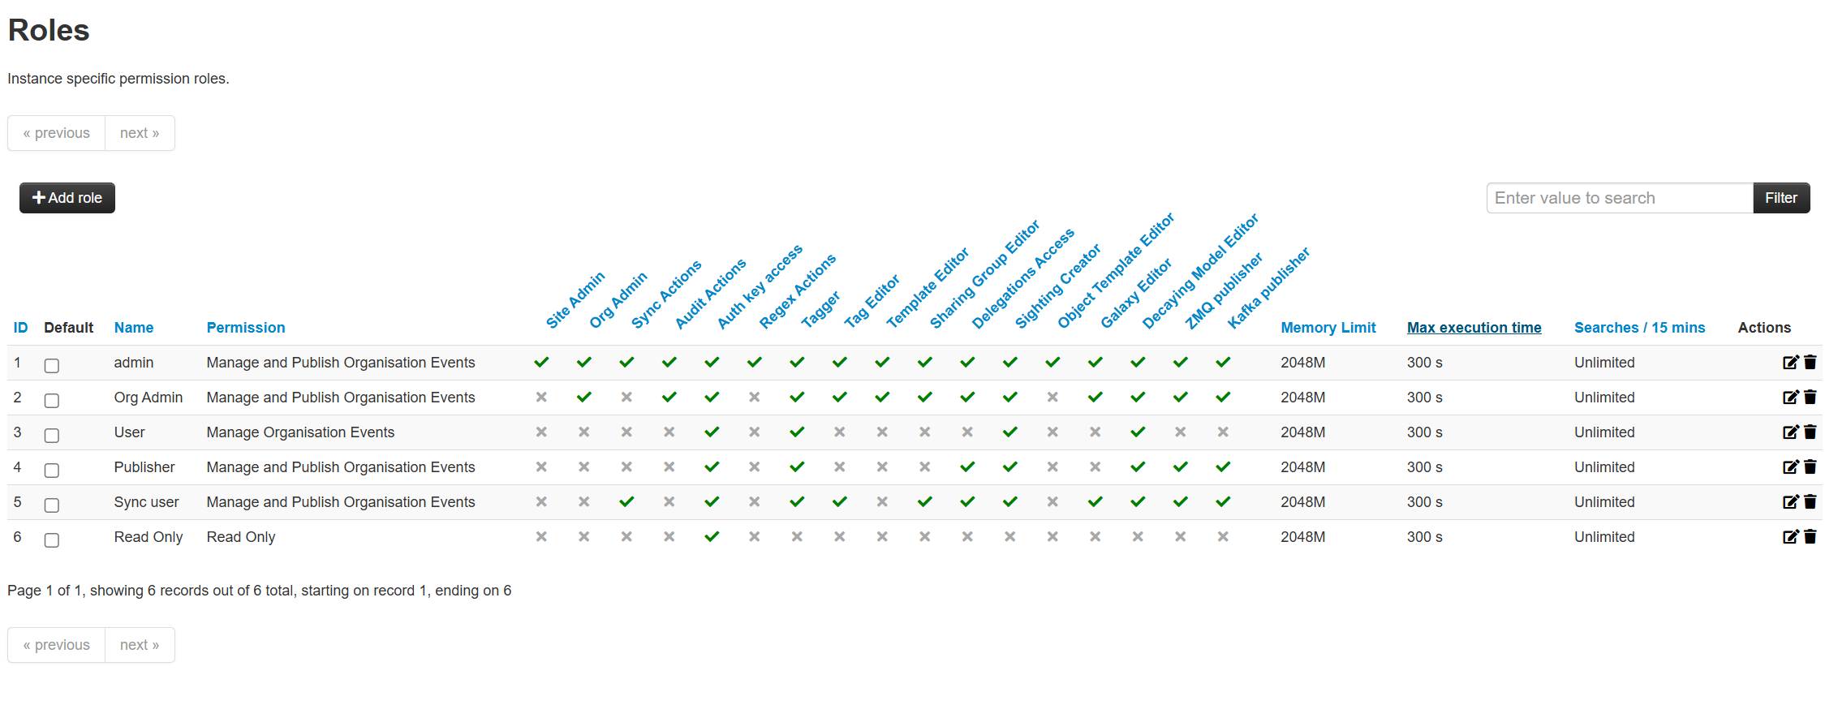
In MISP, a role defines what a user can or cannot do within the system. Roles include:
- Access rights
- Publishing privileges
- Administrative permissions
- Memory and execution limits
- Feature-specific capabilities
Admins can assign these roles to users to control data access and system behaviour securely and efficiently.
Columns Explained (from left to right):
ID
A numeric identifier for the role (internal reference).
Default
A checkbox that marks the role as the default role for newly created users.
Name
The name of the role. Examples in the image:
- admin
- Org Admin
- User
- Publisher
- Sync user
- Read Only
Permission
Defines the scope of allowed actions:
- Manage and Publish Organisation Events: Can create, edit, and publish threat intelligence events.
- Manage Organisation Events: Can create/edit but may not be able to publish.
- Read Only: Only view data—no edit/publish rights.
Role-Specific Capabilities (Columns with checkmarks)
Site Admin
This gives full administrative access across the entire MISP instance. A user with this permission can manage global settings, users, roles, and perform maintenance tasks.
Org Admin
This allows a user to manage everything related to their own organization — such as managing users within their org, setting sharing permissions, and reviewing data.
Sync Actions
Users with this permission can initiate or control synchronization with other MISP instances. This is useful when you're part of a distributed intelligence-sharing network.
Audit Actions
Allows the user to access audit logs. These logs contain details about who did what, which is important for monitoring and accountability.
Authentication Key Access
Gives access to view and manage authentication keys, such as API keys for integration with tools or automation.
Regex Actions
Enables the user to create and use regular expressions for tagging or filtering data. Useful for advanced data manipulation and search.
Tagger
Allows users to apply tags to attributes and events. Tagging helps classify and organize threat data.
Tag Editor
Enables editing and creation of tags, including custom tag definitions used across events and attributes.
Template Editor
Gives permission to modify event templates, which standardize how threat information is reported.
Sharing Group Editor
Allows the user to manage sharing groups, which control who can access shared data (e.g., specific partners, internal only, etc.).
Delegations Access
Let’s users delegate access or tasks to other users — for example, assigning someone to edit an event on your behalf.
Sighting Creator
Enables submission of sightings — confirmations or denials that an indicator has been observed in your environment.
Object Template Editor
Allows editing of MISP object templates, which define structured threat entities (e.g., files, IPs, malware).
Galaxy Editor
Permits editing of Galaxy clusters, which include categorized information like threat actors, tools, attack patterns, etc.
Decaying Model Editor
Allows access to modify decaying models — these determine how the relevance or score of an attribute decreases over time.
ZMQ Publisher
Gives permission to publish real-time data updates via ZeroMQ, often used for live feeds into SIEMs or automation pipelines.
Kafka Publisher
Grants access to publish MISP events and attributes to a Kafka stream, for scalable integration into data pipelines or distributed systems.
System Limits per Role
These control how much system resources each role can use.
Memory Limit
Maximum memory (RAM) allowed per process initiated by users in this role (e.g., exports, searches). Here, all are set to 2048M (2 GB).
Max Execution Time
Max time a process can run. All set to 300s (5 minutes), meaning long exports/searches will be killed after 5 minutes.
Searches / 15 minutes
Limits how many searches the role can make in 15 minutes. All currently show Unlimited.
You can open this page In Administration setting
Manage organisations
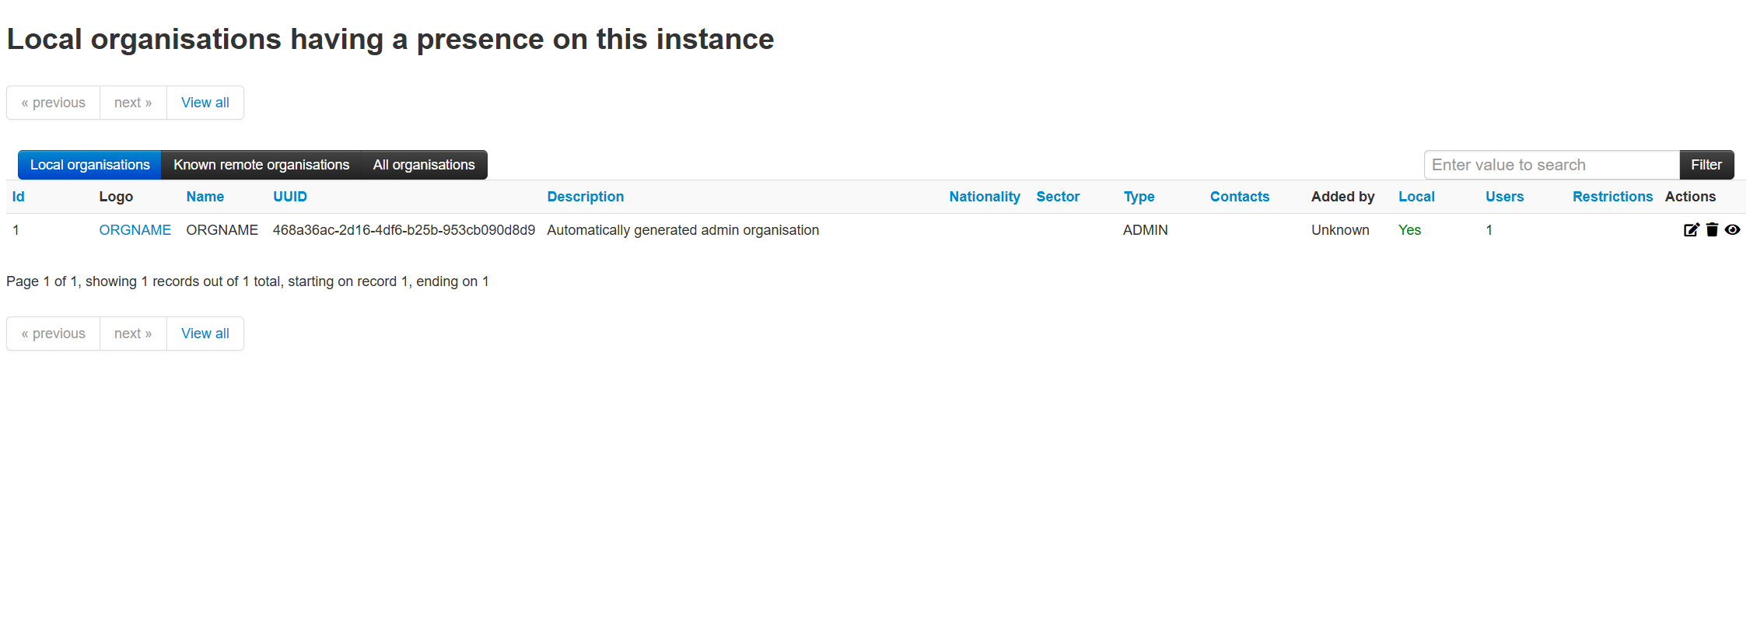
Purpose of This Page
This section is used to manage organisations that:
- Own, create, or receive events and attributes.
- Define the scope of data visibility and sharing.
- Help in multi-tenant environments where many organisations collaborate through a single MISP instance.
Explanation of Each Column:
ID
- Internal unique identifier for the organisation.
- Used in system operations and linking events to organisations.
Logo
- Displays a custom logo (if uploaded) for the organisation.
- In this case, it shows the text link ORGNAME, which when clicked, shows more details.
Name
- Human-readable name for the organisation. Here it's ORGNAME, a placeholder name that typically gets replaced with the real name (e.g., CERT-IN, SOC-X).
UUID
- A Universally Unique Identifier used to distinguish this organisation across MISP instances.
- Critical when syncing between multiple MISP servers to avoid duplication.
Description
- A brief explanation of what this organisation represents.
- In your example: "Automatically generated admin organisation" – this is created during installation for the first admin user.
Nationality
- Optional metadata to indicate the country of the organisation. Here it is blank.
Sector
- Optional field for specifying the organisation's sector (e.g., finance, health, defence). Also blank here.
Type
- Shows the organisation’s role on the instance.
  - ADMIN: Marks it as the primary admin organisation — has full control.
Contacts
- Shows assigned contact information or representatives (not shown here, possibly not configured).
Added by
- Indicates who created this organisation.
  - Unknown: Probably auto-generated during initial setup.
Local
- Indicates whether the organisation is a local entity (i.e., native to this instance) or remote (from federation/sync).
  - Yes: This is a local organisation.
Users
- Number of user accounts belonging to this organisation.
  - One user (likely the admin) is part of this organisation.
Restrictions
- Any imposed restrictions (e.g., data access limits or policy enforcement). This field is empty in your case, meaning no special restrictions.
Actions
- Includes 3 icons:
  - Edit: Modify organisation details.
  - Delete: Remove organisation (cannot delete if events/users are attached).
  - View: View full details and metadata for the organisation.
Tabs at the Top
- Local organisations:
Organisations defined and managed within this instance.
- Known remote organisations:
Organisations from remote MISP servers discovered via sync.
- All organisations:
A complete list combining local and remote ones.
Why This Matters
- Organisations in MISP are essential to data ownership and access control.
- They determine who can:
  - View and edit data
  - Share with specific groups
  - Participate in synchronisation
- In a shared threat Intel environment, clear org boundaries help protect data sovereignty and enforce access control.

Distribution level
You're viewing attributes (like URLs) within a MISP event. Each attribute has its own distribution level, which defines who can see or share that piece of data.
The terms “Organisation” and “Community” are distribution settings applied to each attribute to control its visibility.
Distribution Levels in MISP (Explained)
MISP allows you to control the granularity of information sharing using these distribution settings:
- Your Organisation Only (Organisation)
  - Marked as “Organisation” in your screenshot.
  - The attribute is only visible to users in the same organisation that created the event.
  - Use this setting for internal-use-only data, sensitive or early-stage intel.
- This Community Only (Community)
  - Marked as “Community” in the second row.
  - The attribute is shared with all local organisations registered on this MISP instance.
  - Ideal for collaborative environments where multiple orgs trust each other but you don’t want to federate the data externally.
- (Not shown in the screenshot, but for completeness):
  - Connected Communities
    - Data is shared with trusted external MISP instances via sync.
    - Useful for federation across national CSIRTs, ISACs, or partners.
  - All Communities
    - Shared with everyone, including remote and unknown MISP communities.
    - This is the most open setting — good for global threat indicators with no sensitivity.
  - Sharing Group
    - Fine-grained control where you define a custom group of orgs (local or remote) who can access the attribute.
    - Best for compliance-focused environments (e.g., TLP: AMBER-like behaviour).
How to Interpret the Marked Example
- The first attribute (URL http://125.41...) is set to "Organisation".
  - Only members of that specific organisation can see or use it.
- The second attribute (URL http://196.25...) is set to "Community".
  - All local organisations (defined in your instance) will have access to this data.
These settings help limit or broaden threat Intel sharing based on sensitivity, trust, and policy.
Why This Is Important
- Controls information exposure
- Helps meet compliance or sharing policies (like TLP)
- Enables secure collaboration across different groups or levels of trust
- Prevents oversharing of sensitive indicators
Cyberchef
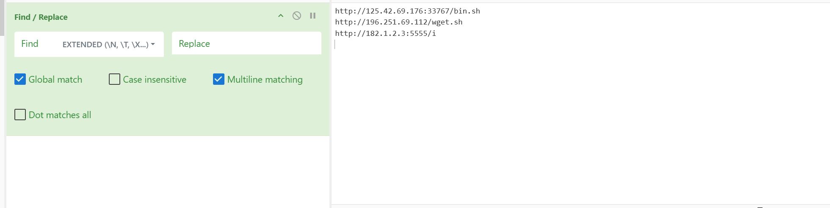
Ind Pattern (EXTENDED mode):
The search is using Extended Regular Expressions, allowing patterns like \n, \t, and back references.
Text Area Content (Right side):
http://125.42.69.176:33767/bin.sh
http://196.251.69.112/wget.sh
http://182.1.2.3:5555//i
These look like potentially malicious URLs or command-and-control (C2) endpoints.
Checkboxes enabled:
- Global match – affects all matches, not just the first.
- Multiline matching – treats input as multiple lines.
- Contextual Explanation — Implementing Data Anonymization and Privacy Measures:
Framework Used: MISP + CyberChef
Anonymization in MISP
MISP allows tagging sensitive attributes like IPs, hashes, or domains with tags such as:
tlp:red – do not share
ANONYMIZE or Pseudonymize
This tagging enables selective filtering/exporting so sensitive values aren’t shared.
CyberChef Integration
- CyberChef can be scripted (via API or manually) to:
  - Encode (Base64, URL-encode)
  - Tokenize (replace IPs/domains with placeholders)
  - Hash values (e.g., SHA-256 for pseudonymization)
- This image likely shows pre-processing in a CyberChef-like pipeline to identify and redact URLs/IPs before ingestion or sharing.
Compliance Support in MISP
- MISP supports:
  - GDPR-aware logging (tracking access/modifications)
  - Pseudonymization using encryption or transformation
  - Audit trails to ensure data minimization and accountability
Why This Matters
The image demonstrates a manual or semi-automated method to:
- Detect malicious or sensitive indicators (IOCs).
- Replace or redact them before:
  - Exporting MISP events
  - Ingesting threat feeds into other systems
  - Sharing with partners who should not see raw indicators
This step is crucial for GDPR, organizational policy, and inter-agency sharing.
SIEM Integration
Goal:
Feed real-time threat intelligence or alerts into your SIEM (e.g., ELK, Splunk, QRadar, etc.).
Methods:
MISP ZMQ (ZeroMQ) Feed
- MISP offers a ZMQ pub/sub feed that publishes events/attributes in real-time.
- A listener (written in Python or another language) subscribes to the ZMQ topic and sends events to:
  - ELK Stack (Elasticsearch + Logstash + Kibana)
  - Splunk (via HTTP Event Collector or syslog)
- Example Listener: misp-dashboard ZMQ listener
MISP Modules (Feed Push)
- Use MISP modules or built-in export functionalities to:
  - Push filtered attributes or indicators as JSON/STIX to the SIEM.
  - Pull IOC feeds periodically via script.
Syslog or Logstash
- MISP or intermediary tools like TheHive can generate alerts, which can be forwarded via syslog to a SIEM.
- Example: TheHive alert → syslog → Logstash → Elasticsearch.
STIX/TAXII Sharing
Goal:
Use structured data formats and automated sharing standards for interoperability.
Details:
- STIX (Structured Threat Information eXpression):
  - Format used to describe threats, indicators, tactics, techniques, and procedures (TTPs).
- TAXII (Trusted Automated Exchange of Indicator Information):
  - Protocol to transport STIX data between parties or platforms.
MISP Implementation:
- MISP natively supports:
  - STIX 1.x and STIX 2.0+ import/export
  - TAXII 2.1 client: Pull/push data from/to TAXII servers.
  - Configuration in:
Administration > Server Settings > Plugin Settings > Plugin.Taxii_*
Use Cases:
- Automatically pull IOC feeds from external TAXII servers (e.g., Anomali, EclecticIQ, DHS).
- Share events with other MISP instances or third-party tools using STIX 2.1.
Periodic Assessments
Goal:
Ensure the secure, consistent, and valid flow of threat Intel between systems.
Activities:
- Test API endpoints:
  - Periodically test MISP, TheHive, OpenDXL brokers, and SIEM connectors via authenticated API calls.
  - Confirm that responses contain updated indicators and no error responses.
- Authentication:
  - Use API keys, TLS certificates, and tokens to ensure secure connections.
- Logging & Monitoring:
  - Enable logging on MISP and TheHive for access and integration attempts.
  - Use SIEM rules to detect anomalies in integration traffic.
- Validation Scripts:
  - Write scripts to validate schema, timestamp freshness, and IOC quality.
  - For example, confirm that MISP events synced from a TAXII feed are under 24h old and tagged properly.
SIEM Integration
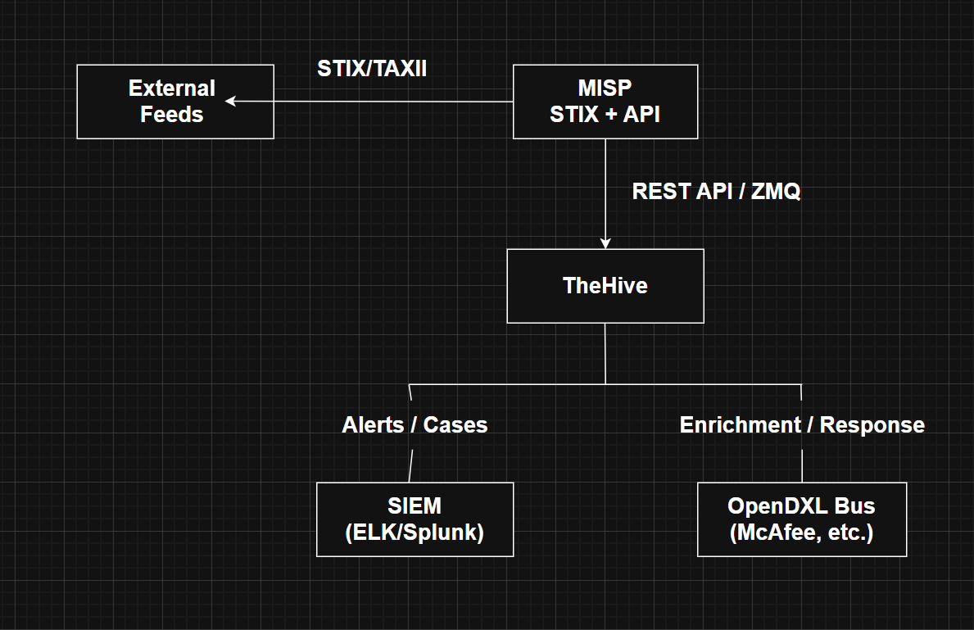
1. External Feeds
These are sources of threat intelligence from outside your organization. Examples include:
- Open threat feeds (AlienVault OTX, AbuseIPDB)
- Government/CERT alerts
- ISACs or industry-specific feeds
These feeds often use STIX (Structured Threat Information eXpression) and TAXII (Trusted Automated Exchange of Intelligence Information) protocols for structured and automated sharing.
2. MISP (STIX + API)
MISP is the central threat intelligence platform. It ingests, processes, and organizes threat indicators (IOCs like IPs, hashes, domains).
How it works:
- MISP imports data from external feeds via STIX/TAXII clients.
- Offers its own REST API and ZMQ (ZeroMQ) interface for consuming or broadcasting threat data.
- Data is structured in events, attributes, and contextual metadata (e.g., TLP tags).
MISP acts as the intelligence brain, collecting data and making it available to other tools like TheHive or SIEMs.
3. TheHive
TheHive is a security incident response platform. It consumes alerts and indicators from MISP using:
- REST API (pull/push IOC info)
- ZeroMQ (for real-time event notification)
Once TheHive receives data:
- It creates cases or alerts automatically from MISP events.
- Analysts can then investigate, correlate, and escalate incidents.
- Analysts may enrich data by querying external tools (e.g., VirusTotal, Shodan) through Cortex analyzers.
4. SIEM (ELK / Splunk)
SIEM platforms are used for monitoring, detection, and correlation of events across an organization's infrastructure.
TheHive can push alerts or case information to the SIEM so that:
- The SOC can correlate these alerts with internal logs.
- Dashboards and alerts can be configured for visibility.
Example:
- A MISP event on a malicious IP is pulled into TheHive.
- TheHive generates an alert.
- That alert is pushed to Splunk.
- Splunk checks internal logs for connections to that IP.
5. OpenDXL Bus (McAfee, etc.)
OpenDXL is an open message bus that allows tools to communicate and trigger automated actions.
From TheHive:
- You can initiate automated response actions (e.g., quarantine host, block IP, update firewall).
- These actions are sent over OpenDXL to compatible tools (like McAfee ePO, TIE, DXL brokers).
This enables SOAR (Security Orchestration, Automation, and Response) functionality.
Key Protocols and Interfaces in Use
- STIX/TAXII – External threat feed import/export standard
- MISP REST API – Used by TheHive or other consumers to pull intel
- ZMQ (ZeroMQ) – Real-time event broadcast by MISP
- OpenDXL – Trigger automated security responses across multiple tools

Sync Actions
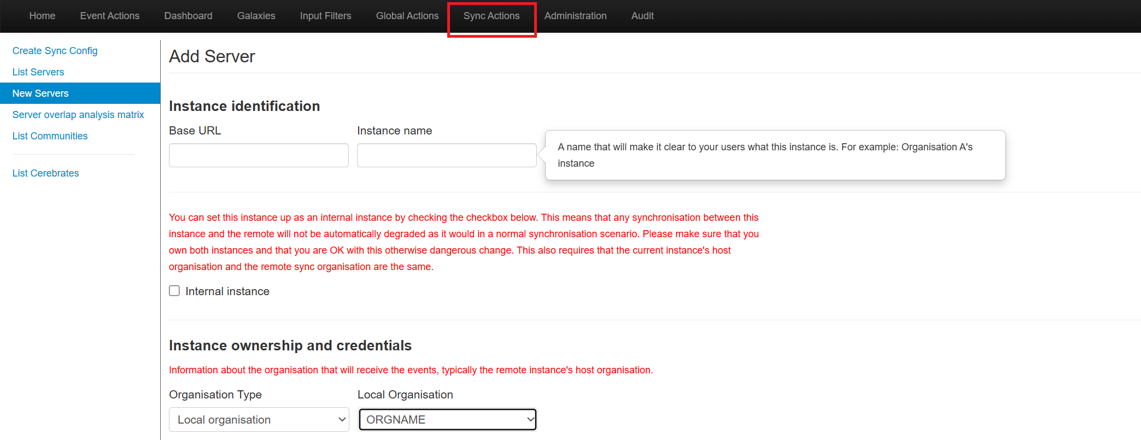
The Sync Actions tab is where MISP administrators configure and manage server-to-server synchronization of events, attributes, sightings, and other data. It enables federated sharing across multiple trusted organizations or MISP nodes.
Create Sync Configure
This option lets you create synchronization configurations between your MISP instance and a remote one. You define whether you want to pull (import) or push (export) data, and you can filter what gets transferred using tags, distribution levels, or time ranges. It is often used after you've added a new server.
List Servers
Displays a list of all the MISP servers you've added for synchronization. For each server, you can see its connection status, last sync time, and manage settings. You can also trigger a manual sync from here or disable synchronization for specific servers.
New Servers
This allows you to register a new external or internal MISP instance that you want to synchronize with. You'll need to enter the remote server’s base URL, name the instance, and specify organization ownership settings. After adding the server, you can configure pull/push behaviour.
Server Overlap Analysis Matrix
This tool compares the data you’ve synced from different servers and helps identify overlapping indicators or events. It’s useful for analysing redundancy and correlation between sources, such as when multiple partners share similar IOCs.
List Communities
Shows a directory of known threat intelligence communities that offer open or restricted MISP instances. This helps you discover potential partners to sync with. You can explore their available data and request access if needed.
List Cerebrates
Displays available Cerebrate instances, which are tools used for managing information sharing communities. If your organization uses Cerebrate alongside MISP, this section helps manage those connections.
New Server (Add Remote MISP Node for Sync)
This is where you add a new remote MISP server to establish a bidirectional or unidirectional data sync.
Main Fields and Explanation:
Instance Identification
- Base URL:
The full URL of the MISP server you want to connect to.
Example: https://threatshare.partner.org
- Instance Name:
A descriptive name to recognize the instance in your MISP UI.
Example: CERT-EU, Gov-CSIRT, or Partner MISP Node.
Internal Instance (Checkbox)
- Mark as an internal sync if:
  - Both MISP instances are within your organization.
  - You control both instances.
- Warning: This disables sync degradation checks and expects both servers to be highly trusted.
Instance Ownership and Credentials
Defines how synced events are attributed.
- Organisation Type:
  - Typically Local Organisation (you own the events).
  - Can also be Remote Organisation for read-only consumption?
- Local Organisation (Dropdown):
  - Select the MISP organisation in your instance that should own the events.
  - Example: CERT-India, ISAC Team, etc.
Audit Logs page
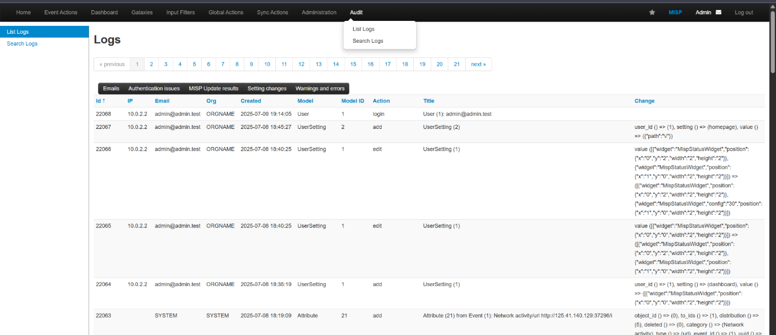
The Audit Logs page is designed to track all important system and user activities within MISP. It supports:
- Security auditing
- User accountability
- Change tracking
- Forensic analysis
- Compliance with regulations (e.g., GDPR, ISO 27001)
Contains tabs like:
- Event Actions – Manage MISP events (threat intelligence).
- Dashboard – View metrics and visual insights.
- Global Actions – Bulk changes or automation tasks.
- Sync Actions – Configure syncing with other MISP instances.
- Administration – Manage users, settings, and plugins.
- Audit – Where you are now: view system logs.
22068 – Login
- Action: login
- User: admin@admin.test
- Time: 2025-07-09 19:14:05
- Change: Redirected to homepage (path: "/")
22067–22064 – Dashboard Widget Changes
- Model: UserSetting
- Action: add or edit
- Changes: The MispStatusWidget was positioned, resized, or reconfigured.
- Use case: Admin is customizing the dashboard layout.
22063 – Threat Intelligence Attribute Added
- User: SYSTEM (automated action)
- Model: Attribute
- Action: add
- Data: An IOC (http://125.41.140.129:37296/i) was added to event ID 1.
Why this is Important and Helpful
1. Security Monitoring
- Detect unauthorized access attempts
- See who modified which events or attributes
- Monitor use of privileged functions
2. Compliance & Audit Trails
- Meets audit requirements for:
  - GDPR
  - ISO 27001
  - SOC 2
- You can show who accessed or edited sensitive data
3. Forensic Investigations
- After a breach, trace:
  - Which accounts logged in
  - What changes were made
  - Where the activity originated (IP)
4. Accountability
- Hold users accountable for actions
- Easily identify when a misconfigured setting or data corruption occurred
5. Operational Insights
- Track usage patterns
- Spot configuration drift
- Identify unused features or underactive users
MISP Dashboard Overview
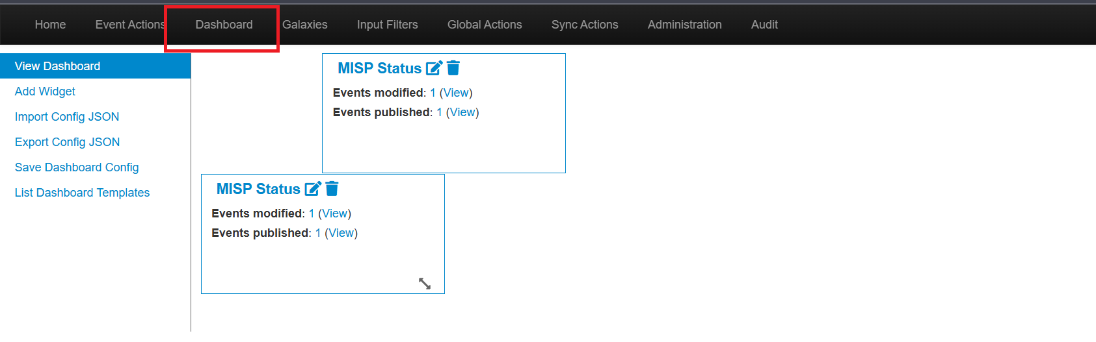Key Elements:
- Dashboard Menu Selected: This is the visual dashboard module of MISP. It provides real-time summaries and performance indicators of your threat intelligence activity.
- Side Menu Options:
  - Add Widget: Add new statistics/info boxes to the dashboard.
  - Import/Export Configure JSON: Backup and transfer dashboard settings.
  - Save Dashboard Configure: Save the current layout and widgets.
  - List Dashboard Templates: Access predefined widget templates.
Displayed Widget: MISP Status
- Shows:
  - Events modified — Number of threat events that were changed.
  - Events published — Number of events made available to sharing partners.
Relevance to Project:
This view supports Objective 7 (Monitoring and Auditing Platform Activities) from your project.
- You can monitor threat Intel activity and changes in near real-time.
- Helps in tracking analyst engagement and detecting anomalies (e.g., unexpected mass edits).

- Serves as a visual tool for reporting and auditing.
Add Widget Dialog
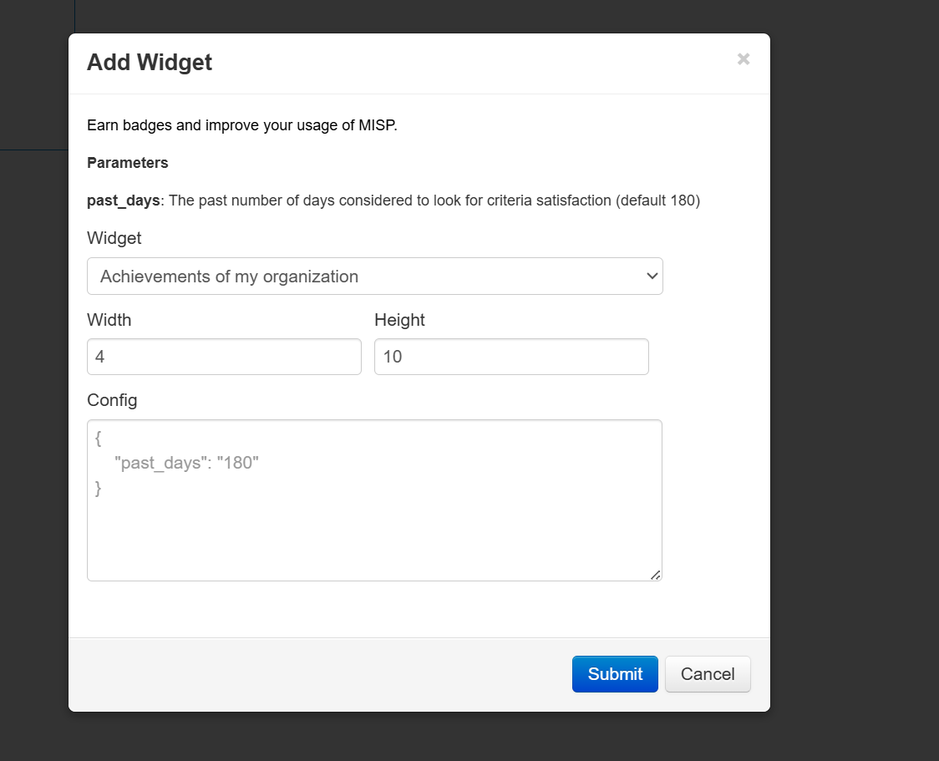Key Elements:
- Widget Type: Achievements of my organization
- Parameters:
  - past_days: Specifies how many days to look back to generate the widget data (default is 180).
  - Width and Height: Define how the widget will appear in the dashboard grid.
- Config Box (JSON):
{"past_days": "180"}

Relevance to Project:
This feature supports Objective 9 (Security and Compliance Documentation) and Objective 7 (Monitoring):
- Track organizational contributions to threat intelligence over time (useful for audits).
- Helps generate automated documentation of engagement, useful for ISO 27001 control A.16.1.4 (Lessons Learned from Information Security Incidents).
- Customizable to show incident trends, user activity, or data enrichment levels.
Security Configuration Guides
These documents help administrators configure the platform securely and consistently. They should be version-controlled and updated with every major platform upgrade or policy change.
config.php (MISP Application Configuration)
- Purpose: This file governs how MISP behaves.
- Security-Relevant Settings:
  - Debug should be set to false in production.
  - Log_auth enables logging of user authentication.
  - API key configurations for user/service access.
  - GPG or PGP settings for encrypted attribute sharing.
  - Tagging and role-based controls to limit access to sensitive data.
- Documentation Must Include:
  - A list of security-sensitive parameters and their expected values.
  - Notes on why certain features are enabled/disabled.
Apache/Nginx Web Server Configuration
- Purpose: Ensure encrypted and secure access to the MISP web UI and API.
- Security Best Practices:
  - Enforce HTTPS (TLS 1.2 or above).
  - Redirect all HTTP requests to HTTPS.
  - Use security headers:
    - Strict-Transport-Security
    - X-Content-Type-Options
    - Content-Security-Policy
  - Disable methods like TRACE, TRACK.
- Documentation Should Contain:
  - Sample Apache or Nginx configure blocks.
  - Explanation of each header's role in improving security.
  - Hardening steps like disabling directory listing or exposing server version.
MySQL Database Configuration
- Purpose: Protect MISP's data layer from unauthorized access or data corruption.
- Secure Configuration:
  - Use strong passwords and limited privileges for the MISP DB user.
  - Set bind-address to localhost or internal IP.
  - Enable binary logging for auditing.
  - Configure regular backups.
- Documentation Should Detail:
  - User privilege table.
  - Backup procedures (mysqldump, mysqlpump, etc.).
  - Disaster recovery testing process.
Mapping MISP to GDPR (General Data Protection Regulation)
- Data Minimization
MISP allows tagging of sensitive data (e.g., tlp:red, do_not_share) and limiting the distribution scope. This supports the GDPR principle of collecting only necessary data and sharing it selectively.
- Consent and Lawful Basis
before sharing data, MISP users can manually confirm whether the intelligence has a legal basis for sharing. Sharing groups and role-based restrictions help ensure data is only shared with authorized recipients.
- Right to Access and Erasure
MISP administrators can export all data related to a specific user or entity and delete it if required. This supports GDPR rights such as data access and the "right to be forgotten."
- Data Security and Integrity
MISP provides audit logs, secure HTTPS communication, access control via RBAC, and support for encryption—all of which are necessary to ensure data confidentiality and integrity.
- Audit Logging
MISP maintains detailed logs of user activity, changes, logins, and data sharing. This supports GDPR's accountability principle, allowing you to track how and when data is accessed.
Mapping MISP to ISO 27001 (Information Security Management)
- User Access Management
MISP uses Role-Based Access Control (RBAC) to define what each user can do—like view, edit, publish, or sync data. This aligns with ISO controls around secure access provisioning and least privilege.
- Security Logging and monitoring
the audit functionality in MISP records all user actions, configuration changes, and data handling events. This supports the requirement to monitor information processing and detect anomalies.
- Operational Security Controls
MISP’s encryption of data in transit (via HTTPS) and data at rest (using file-level or disk-level encryption) ensures that sensitive intelligence is protected, fulfilling ISO’s confidentiality and integrity requirements.
- Backup and Recovery
You can configure regular backups of MISP’s database and file storage and document recovery procedures. This ensures availability and aligns with business continuity and disaster recovery standards in ISO 27001.
- Privacy by Design
MISP enables pseudonymization of data through tagging and supports privacy controls by default. You can configure default sharing levels and control external synchronization settings
Docs to Maintain
These policies are formal documents that should be maintained by your InfoSec or system administration team:
1. Access Control Policy
- What It Covers:
  - Role definitions (admin, analyst, publisher, etc.).
  - Authentication mechanisms (LDAP/SAML/2FA).
  - Rules for access provisioning, modification, and revocation.
- Why It Matters:
  - Prevents unauthorized access.
  - Supports principle of least privilege.
  - Aligns with ISO 27001 (Annex A.9).
2. Data Retention and Anonymization Policy
- What It Covers:
  - How long events and attributes are kept (e.g., 90, 180, 365 days).
  - Tags like tlp:red, do_not_share, and anonymize for sensitive content.
  - Workflow for periodic review and deletion.
- Why It Matters:
  - Supports GDPR requirements for data minimization and limited retention.
  - Protects against overexposure or outdated threat data.
3. Incident Handling SOP (Standard Operating Procedure)
- What It Covers:
  - How to detect, investigate, and respond to:
    - Unauthorized access
    - Data leaks
    - Platform abuse
  - Roles and responsibilities during incidents.
  - Reporting/escalation process.
- Why It Matters:
  - Enables fast, documented response.
  - Reduces legal risk.
  - Aligns with ISO 27001 A.16 (Incident Management).
4. Backup and Recovery Policy
- What It Covers:
  - Backup frequency (daily, weekly).
  - Tools used (mysqldump, rsync, VM snapshots).
  - Encryption of backups.
  - Storage location (on-site, cloud, offsite).
  - Restoration testing schedule.
- Why It Matters:
  - Ensures data is not lost due to human error or attack.
  - Critical for disaster recovery and business continuity (ISO A.17).

