PROJECT - Conducting in-depth network analysis
Wireless Network Architecture Review
Objective:
To assess the current architecture of Wi-Fi and Bluetooth networks to understand their design, deployment, and security posture.
Wi-Fi Network Architecture Review
Network Topology:
Analyse how Wi-Fi access points (APs) are deployed—whether in a centralized or distributed manner. Check if there is a clear segmentation between guest, corporate, and IoT devices. Review the placement of APs to ensure optimal coverage and minimal interference.
Authentication and Access Control:
Evaluate the authentication mechanisms in place, such as WPA3, WPA2-Enterprise with 802.1X, or pre-shared keys (PSK). Enterprise-grade authentication (e.g., RADIUS servers) is preferred for better control and auditing. Check if MAC filtering or captive portals are used and their effectiveness.
Encryption:
Confirm the encryption standards used for data in transit. WPA3 is the latest and most secure standard, while WPA2 is still common but vulnerable to some attacks if not configured properly. Avoid deprecated protocols like WEP.
Network Segmentation:
Assess if VLANs or separate SSIDs are used to isolate different types of traffic (e.g., guest vs. internal). Proper segmentation limits the blast radius of a compromised device.
Management and Monitoring:
Review how APs and controllers are managed—whether management interfaces are secured and isolated from user traffic. Check if logging, monitoring, and alerting systems are in place to detect anomalies.
Firmware and Patch Management:
Verify that APs and controllers are regularly updated with security patches to mitigate known vulnerabilities.
Bluetooth Network Architecture Review:
Device Types and Roles
Identify the types of Bluetooth devices in use (e.g., classic Bluetooth, Bluetooth Low Energy - BLE) and their roles (master/slave, central/peripheral). Understand the communication patterns and data exchanged.
Pairing and Bonding Methods:
Review the pairing methods used (Just Works, Passkey Entry, Numeric Comparison, Out of Band). Stronger pairing methods reduce the risk of man-in-the-middle attacks.
Security Modes and Levels:
Check the Bluetooth security modes (e.g., Security Mode 4 for LE Secure Connections) and encryption levels. Ensure devices support and enforce encryption and authentication.
Device Discovery and Visibility:
Assess how devices are discoverable and connectable. Devices should minimize discoverability to reduce exposure to unauthorized connections.
Network Topology and Range:
Understand the physical layout and range of Bluetooth devices, especially in environments with many devices, to identify potential interference or unauthorized access points.
Vulnerability Assessment
Objective:
To identify potential vulnerabilities in the existing Wi-Fi and Bluetooth networks that could be exploited by attackers.
Wi-Fi Vulnerabilities:
Weak Encryption and Authentication:
Use of outdated protocols like WEP or WPA-TKIP, or weak pre-shared keys, can allow attackers to decrypt traffic or gain unauthorized access.
Rogue Access Points and Evil Twins:
Unauthorized APs mimicking legitimate ones can trick users into connecting, enabling man-in-the-middle attacks.
Misconfigured Access Points:
Default credentials, open management interfaces, or improper SSID broadcasting can expose the network to attacks.
Lack of Network Segmentation:

Flat networks allow lateral movement once an attacker gains access.
Denial of Service (DoS) Attacks:
Attackers can flood the network with DE authentication frames or channel interference to disrupt service.
Insufficient Monitoring:
Without proper logging and alerting, attacks may go unnoticed.
Bluetooth Vulnerabilities:
Weak Pairing Methods:
Just Works pairing is vulnerable to man-in-the-middle attacks due to lack of authentication.
Blue jacking and Bluesnarfing:
Unauthorized sending of messages or data theft from devices with poor security settings.
Bluetooth Low Energy (BLE) Spoofing and Relay Attacks:
Attackers can impersonate devices or relay communications to intercept or manipulate data.
Device Discoverability:
Devices left in discoverable mode are more susceptible to unauthorized connections.
Firmware Vulnerabilities:
Outdated Bluetooth stacks can have exploitable bugs.

Wi-Fi Network Architecture Explanation
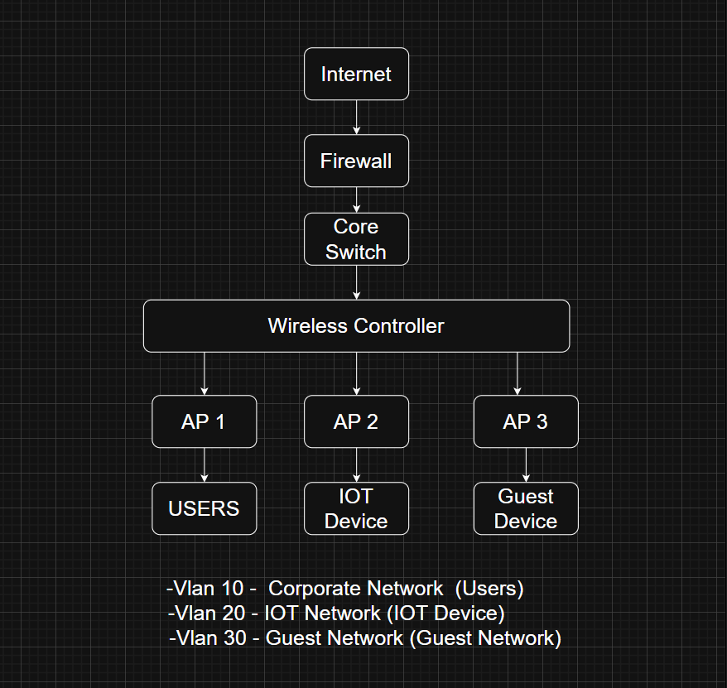
The Wi-Fi network architecture is designed to provide wireless connectivity to different types of users and devices while maintaining security and control.
Internet and Firewall:
The network connects to the internet through a firewall, which acts as the first line of defence by filtering incoming and outgoing traffic to block unauthorized access.
Core Switch:
This device routes traffic within the internal network and connects different network segments, including wired and wireless parts.
Wireless Controller:
The wireless controller centrally manages multiple Access Points (APs). It handles tasks like authentication, encryption, channel management, and roaming between APs.
Access Points (APs):

APs are the wireless radios that broadcast Wi-Fi signals to users and devices. Each AP can broadcast multiple SSIDs (network names) mapped to different VLANs for segmentation.
Network Segmentation (VLANs):
The network is divided into VLANs to isolate traffic types:
VLAN 10 for corporate users who need access to sensitive resources.
VLAN 20 for IoT devices, which often have weaker security and should be isolated.
VLAN 30 for guest users, restricting their access to internal resources.
Authentication and Encryption:
Users authenticate using secure protocols like WPA3 or WPA2-Enterprise with 802.1X, which uses a RADIUS server to verify credentials. This ensures only authorized users connect.
Management and Monitoring:
APs and controllers have management interfaces on a separate VLAN, isolated from user traffic to prevent unauthorized access. Logs and alerts are collected to detect suspicious activity.
Central Device:
Usually a smartphone, tablet, or computer that controls connections and communication with peripherals.
Peripheral Devices:
Devices like headsets, fitness bands, or smart locks that connect to the central device. They usually have limited functionality and rely on the central device for control.
Pairing and Bonding:
Devices pair using secure methods such as Numeric Comparison or Passkey Entry, which help prevent man-in-the-middle attacks. After pairing, devices bond to remember each other for future connections.
Discoverability:
Devices are discoverable only during pairing and become non-discoverable afterward to reduce the risk of unauthorized connections.
Encrypted Communication:
Bluetooth LE Secure Connections encrypt data exchanged between devices to protect confidentiality and integrity.
Firmware Updates:
Regular updates to device firmware patch vulnerabilities in the Bluetooth stack, improving security.
Wi-Fi Encryption Mechanisms
Current Protocols: WPA2 and WPA3
WPA2 (Wi-Fi Protected Access 2):
- Encryption: Uses AES (Advanced Encryption Standard) with CCMP (Counter Mode with Cipher Block Chaining Message Authentication Code Protocol) for data confidentiality and integrity.
- Authentication: Typically uses a Pre-Shared Key (PSK) or Enterprise mode with 802.1X authentication.
- Security: Considered secure for many years but has vulnerabilities like the KRACK (Key Reinstallation Attack) discovered in 2017, which exploits weaknesses in the 4-way handshake.
- Limitations: Vulnerable to offline dictionary attacks if weak passwords are used in PSK mode; lacks forward secrecy.
WPA3 (Wi-Fi Protected Access 3):
- Encryption: Continues to use AES-CCMP but introduces Simultaneous Authentication of Equals (SAE) for key exchange, replacing the PSK handshake.
- Authentication: SAE provides a more secure handshake resistant to offline dictionary attacks.
Security Enhancements:
- Forward secrecy: Ensures that session keys are not compromised even if the password is later exposed.
- Improved protection for open networks: WPA3 introduces Opportunistic Wireless Encryption (OWE) to encrypt traffic on open networks.
- 192-bit security suite: For high-security environments, WPA3 offers an optional 192-bit security mode.
- Limitations: Adoption is still growing; some legacy devices may not support WPA3.
- Recommendations for Wi-Fi Encryption Improvements
- Mandatory WPA3 Adoption: Encourage upgrading all devices and access points to WPA3 to leverage SAE and forward secrecy.
- Strong Password Policies: Enforce complex passwords or use Enterprise mode with 802.1X authentication to prevent brute-force attacks.
- Regular Firmware Updates: Patch vulnerabilities like KRACK by keeping firmware up to date.
- Use of 192-bit Security Suite: For sensitive environments, implement WPA3’s 192-bit mode.
- Network Segmentation: Separate guest and IoT devices on different VLANs with appropriate encryption policies.
- Monitor and Detect Anomalies: Use intrusion detection systems to identify unusual Wi-Fi traffic or handshake anomalies.

Bluetooth Network Architecture Explanation
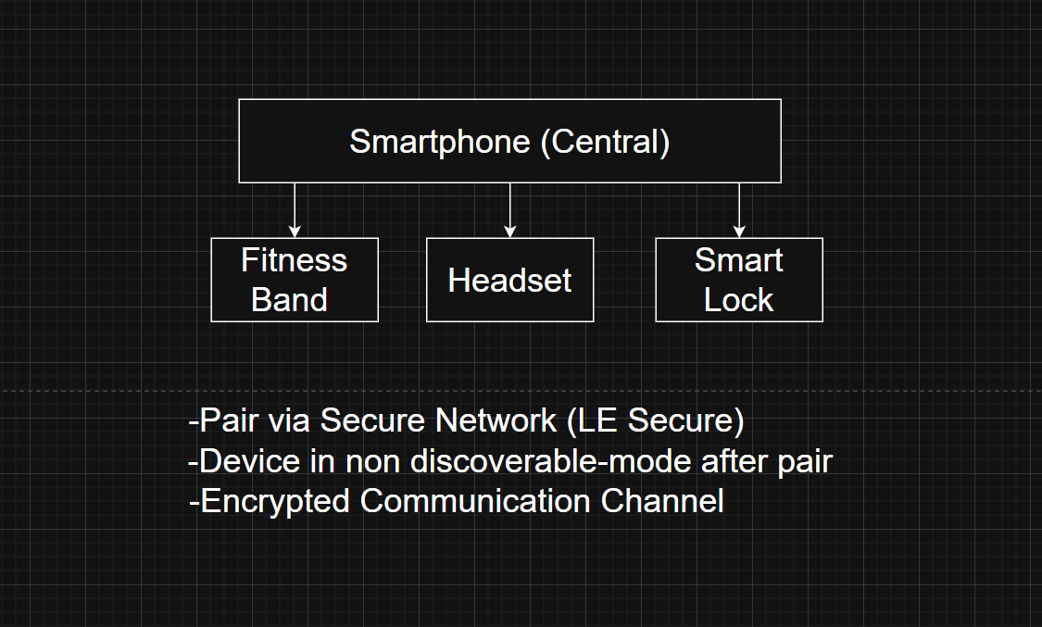
Bluetooth architecture typically involves a central device connecting to multiple peripheral devices in a personal area network.
Bluetooth Encryption Mechanisms
Current Standards
Bluetooth encryption is defined primarily in the Bluetooth Core Specification, with security evolving through versions:
Bluetooth Classic (BR/EDR): Uses E0 stream cipher and SAFER+ block cipher in some modes.
Bluetooth Low Energy (BLE): Uses AES-CCM (Counter with CBC-MAC) for encryption and authentication.
Pairing Methods:
- Just Works: No authentication, vulnerable to MITM (Man-in-the-Middle) attacks.
- Passkey Entry: User enters a passkey, better security but user-dependent.
- Numeric Comparison: User confirms matching numbers on devices.
- Out of Band (OOB): Uses an external channel for key exchange, most secure.
Security Modes:
Mode 1: No security.
Mode 2: Service-level enforced security.
Mode 3: Link-level enforced security (encryption and authentication).
Bluetooth 5.x Enhancements:
- Improved LE Secure Connections using Elliptic Curve Diffie-Hellman (ECDH) for key exchange.
- Stronger encryption keys (128-bit AES).
- Protection against passive eavesdropping and active MITM attacks.
- Recommendations for Bluetooth Encryption Improvements
- Use LE Secure Connections: Always use Bluetooth 4.2+ or 5.x devices supporting LE Secure Connections with ECDH for key exchange.
- Avoid Just Works Pairing: Prefer Numeric Comparison or OOB methods to prevent MITM attacks.
- Implement Strong Authentication: Use passkeys or biometric authentication where possible.
- Regular Firmware Updates: Patch known vulnerabilities in Bluetooth stacks.
- Limit Discoverability: Devices should be non-discoverable or discoverable only when pairing.
- Encrypt Sensitive Data: Use application-layer encryption in addition to Bluetooth’s link-layer encryption for highly sensitive data.
- Monitor for Anomalies: Detect unusual pairing attempts or repeated failed connections.
Wi-Fi Authentication Mechanisms
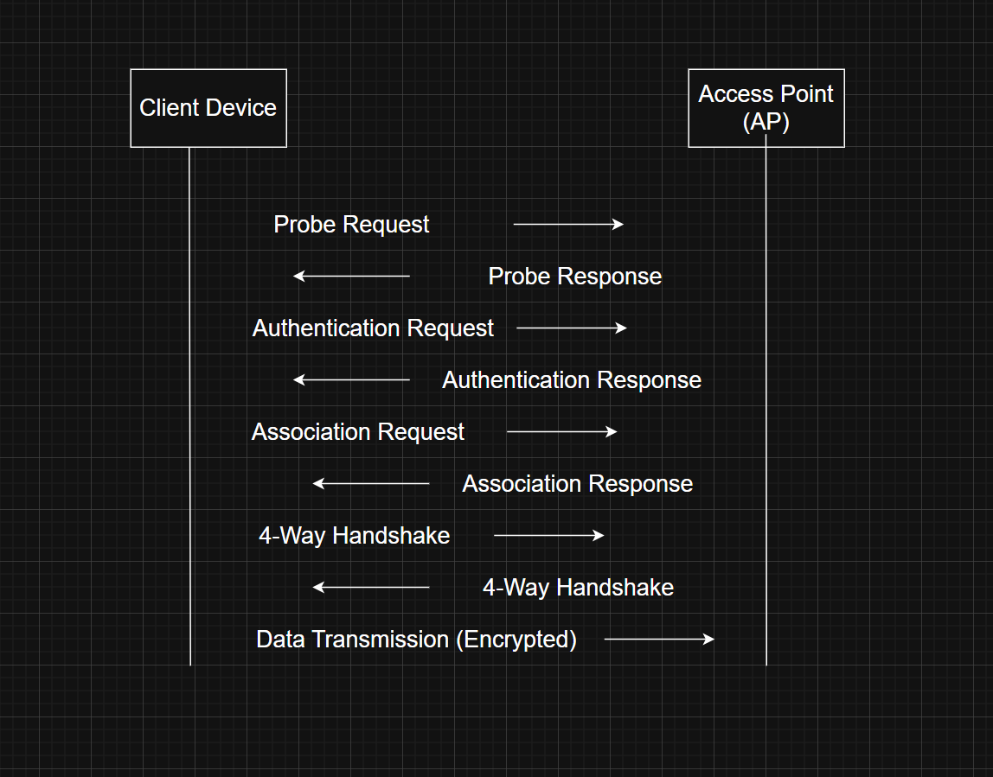
Explanation: The client first probes and authenticates with the AP, then associates. After association, the 4-Way Handshake occurs to establish encryption keys based on the pre-shared key. Once keys are established, encrypted data transmission begins.
Overview of Wi-Fi Authentication
Wi-Fi authentication is the process by which a client device proves its identity to the access point (AP) before gaining network access. Authentication can be broadly categorized into:
- Personal Mode (WPA2/WPA3-PSK): Uses a Pre-Shared Key (PSK) known to all users.
- Enterprise Mode (WPA2/WPA3-Enterprise): Uses an authentication server (typically RADIUS) to authenticate users individually.
WPA2-Enterprise Authentication
How it works:
802.1X Framework: WPA2-Enterprise uses the IEEE 802.1X standard for port-based network access control.
- EAP (Extensible Authentication Protocol): Various EAP methods are used to authenticate users/devices.
- RADIUS Server: Acts as the authentication server validating credentials.
Common EAP Methods:
- EAP-TLS (Transport Layer Security): Uses client and server certificates for mutual authentication.
- PEAP (Protected EAP): Encapsulates EAP within a TLS tunnel; typically uses username/password.
- EAP-TTLS (Tunnelled TLS): Similar to PEAP but supports legacy authentication inside the tunnel.
- EAP-FAST: Cisco’s method using a Protected Access Credential (PAC).
- Strengths of WPA2-Enterprise
- Individual Credentials: Each user/device has unique credentials, reducing risk of credential sharing.
- Mutual Authentication: EAP-TLS provides strong mutual authentication via certificates.
- Dynamic Key Management: Session keys are dynamically generated per session.
- Centralized Control: RADIUS server allows centralized policy enforcement and logging.
- Weaknesses and Challenges
- Certificate Management: EAP-TLS requires managing certificates, which can be complex.
- Password-based EAP Vulnerabilities: PEAP and EAP-TTLS rely on passwords, which can be weak or phished.
- Misconfiguration Risks: Incorrect RADIUS or AP configuration can weaken security.
- Legacy Device Support: Older devices may not support strong EAP methods.
- Recommendations for Stronger Wi-Fi Authentication
- Adopt EAP-TLS: Use certificate-based mutual authentication to eliminate password risks.
- Implement Robust PKI: Deploy a Public Key Infrastructure (PKI) for certificate issuance and revocation.
- Use WPA3-Enterprise: WPA3-Enterprise enhances security with 192-bit encryption and improved handshake.
- Enforce Strong Password Policies: For password-based EAP, enforce complex passwords and multi-factor authentication (MFA).
- Regular Audits and Monitoring: Continuously monitor authentication logs for anomalies.
- User Training: Educate users on phishing and credential security.
Bluetooth Pairing Processes
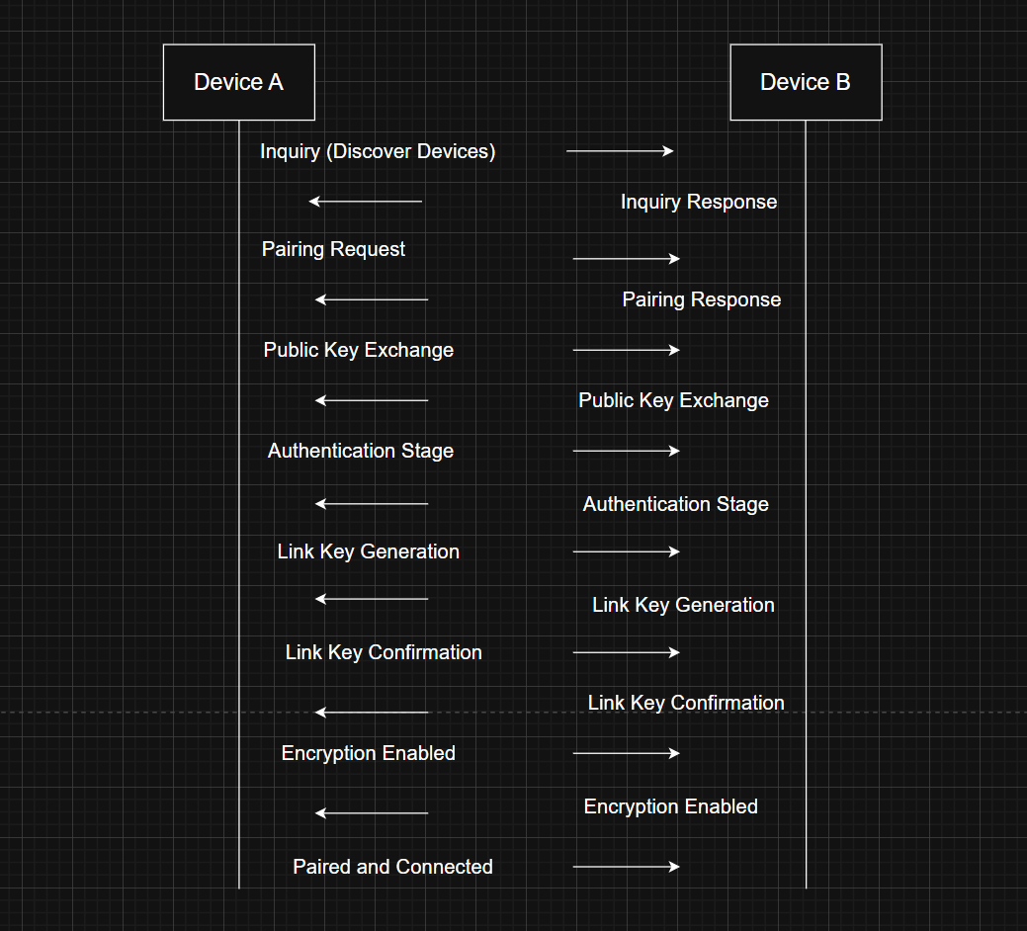
Overview of Bluetooth Pairing
Pairing is the process of establishing trust between two Bluetooth devices, enabling encrypted communication. It involves key exchange and authentication.
Bluetooth Pairing Methods
Just Works:
No authentication.
Vulnerable to Man-in-the-Middle (MITM) attacks.
Used for devices without input/output capabilities.
Passkey Entry:
One device displays a 6-digit passkey; the other enters it.
Provides MITM protection if passkey is secret.
Numeric Comparison:
Both devices display a number; user confirms if they match.
Provides MITM protection.
Out of Band (OOB):
Uses an external channel (e.g., NFC) to exchange cryptographic data.
Most secure method, resistant to MITM.
Bluetooth Security Modes and Levels
Security Mode 1: No security.
Security Mode 2: Service-level enforced security.
Security Mode 3: Link-level enforced security (encryption and authentication).
Security Mode 4: (Bluetooth 2.1+): Introduced Secure Simple Pairing (SSP) with ECDH key exchange.
Bluetooth Secure Simple Pairing (SSP)
Introduced in Bluetooth 2.1.
Uses Elliptic Curve Diffie-Hellman (ECDH) for key exchange.
Supports the four pairing methods above.
Provides protection against passive eavesdropping and MITM attacks (except Just Works).
Weaknesses in Bluetooth Pairing
Just Works Vulnerability: No MITM protection.
User Interaction Dependency: Numeric Comparison and Passkey Entry rely on user vigilance.
Legacy Devices: Older devices may not support SSP or strong encryption.
OOB Channel Security: OOB is secure only if the external channel is secure.
 VPN over Wi-Fi
A Virtual Private Network (VPN) is a secure tunnel that encrypts all internet traffic from a user's device to a VPN server. When connected to a VPN, the data that leaves the device is encrypted so that even if someone intercepts the wireless transmission, they would only see scrambled data. The VPN decrypts the traffic at its secure endpoint, usually located in a trusted server environment. This is particularly useful when using public Wi-Fi, where traffic is otherwise open to sniffing.
VPNs typically use strong encryption algorithms like AES-256 or ChaCha20 and secure tunneling protocols such as OpenVPN, WireGuard, or IKEv2/IPSec. These ensure not only encryption but also authentication, which prevents rogue servers from impersonating trusted services. Once traffic is inside the VPN tunnel, it cannot be read or altered by anyone monitoring the Wi-Fi network, including malicious actors, other users, or even the network administrator.
From a deployment standpoint, VPNs are relatively easy to set up. They are widely supported across operating systems and devices, and many commercial and enterprise VPN services offer user-friendly clients. However, VPNs do introduce some latency and depend on the trustworthiness of the VPN provider. While VPNs protect data from local network threats, they do not provide end-to-end protection—data is decrypted at the VPN server before being forwarded to its destination.
VPNs are especially effective in scenarios such as remote work, where employees access internal systems over potentially insecure connections, or when users need to access sensitive services on untrusted Wi-Fi networks. In such cases, VPNs provide a strong security baseline by encrypting all data in transit and masking the user’s IP address.
End-to-End Encryption (E2EE)
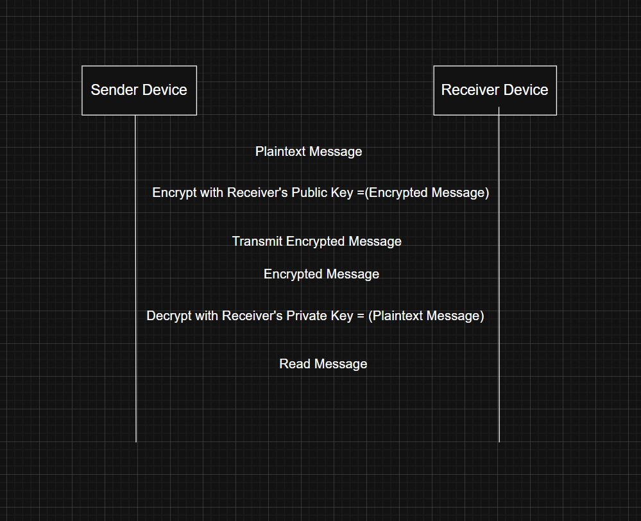
End-to-End Encryption (E2EE) goes a step further by ensuring that data is encrypted on the sender’s device and can only be decrypted by the intended recipient’s device. This means that no intermediary—including network routers, internet service providers, or even the servers facilitating the communication—can read the contents of the message or file.
E2EE is implemented at the application level. For instance, secure messaging apps like Signal, WhatsApp, or Apple iMessage use E2EE to protect messages from end to end. This involves complex key exchanges and encryption algorithms such as the Signal protocol or elliptic curve cryptography. These systems often involve the use of public and private keys, where only the recipient has access to the private key needed to decrypt the message.
The main advantage of E2EE is that it provides the highest level of confidentiality. Even if a network is compromised or if someone intercepts the communication at the server level, the content remains secure. This makes E2EE crucial for transmitting sensitive information such as personal health data, financial details, legal documents, and private conversations.
Implementing E2EE is more complex than using a VPN. It requires careful key management, secure application development, and sometimes additional user responsibilities such as verifying recipient keys. Unlike VPNs, which protect all data indiscriminately, E2EE must be specifically implemented in each application and tailored to its data flow.
Despite its complexity, E2EE is essential in environments where privacy is paramount. For example, in healthcare or financial applications, where regulatory compliance demands confidentiality, E2EE ensures that only the intended parties can access sensitive data. It also plays a key role in protecting data against breaches on the server-side, since even the service provider cannot decrypt the data.
Integrating VPN and E2EE for Robust Security
Both VPN and E2EE are not mutually exclusive—in fact, they complement each other well. Using a VPN can protect against local threats on the Wi-Fi network, such as packet sniffing and session hijacking, while E2EE ensures that sensitive application-level data remains secure throughout the entire journey, even beyond the VPN endpoint. Together, they provide layered security that is highly effective in mitigating threats on wireless networks.
Network Segmentation and Access Control
In any wireless communication environment—especially those involving Wi-Fi and Bluetooth—ensuring that devices and data are segmented and restricted according to sensitivity is crucial. Poorly segmented networks and uncontrolled Bluetooth access can result in unauthorized data access, lateral movement by attackers, and data leakage. To mitigate these risks, two core strategies are effective: Wi-Fi network segmentation and Bluetooth access control.
Wi-Fi Segmentation
Network segmentation refers to dividing a network into multiple distinct sub-networks (segments) to control traffic flow and restrict access based on trust levels and function. In Wi-Fi environments, segmentation is critical because all devices within range of the access point can potentially try to communicate or scan each other.
Why Segment Wi-Fi?
- To isolate sensitive data traffic (e.g., financial records, health information) from general traffic.
- To contain breaches, limiting the attack surface.
- To enforce policies based on user roles, device types, or access levels.
- Strategies for Wi-Fi Network Segmentation
Create Separate SSIDs
- Define different Wi-Fi networks (SSIDs) for various user groups or purposes, such as:
- Corp Network: for employee access with full resource privileges.
- Guest WiFi: for visitors with internet-only access.
- IoT Network: for smart devices, isolated from sensitive systems.
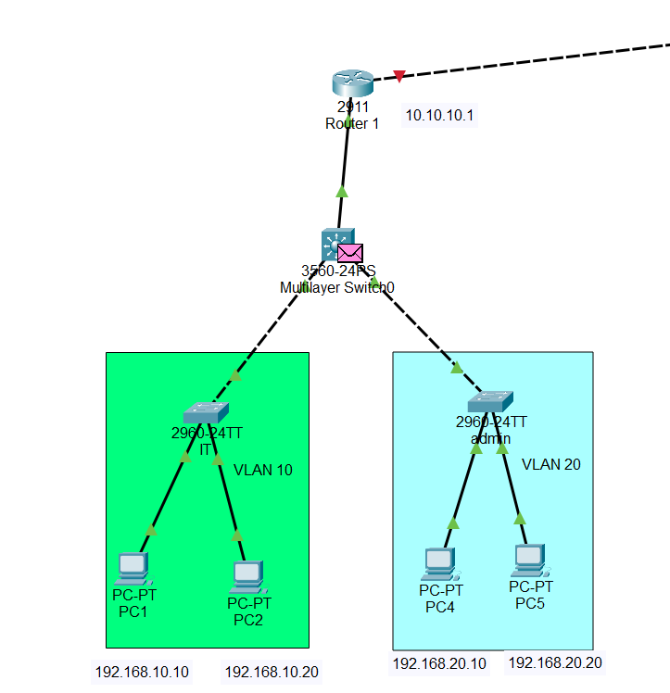
Use VLANs (Virtual LANs)
Associate each SSID with a specific VLAN. VLANs logically segment the traffic even if devices connect to the same physical hardware.
VLAN 10: Corporate devices
VLAN 20: Guests
VLAN 30: IoT
Apply Firewall Rules between Segments
Use internal firewalls or Layer 3 switches to block or allow traffic between VLANs based on need. For example, guests should not be able to access internal databases or file servers.
Enable AP Isolation
On guest networks, Access Point Isolation prevents devices on the same SSID from communicating with each other directly. This helps block peer-to-peer attacks.
Use WPA3 Enterprise with RADIUS Authentication
Implement WPA3-Enterprise along with a RADIUS server to enforce user-specific authentication and dynamic VLAN assignment. This means employees are automatically assigned to different network segments based on their credentials.
Monitor and Audit Traffic
Implement network monitoring tools to inspect traffic flows between segments. This helps in identifying policy violations or unusual access attempts.
Real-World Application
In enterprise environments, Wi-Fi segmentation is commonly used to separate the finance department from general staff, or development environments from production systems. In hospitals, it's used to keep patient-monitoring devices on a medically-certified network while staff and guests use a completely separate Wi-Fi.
Bluetooth Access Control
Bluetooth is inherently designed for short-range, device-to-device communication. However, its convenience also opens up vulnerabilities such as unauthorized pairing, data leakage, and device hijacking. Access control ensures that only trusted and authorized Bluetooth devices can connect, and that they have limited access to sensitive data.
Why Control Bluetooth Access?
To prevent unauthorized device pairing.
To limit data exfiltration through wireless channels.
To protect against Bluetooth-based attacks like BlueBorne, Bluesnarfing, or Bluejacking.
Bluetooth Access Control Mechanisms
Enforce Pairing Restrictions
Only allow pairing with whitelisted devices. For example, configure a computer or phone to accept connections only from known headsets, keyboards, or IoT devices.
Use Authentication and Encryption
- Always enable Bluetooth security modes that require authentication and encryption:
- Bluetooth Secure Simple Pairing (SSP): Provides MITM protection with passkey verification.
- Use Bluetooth 4.2+ or Bluetooth 5.0+, which offer improved security features.
Implement Role-Based Bluetooth Access
- On managed devices, enforce Bluetooth policies via MDM (Mobile Device Management) solutions that control:
- Whether Bluetooth can be turned on/off
- Which profiles (audio, file transfer, etc.) are permitted
- Time-of-day restrictions for Bluetooth usage
- Disable Unnecessary Bluetooth Services
- Many devices support multiple Bluetooth profiles. Disable unused services like file transfer (OBEX) to reduce exposure.
- Regularly Scan for Nearby Devices
- Use Bluetooth scanners to detect unauthorized or rogue devices attempting to connect. Alert or block unexpected devices.
- Turn Off Bluetooth When Not in Use
- Encourage or enforce policies where Bluetooth is disabled when not needed—particularly in secure environments like government offices, data centres, or healthcare facilities.
- Log and Monitor Bluetooth Activity
- Maintain logs of all pairing attempts and data transfers. This can be useful for forensic analysis if a breach occurs.
Real-World Application
In industries like manufacturing or healthcare, where IoT devices and wearable sensors are prevalent, Bluetooth access control helps restrict what devices can communicate with each other. For example, a glucose monitor should only be able to pair with a registered medical tablet, not a personal smartphone or unknown laptop.
Intrusion Detection and Prevention: Securing Wireless Communications
Intrusion Detection and Prevention: Securing Wireless Communications
Wireless technologies like Wi-Fi and Bluetooth are ubiquitous but inherently vulnerable to a range of attacks due to their open-air signal transmission. To maintain security and integrity, it's essential to implement Intrusion Detection Systems (IDS) and Intrusion Prevention Systems (IPS) that can monitor, detect, and block malicious activities in real time.
Wi-Fi Intrusion Detection and Prevention (Wi-Fi IDS/IPS)
Wi-Fi networks are vulnerable to attacks such as rogue access points, authentication attacks, MAC spoofing, Evil Twin attacks, and unauthorized access. Implementing a Wi-Fi IDS/IPS allows organizations to monitor wireless traffic, identify anomalies or threats, and take automated or manual action.
What Is Wi-Fi IDS/IPS?
Intrusion Detection System (IDS) monitors Wi-Fi traffic passively and generates alerts upon detecting suspicious behaviour.
Intrusion Prevention System (IPS) not only detects threats but also takes proactive actions, such as disconnecting malicious users or blocking rogue devices.
Key Components and Features
Wireless Packet Capturing
Use specialized Wi-Fi adapters or sensors to capture wireless packets in real-time.
Tools like Kismet, Aircrack-ng, or commercial systems like Cisco Meraki Air Marshal can analyse 802.11 frames.
Signature-Based Detection
Maintain a database of known attack patterns (e.g., known deauth attack sequences, unauthorized SSIDs).
IDS flags traffic that matches these patterns.
Anomaly-Based Detection
Establish a baseline of “normal” Wi-Fi behaviour (signal strength, MAC addresses, traffic volume).
Deviations from the norm (e.g., a sudden spike in probe requests) trigger alerts.
Rogue Device Detection
Detect unauthorized access points broadcasting the same SSID as legitimate ones (Evil Twin).
Identify devices trying to spoof MAC addresses of trusted clients.
Deauthentication and Mitigation
An IPS can automatically deauthenticate rogue devices or isolate them using firewall rules.
Some systems can perform “containment” by sending deauth packets to rogue APs and clients.
Integration with Network Infrastructure
Integrate IDS/IPS with switches, firewalls, and authentication systems (like RADIUS).
Quarantine compromised devices or automatically block their MAC/IP addresses.
Real-Time Alerting and Logging
Send alerts via email, SMS, or management dashboards.
Maintain detailed logs for auditing and incident response.
Real-World Example
In corporate networks, Wi-Fi IDS/IPS can alert administrators if a new unauthorized AP pops up in the office or if someone attempts a brute-force attack on WPA2 handshakes. In high-security zones (e.g., military bases), rogue device detection is used to enforce a strict no-wireless policy.
Bluetooth Monitoring and Intrusion Detection
Bluetooth is more difficult to monitor than Wi-Fi due to its short-range and frequency-hopping nature, but it remains a security risk. Attacks like Bluejacking, Bluesnarfing, and BlueBorne can exploit unprotected Bluetooth interfaces.
Why Monitor Bluetooth?
Detect unauthorized devices trying to connect or pair.
Monitor paired device history to identify tampering or misuse.
Prevent data leakage from wearable devices or peripherals.
Bluetooth Monitoring Strategies
Bluetooth Scanning and Discovery Logging
Use tools like BTScanner, BlueHydra, or Ubertooth One to continuously scan for nearby devices.
Log MAC addresses, device names, signal strengths (RSSI), and Bluetooth profiles.
Device Whitelisting and Pairing Control
Maintain a whitelist of authorized Bluetooth devices.
Alert or block devices not on the list when they attempt to pair or communicate.
Profile-Level Monitoring
Monitor Bluetooth profiles in use (e.g., audio, file transfer, keyboard).
Block dangerous profiles like OBEX (used in file pushing attacks).
Passive Monitoring for Anomalies
Establish normal behaviour patterns for paired Bluetooth devices (e.g., signal strength, usage time).
Flag anomalies such as unexpected pairing requests or increased data transfer.
Geofencing and Physical Security Integration
Combine Bluetooth monitoring with physical access controls (e.g., turn off Bluetooth near restricted zones).
Alert security if unknown Bluetooth devices are detected in sensitive areas.
Mobile Device Management (MDM) Integration
On smartphones and tablets, use MDM tools to control Bluetooth:
Enforce encryption
Disable Bluetooth when not in use
Audit connection history
Real-World Example
In a healthcare environment, patient monitoring equipment might use Bluetooth to communicate. Monitoring tools can alert administrators if a foreign device tries to connect or if a known device suddenly exhibits abnormal behaviour, such as sending data to an unknown IP.
Policy and Compliance in Wireless Security
Securing wireless communication involves not only implementing technical controls but also enforcing clear policies and adhering to regulatory standards. These ensure that both users and systems operate within a secure and legally compliant framework, minimizing the risk of breaches, data leakage, and legal consequences.
Wireless Security Policies
Wireless Security Policies define the rules, guidelines, and procedures for the secure use of wireless technologies (e.g., Wi-Fi, Bluetooth, mobile hotspots) within an organization. These policies are critical to protect sensitive data, manage risk, and ensure accountability.
Objectives of a Wireless Security Policy
- Protect data transmitted over wireless networks.
- Define access control mechanisms and encryption standards.
- Regulate usage of personal devices and guest access.
- Establish monitoring and incident response procedures.
- Key Components of a Comprehensive Wireless Security Policy
Access Control and Authentication
- Enforce strong user authentication for Wi-Fi access (e.g., WPA3-Enterprise with RADIUS).
- Use MAC address filtering or certificate-based access for corporate devices.
- Disallow open (unencrypted) Wi-Fi networks within the organization.
Encryption Standards
- Mandate WPA3 for all organizational wireless networks.
- Require end-to-end encryption for sensitive data transmission (e.g., TLS, VPN).
- Encrypt stored credentials and traffic logs.
SSID Management
Define rules for broadcasting SSIDs:
- Use non-identifiable names (avoid company name in SSID).
- Segment networks by department or function.
- Hide internal SSIDs from public view when possible.
Guest Access Policy
- Provide a segmented guest Wi-Fi network with internet-only access.
- Use captive portals with authentication and session timeouts.
- Log guest activity for compliance and auditing.
Bring Your Own Device (BYOD) Policy
- Allow personal devices only after registration and approval.
- Enforce security controls like mobile antivirus, VPN use, and OS patching.
- Use Mobile Device Management (MDM) to control Bluetooth/Wi-Fi settings.
Bluetooth Usage Guidelines
- Disable Bluetooth on devices not requiring it.
- Whitelist trusted devices and prohibit file transfer profiles.
- Mandate encryption and authentication for all Bluetooth connections.
Monitoring and Logging
- Log all access attempts, connected devices, and security incidents.
- Retain logs according to compliance requirements (e.g., 90–365 days).
- Conduct regular wireless audits using tools like Wi-Fi scanners and spectrum analysers.
Incident Response Plan
- Define steps for detecting, reporting, and mitigating wireless security incidents.
- Include procedures for rogue AP detection, DDoS, MITM, and data breach responses.
- Assign roles to specific IT/security personnel.
User Awareness and Training
- Conduct regular training on wireless security best practices.
- Educate users on risks like public Wi-Fi, phishing over mobile, Bluetooth eavesdropping.
Regulatory Compliance
In addition to internal policies, organizations must ensure that their wireless infrastructure and practices comply with applicable laws, industry standards, and regulatory frameworks. Non-compliance can lead to fines, data breaches, and loss of trust.
Key Regulations Affecting Wireless Communication
GDPR (General Data Protection Regulation – EU)
- Requires protection of personal data during wireless transmission.
- Mandates explicit consent for data collection via mobile apps.
- Breach of unprotected Wi-Fi traffic containing personal data could trigger penalties.
- Compliance Tip: Use WPA3, VPN, and TLS to encrypt all personal data over wireless networks. Regularly assess access control logs for unauthorized activity.
HIPAA (Health Insurance Portability and Accountability Act – US)
- Applies to healthcare providers and systems.
- Requires protection of ePHI (electronic Protected Health Information), including data transmitted over Wi-Fi and Bluetooth.
- Violations include use of unsecured Wi-Fi for transmitting patient data.
- Compliance Tip: Enforce strict access control, end-to-end encryption, and audit logging for all wireless communication involving ePHI.
PCI DSS (Payment Card Industry Data Security Standard)
- Relevant if wireless networks transmit, process, or store credit card data.
- Wireless environments must use strong encryption (WPA2/WPA3) and be segmented from cardholder data environments (CDE).
- Requires quarterly scans for rogue wireless devices.
- Compliance Tip: Set up a separate VLAN for point-of-sale (POS) terminals and scan for unauthorized APs near payment systems.
ISO/IEC 27001
- An international standard for Information Security Management Systems (ISMS).
- Requires organizations to implement risk-based controls, including secure wireless use policies.
- Compliance Tip: Map wireless risks in the ISMS and document controls in place to mitigate them.
NIST SP 800-153 & SP 800-121 (US Standards)
- Provides specific guidance for securing Wi-Fi (SP 800-153) and Bluetooth (SP 800-121).
- Recommends using FIPS-validated cryptography and performing periodic vulnerability assessments.

Wi-Fi Encryption Strategy
Wi-Fi networks are susceptible to eavesdropping, man-in-the-middle (MITM) attacks, and rogue access points. The encryption strategy for Wi-Fi must secure all data transmitted between clients and access points.
Recommended Encryption Protocols:
WPA3 (Wi-Fi Protected Access 3)
Latest and most secure standard.
Uses SAE (Simultaneous Authentication of Equals) for protection against offline dictionary attacks.
Mandates forward secrecy – past sessions cannot be decrypted even if a key is compromised.
WPA2-Enterprise (802.1X + RADIUS)
For environments where WPA3 is not yet feasible.
Uses centralized authentication via a RADIUS server and individual user credentials or certificates.
Stronger than WPA2-Personal (pre-shared key).
End-to-End Encryption (E2EE)
While WPA3 encrypts the link, application-layer encryption like TLS 1.3 ensures that even if the Wi-Fi is compromised, the data remains secure.
VPN (Virtual Private Network)
Mandatory for remote users or employees on public Wi-Fi.
Use strong protocols like IPSec or OpenVPN with AES-256 encryption.
Implementation Guidelines:
- Enforce WPA3 as the default for all new access points.
- Use WPA2-Enterprise in environments that cannot yet upgrade, with digital certificates or strong credentials.
- Disable legacy protocols (e.g., WEP, WPA, TKIP).
- Regularly update firmware on access points to patch encryption-related vulnerabilities.
- Segment WI-Fi networks using VLANs and encrypt all inter-VLAN traffic.
- For guest networks, use WPA3-Personal or WPA2 with captive portal + TLS.
- Mandate VPN usage for remote access or in public areas.
- Educate users not to connect to open or unknown Wi-Fi networks.
Bluetooth Encryption Strategy
Bluetooth is vulnerable to sniffing, pairing hijacks, and malware via unencrypted transfers. A robust encryption policy ensures secure short-range communication for devices like headsets, health monitors, keyboards, and wearables.
Recommended Encryption Protocols:
- Bluetooth Secure Simple Pairing (SSP)
- Used in Bluetooth 2.1 and above.
- Supports encryption during the pairing process and is resistant to MITM attacks when using Numeric Comparison or Passkey Entry modes.
- Bluetooth Low Energy (BLE) Secure Connections
- BLE 4.2 and later supports Elliptic Curve Diffie-Hellman (ECDH) key exchange.
- Provides strong encryption and forward secrecy.
AES-CCM Encryption for Data
All encrypted Bluetooth connections use AES-128 in CCM mode, ensuring confidentiality and integrity.
Implementation Guidelines:
- Require pairing only in secure modes (Numeric Comparison or Passkey Entry).
- Disable "Just Works" pairing for sensitive devices, as it lacks MITM protection.
- Whitelist approved Bluetooth devices and disallow unapproved pairings.
- Configure devices to become non-discoverable after initial pairing.
- Disable or restrict Bluetooth usage in sensitive zones (e.g., data centres).
- Enforce Bluetooth version 4.2+ with Secure Connections on all supported hardware.
- Regularly audit paired device lists and remove unused or unknown entries.
- Monitor for Bluetooth MAC address spoofing or rogue device attempts.
Compliance and Standards Alignment
- GDPR: Encrypt all personal data in transit over Wi-Fi and Bluetooth.
- HIPAA: Ensure that ePHI (electronic protected health information) sent over wireless links is encrypted using FIPS 140-2 validated algorithms.
- PCI-DSS: Enforce strong encryption for any wireless networks transmitting payment card data.
- NIST SP 800-121 & SP 800-153: Follow NIST guidance on wireless and Bluetooth encryption.

