|  |
| --- |
|  |

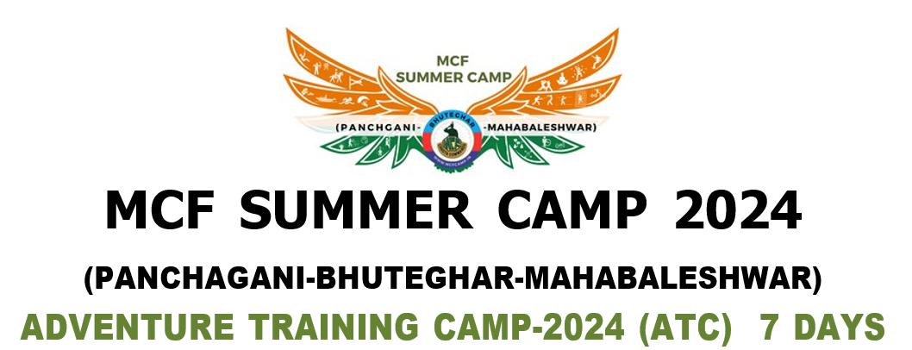

|  |  |  |  |  |  |  |
| --- | --- | --- | --- | --- | --- | --- |
| MRN: | {MERGEFIELD REG_NO} | | | RANK: | | CDT |
| CADET NAME: | | {MERGEFIELD CADET_NAME} | | | | |
| ADDRESS: | | {MERGEFIELD ADDRESS} | | | | |
| EMAIL ID: | | {MERGEFIELD EMAIL_ID} | | CONTACT NO : | | {MERGEFIELD CONTACT_NO} |
| CAMP NAME: | | {MERGEFIELD CAMP_NAME} | | DAYS : | | {MERGEFIELD DAYS} |
| CAMP DATE: | | {MERGEFIELD CAMP_DATE} | | BATCH : | | {MERGEFIELD BATCH} |
| CQY NAME: | | {MERGEFIELD CQY_NAME} | INCHARGE NAME: | | {MERGEFIELD INCHARGE_NAME} | |

**CAMP REPORT**

|  |  |  |  |
| --- | --- | --- | --- |
| CHECK IN DATE : | {MERGEFIELD CHECK_IN_DATE} | PICK UP DATE : | {MERGEFIELD PICK_UP_DATE} |
| CHECK OUT DATE : | {MERGEFIELD CHECK_OUT_DATE} | DROP DATE : | {MERGEFIELD DROP_DATE} |

|  |  |  |  |  |  |  |
| --- | --- | --- | --- | --- | --- | --- |
| **SR.**  **NO.** | **SKILL** | **TIMES TO REPEAT** | **TRAINED BY INS** | **PHYSICAL** | **TIMES TO REPEAT** | **TRAINED BY INS** |
| 1 | Archery | {MERGEFIELD ARCHERY_TTR} | {MERGEFIELD ARCHERY_TBI} | Trekking | {MERGEFIELD TREKKING_TTR} | {MERGEFIELD TREKKING_TBI} |
| 2 | Lathi-Kathi | {MERGEFIELD LATHI_KATHI_TTR} | {MERGEFIELD LATHI_KATHI_TBI} | Aerobics /Yoga | {MERGEFIELD AEROBICS_TTR} | {MERGEFIELD AEROBICS_TBI} |
| 3 | Rifle Shooting | {MERGEFIELD RIFLE_SHOOTING_TTR} | {MERGEFIELD RIFLE_SHOOTING_TBI} | P.T. and Mass P.T. Exercise | {MERGEFIELD PT_EXERCISE_TTR} | {MERGEFIELD PT_EXERCISE_TBI} |
| 4 | Martial Arts | {MERGEFIELD MARTIAL_ARTS_TTR} | {MERGEFIELD MARTIAL_ARTS_TBI} |  |  |  |
| 5 | Horse Riding | {MERGEFIELD HORSE_RIDING_TTR} | {MERGEFIELD HORSE_RIDING_TBI} |  |  |  |

|  |  |  |  |  |  |  |
| --- | --- | --- | --- | --- | --- | --- |
| **SR**  **NO.** | **WATER** | **TIMES TO REPEAT** | **TRAINED BY INS** | **ADVENTURE** | **TIMES TO REPEAT** | **TRAINED BY INS** |
| 1 | Rain Dance | {MERGEFIELD RAIN_DANCE_TTR} | {MERGEFIELD RAIN_DANCE_TBI} | Rock Climbing | {MERGEFIELD ROCK_CLIMBING_TTR} | {MERGEFIELD ROCK_CLIMBING_TBI} |
| 2 |  |  |  | Zip Line | {MERGEFIELD ZIP_LINE_TTR} | {MERGEFIELD ZIP_LINE_TBI} |

|  |  |  |  |  |  |  |
| --- | --- | --- | --- | --- | --- | --- |
| **SR.**  **NO.** | **MCF ROPE COURSE** | **TIMES TO REPEAT** | **TRAINED BY INS** | **CULTURAL** | **TIMES TO REPEAT** | **TRAINED BY INS** |
|
| 1 | Burma Bridge | {MERGEFIELD BURMA_BRIDGE_TTR} | {MERGEFIELD BURMA_BRIDGE_TBI} | Camp Fire / Solo Songs / Solo Dance | {MERGEFIELD CAMP_FIRE_TTR} | {MERGEFIELD CAMP_FIRE_TBI} |
| 2 | Tawa Walk | {MERGEFIELD TAWA_WALK_TTR} | {MERGEFIELD TAWA_WALK_TBI} |  |  |  |
| 3 | Single Rope Walk | {MERGEFIELD SINGLE_ROPE_WALK_TTR} | {MERGEFIELD SINGLE_ROPE_WALK_TBI} |  |  |  |
| 4 | Zig Zag Ladder Walk | {MERGEFIELD ZIGZAG_LADDER_WALK_TTR} | {MERGEFIELD ZIGZAG_LADDER_WALK_TBI} |  |  |  |
| 5 | One Feet Walk | {MERGEFIELD ONE_FEET_WALK_TTR} | {MERGEFIELD ONE_FEET_WALK_TBI} |  |  |  |

|  |  |  |  |  |
| --- | --- | --- | --- | --- |
| LAST CLOSING CEREMONY DATE: | | {MERGEFIELD LAST_CLOSE_DATE} | TIME: | {MERGEFIELD LAST_CLOSE_TIME} |
| PARENTS PRESENT/ABSENT: | | {MERGEFIELD PARENT_P_A} | | |
| BEST ACTIVITY: | {MERGEFIELD BEST_ACTIVITY} | | | |

**INDIVIDUAL REMARK**

|  |  |
| --- | --- |
| 1) FUTURE CAREER : | {MERGEFIELD FUTURE_CAREER} |
| 2) TIME MANAGEMENT : | {MERGEFIELD TIME_MANAGEMENT} |
| 3) ACCOMMODATION : | {MERGEFIELD ACCOMMODATION} |
| 4) FACILITIES : | {MERGEFIELD FACILITIES} |
| 5) INS TRAINING : | {MERGEFIELD INS_TRAINING} |
| 6) ATMOSPHERE : | {MERGEFIELD ATMOSPHERE} |
| 7) ACTIVITY : | {MERGEFIELD ACTIVITY} |
| 8) UNIFORM : | {MERGEFIELD UNIFORM} |
| 9) CERTIFICATION : | {MERGEFIELD CERTIFICATION} |
| 10) SUGGESTION : | {MERGEFIELD SUGGESTION} |
| 11) BEST ACHIEVEMENT : | {MERGEFIELD BEST_ACHIEVEMENT} |
| 12) ACHIEVEMENT : | {MERGEFIELD ACHIEVEMENT} |

**REMARKS :**

|  |
| --- |
| {MERGEFIELD REMARKS} |

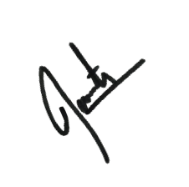



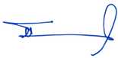

# Mr. Ganesh Borate Sadashiv Jadhav

DIRECTOR – MCF CAMP COMMANDER