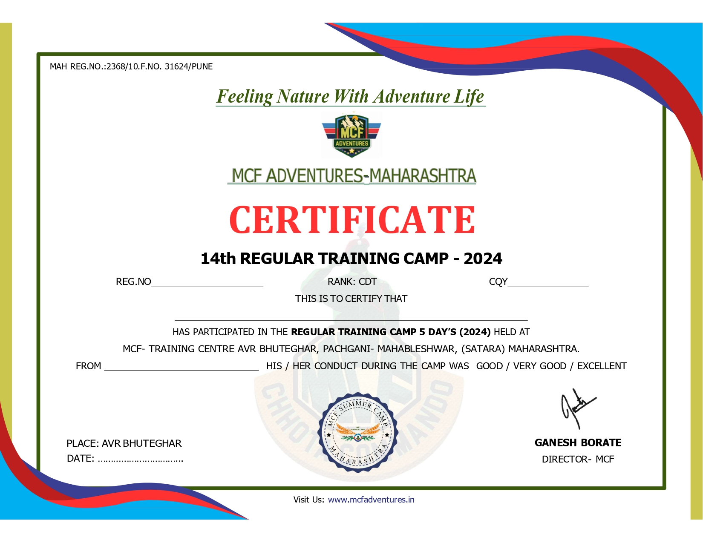

**{MERGEFIELD REG_NO}**

**{MERGEFIELD CQY}**

**{MERGEFIELD CADET_NAME}**

**{MERGEFIELD START_DATE}**

**{MERGEFIELD END_DATE}**