***"Creating Tomorrow's Responsible Citizen"***

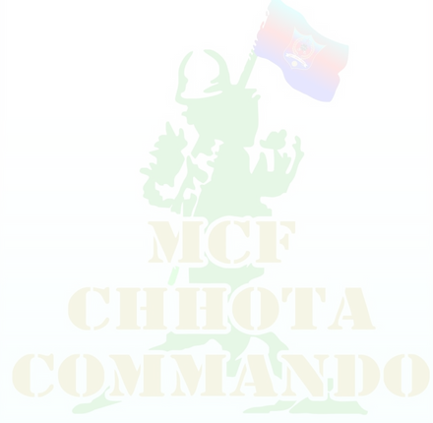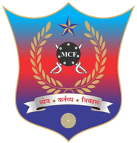

MCF SUMMER CAMP -2024

MCF CAMPUS, Ashok Villa, Near Mapro Garden, Bio-Diversity Park, Panchgani- Mahabaleswar RD, 412806.

**Call us**: 9604082000 / 8806508787 / 7720014900 / 9604087000

**Web** - [www.mcfcamp.in](http://www.mcfcamp.in/) **Email** - [mcfcamp@gmail.com](mailto:mcfcamp@gmail.com)

ESCORT CARD / VISITING PASS - 2024

CAMP NAME : {MERGEFIELD CAMP_NAME} BATCH : {MERGEFIELD BATCH} DATE: {MERGEFIELD CAMP_DATE}

REGISTRATION NUMBER : {MERGEFIELD REG_NO} CADET NAME : {MERGEFIELD CADET_NAME}

ADDRESS : {MERGEFIELD ADDRESS} PICKUP POINT : {MERGEFIELD PICKUP_POINT}

CONTACT NO : {MERGEFIELD CONTACT} WHATSAPP NO : {MERGEFIELD WHATSAPP_NO}

|  |  |  |  |  |
| --- | --- | --- | --- | --- |
| F1 | M1 |  | C1 | G1 |
| FATHER | MOTHER | **AUTHORISED SIGN** | CADET | GUARDIAN |