Sort Lab Project Guide
Components, algorithms and controls
Sort Lab is a static, browser-based sorting visualizer. Choose an input and algorithm, then inspect each comparison, write and final position in a step-by-step trace. This guide explains the visible panels and the code that connects them.
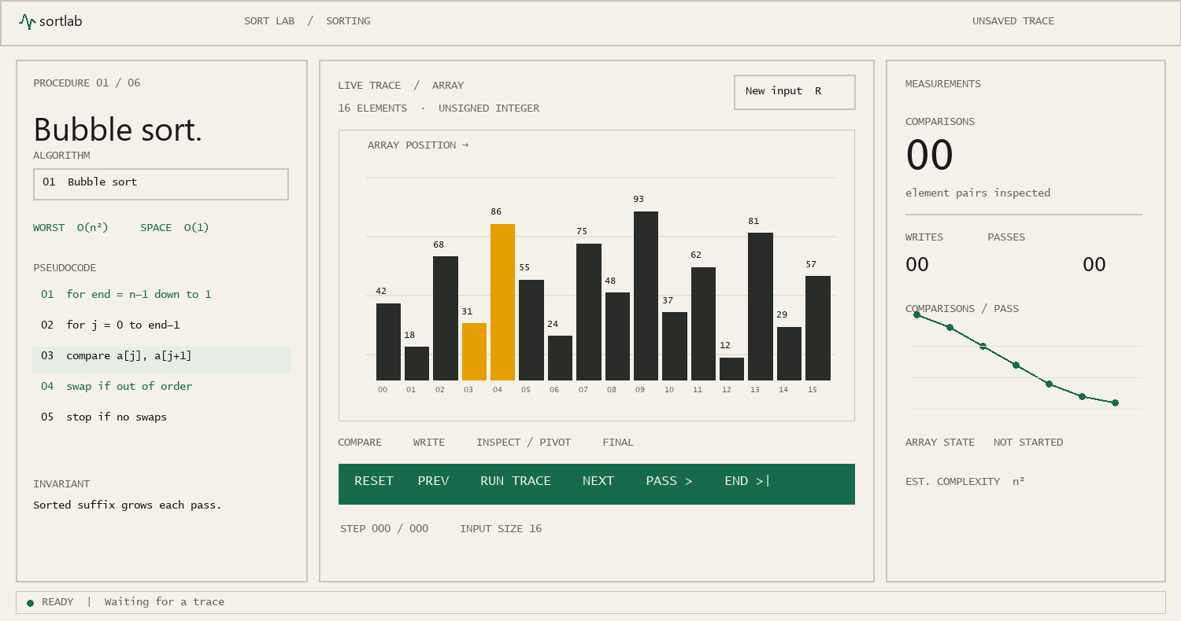
Main workspace layout map. This schematic labels the live interface regions; it is not a browser screenshot.
START HERE Choose an algorithm and input preset, then press Run trace. The center panel shows the array change while the left panel highlights the active pseudocode line.

1. Workspace components
The workspace opens directly into the tool. Thin borders separate the procedure, visualization and measurement panels; transport controls and the status bar sit beneath the visualization.
Component | What it does
Header | Names the tool, shows the sorting context and provides the light/dark theme control. Theme choice is stored locally when browser storage is available.
Procedure panel | Selects one of six algorithms. It shows a short explanation, worst-case time and extra space, pseudocode, an invariant and the meaning of one pass.
Array visualization | Draws values as proportional bars with array indexes below. Compare, write, pivot and final-position colors identify the current event.
Measurements panel | Shows an algorithm-specific operation count, array writes, progress count, operations-by-pass chart, array state and estimated complexity.
Transport and status | Provides playback, step navigation, a scrubber, speed control and input-size slider. The status bar reports the event, step number and pseudocode line.

The procedure panel
Pseudocode highlighting follows the current trace event. Complexity and invariant notes change with the selected algorithm, so this panel works as a quick reference while the trace runs.

Visualization colors
Mark | Meaning
Amber | Values currently being compared.
Red-orange | Array positions written by a swap or assignment.
Blue | A pivot or other inspected value.
Gray | A position not touched yet.
Green | A value placed in its final position.

For arrays of up to 20 values, every bar keeps its value label visible above it throughout playback and after sorting.

2. How the trace works
The sorting engine runs when the input or selected algorithm changes. It creates a sequence of events before playback begins. Moving the scrubber selects an event; it does not rerun the sort on every frame.
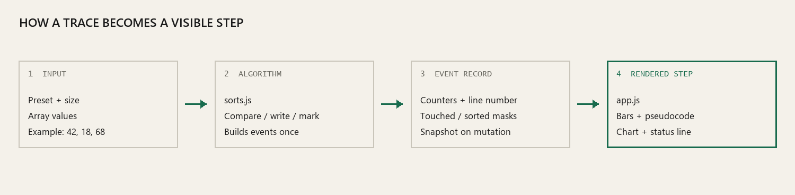
Trace flow from selected input to the rendered step.
Event information | Why it is recorded
Event type and indexes | Identifies a compare, write, swap, pivot, pass boundary or completion, and the bars involved.
Counters and line number | Keeps the metrics, status and pseudocode highlight synchronized.
Touched and sorted masks | Tracks visited positions and values confirmed in their final positions.
Array snapshot on mutation | Stores values only after a write or swap. The renderer finds the nearest prior mutation snapshot for the selected step.

Six implemented algorithms
Algorithm | Core idea | Worst time | Extra space
Bubble | Adjacent comparisons move large values toward the right edge. | O(n²) | O(1)
Selection | Finds the minimum in the unsorted suffix and places it next. | O(n²) | O(1)
Insertion | Holds a key, shifts larger values, then inserts it into an ordered prefix. | O(n²) | O(1)
Merge | Merges pairs of sorted runs, doubling run width each pass. | O(n log n) | O(n)
Quick | Partitions around the last value as pivot, then sorts each side. | O(n²) | O(n) worst
Heap | Builds a max heap, then moves its root to the sorted suffix. | O(n log n) | O(1)

The time column gives worst-case running time. Quick sort’s displayed O(log n) space is its usual stack depth; a badly unbalanced sequence of last-element pivots can make the recursive stack O(n). The current interface summarizes typical stack use and does not show the worst-case stack bound.

3. Using the controls
Control | Action
Algorithm selector | Changes pseudocode and builds a new trace for the same input.
Input preset | Creates Random, Sorted, Reversed, Nearly sorted or Few unique values.
New input · R | Generates another input using the current preset.
Input size slider | Resizes from 8 to 32 values. Existing values are retained where possible; Sorted and Reversed ordering is preserved.
Run trace · Space | Starts or pauses playback. Speeds cycle through 0.5×, 1×, 2×, 4×, 8× and 16×.
Previous / Next · arrows | Moves one event backward or forward.
Step scrubber | Jumps directly to a trace event.
Next pass / End | Skips to the next pass boundary or the final result.
Reset · Home or Shift+R | Returns to the start without changing the current input.

A typical study session
- Choose an input preset. Sorted input illustrates early exit behavior; reversed input produces many shifts and swaps.
- Select an algorithm and read its complexity and invariant.
- Press Next a few times. Watch the active bars and pseudocode line.
- Run the trace or scrub forward; compare the counter and chart by pass.
- Skip to end. Green bars indicate values in final positions.
METRIC NOTE The primary counter reports comparisons. Writes count every array position written, so one swap contributes two writes.

4. Code organization and verification
File | Responsibility
index.html | Page structure, accessible labels, theme initialization before CSS and script loading.
styles.css | Warm-paper and graphite themes, panel layout, chart, responsive breakpoints, reduced-motion rules and focus states.
app.js | Input presets, playback, event rendering, metrics, chart, keyboard shortcuts and theme toggle.
sorts.js | Algorithm metadata, six sorting implementations, event helpers and final sorted/permutation self-check.
test.js | Deterministic randomized checks for every algorithm.
TOKENS.md | Design tokens for color, typography, spacing, borders and motion.

Trace event vocabulary
Algorithms use shared helpers such as compare, write, swap, mark and finishPass. The helpers update counters and masks, then append an event. A final done event marks all positions sorted. After building a trace, the engine checks that its result is ordered and preserves the original values.

Tests
Run the suite from the project folder:
node test.js
The suite checks 200 seeded random arrays per algorithm, sized 8–32. It verifies output length, sorted order, preservation of input values and a completion event: 1,200 randomized cases across the current six algorithms.

Design, access and themes
- Light mode uses warm paper and dark ink; dark mode uses graphite and a phosphor-green signal. The app uses a saved theme when storage is available and otherwise follows the system preference.
- Headings use a serif display face, with sans-serif interface text and monospace metrics. Flat bar fills, fine rules and tabular counters match the lab-instrument visual direction.
- Keyboard shortcuts ignore modifier keys and focused form controls. Buttons have accessible names, the array announces its values, and trace status uses a polite live region.
- Reduced-motion settings shorten transitions. Responsive CSS reorganizes panels for narrow screens; value labels hide when bars do not have enough room.
OPENING THE PROJECT Open index.html in a modern browser. Sort Lab uses vanilla JavaScript and has no install or build command.

5. Algorithm walkthroughs
All six algorithms sort the same kind of input: a small array of unsigned integers. To make their strategies easier to compare, the examples below start with [5, 2, 4, 1]. An algorithm “pass” means a different well-defined unit for each implementation; Quick sort uses partitions, while the other five use sweeps, insertions, merges or heap operations.
Algorithm | Stable? | Best case | Extra space | What its green marks mean
Bubble | Yes | O(n) | O(1) | A suffix position fixed by a completed sweep.
Selection | No, in general | O(n²) | O(1) | The selected minimum placed at its final index.
Insertion | Yes | O(n) | O(1) | Only the whole-array completion; an ordered prefix is not final.
Merge | Yes | O(n log n) | O(n) | Only the whole-array completion in this trace.
Quick | No | O(n log n) typical | O(n) worst stack | A pivot after its partition.
Heap | No | O(n log n) | O(1) | An extracted maximum in the fixed suffix.

Bubble sort
Bubble sort checks adjacent pairs from left to right. When the left value is larger, it swaps the pair. The largest value that remains unsorted therefore drifts to the end on each sweep. For [5, 2, 4, 1], the first sweep produces [2, 4, 1, 5]; the final 5 is now fixed. The implementation checks whether a sweep made any swaps and exits early if it did not. Its in-place adjacent swaps preserve the relative order of equal values, so it is stable.

Selection sort
Selection sort scans the remaining suffix and remembers the index of its smallest value. At the end of a scan, it swaps that minimum into the first unsorted position. On [5, 2, 4, 1], the first scan chooses 1 at index 3 and swaps it with 5, yielding [1, 2, 4, 5]. The method still scans the suffix on every later pass, even when it is already ordered; this is why its comparison count stays quadratic. It does relatively few writes, but swapping a distant minimum can change the order of equal values, so selection sort is not generally stable.

Insertion sort
Insertion sort takes the next value as a key and moves larger prefix values one slot to the right until the key fits. Starting from [5, 2, 4, 1], it holds key 2, shifts 5 and inserts 2 to get [2, 5, 4, 1]. The next key, 4, shifts 5 and becomes [2, 4, 5, 1]. In the visualization, the held key floats above its original position while the gap is being found. The prefix is ordered after each iteration, but its members are not all in their final positions yet; green is therefore reserved for full completion. Equal values are not shifted past one another, so insertion sort is stable.

Merge sort
The implementation is bottom-up. It begins with runs of width 1, merges neighboring runs, then doubles the width to 2, 4, 8 and so on. On [5, 2, 4, 1], width 1 creates runs [2, 5] and [1, 4]; width 2 merges them into [1, 2, 4, 5]. The merge compares values held in temporary left and right buffers, then writes the selected value into the array. This avoids reading from an array slot that a previous write may already have overwritten. Run-boundary marks show the active left run, midpoint and right edge. Merge sort is stable and uses extra memory proportional to the input size.

Quick sort
Quick sort partitions a range around its last value, the pivot. It scans the values before the pivot and moves values no greater than the pivot to its left. The final pivot swap places the pivot at its sorted index; the algorithm then repeats on the smaller ranges to either side. On [5, 2, 4, 1], pivot 1 moves to index 0, leaving [2, 4, 5] to sort. Each partition is shown as a progress unit, which is why its chart is labeled comparisons per partition rather than comparisons per pass. This simple pivot rule is easy to follow, but can lead to O(n²) comparisons and O(n) call-stack depth on unfavorable input.

Heap sort
Heap sort first arranges the array into a max heap: each parent is at least as large as its children, so the maximum sits at index 0. It then swaps that root with the last position in the active heap, marks the maximum as final, shrinks the heap and sifts the new root downward until the heap property is restored. Repeating this operation grows a sorted suffix from right to left. Heap sort has a guaranteed O(n log n) time bound and uses constant extra array space, though it is not stable.

6. Inputs, metrics and trace navigation

What each input preset creates
Preset | Construction | Useful observation
Random | Draws values from 10 through 99. | Shows an ordinary, mixed ordering.
Sorted | Sorts a newly generated set into ascending order. | Bubble sort can stop after its first no-swap sweep; Insertion sort makes no shifts.
Reversed | Sorts a newly generated set into descending order. | Shows many shifts and swaps for simple quadratic sorts.
Nearly sorted | Sorts values, then swaps a small number of randomly chosen pairs. | Shows how a small number of inversions affects adaptive algorithms.
Few unique | Chooses values from a short fixed set: 15, 35, 55, 75 and 95. | Makes repeated values visible and helps discuss stability.

Changing algorithms preserves the current values and rebuilds the event list. Choosing a different preset makes a new input. Pressing R makes another input with the selected preset. Resizing keeps the existing prefix where possible and extends it according to the current preset; this avoids replacing every value just because the slider moved.

What the counters mean
Display | Definition in the trace
Comparisons | One recorded ordering decision: a pair of array values, or an array value against a held key or pivot.
Writes | Array positions assigned. A swap writes two positions and adds 2; a single shift or insertion write adds 1. Self-swaps are skipped.
Passes | A unit defined by the selected algorithm metadata. For Quick sort, the count is partitions; for Bubble, a sweep; for Insertion, one key insertion; for Merge, one full run-width sweep; for Selection, one suffix scan; for Heap, heap construction or one extract-and-sift operation.
Chart | The number of recorded comparisons in each progress unit, plotted in order. The first and last labels identify the span of the recorded units.

Moving through a trace
The step counter counts every event, not only comparisons. A single algorithm pass can include a compare event, one or more write events, a final-position mark and a pass-boundary event. The scrubber therefore moves at event granularity. Skip to next pass searches for the next higher progress count; Skip to end selects the done event. Playback speed changes only the timer interval, not the algorithm or event order.

7. Trace event details
Each event is a small description of what happened at one point in the precomputed trace. The display uses the event type and index list to color bars, its line number to highlight pseudocode, its message for the status bar, and its counters for the measurement panel.
Event type | Example message | What changes on screen
start | Bubble sort initialized. | Initial values and zeroed counters appear; no bars are touched.
compare | Compared a[3] with a[4]: swapping. | Those positions turn amber; the pseudocode compare line is highlighted.
swap | Swapped a[3] and a[4]. | The stored array snapshot updates the two values; both bars turn red-orange.
write | Wrote 4 to a[2]. | One bar value and height update; the write counter increases by one.
hold / release | Held 4 from a[2]… / Placed the held key… | Insertion sort shows the key above the chart until it is inserted.
pivot | Pivot is a[high] = value. | The pivot bar uses blue; Quick sort’s comparison events follow.
mark | Maximum fixed at index 7. | The identified final position turns green and remains green in later events.
region | Merge run boundaries updated. | Merge sort’s active run limits appear over the array.
pass / done | Pass complete / sort finished. | Progress advances; done marks every position green and changes array state to SORTED.

Why snapshots are sparse
Most events only inspect values. They do not need a full copy of the array. The trace stores an array snapshot when a write or swap changes it. To display any cursor position, app.js scans backward to the nearest such snapshot; if none exists, it uses the original input. This reduces repeated array copies while allowing the scrubber to jump backward and forward.
Touched and sorted positions are stored as bit masks on events. A touched bit means an algorithm has examined or changed that index at or before the displayed event. A sorted bit is narrower: it means the algorithm has explicitly fixed that index, or the entire trace has completed. Thus gray means untouched and green means final, not merely part of an ordered region.

8. Source code walkthrough

Page startup
The inline script in the document head reads the saved theme inside try/catch before styles.css loads. If no usable theme is saved, it checks prefers-color-scheme. index.html then creates the panels and loads sorts.js before app.js so the app can access the shared SortCore object.

Trace construction in sorts.js
- createContext copies the input and initializes counters, pass history, touched/sorted masks, held-key state and merge-region state.
- Each algorithm function receives the context and calls helpers such as begin, compare, compareValue, compareValues, write, swap, mark and finishPass.
- The helpers update the context and append event objects. write and swap attach a snapshot; comparisons and marks do not.
- complete marks all indexes sorted and appends a done event. buildEvents checks that the final snapshot is sorted and retains the same multiset of values as the input.

Rendering in app.js
The app builds the trace when the algorithm or input changes. On each playback, scrubber or keyboard action, render() selects the event at cursor, resolves the current array from the latest earlier mutation, and updates existing bar elements. It also applies touched/sorted colors, adjusts heights, selects the active pseudocode line, updates counters and status, and redraws chart points from the saved per-pass operation counts.

Why test.js uses a shared core
sorts.js supports both browser loading and CommonJS export. In a browser it attaches SortCore to window; in Node it exports the same metadata and buildEvents function. test.js imports that module directly, so the test exercises the same algorithm implementations without needing a browser or a build tool.

9. Interpreting results and known trade-offs

Compare like with like
The counters describe this trace implementation, not machine time. They count comparisons and array writes, but omit JavaScript engine overhead, drawing time, temporary-buffer reads and recursive call cost. The chart compares recorded operations by the app’s defined progress units. Since Quick sort uses partitions and Merge sort uses width sweeps, compare their total counts and asymptotic bounds as well as the chart shape.

Stability and duplicates
A stable sort keeps equal values in their original relative order. This interface uses numeric bars, so equal bars can look identical; choose Few unique to create duplicates. Bubble, Insertion and Merge are stable in these implementations. Selection, Quick and Heap are not generally stable.

Bounds and pivot choice
Big-O describes how work grows with input size, not an exact number of events for a particular array. Bubble sort’s early exit improves the already sorted best case, but its reversed-input work remains quadratic. Quick sort’s last-element pivot makes its example easy to follow but does not provide randomized balancing. Its UI space estimate is O(log n), while the actual recursion can require O(n) stack space in the worst case; the detailed complexity table above records that worst case.

Test scope
The automated suite uses 200 deterministic pseudo-random arrays per algorithm, each with 8–32 integers. It checks output length, nondecreasing order, permutation equality and the final done event. It does not test browser rendering, pointer interaction, responsive layout or assistive technology behavior. Those need a browser-based manual review.

10. Screenshots from the application
These captures show the running Sort Lab interface at three useful points: before tracing, during a swap, and after the array reaches its final order.

Workspace before tracing
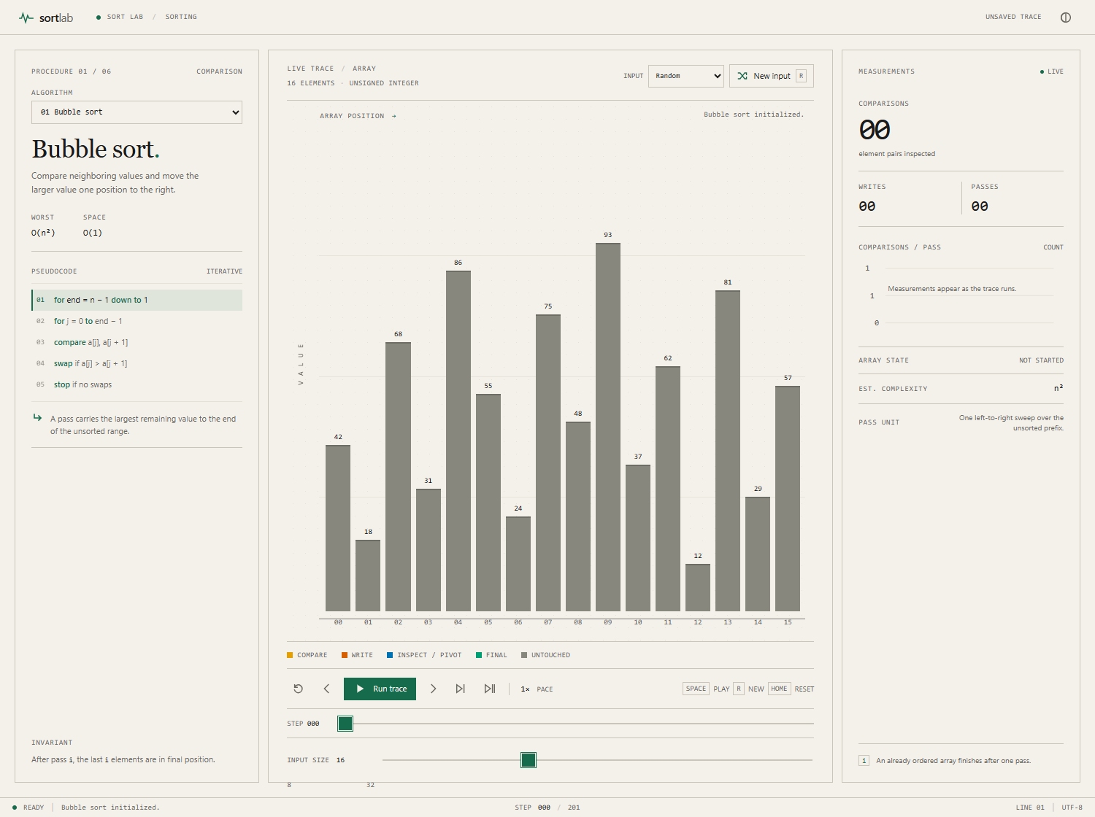
The procedure, live array, controls, metrics and status bar are visible together. Values are labeled above all bars.

A swap in progress
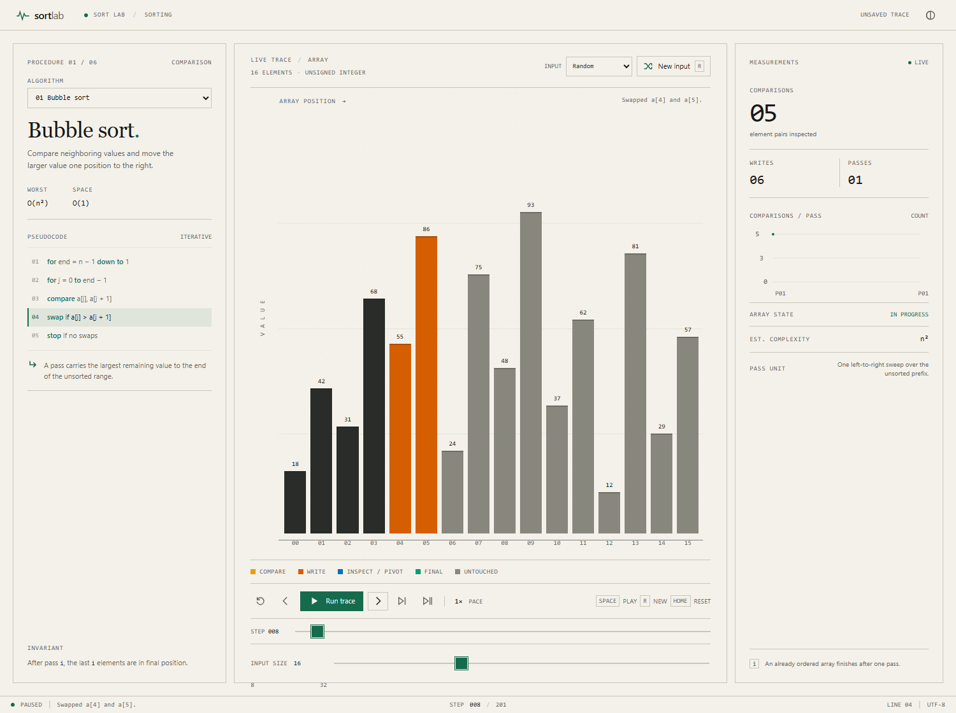
At step 008, the active values are highlighted, the pseudocode line is marked, and the event message and counters describe the swap.

Completed Bubble sort trace
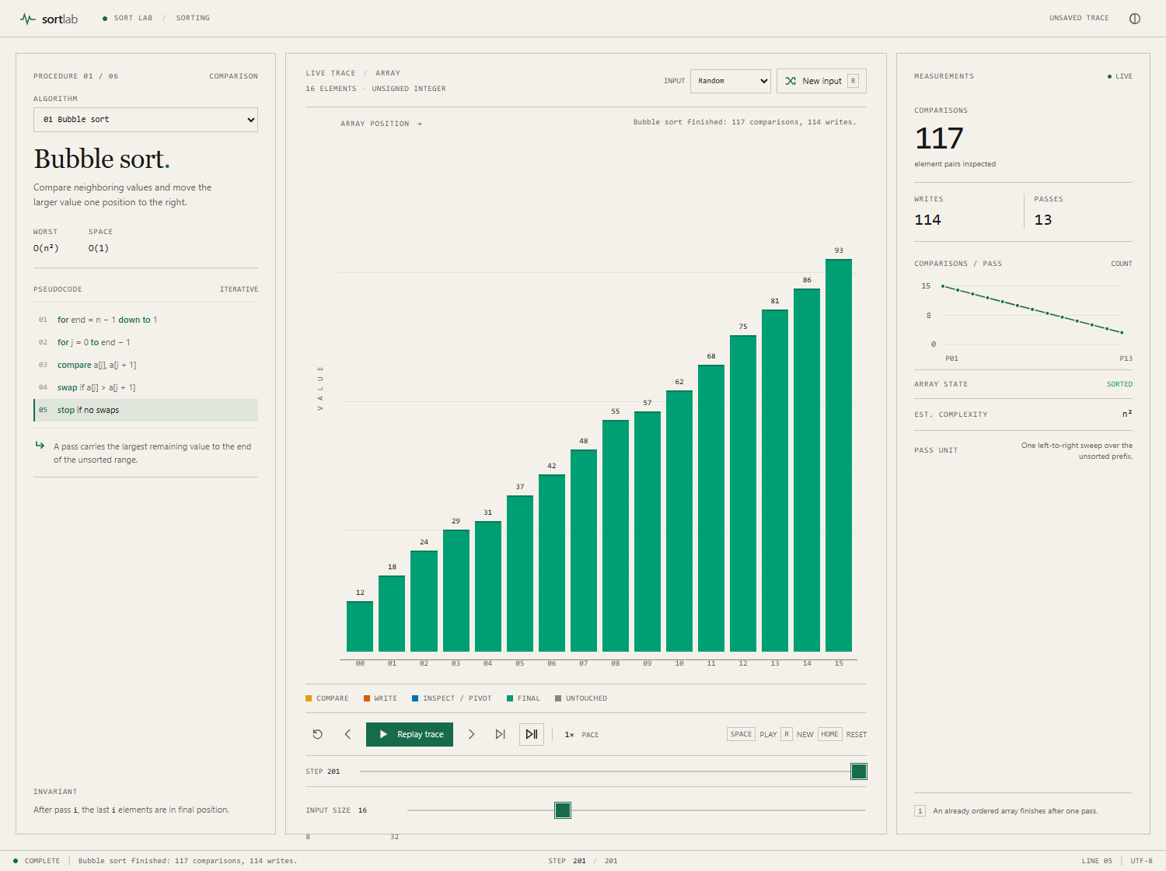
At step 201, all bars remain green, their values remain visible, and the measurements summarize the finished trace.

