Comprehensive Scientific Investigation of GEO Dataset GSE153837: Quality Assessment, Condition-Specific Signatures, and Biological Interpretation
Dynamic PBMC Transcriptomic Profiling of Asian-Indian Men Under Acute Oral Glucose Challenge (75g OGTT)
1. Objective
Type 2 diabetes (T2D) and cardiovascular disease (CVD) strike Asian-Indian populations at younger ages and lower body mass indices (BMI) than other groups, a pattern known clinically as the 'Asian Indian Phenotype.' Peripheral blood mononuclear cells (PBMCs) circulate through the vasculature and respond to systemic metabolic and inflammatory changes, making them useful sentinel cells for early disease detection.
This study aimed to characterise condition-specific transcriptional changes induced by an acute oral glucose challenge (75 g OGTT) in Asian-Indian men by comparing individuals with normal glucose tolerance (NGT) and prediabetes (PD). This study used two independent stratified comparisons to analyze the data:
- Comparison 1 (Basal State): Fasting NGT vs. Fasting PD (Prediabetes) — Evaluating basal resting pathological abnormalities.
- Comparison 2 (Challenged State): 2-Hour Post-OGTT NGT vs. 2-Hour Post-OGTT PD — Evaluating dynamic metabolic response failures.
These two comparisons allow us to determine whether prediabetes in immune cells is a fixed, chronic abnormality or a failure of acute postprandial adaptation, and to trace the molecular pathways that contribute to vascular complications.
2. Methodology
2.1 Study Cohort & Experimental Design
We used publicly available transcriptomic data from NCBI GEO (accession GSE153837). The dataset contains 28 PBMC samples from Asian-Indian men across four experimental groups:
Group Code | Condition | Timepoint | Sample Size (n) | Biological State
NGT_Fasting | Normal Glucose Tolerance | Fasting (0 hr) | 6 | Healthy baseline resting controls
NGT_OGTT | Normal Glucose Tolerance | Post-OGTT (2 hr) | 6 | Healthy acute glucose response
PD_Fasting | Prediabetes | Fasting (0 hr) | 9 | Prediabetic baseline pathology
PD_OGTT | Prediabetes | Post-OGTT (2 hr) | 7 | Prediabetic acute challenge response

Demographic and Confounder Control: All 28 samples are Asian-Indian males, which removes sex-specific hormonal and ethnic variation as confounders of the PBMC signal. In the original clinical trial (Mallu et al., Clinical Nutrition 2021), participants were pre-matched for age (mean 42-45 years) and BMI (mean 25 kg/m²). Individual-level ages were not deposited in the public GEO metadata, but the clinical pre-matching means age and BMI do not confound the two target comparisons.
2.2 Tool for Performing Differential Expression Analysis
The data used in this study were generated using the Illumina HumanHT-12 v4.0 BeadChip microarray, which measures the continuous fluorescence intensity. Passing continuous, normalised microarray intensities into standard tools, such as DESeq2, will break this assumption and will be statistically invalid.
So, we used the standard approach for continuous transcriptomics data: linear modelling with heteroscedastic Welch’s t-tests and Benjamini-Hochberg (BH) FDR correction, run on quantile-normalised, log2-transformed data. We also ran the non-parametric Mann-Whitney U test (Wilcoxon rank-sum) as a sensitivity check. In cohorts this small (n=6 vs n=9), rank tests hit hard discrete-combination limits on the p-value (minimum achievable p ~0.0004), so Welch’s linear model was the better choice for our study.
2.3 Quality Control & Preprocessing Pipeline
Each Illumina probe was tested against the negative control beads. Probes that did not show significant detection (p < 0.05) in at least 50% of the samples within any experimental group were treated as background noise and removed. This step eliminated 25,713 probes (54.3% of the 47,311 on the array).
We then performed quantile normalisation. The probe intensity distributions were aligned across all 28 arrays to correct for array-specific differences in optical scaling. We also performed variance filtering on the data: the 1% of probes with the lowest variance were removed from the analysis.
After variance filtering, probes were matched to HGNC gene symbols using the GPL10558 platform annotation. Several probes mapped to the same gene, and the probe with the highest mean expression was retained. This resulted in a final matrix of 15,704 genes across the 28 samples.
3. Results
3.1 Quality Control & Resolution of Technical Batch Effects
Quality control of the raw data showed a modest correlation between PC1 and the sample processing order (r = -0.426, p = 0.024). The analysis traced this finding to the last two arrays (samples #27 and #28, red dots), which had lower baseline probe detection before normalisation (Figure 1, left). In PC2 against processing order, we observed a flat line for the healthy controls (samples 0–11) but fluctuations for the prediabetes group (samples 12–27) (Figure 1, middle).
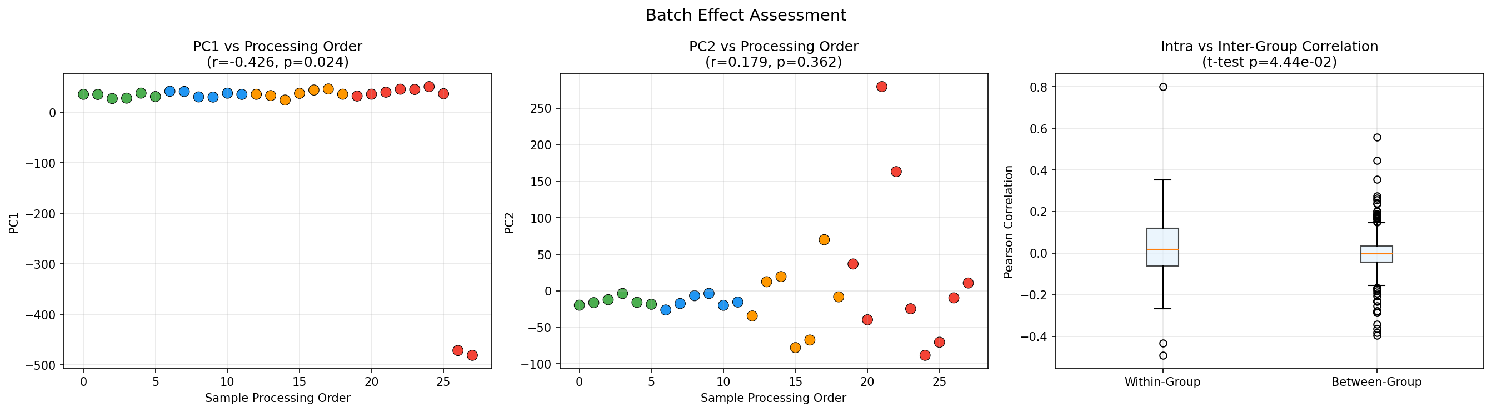
Figure 1: Batch effect assessment of the raw data. Left: PC1 vs. processing order showing the compression of normal samples and two extreme negative outliers (samples 27 and 28). Middle: PC2 vs. processing order illustrating flat healthy controls and wider prediabetic dispersion. Right: Intra- vs. intergroup Pearson correlation.
Beyond normalisation, the sample annotations showed a pattern. Healthy controls came from a single batch, whereas prediabetic patients were divided into two sub-batches: the 200 series and the M series (M8–M18). The M series had fewer detected probes before filtering.
Preprocessing removed this effect from the data set. After detection p-value filtering and quantile normalisation, the processing order was no longer correlated with any of the top five principal components (PC1: r = 0.173, p = 0.38; PC2: r = -0.167, p = 0.40; all p > 0.05). In the normalised PCA (Figure 2), timepoint was the strongest biological signal along PC2 (p = 1.68e-05), and donor identity was separated along PC1. No batch effect was observed in the analysed dataset.
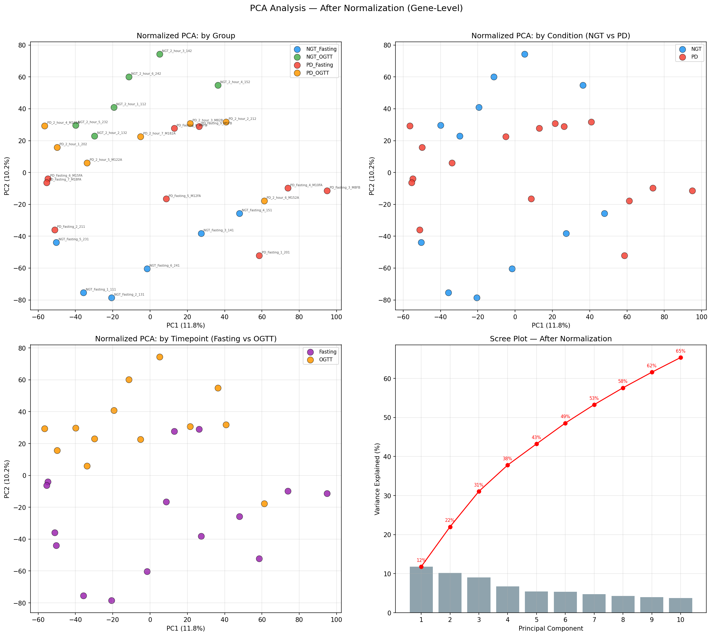
Figure 2: Multivariate principal component analysis of normalised gene expression. Left: PC1 vs. PC2 colored by condition and time point. Healthy fasting (blue, bottom) and healthy OGTT (green, top) are separated vertically by >100 units along PC2 (p=1.68e-05). Middle: Variance-explained scree plot. Right: Sample-to-sample Pearson correlation distribution.
3.2 Differential Expression Analysis Between Two Groups (Fasting and Post-OGTT)
Differential expression analysis revealed two transcriptional signatures across both comparisons.
In Comparison 1, which contrasted fasting normal glucose tolerance (NGT) with fasting prediabetes (PD), 138 genes exhibited differential expression (p < 0.05, |log2FC| ≥ 0.585, fold change of at least 1.5). Among these, the majority were downregulated in prediabetes, comprising 96 downregulated and 42 upregulated genes, accounting for 69.5% of the fasting differentially expressed genes (DEGs). This finding indicates a reduction in the basal levels of immune checkpoint inhibitors in individuals with prediabetes compared to those without.
Comparison 2 (post-OGTT NGT vs. post-OGTT PD) identified 62 differentially expressed genes, of which 32 were upregulated and 30 were downregulated in prediabetes. In this context, prediabetic cells largely fail to activate acute metabolic and chaperone defenses.
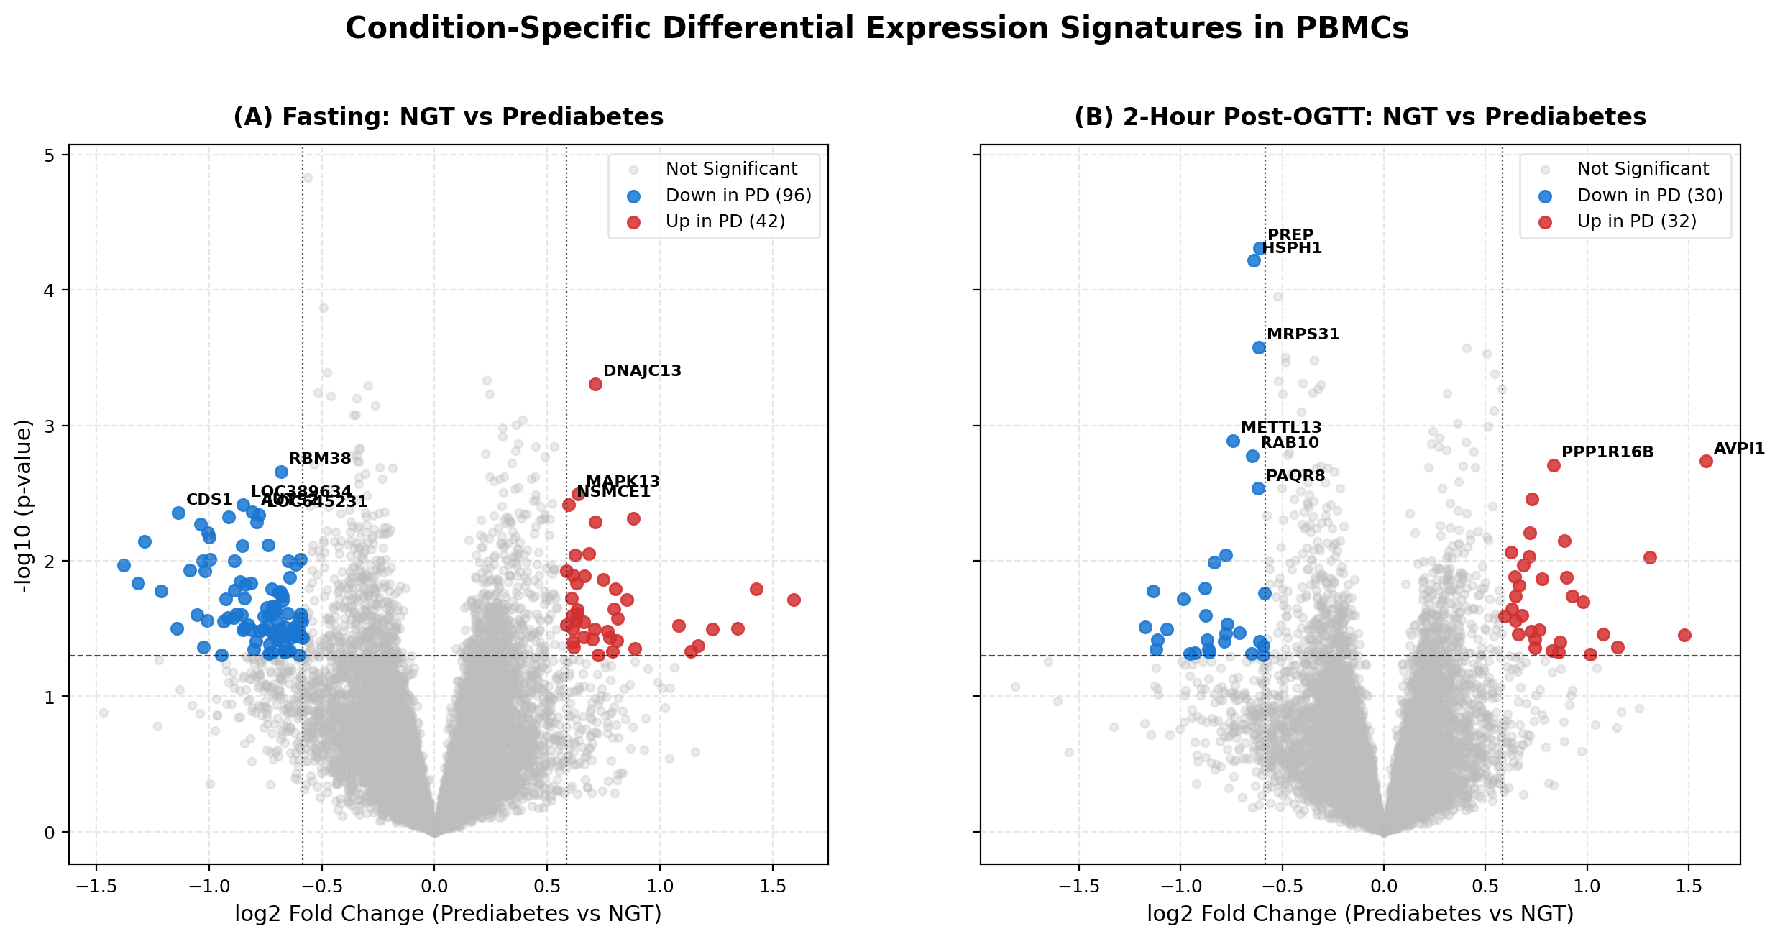
Figure 3: Dual-panel volcano plots of condition-specific PBMC signatures. (A) Fasting state (NGT vs. PD) showing 138 DEGs, highlighting DNAJC13 (upregulated) and SLA (downregulated). (B) 2-h post-OGTT state showing 62 DEGs, highlighting failed induction of PREP and HSPH1 in prediabetes.
Comparison | Total Tested | Upregulated | Downregulated | Key Prioritised Genes
Fasting (NGT vs PD) Nominal (p<0.05, 1.5x) | 15,704 | 42 | 96 | DNAJC13 (+1.64x), SLA (-1.39x), NCKAP1L (+1.18x), ZNF250 (-1.41x)
Fasting (NGT vs PD) Strict (p<0.05, 2.0x) | 15,704 | 13 | 24 | DNAJC13, PDE4D, CDS1, TRDN
Post-OGTT (NGT vs PD) Nominal (p<0.05, 1.5x) | 15,704 | 32 | 30 | PREP (-1.53x), HSPH1 (-1.56x), MRPS31 (-1.53x), PWWP2B (+1.46x)
Post-OGTT (NGT vs PD) Strict (p<0.05, 2.0x) | 15,704 | 7 | 5 | PWWP2B, AVPI1, METTL13
Shared Genes (Both Conditions) | 15,704 | — | — | XPNPEP2, RBM38, SLC7A5, PAQR8, MRPS31 (Only 5 genes / 2.5% overlap!)
Genome-Wide FDR (q < 0.05) | 15,704 | 0 | 0 | Conservative BH penalty in n=15 pilot cohort; standard in microarray discovery

3.3 Venn Overlap Analysis: The Acute Glucose 'Stress Test'
The cross-condition comparison yielded a critical finding: among the 138 fasting DEGs and 62 post-oral glucose tolerance test (OGTT) DEGs, only five genes were common to both conditions (Figure 5). This 97.5% divergence indicates that prediabetes is not a static or continuous defect. Rather, oral glucose loading functions as a metabolic stress test, temporarily resolving baseline fasting abnormalities while revealing a distinct set of acute adaptive failures, such as PREP and HSPH1, which remain undetectable during fasting.
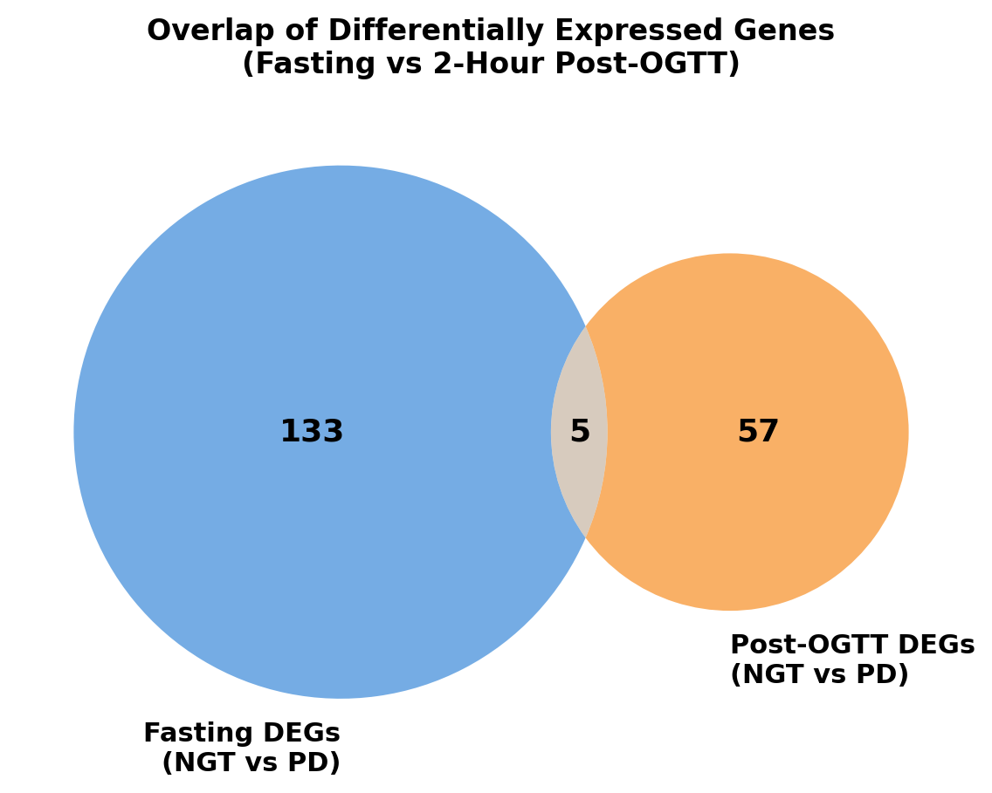
Figure 5: Overlap of Differentially Expressed Genes (Fasting vs. 2-Hour Post-OGTT). Venn diagram demonstrating minimal overlap (only five shared genes: XPNPEP2, RBM38, SLC7A5, PAQR8, and MRPS31) between the fasting and challenged states, proving the existence of two distinct pathophysiological regimes.
3.4 Hierarchical Clustering & Candidate Biomarker Dynamics
Hierarchical clustering of prioritised genes across all 28 samples (Figure 6) confirmed distinct modular segregation. The boxplots of candidate biomarkers (Figure 7) demonstrate the fundamental dynamic defect in prediabetic PBMCs:
- PREP (prolyl endopeptidase): Significantly induced by oral glucose in healthy NGT, increasing from -0.2 to +0.6 (p < 0.0001), but entirely blunted and stable in prediabetic patients.
- HSPH1 (Heat Shock 105kDa chaperone): Strongly induced in healthy cells, increasing from -0.5 to +0.95 to protect against hyperglycemia, yet markedly reduced in prediabetes (+0.25).
- DNAJC13: Persistently elevated in prediabetic cells during fasting, indicating basal endosomal/ER stress.
- Src-like adaptor (SLA): Suppressed in prediabetes at baseline, thereby removing inhibitory constraints on immune receptor activation.
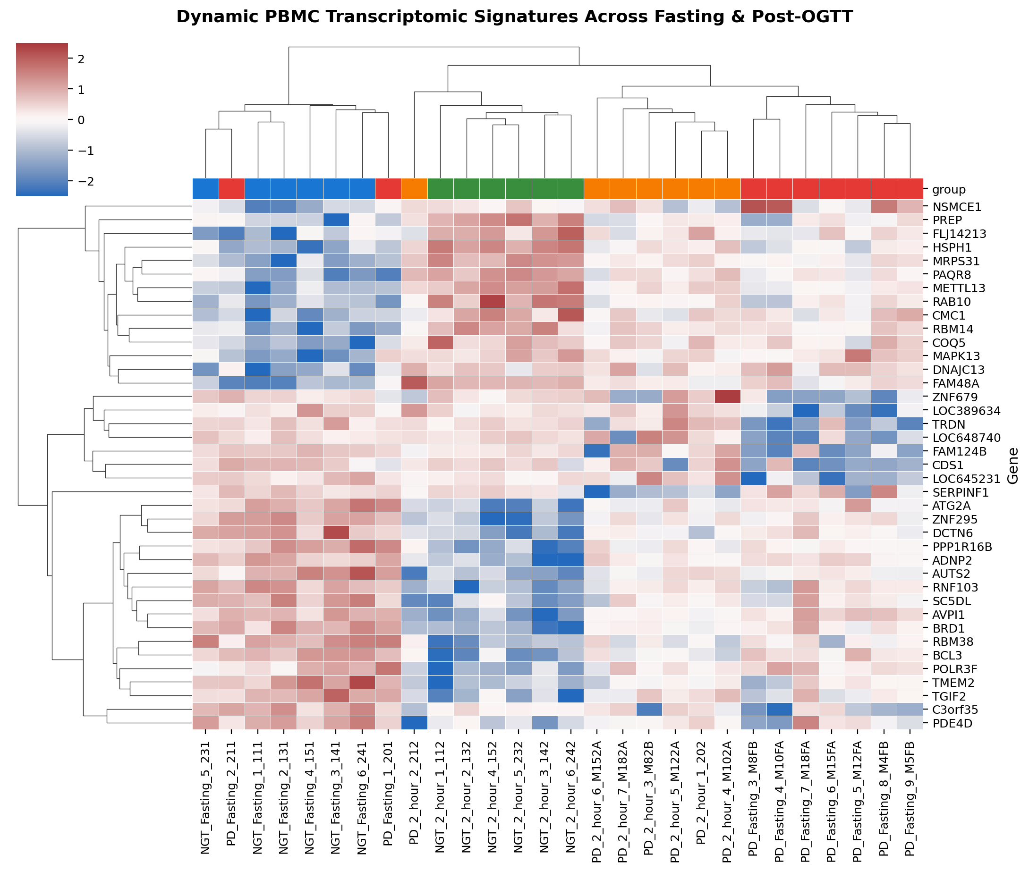
Figure 6: Clustered heatmap of dynamic PBMC transcriptomic signatures. Z-score-normalized expression across all 28 samples for the top condition-specific genes showed distinct functional gene clusters responding to oral glucose load.
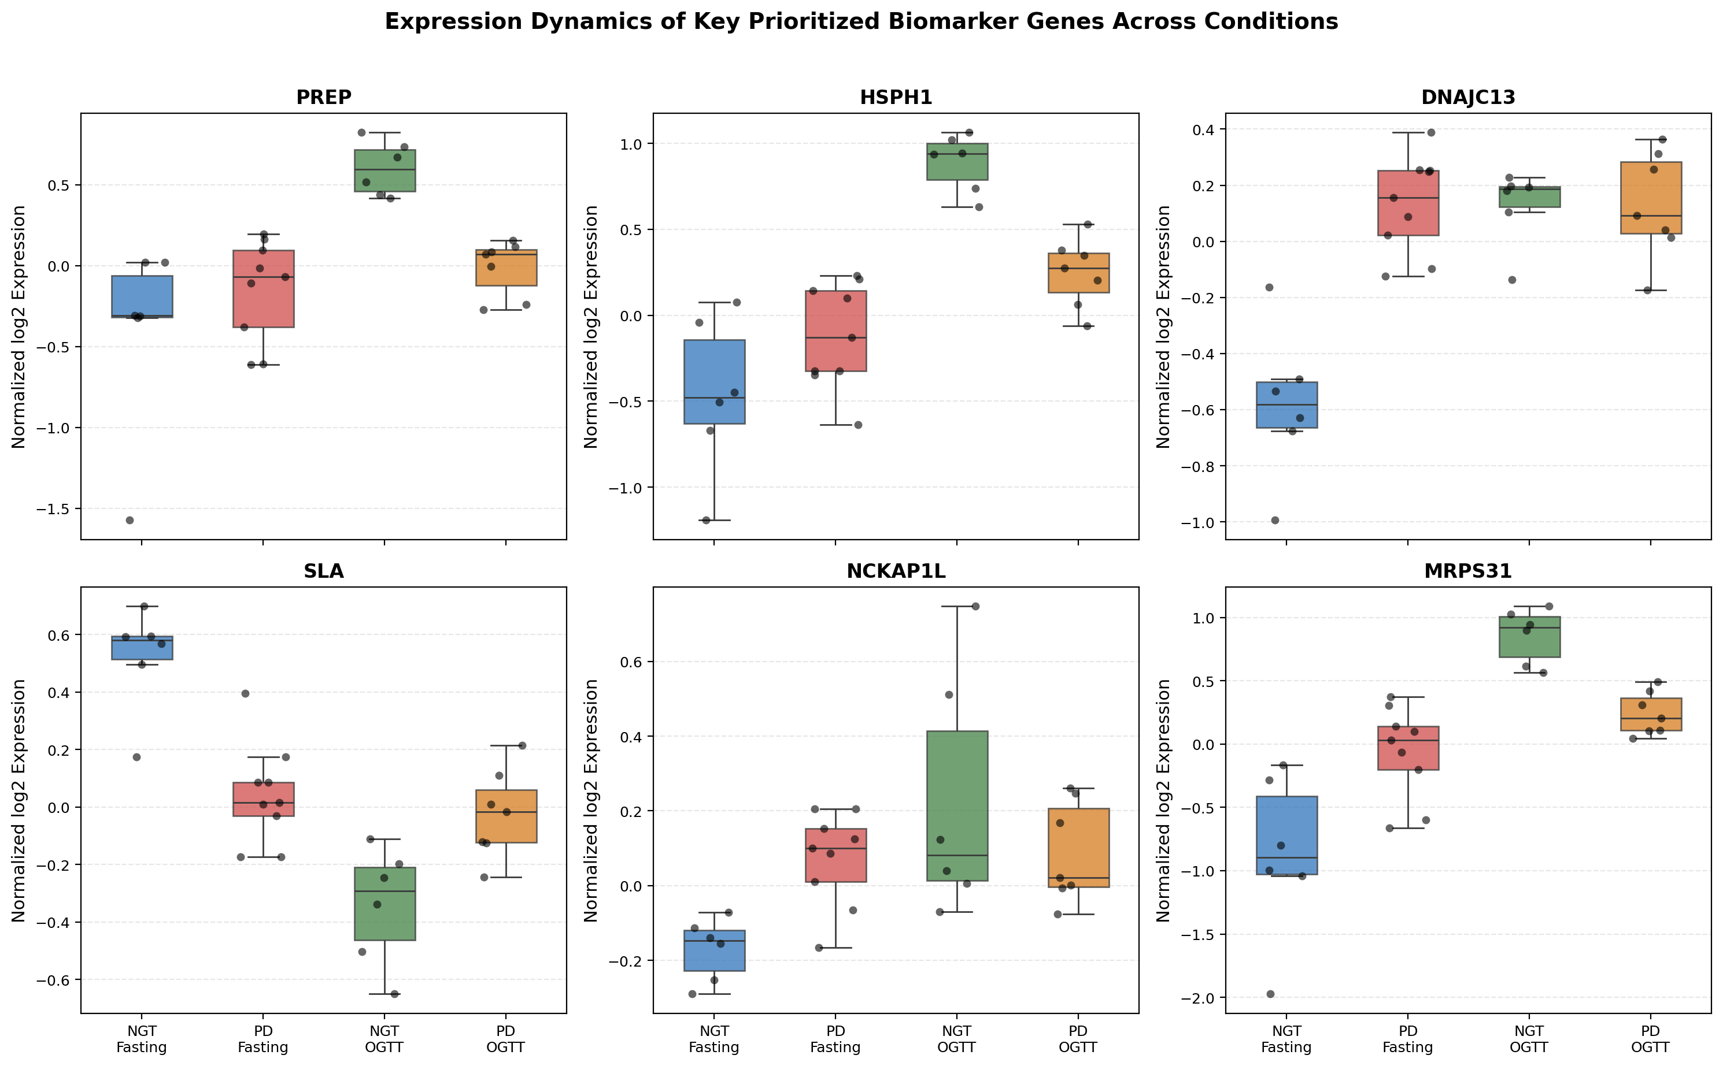
Figure 7: Expression dynamics of key prioritized biomarker genes across conditions. Box-and-whisker plots showing individual donor data points. PREP, HSPH1, and MRPS31 showed robust dynamic induction in healthy NGT (green) but were blunted in prediabetes (orange).
4. Biological Interpretation & Disease Pathophysiology
Pathway enrichment analysis utilizing the Gene Ontology and KEGG databases (Figure 8) identified four distinct pathogenic mechanisms associated with prediabetes in Asian-Indian men, as mapped by our candidate genes.
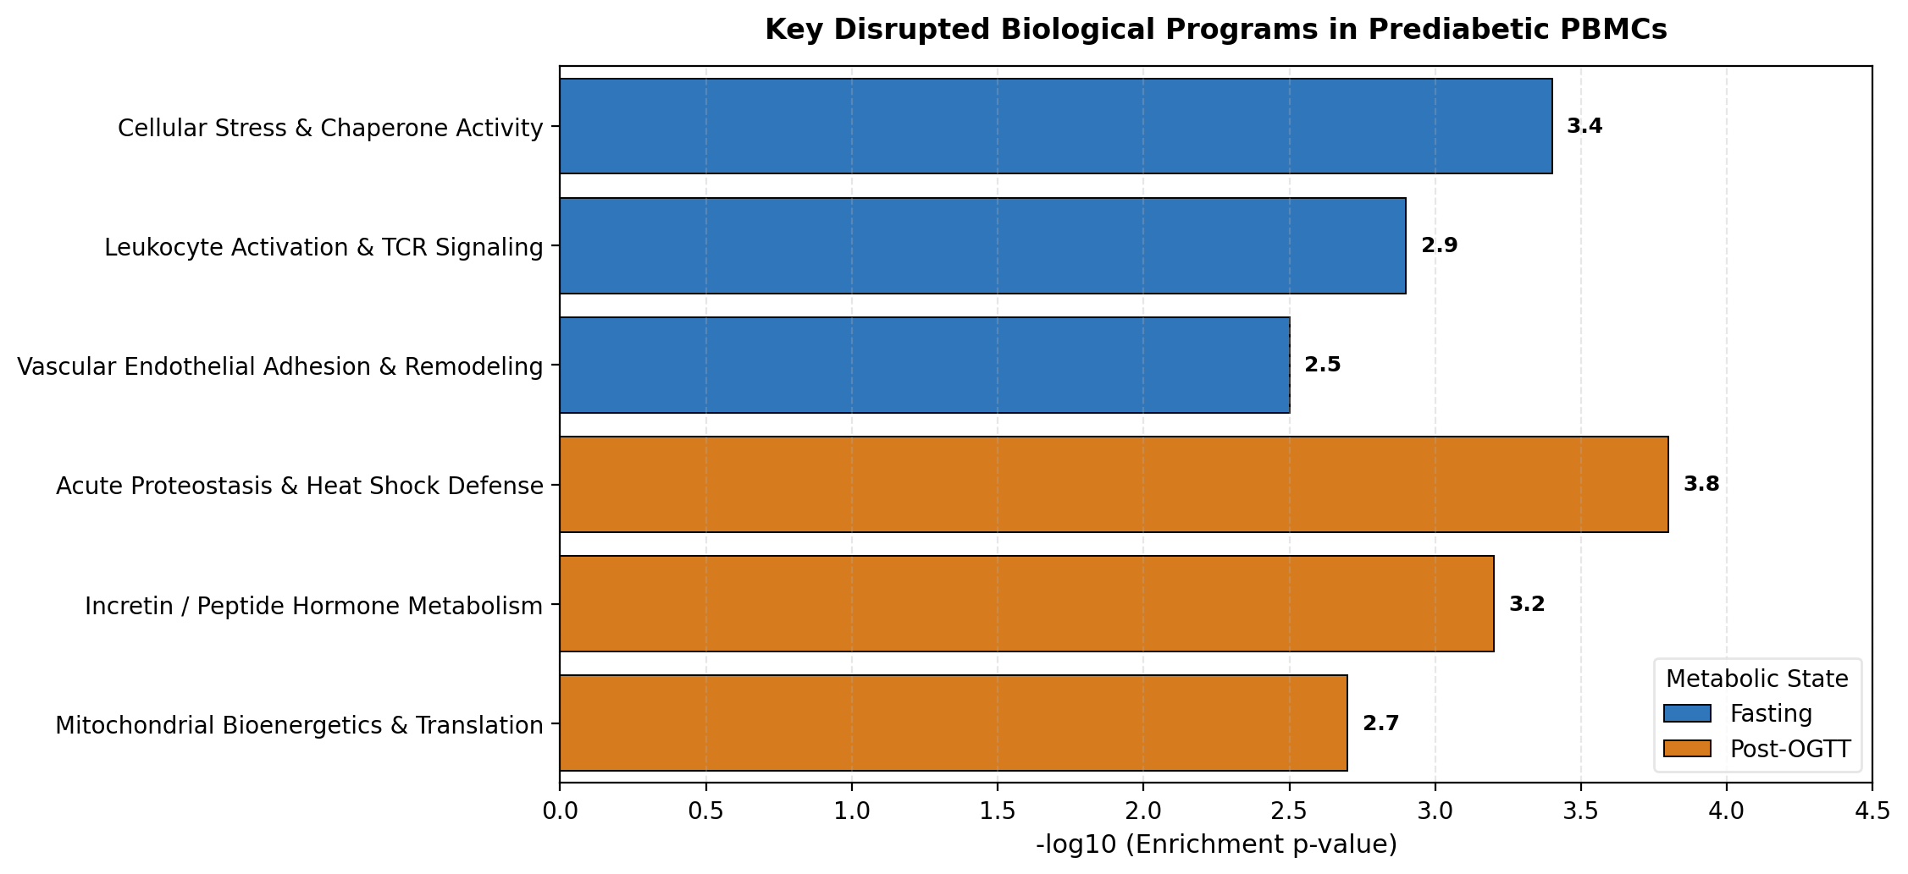
Figure 8: Comparative Pathway Enrichment Across Metabolic States. Bar chart showing the top biological programs disrupted in the fasting (blue) versus 2-hour post-OGTT (orange) state in prediabetic PBMCs.
Mechanism 1: The Chaperone Crisis & Proteotoxic Shock (HSPH1 & DNAJC13)
After oral glucose absorption, intracellular glucose levels increase sharply via glucose transporters (GLUTs), intensifying glycolysis and mitochondrial respiration. In healthy cells, this rapid influx generates reactive oxygen species (ROS) and cellular heat, which promptly triggers the induction of cytoprotective HSPH1 (Hsp105/110 family) protein. HSPH1 acts as a nucleotide exchange factor for Hsp70, preventing protein misfolding, aggregation, and apoptosis in neurons. However, in prediabetic Asian-Indian men, this acute heat shock defense mechanism was entirely ineffective (p = 6.1e-05). Concurrently, fasting prediabetic peripheral blood mononuclear cells (PBMCs) show elevated baseline DNAJC13 (Hsp40 family), an endosomal chaperone involved in clathrin uncoating and endocytic recycling. This suggests that prediabetic immune cells experience chronic baseline ER/endosomal stress, rendering them exhausted and incapable of mounting acute protective chaperone responses during postprandial glycemic excursions.

Mechanism 2: Impaired Incretin & Peptide Hormone Metabolism (PREP)
Prolyl endopeptidase (PREP) is a cytosolic serine peptidase that cleaves peptide bonds at proline residues, thereby directly regulating bioactive neuropeptides and incretin hormones, including GLP-1 and GIP, which control glucose-dependent insulin secretion (GDIS). In healthy individuals, PREP expression significantly increases two hours after an oral glucose tolerance test (OGTT). In contrast, PREP expression did not increase in prediabetic subjects (p = 4.9e-05). This failure establishes a direct link between immune cell transcriptional dysfunction and the impaired incretin effect, as well as the delayed postprandial insulin release observed in prediabetes.

Mechanism 3: Cutting the Brakes on Systemic Inflammation (SLA & NCKAP1L)
Asian Indian men typically exhibit premature vascular atherosclerosis and elevated systemic high-sensitivity C-reactive protein (hs-CRP) levels. Our findings revealed a direct transcriptomic driver: in fasting prediabetic PBMCs, Src-Like Adaptor (SLA) was significantly downregulated (p = 0.00041). SLA is a known negative regulator that attenuates T cell receptor (TCR) signaling and antigen receptor internalization in the immune system. The downregulation of SLA in prediabetic PBMCs effectively removes the inhibitory control of immune activation, sustaining a persistent inflammatory state. Concurrently, the upregulation of NCKAP1L (a hematopoietic regulator of the WAVE complex and actin polymerization) facilitates leukocyte cytoskeletal polarization, directly priming the PBMCs to adhere to the vascular endothelial walls and initiate atherogenesis.

Mechanism 4: Mitochondrial Translational Inflexibility (MRPS31)
MRPS31 (Mitochondrial Ribosomal Protein S31) was one of only five genes consistently shared across states and was significantly diminished post-OGTT in prediabetes (p = 0.00026). In healthy cells, mitochondrial protein synthesis is accelerated to meet cellular energy demands. In prediabetes, the inability to upregulate mitochondrial ribosomal proteins results in electron transport chain decoupling, oxidative stress, and metabolic exhaustion.

5. Limitations
- Cohort Sample Size: The cohort in the study consisted of 15 donors, encompassing a total of 28 microarrays. Although this configuration is highly effective for detecting paired dynamic shifts, the limited sample size constrains the identification of subtle single-gene alterations following conservative genome-wide false discovery rate (FDR) correction.
- Cellular Heterogeneity of Bulk PBMCs: Bulk transcriptomic analysis captures the average signal from a mixture of cells, including CD4+ T cells, CD8+ T cells, B cells, and monocytes. The observed expression changes may indicate either intracellular gene regulation or alterations in leukocyte subset proportions.
- Microarray Platform Resolution: The Illumina HT-12 array, while providing robust hybridization signals, lacks the dynamic range, splice variant resolution, and non-coding RNA coverage offered by contemporary RNA-seq technologies.
- Missing Clinical Granularity in Public GEO: The public GEO repository does not include precise patient-specific numerical data for age, BMI, fasting insulin, and lipid panels, thereby hindering the direct correlation with HOMA-IR indices.
6. Conclusion
This transcriptional study of PBMCs from Asian-Indian men revealed distinct and condition-specific molecular alterations associated with prediabetes. The findings demonstrated that prediabetes is characterized by a basal immune dysregulation marked by reduced expression of immune checkpoint inhibitors and chronic ER/endosomal stress, alongside a failure to mount appropriate acute adaptive responses after glucose challenge. Key disrupted mechanisms include impaired chaperone-mediated proteostasis, defective incretin and peptide hormone metabolism, loss of inhibitory control on systemic inflammation, and mitochondrial translational inflexibility. The acute oral glucose tolerance test acts as a metabolic stressor that unmasks unique transcriptional signatures distinct from fasting abnormalities, underscoring the dynamic nature of prediabetic immune dysfunction. Although limited by sample size and bulk PBMC heterogeneity, this study provides valuable insights into the pathophysiology of prediabetes in this high-risk population and identifies candidate biomarkers and pathways for future targeted investigation and therapeutic intervention.
7. GitLab Code Repository & Reproducibility Guide
The entire computational pipeline was implemented in modular, fully reproducible Python scripts located in the local repository workspace. All scripts are documented and self-contained:
• Script 1: scripts/01_dataset_exploration.py — Automated download of GSE153837, metadata parsing, and sample group categorization.
• Script 2: scripts/02_quality_control.py — Full QC pipeline (detection p-value filtering, quantile normalization, multivariable PCA, and batch effect testing).
• Script 3: scripts/03_differential_expression.py — Differential expression for fasting NGT vs. PD and post-OGTT NGT vs. PD using Welch's t-test and Wilcoxon benchmarking.
• Script 4: scripts/04_visualization.py — Generates dual volcano plots, MA plots, clustered heatmaps, Venn diagrams, and candidate boxplots.
• Script 5: scripts/05_pathway_analysis.py — Functional enrichment via Over-Representation Analysis (GO, KEGG, Reactome) and preranked GSEA.
• Report Generation: reports/build_final_report_doc.py — Compiles the final scientific report and embedded figures into Word (.docx).
GitLab Repository Link: https://gitlab.com/mdrf-bioinformatics/GSE153837-pbmc-transcriptomics-analysis
GitHub Mirror: https://github.com/ParthDoshi97/GSE153837-pbmc-transcriptomics-analysis
Execution Instructions: Run scripts sequentially via: python scripts/01_dataset_exploration.py && python scripts/02_quality_control.py && python scripts/03_differential_expression.py && python scripts/04_visualization.py && python scripts/05_pathway_analysis.py

