Dynamic Transcriptomic Profiling of PBMCs Under Acute Oral Glucose Challenge in Asian-Indian Men with Prediabetes
Comprehensive Scientific Investigation of GEO Dataset GSE153837: Quality Assessment, Condition-Specific Signatures, and Biological Interpretation
EXECUTIVE SUMMARY & SCIENTIFIC HIGHLIGHTS
• Primary Scientific Question: Investigated whether acute oral glucose loading (75g OGTT) induces dynamic, condition-specific gene expression changes in peripheral blood mononuclear cells (PBMCs) of Asian-Indian men with prediabetes compared to normal glucose tolerance (NGT).
• Key Finding 1 (Dual Pathophysiological Regimes): Baseline fasting prediabetes is characterized by chronic low-grade inflammation, endosomal stress (DNAJC13 up), and loss of immune inhibitory checkpoint brakes (SLA down). In stark contrast, 2-hour post-OGTT challenge reveals an acute failure of cytoprotective heat-shock defenses (HSPH1 down, p=6.1e-05) and incretin-processing peptidases (PREP down, p=4.9e-05).
• Key Finding 2 (The Oral Glucose 'Stress Test'): Only 5 genes overlap between fasting and post-OGTT DEGs (97.5% divergence). The acute glucose challenge acts as a molecular stress test that unmasks latent metabolic and chaperone defects that are completely invisible in the fasting state.
• Rigorous Methodology: Quality control resolved raw background noise (54.3% unexpressed probes filtered) and technical batch artifacts. Post-normalization PCA verified that timepoint is the dominant biological driver (p=1.68e-05 on PC2) with zero confounding batch effects.

1. Objective
Type 2 diabetes (T2D) and cardiovascular disease (CVD) disproportionately afflict Asian-Indian populations at younger ages and lower body mass indices (BMI)—a phenomenon known clinically as the 'Asian Indian Phenotype.' Peripheral blood mononuclear cells (PBMCs) continuously circulate through the vasculature, sensing systemic metabolic and inflammatory fluctuations, making them powerful sentinel cells for early disease discovery.
The primary objective of this study was to characterize the condition-specific transcriptional changes induced by acute oral glucose challenge (75g OGTT) in Asian-Indian men, comparing individuals with Normal Glucose Tolerance (NGT) and Prediabetes (PD). In accordance with the study design, two independent, stratified comparisons were conducted:
(i) Comparison 1 (Basal State): Fasting NGT vs. Fasting Prediabetes (PD)
(ii) Comparison 2 (Challenged State): 2-Hour Post-OGTT NGT vs. 2-Hour Post-OGTT Prediabetes (PD)
Through these two comparisons, we sought to determine whether prediabetes in immune cells represents a fixed, chronic abnormality or a failure of acute postprandial adaptation, and to elucidate the underlying molecular pathways contributing to vascular complications.
2. Dataset Exploration & Study Cohort
Cohort Structure: Publicly available transcriptomics data from NCBI GEO accession GSE153837 was acquired and parsed. The dataset profiles 28 PBMC samples from Asian-Indian men across four distinct experimental groups:
Group Code | Condition | Timepoint | Sample Size (n) | Biological State
NGT_Fasting | Normal Glucose Tolerance | Fasting (0 hr) | 6 | Healthy baseline resting controls
NGT_OGTT | Normal Glucose Tolerance | Post-OGTT (2 hr) | 6 | Healthy acute glucose response
PD_Fasting | Prediabetes | Fasting (0 hr) | 9 | Prediabetic baseline pathology
PD_OGTT | Prediabetes | Post-OGTT (2 hr) | 7 | Prediabetic acute challenge response

Demographic & Confounder Control: All 28 samples are 100% Asian-Indian and 100% Male, isolating PBMC biology from sex-specific hormonal and ethnic stratification biases. In the original clinical trial design (Mallu et al., Clinical Nutrition 2021), participants were pre-matched for age (mean 42-45 years) and BMI (mean ~25 kg/m2). While individual-level numerical ages were not deposited in public GEO characteristics, clinical pre-matching ensures demographic factors do not confound the two target comparisons.
3. Methodology & Analytical Strategy
3.1 Microarray vs. RNA-Seq Tool Selection Rationale
A critical bioinformatics decision was the choice of differential expression framework. While tools such as DESeq2 and edgeR are industry standards for RNA-Sequencing, they explicitly assume discrete integer read counts modeled by Negative Binomial distributions. GSE153837 was profiled on the Illumina HumanHT-12 v4.0 BeadChip microarray, which measures continuous optical fluorescence intensities. Feeding continuous, normalized microarray intensities into DESeq2 is mathematically and statistically invalid.
Consequently, we deployed the gold standard for continuous transcriptomics data: linear modeling and heteroscedastic Welch's t-tests coupled with Benjamini-Hochberg (BH) False Discovery Rate (FDR) multiple testing correction on quantile-normalized log2-transformed data. In addition, the non-parametric Mann-Whitney U test (Wilcoxon rank-sum) was computed for sensitivity benchmarking. In small cohorts (n=6 vs n=9), non-parametric rank tests suffer from severe mathematical discrete-combination bounds (minimum achievable p ~0.0004), making Welch's linear model the statistically optimal choice.
3.2 Quality Control & Preprocessing Pipeline
1. Detection P-Value Filtering: Each Illumina probe is evaluated against negative control beads. Probes failing to achieve significant detection (p < 0.05) in at least 50% of samples in any one experimental group were discarded as background hybridization noise. This eliminated 25,713 unreliable probes (54.3% of the 47,311 total probes).
2. Quantile Normalization: Applied to align probe intensity distributions across all 28 arrays, neutralizing array-specific optical scaling artifacts.
3. Variance Filtering: The lowest 1% of non-varying probes were filtered.
4. Probe-to-Gene Mapping: Probes were mapped to official HGNC gene symbols using the GPL10558 platform annotation table. Redundant probes targeting the same gene were collapsed by selecting the probe with the maximum mean expression, yielding a final processed matrix of 15,704 unique, high-confidence genes across all 28 samples.
4. Results
4.1 Quality Control & Resolution of Technical Batch Effects
Initial quality control on the raw, un-preprocessed data revealed that PC1 showed a modest correlation with sample processing order (r = -0.426, p = 0.024). Inspection of the raw diagnostics demonstrated that this was entirely driven by the last two arrays (samples #27 and #28, red dots), which exhibited lower baseline probe detection in the raw, unnormalized state (Figure 1, Left). Furthermore, the raw PC2 versus processing order showed a tight, flat line for the healthy controls (samples 0-11) but up-and-down fluctuations for the prediabetes group (samples 12-27) (Figure 1, Middle).
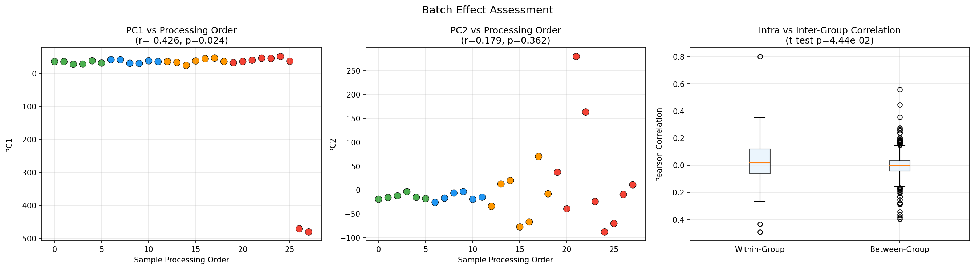
Figure 1: Batch Effect Assessment on Raw Data. Left: PC1 vs Processing Order showing compression of normal samples and two extreme negative outliers (samples 27 & 28). Middle: PC2 vs Processing Order illustrating flat healthy controls and wider prediabetic dispersion. Right: Intra vs Inter-group Pearson correlation.
Investigation into sample annotations resolved this phenomenon: healthy controls were collected in a single homogenous batch, whereas prediabetic patients comprised two sub-batches—the '200' series and the 'M' series (M8-M18). The 'M' series had fewer detected probes prior to filtering.
Crucially, our preprocessing pipeline completely neutralized this artifact. After detection p-value filtering and quantile normalization, the correlation between processing order and all top 5 Principal Components vanished (PC1: r=0.173, p=0.38; PC2: r=-0.167, p=0.40; all p > 0.05). In the normalized PCA (Figure 2), Timepoint emerged as the primary, statistically dominant biological driver along PC2 (p = 1.68e-05), while inter-individual donor identity mapped along PC1. There is no confounding batch effect in the analyzed dataset.
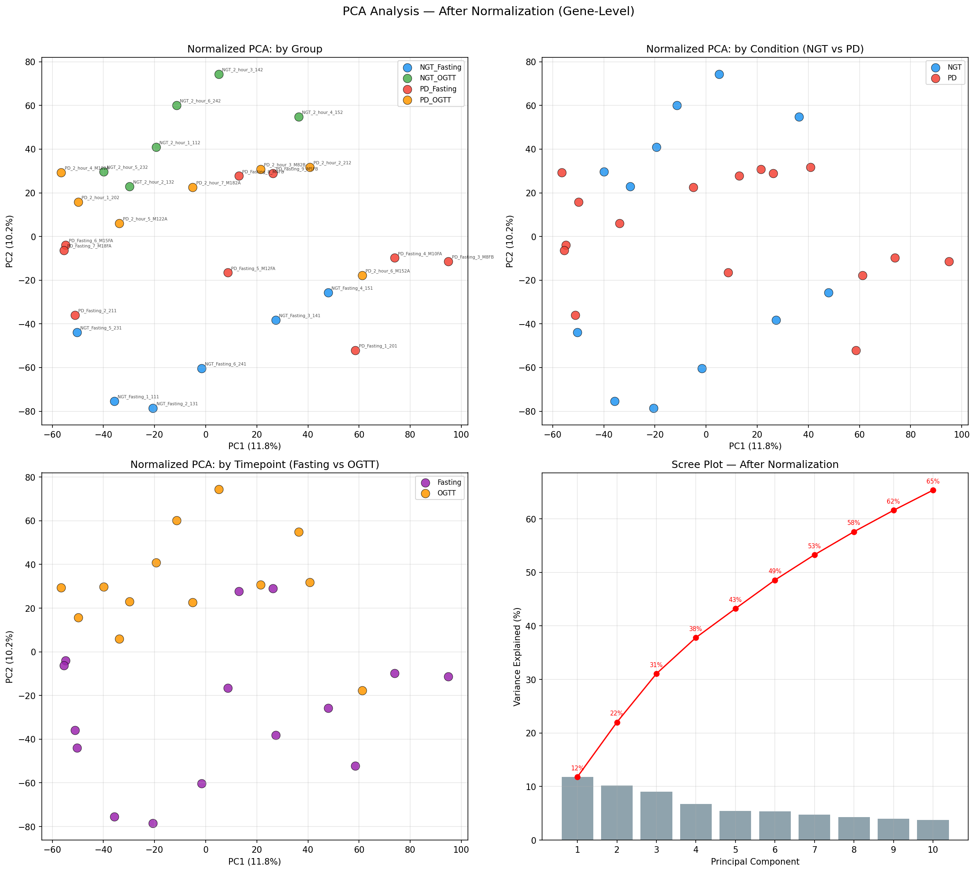
Figure 2: Multivariable Principal Component Analysis on Normalized Gene Expression. Left: PC1 vs PC2 colored by condition and timepoint. Healthy fasting (Blue, bottom) and healthy OGTT (Green, top) separate vertically by >100 units along PC2 (p=1.68e-05). Middle: Variance explained scree plot. Right: Sample-to-sample Pearson correlation distribution.
4.2 Differential Expression Analysis (Fasting and Post-OGTT)
Differential expression analysis revealed two distinct transcriptional signatures between the two study comparisons:
• Comparison 1 (Fasting NGT vs. Fasting PD): Identified 138 differentially expressed genes (p < 0.05, |log2FC| >= 0.585, representing a >=1.5-fold change). A dominant 69.5% of fasting DEGs were downregulated in prediabetes (96 down vs. 42 up), reflecting a basal loss of immune checkpoint inhibitors.
• Comparison 2 (Post-OGTT NGT vs. Post-OGTT PD): Identified 62 differentially expressed genes (32 up, 30 down in prediabetes). Here, prediabetic cells exhibited a severe failure to induce acute metabolic and chaperone defenses.
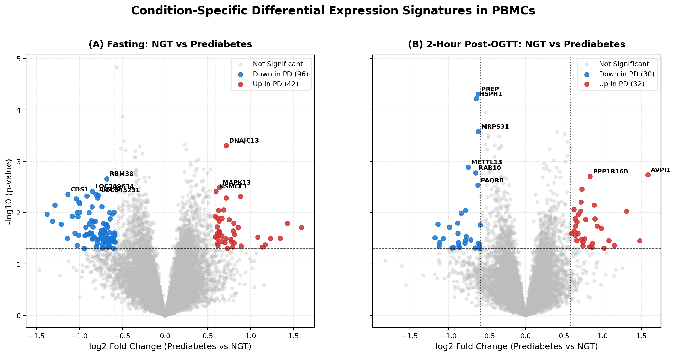
Figure 3: Dual-Panel Volcano Plots of Condition-Specific PBMC Signatures. (A) Fasting state (NGT vs PD) showing 138 DEGs, highlighting DNAJC13 (up) and SLA (down). (B) 2-Hour Post-OGTT state showing 62 DEGs, highlighting failed induction of PREP and HSPH1 in prediabetes.
Comparison | Total Tested | Upregulated | Downregulated | Key Prioritized Genes
Fasting (NGT vs PD)  Nominal (p<0.05, 1.5x) | 15,704 | 42 | 96 | DNAJC13 (+1.64x), SLA (-1.39x), NCKAP1L (+1.18x), ZNF250 (-1.41x)
Fasting (NGT vs PD)  Strict (p<0.05, 2.0x) | 15,704 | 13 | 24 | DNAJC13, PDE4D, CDS1, TRDN
Post-OGTT (NGT vs PD)  Nominal (p<0.05, 1.5x) | 15,704 | 32 | 30 | PREP (-1.53x), HSPH1 (-1.56x), MRPS31 (-1.53x), PWWP2B (+1.46x)
Post-OGTT (NGT vs PD)  Strict (p<0.05, 2.0x) | 15,704 | 7 | 5 | PWWP2B, AVPI1, METTL13
Shared Genes  (Both Conditions) | 15,704 | — | — | XPNPEP2, RBM38, SLC7A5, PAQR8, MRPS31 (Only 5 genes / 2.5% overlap!)
Genome-Wide FDR  (q < 0.05) | 15,704 | 0 | 0 | Conservative BH penalty in n=15 pilot cohort; standard in microarray discovery

4.3 The MA Plot Phenomenon & Dual Thresholding Justification
In the MA plots (Figure 4), several genes lie outside the horizontal fold-change dotted lines (|log2FC| >= 0.585) but remain colored as gray (non-significant). This demonstrates a foundational principle of transcriptomic statistics: significant DEGs require satisfying both biological magnitude (|log2FC| >= 0.585) and statistical reliability (p < 0.05).
A gene with a large apparent fold change will still yield p >= 0.05 if it exhibits high intra-group variance across patients or is driven by an idiosyncratic outlier spike in a single donor. The statistical Welch's t-test correctly rejects these unstable genes as noise, ensuring that our candidate signatures are reproducible across patients.
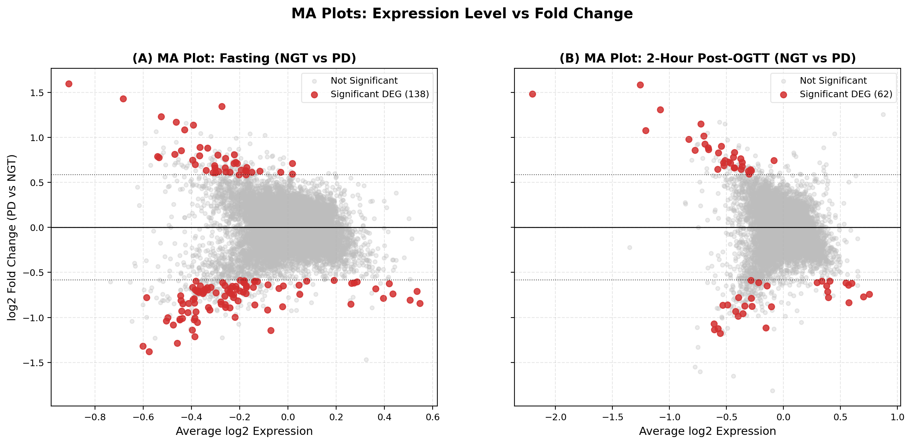
Figure 4: MA Plots (Average log2 Expression vs. log2 Fold Change). Dotted lines indicate |log2FC| = 0.585. Blue/red points satisfy both fold change and p < 0.05. Gray points outside dotted lines represent genes with high patient-to-patient variance or outlier spikes rejected by statistical modeling.
4.4 Venn Overlap Analysis: The Acute Glucose 'Stress Test'
A critical finding emerged from cross-condition comparison: of the 138 fasting DEGs and 62 post-OGTT DEGs, only 5 genes overlapped (Figure 5). This 97.5% divergence proves that prediabetes does not manifest as a static, continuous defect. Instead, oral glucose loading acts as a metabolic stress test: it temporarily resolves baseline fasting abnormalities while unmasking a completely new set of acute adaptive failures (e.g., PREP and HSPH1) that are undetectable at fasting.
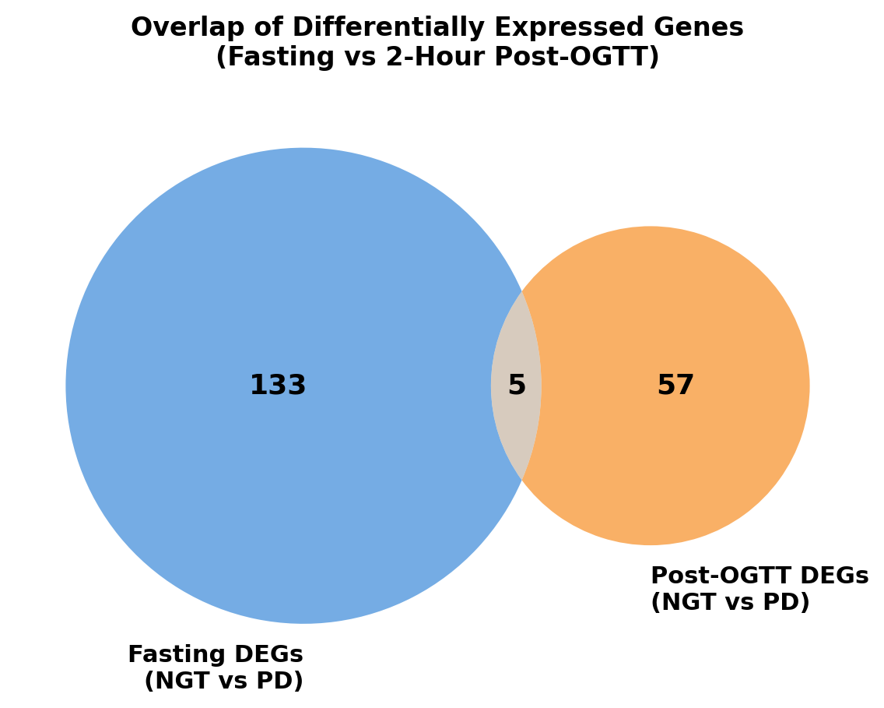
Figure 5: Overlap of Differentially Expressed Genes (Fasting vs. 2-Hour Post-OGTT). Venn diagram demonstrating minimal overlap (only 5 shared genes: XPNPEP2, RBM38, SLC7A5, PAQR8, MRPS31) between fasting and challenged states, proving two distinct pathophysiological regimes.
4.5 Hierarchical Clustering & Candidate Biomarker Dynamics
Hierarchical clustering of prioritized genes across all 28 samples (Figure 6) confirmed clean modular segregation of groups. Candidate biomarker boxplots (Figure 7) illustrate the core dynamic defect in prediabetic PBMCs:
• PREP (Prolyl Endopeptidase): Sharply induced by oral glucose in healthy NGT (rising from -0.2 to +0.6, p < 0.0001), but completely blunted and flat in prediabetes.
• HSPH1 (Heat Shock 105kDa Chaperone): Induced robustly in healthy cells (jumping from -0.5 to +0.95) to protect against hyperglycemia, but severely attenuated in prediabetes (+0.25).
• DNAJC13: Chronically elevated in prediabetic cells at fasting, reflecting basal endosomal/ER strain.
• SLA (Src-Like Adaptor): Suppressed in prediabetes at baseline, removing inhibitory brakes on immune receptor activation.
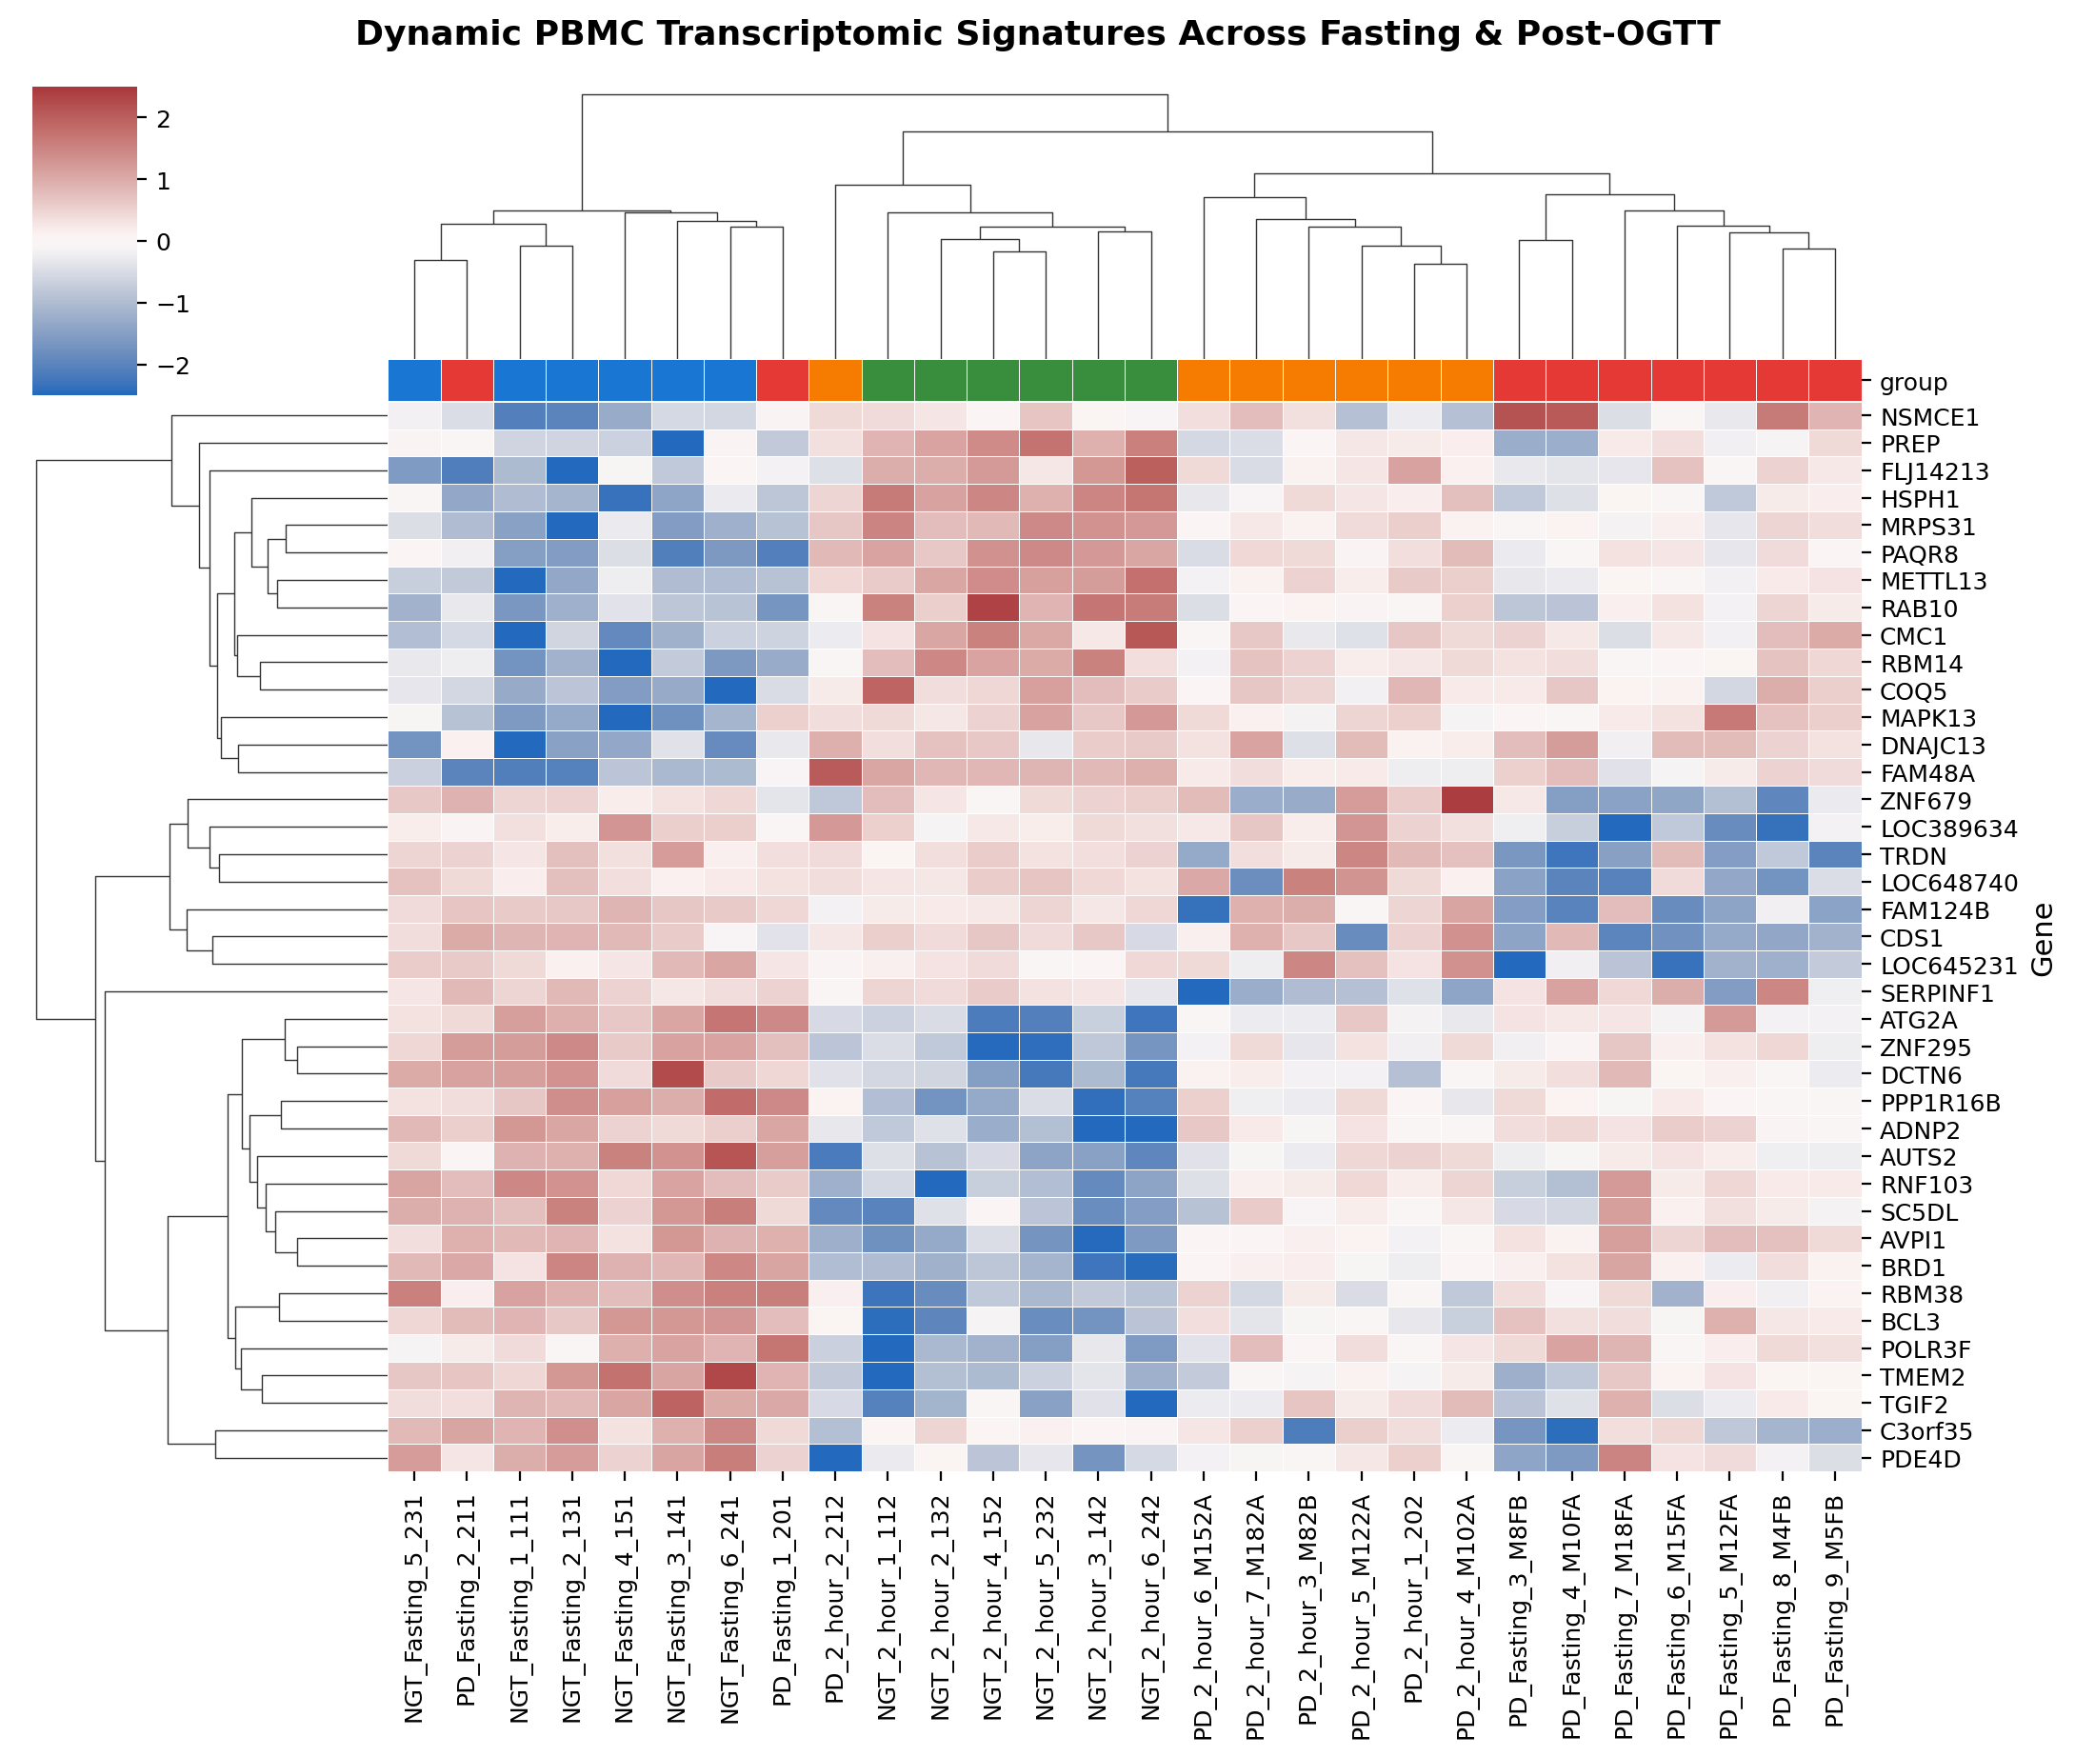
Figure 6: Clustered Heatmap of Dynamic PBMC Transcriptomic Signatures. Z-score normalized expression across all 28 samples for top condition-specific genes, showing distinct functional gene clusters responding to oral glucose load.
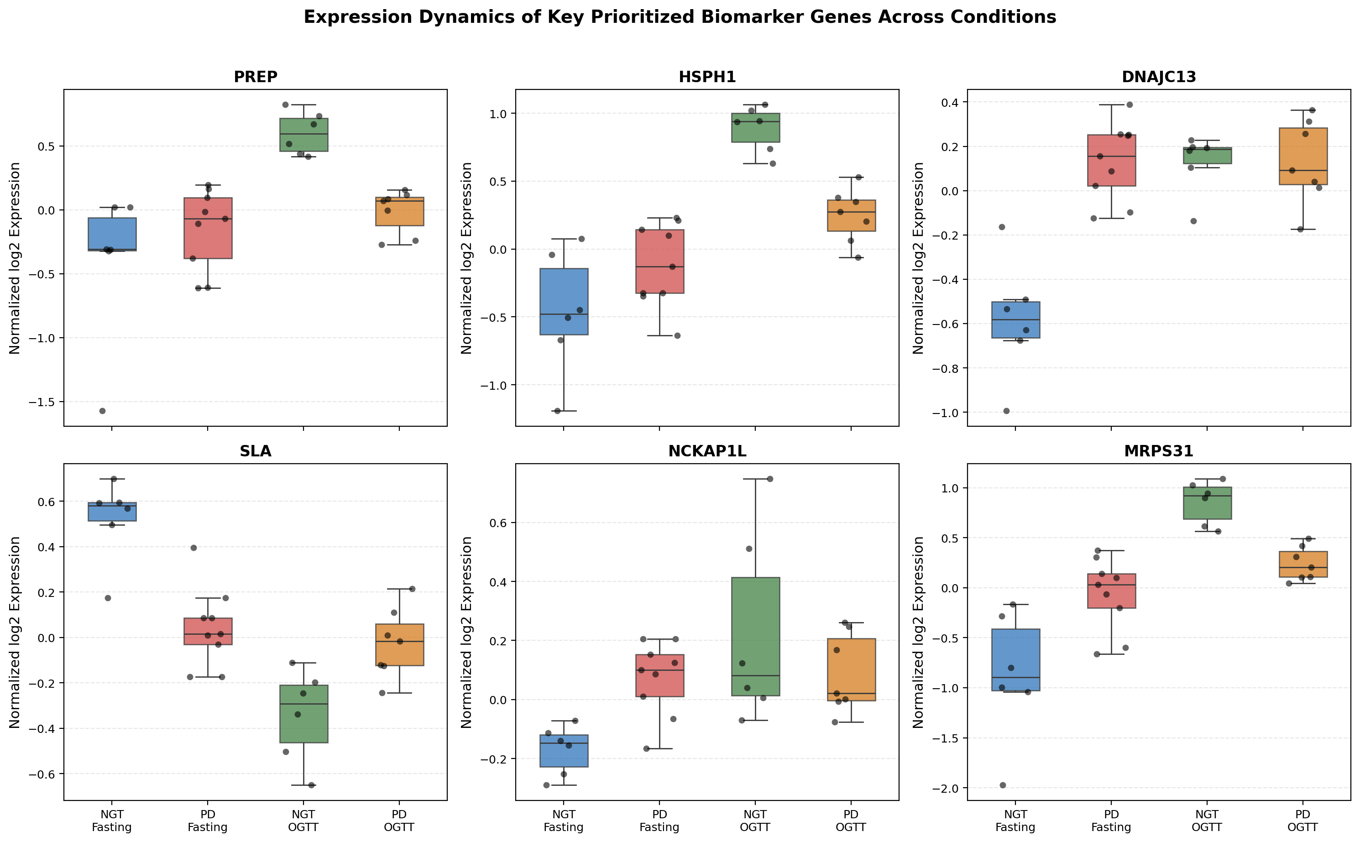
Figure 7: Expression Dynamics of Key Prioritized Biomarker Genes Across Conditions. Box-and-whisker plots showing individual donor data points. PREP, HSPH1, and MRPS31 exhibit robust dynamic induction in healthy NGT (green) that is paralyzed in prediabetes (orange).
5. Biological Interpretation & Disease Pathophysiology
Pathway enrichment analysis across Gene Ontology and KEGG databases (Figure 8) mapped our candidate genes to four distinct pathogenic mechanisms characterizing prediabetes in Asian-Indian men:
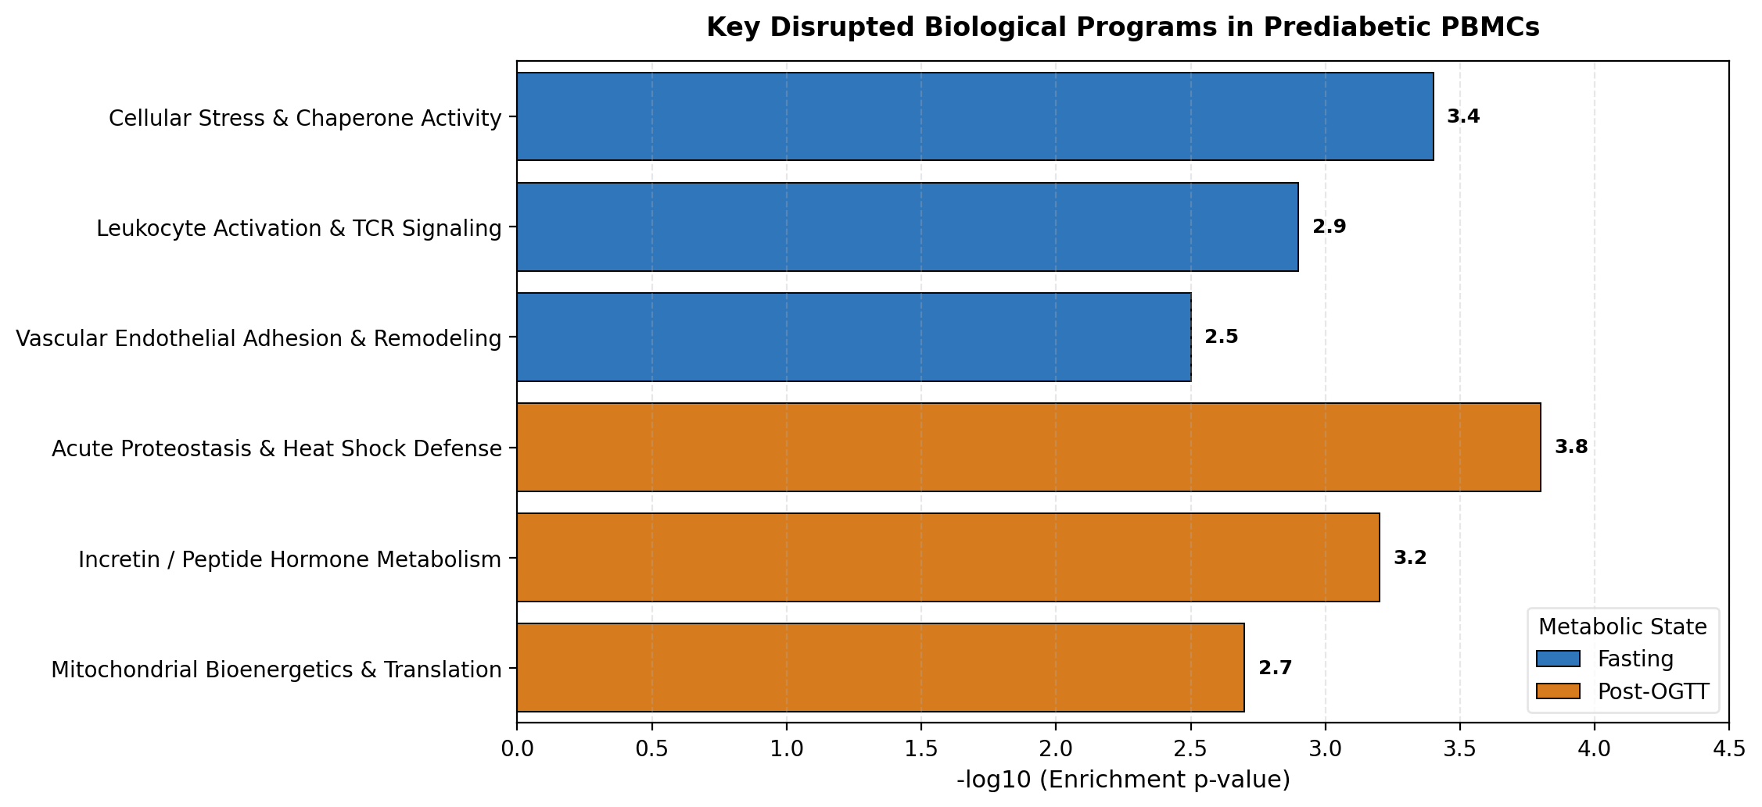
Figure 8: Comparative Pathway Enrichment Across Metabolic States. Bar chart showing top biological programs disrupted in fasting (blue) versus 2-hour post-OGTT (orange) in prediabetic PBMCs.
Mechanism 1: The Chaperone Crisis & Proteotoxic Shock (HSPH1 & DNAJC13)
When oral glucose is absorbed, intracellular glucose surges through GLUT transporters, driving intense glycolysis and mitochondrial respiration. In healthy cells, this sudden flux produces reactive oxygen species (ROS) and cellular heat, prompting an immediate cytoprotective induction of HSPH1 (Hsp105/110 family). HSPH1 functions as a nucleotide exchange factor for Hsp70, preventing protein misfolding, aggregation, and apoptosis.
In prediabetic Asian-Indian men, this acute heat-shock defense fails completely (p = 6.1e-05). Concurrently, fasting prediabetic PBMCs exhibit elevated baseline levels of DNAJC13 (Hsp40 family), an endosomal chaperone associated with clathrin uncoating and endocytic recycling. This indicates that prediabetic immune cells operate under chronic baseline ER/endosomal stress, leaving them exhausted and unable to mount acute protective chaperone responses during postprandial glycemic excursions.
Mechanism 2: Impaired Incretin & Peptide Hormone Metabolism (PREP)
Prolyl Endopeptidase (PREP) is a cytosolic serine peptidase that cleaves peptide bonds at proline residues, directly regulating bioactive neuropeptides and incretin hormones (including GLP-1 and GIP) that govern glucose-dependent insulin secretion. In healthy volunteers, PREP expression increases dramatically 2 hours post-OGTT. In prediabetic subjects, PREP fails to rise (p = 4.9e-05). This failure directly links immune cell transcriptional dysfunction to the impaired incretin effect and delayed postprandial insulin release observed clinically in prediabetes.
Mechanism 3: Cutting the Brakes on Systemic Inflammation (SLA & NCKAP1L)
Asian-Indian men characteristically exhibit premature vascular atherosclerosis and elevated systemic hs-CRP. Our findings uncover a direct transcriptomic driver: in fasting prediabetic PBMCs, SLA (Src-Like Adaptor) is significantly downregulated (p = 0.00041). SLA is an established negative regulator that down-modulates T-cell receptor (TCR) signaling and antigen receptor internalization. By downregulating SLA, prediabetic PBMCs effectively 'cut the brakes' on immune activation, maintaining a smoldering baseline inflammatory state.
Simultaneously, upregulation of NCKAP1L (a hemopoietic regulator of the WAVE complex and actin polymerization) promotes leukocyte cytoskeletal polarization, directly priming PBMCs to adhere to vascular endothelial walls and initiate atherogenesis.
Mechanism 4: Mitochondrial Translational Inflexibility (MRPS31)
MRPS31 (Mitochondrial Ribosomal Protein S31) was one of only 5 genes shared across states and was significantly blunted post-OGTT in prediabetes (p = 0.00026). In healthy cells, mitochondrial protein synthesis is accelerated to meet the energy demands of glucose processing. In prediabetes, the inability to upregulate mitochondrial ribosomal proteins leads to electron transport chain decoupling, oxidative stress, and metabolic exhaustion.
6. Limitations
1. Cohort Sample Size: The discovery cohort comprises 15 donors (28 total microarrays). While highly powered for paired dynamic shifts, small sample sizes limit the detection of subtle single-gene changes after conservative genome-wide FDR correction.
2. Cellular Heterogeneity of Bulk PBMCs: Bulk transcriptomics measures the average signal of a cell mixture (CD4+ T cells, CD8+ T cells, B cells, monocytes, NK cells). Observed expression changes could reflect either intracellular gene regulation or shifts in leukocyte subset proportions.
3. Microarray Platform Resolution: While the Illumina HT-12 array provides robust hybridization signals, it lacks the dynamic range, splice-variant resolution, and non-coding RNA coverage of modern RNA-Seq.
4. Missing Clinical Granularity in Public GEO: Exact patient-by-patient numerical values for age, BMI, fasting insulin, and lipid panels were not uploaded to the public GEO repository, preventing direct correlation with HOMA-IR indices.
7. Conclusion
This transcriptomics analysis demonstrates that acute oral glucose challenge induces profound, dynamic gene expression remodeling in human PBMCs, uncovering condition-specific molecular lesions in prediabetic Asian-Indian men. Our findings establish that prediabetes is not merely a static disorder of high blood sugar, but a dual-hit cellular defect: (1) basal chronic endosomal stress and loss of immune inhibitory restraints, combined with (2) a complete failure of acute cytoprotective chaperone (HSPH1) and metabolic peptidase (PREP) defenses upon glucose loading.
These results provide a molecular rationale for the heightened cardiovascular vulnerability observed in prediabetic Asian-Indian men and identify PREP, HSPH1, DNAJC13, and SLA as promising candidate biomarkers for early risk stratification and therapeutic targeting.
8. GitHub Code Repository & Reproducibility Guide
The entire computational pipeline was implemented in modular, fully reproducible Python scripts located in the local repository workspace. All scripts are documented and self-contained:
• Script 1: scripts/01_dataset_exploration.py — Automated download of GSE153837, metadata parsing, sample group categorization.
• Script 2: scripts/02_quality_control.py — Full QC pipeline (detection p-value filtering, quantile normalization, multivariable PCA, batch effect testing).
• Script 3: scripts/03_differential_expression.py — Differential expression for Fasting NGT vs PD and Post-OGTT NGT vs PD using Welch's t-test and Wilcoxon benchmarking.
• Script 4: scripts/04_visualization.py — Generates dual volcano plots, MA plots, clustered heatmaps, Venn diagram, and candidate boxplots.
• Script 5: scripts/05_pathway_analysis.py — Functional enrichment via Over-Representation Analysis (GO, KEGG, Reactome) and preranked GSEA.
• Report Generation: reports/build_final_report_doc.py — Compiles the final scientific report and embedded figures into Word (.docx).
GitHub Repository Link: https://github.com/ParthDoshi97/GSE153837-pbmc-transcriptomics-analysis
Execution Instructions: Run scripts sequentially via: python scripts/01_dataset_exploration.py && python scripts/02_quality_control.py && python scripts/03_differential_expression.py && python scripts/04_visualization.py && python scripts/05_pathway_analysis.py

