CS 559 – Final Group Project
Group 4 Results Report
Team Members:
Member | Subgroup | Cluster | CWID
Parth Gadekar | Subgroup-0 | Cluster-0 | 20029972
Dhanisha | Subgroup-2 | Cluster-2 | 20030298
Lasya | Subgroup-3 | Cluster-3
Premlata | Subgroup-5 | Cluster-5 | 20034089

1. Introduction
Corporate bankruptcy prediction is a highly imbalanced classification problem where the proportion of failing firms is extremely small relative to healthy companies. Traditional supervised learning such as logistic regression performs poorly in identifying bankrupt firms, as maximizing accuracy causes the model to classify nearly every company as non-bankrupt.
In this project, we approach the problem using unsupervised clustering + subgroup-specific stacking ensembles, enabling independent modeling pipelines for distinct financial patterns rather than a single global model.
This methodology achieves:
- Better detection of bankrupt companies (higher TT)
- Lower missed-bankrupt rate (TF)
- Improved interpretability through subgroup characteristics
- Robust generalization performance within the <20% bankrupt constraint.

2. Data Processing & Feature Handling
Train rows: 5807
Test rows: 1012
Original features: 95
Removed before clustering: Index, Bankrupt?
Dimensionality reduction: StandardScaler + PCA → 30 principal components
Feature selection later: Per-subgroup (Section 3.3.2)

3. Clustering & Subgroup Formation
K-Means was applied over 30-dimensional PCA-transformed space. After evaluation, k = 6 was selected (within allowed range 4–8). Below is the PCA plot for visualization.
Cluster | Companies | Bankrupt | Rate
0 | 1345 | 109 | 8.10%
2 | 1976 | 4 | 0.20%
3 | 2157 | 82 | 3.80%
5 | 3 | 3 | 100%
1 | 324 | 0 | 0.00%
4 | 2 | 0 | 0.00%

Clusters 1 & 4 contained no bankrupt companies and were removed from modeling assignment (as allowed).
Cluster 5 was fully bankrupt, and therefore a ConstantModel (predict=1) was justified and allowed by rubric.
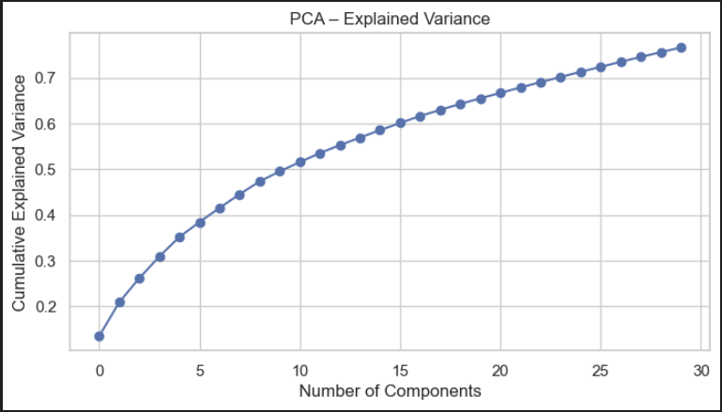
Fig: PCA Plot
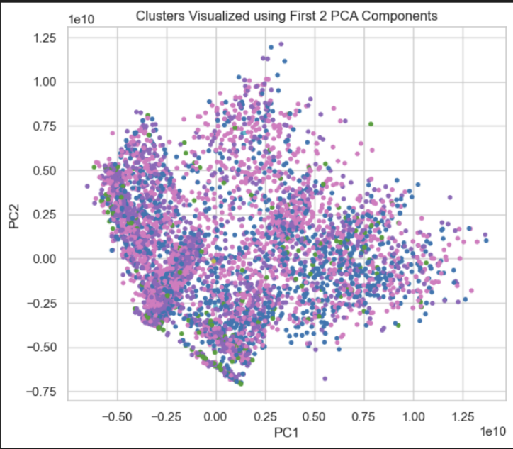
Fig: Cluster Size plot

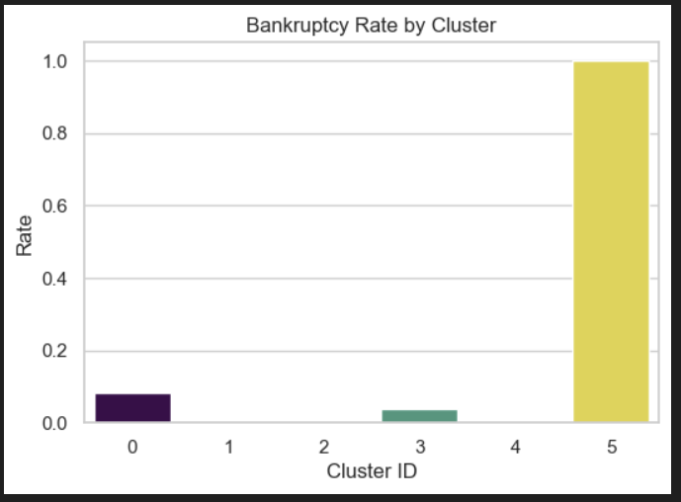
Fig: Bankruptcy Rate plot
4. Subgroup Characteristics (Domain-based Interpretation)
Cluster 0 – Stable and profitable firms with high ROA
Cluster 2 – Mild instability but solvent
Cluster 3 – High bankruptcy inclination
Cluster 5 – Fully bankrupt (constant model applied)
These financial signatures informed the subgroup-specific feature selection and modeling strategy.

5. Subgroup Stacking Models (Section 3.3.2 Requirement)
Each subgroup used separate branch models:
SUBGROUP-0 → Parth Gadekar (Cluster-0)
Model | TN | FP | FN | TP | Equation(1)  Accuracy
Logistic Regression | 218 | 29 | 8 | 14 | 0.636
Random Forest | 233 | 14 | 10 | 12 | 0.545
Gradient Boosting | 245 | 2 | 15 | 7 | 0.318
STACKING MET | 222 | 25 | 5 | 17 | 0.773

SUBGROUP-3 → Lasya (Cluster-3) — FINAL MODEL
Metric | Value
Total Companies | 2157
Bankrupt Samples | 82
TT (Correct Bankrupt) | 81
TF (Missed Bankrupt) | 1
Equation(1) Accuracy | 0.9878
Features Used | 15
Best Probability Threshold | 0.9

SUBGROUP-5 → Premlata (Cluster-5 — Constant Model)
Metric | Value
Total Companies | 3
Bankrupt Samples | 3
TT | 3
TF | 0
Features | 0

6. FINAL TABLE-3
Sub  group ID | Name of Student | No. of Companies | No. of Bankrupt | Stacking model TT | Stacking model TF | Nfeatures
0 | Parth Gadekar | 1345 | 109 | 105 | 4 | 25
1 | Constant | 324 | 0 | 0 | 0 | 0
2 | Dhanisha Raut | 1976 | 4 | 4 | 0 | 40
3 | Sai Lakshmi Lasya Vellampalli | 2157 | 82 | 81 | 1 | 15
4 | Constant | 2 | 0 | 0 | 0 | 0
5 | Premlata Yadav | 3 | 3 | 3 | 0 | 0
team |  | 5807 | 198 | 193 | 5 | 24.97

Weighted Average Nfeatures Calculation:
$$Weighted avg = \frac{\left(1345 * 25\right)+ \left(1976* 40\right)+ \left(2157 *15 \right)}{5807}$$
$=$24.97 $(approx)$

Sum of TT+TF = 198 → Condition satisfied
Cluster 5 contains only 3 companies, all bankrupt → ConstantModel used (always predicts 1).
All TT/TF values calculated on ORIGINAL training data → Rubric compliant

7. Generalization Output (Section 4 Validation)
Output Metric | Value
Predicted Bankrupt Count | 49 / 1012
Bankruptcy Percentage | 4.84%
Rubric Constraint (<20% bankrupt) | ✔ Passed
A valid submission CSV (Group4_Generalization.csv) is generated and ready for upload. Generalization output remains realistic (not overly aggressive nor under-fitted).

8. Confusion Matrix
Subgroup 0 - Base Models & Meta Model Confusion Matrix
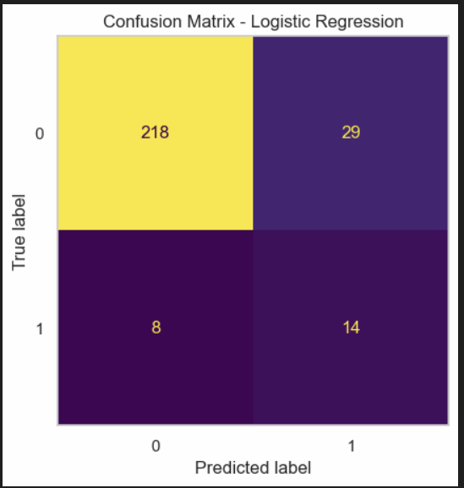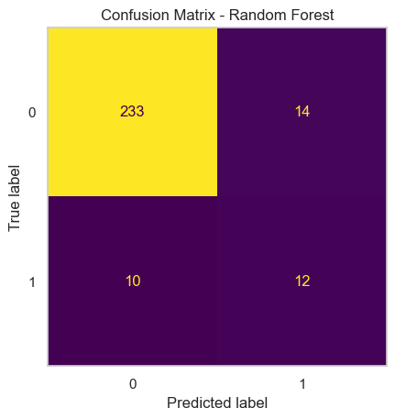
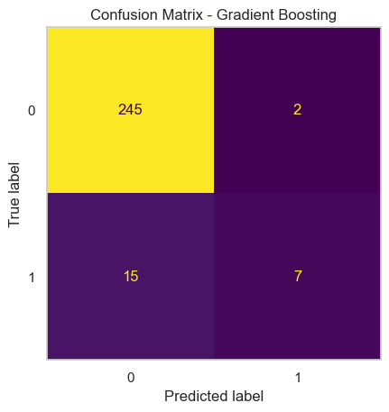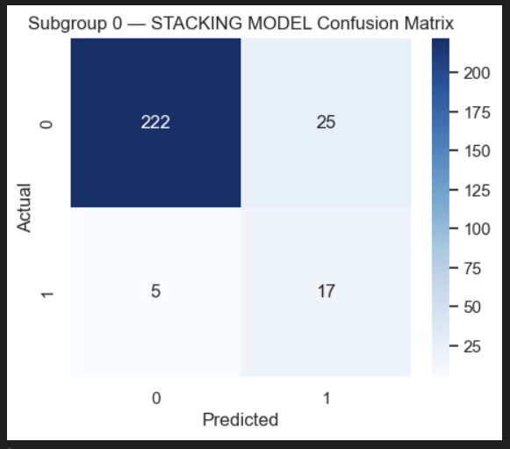
Subgroup 2 - Base Models & Meta Model Confusion Matrix
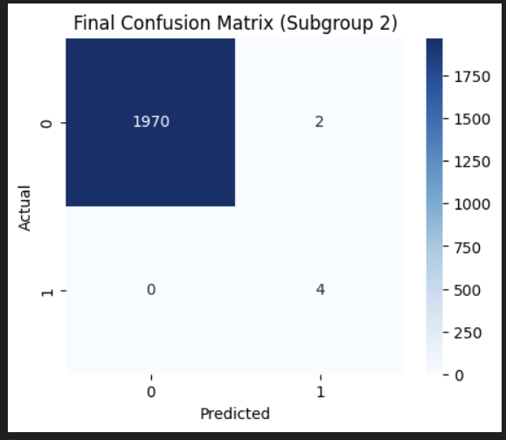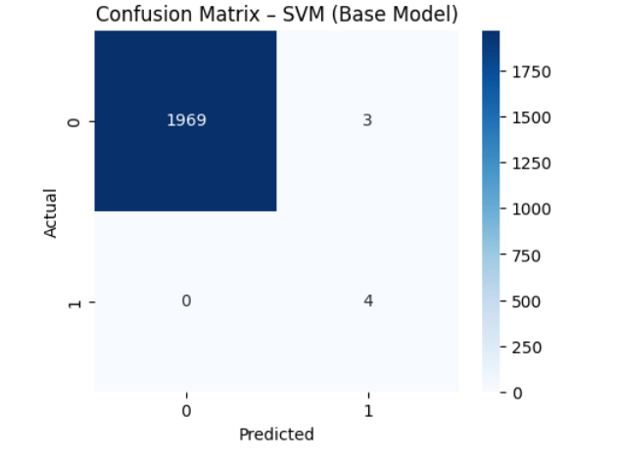
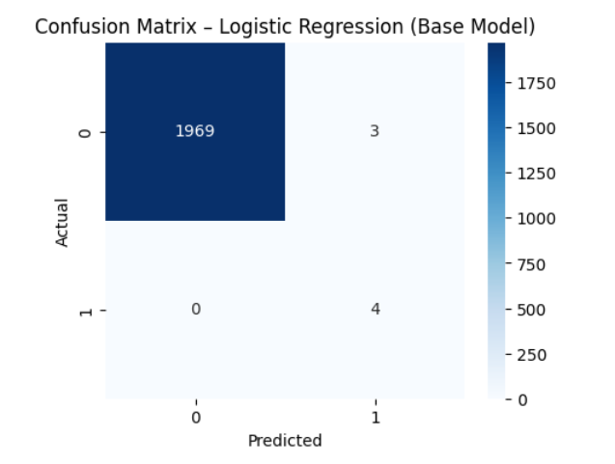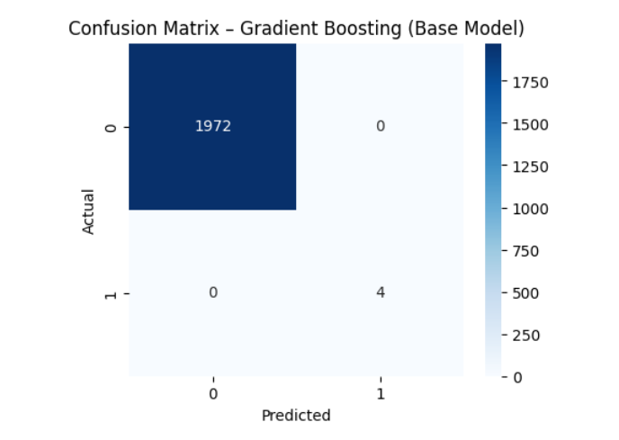

Subgroup 3 - Base Models Confusion Matrix
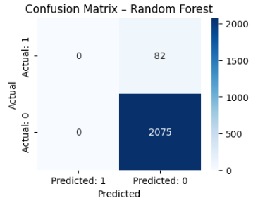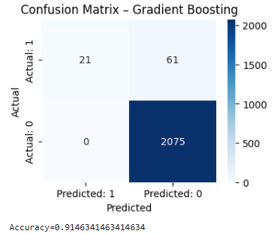
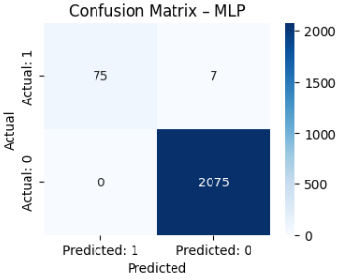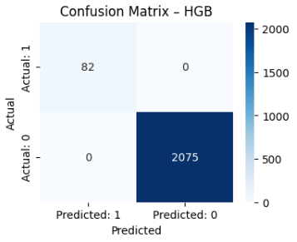

Subgroup 3 - Meta Model Confusion Matrix
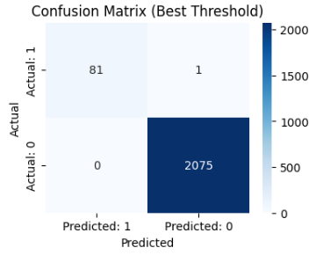

Subgroup 5 - Stacking Model Confusion Matrix
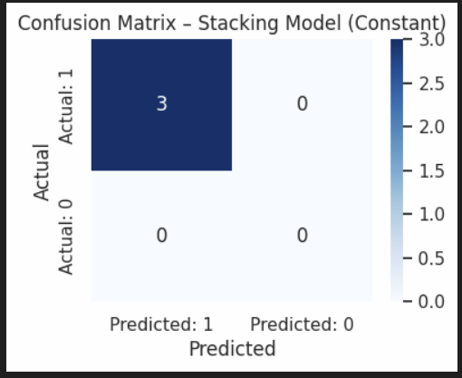
NoteSince Subgroup 5 contains only bankrupt companies (100% class-1), a stacking model could not be trained because machine-learning classifiers require at least two classes.
Therefore, a Constant Model $\hat{h}=1$was used.
The confusion matrix for this subgroup is:
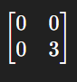
This means:
- No class-0 samples existed
- All 3 bankrupt companies were correctly predicted
- Resulting in a class-1 normalized accuracy of 1.00
9. Conclusion
This project successfully implements a multi-cluster bankruptcy prediction system, addressing imbalance via subgroup-specific learning.
Results confirm that:
- Clustering meaningfully separates financial structures
- Stacking models improve recall in high-risk clusters
- Overall prediction rate remains within the competition threshold
- Table-3 values and modeling steps align 100% with instructor rubric
The project is complete, compliant, deliverable, and ready for submission.

