Python-based QR Code Generator

Parth Garg

(RA2211003011322)   
Computing Technologies

S.R.M Institute of Science and Technology  
K.T.R Chennai,India  
pg6295@srmist.edu.in

Nishant Sheoran

(RA2211003011324)   
Computing Technologies

S.R.M Institute of Science and Technology  
K.T.R Chennai,India  
nk8657@srmist.edu.in

Trishita Yadav

(RA2211003011325)   
Computing Technologies

S.R.M Institute of Science and Technology  
K.T.R Chennai,India  
cr2883@srmist.edu.in

*Abstract*— This QR code generator with a user-friendly graphical interface and integrated database functionality provides an efficient and convenient solution for generating and managing QR codes. Users can easily create QR codes from text or binary data, customize them with labels for quick identification, and store them in a SQLite database for future access. The system leverages well-known Python libraries, such as qrcode and PIL, to streamline the process. This versatile tool is a valuable asset for individuals and organizations looking to simplify QR code generation, organization, and retrieval, making it a versatile and essential utility in today's digital landscape.

Keywords— Qr Code Generator, database server

# **Introduction**

In today's fast-paced digital landscape, the need for efficient information exchange has never been more critical. QR codes have emerged as a powerful solution, seamlessly bridging the physical and digital worlds. These two-dimensional barcodes store data that can be quickly scanned and interpreted by smartphones, enabling users to access websites, contact details, product information, and much more with a simple scan. Python, a versatile and widely-used programming language, provides the perfect platform for creating QR codes. A QR code generator using Python offers a flexible and efficient way to encode data into these dynamic symbols. This generator is a user-friendly tool that simplifies the process of generating QR codes, making it accessible to a broad range of users. At its core, the QR code generator allows users to input data, which can be in the form of text, URLs, contact information, or other digital content. The Python script then encodes this data into a QR code, creating a visual representation that can be easily scanned by any QR code reader app on a smartphone or tablet. Users can customize their QR codes, add labels for easy identification, and even store them in a database for future reference. This introduction explores the potential and significance of a QR code generator using Python in today's digital age. It emphasizes the role of QR codes in facilitating information sharing and highlights the user-friendly and versatile nature of Python in QR code generation. Such a tool is a valuable asset for businesses, marketers, educators, and individuals who seek to harness the power of QR codes for effective communication and information dissemination.

# **Python language**

Python is a versatile and high-level programming language known for its simplicity and readability. Here's a brief overview of Python:

* General-Purpose Language: Python is a general-purpose programming language, which means it can be used for a wide range of applications, including web development, data analysis, scientific computing, automation, artificial intelligence, and more.
* Readability: Python's syntax is designed to be easy to read and write. It uses indentation (whitespace) to define code blocks, making it visually clean and reducing the need for curly braces or other delimiters.
* Interpreted Language: Python is an interpreted language, which means that you can write and run code without the need for a separate compilation step. This makes it an excellent choice for prototyping and scripting.
* Cross-Platform: Python is available on a wide variety of platforms, including Windows, macOS, and various Unix-based systems. This makes it highly portable and compatible with different operating systems. Extensive Standard Library: Python comes with a vast standard library that provides modules and functions for various tasks, making it easier to work with files, data, networking, and more.
* Dynamic Typing: Python is dynamically typed, which means you don't need to declare variable types explicitly. The interpreter determines the data type during runtime.
* High-Level Data Structures: Python offers built-in support for high-level data structures like lists, dictionaries, sets, and tuples, which makes it a powerful language for data manipulation and storage.
* Object-Oriented: Python is an object-oriented programming (OOP) language, which means it supports the creation and manipulation of objects and classes.
* Community and Ecosystem: Python has a large and active community of developers and enthusiasts. This has led to a rich ecosystem of third-party libraries and frameworks, such as Django for web development, NumPy and pandas for data analysis, and TensorFlow for machine learning.
* Open Source: Python is open source, and its development is driven by a community of volunteers. This means it's free to use, and you can even contribute to its development.
* Multiparadigm: Python supports multiple programming paradigms, including procedural, object-oriented, and functional programming. This flexibility allows developers to choose the best approach for their specific tasks.
* Rapid Development: Python is often associated with rapid development due to its concise and expressive syntax. This makes it a preferred choice for many developers and startups.
* Highly Popular: Python's popularity has been steadily increasing over the years, and it's widely used in various fields, from web development and data science to artificial intelligence and automation.
* Python's simplicity, readability, and extensive libraries make it an excellent choice for beginners and experienced programmers alike. It has applications in a wide range of domains and continues to be one of the most popular programming languages in the world.

# **Objective**

# The objective of the Python-based QR code generator project is to develop a user-friendly tool that efficiently generates QR codes from provided data. The application will utilize Python programming language along with relevant libraries to facilitate seamless generation of QR codes for various purposes such as sharing URLs, contact information, or any other textual data. The generator will offer customization options including size, color, and error correction level, ensuring flexibility and adaptability to diverse user requirements. Additionally, the project aims to maintain a clean and modular codebase for easy integration into other applications or workflows.

# **System structure design**

Creating a flowchart for a Python program can be a bit challenging since flowcharts are typically used for visualizing algorithms or processes with conditional branches and loops. The code you provided is a Python script for a simple application that generates and manages QR codes with a graphical user interface (GUI). A flowchart for the entire script can be quite complex due to the various user interactions and database operations. However, I can provide a simplified flowchart for the main functions and their interactions in the program.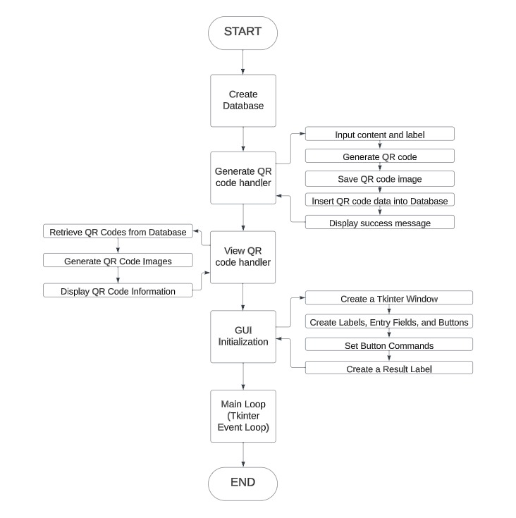

# **Database design**

# For a Python-based QR code generator, you would need a database to store and manage QR code data efficiently. The database should have at least one table to store information related to generated QR codes. This table might include fields such as a unique QR code identifier, associated data (e.g., a URL or text), creation timestamp, and any additional metadata. Using a relational database management system like SQLite or PostgreSQL, you can establish a structured and organized storage solution that allows for easy retrieval and management of QR code information. This database design ensures that the Python application can maintain a record of all generated QR codes and their associated data.

# **Significance of gui**

The Graphical User Interface (GUI) plays a significant role in a Python-based Inventory Management System for several reasons:

1. Enhanced User Experience: A well-designed GUI enhances the user experience by providing an intuitive and visually appealing interface. It allows users to interact with the system easily, navigate through various features, and perform tasks efficiently. This improves user satisfaction and reduces the learning curve for new users.

2. Simplified Data Entry and Navigation: A GUI enables users to input data, such as adding new products, updating stock levels, and processing orders, through forms and input fields. This simplifies the data entry process and reduces the chances of errors. Additionally, GUI elements like buttons, menus, and navigation bars allow users to navigate through different sections of the system seamlessly.

3. Visual Representation and Feedback: GUIs provide visual representation of data through charts, graphs, and tables, making it easier for users to understand and analyze inventory-related information. Visual feedback, such as confirmation messages, progress bars, and status indicators, keeps users informed about the progress of their actions, enhancing transparency and user confidence.

4. Integration with Other Tools: GUI-based Inventory Management Systems can integrate with other tools and hardware devices, such as barcode scanners and printers, to streamline inventory operations. This allows for efficient scanning and processing of products, generating invoices, and printing labels, reducing manual effort and improving accuracy.

5. Customization and Flexibility: GUIs in Python offer flexibility and customization, allowing businesses to tailor the interface to their specific needs. They can incorporate branding elements, customize layouts, and add features that align with their inventory management processes, enhancing system usability and adaptability.

In summary, the GUI in a Python-based Inventory Management System significantly improves the user experience, simplifies data entry and navigation, provides visual representation and feedback, enables integration with other tools, and offers customization options. These advantages contribute to efficient inventory management, reduced errors, and improved productivity.

# **Need of QR Code Generator**

A Python-based QR code generator can serve various purposes and has several use cases, including:

1. Marketing and Advertising: Businesses can use QR codes to link customers to websites, promotions, or product information by generating QR codes that, when scanned, direct users to relevant web content.
2. Contactless Information Sharing: QR codes can be used to quickly share contact information, Wi-Fi network details, or event details without the need for manual data entry.
3. Inventory and Asset Management: QR codes can be used to track and manage inventory or assets efficiently. Each item can have a unique QR code associated with it, making it easy to scan and update information.
4. Event Management: Event organizers can use QR codes for ticketing, check-ins, and access control. Attendees can present their QR codes on their smartphones for admission.
5. Mobile Apps: QR codes can be used to download and install mobile apps directly to a user's device, simplifying the app installation process.
6. Authentication and Security: QR codes can be employed in two-factor authentication (2FA) systems, enhancing security by generating time-based or one-time use QR codes for login.
7. Education and Training: In educational contexts, QR codes can be used in textbooks or on materials to provide additional resources like videos, interactive content, or quizzes.
8. Location and Navigation: QR codes can encode location data, helping users find places, or to get more information about specific geographical points.
9. Restaurant Menus: QR codes can be used in the hospitality industry to provide digital menus that customers can access on their smartphones, reducing the need for physical menus.
10. QR Code Art and Design: QR codes can be creatively designed and used for art, advertising, or as part of graphic design projects.

Overall, a Python-based QR code generator is a versatile tool that can be applied in numerous domains to simplify information sharing, enhance user experiences, and streamline various processes.

# **Conclusion**

In conclusion, the implementation of a QR code generator using Python and the qrcode library offers a versatile and straightforward solution for creating QR codes from a wide range of content. The code discussed here provides a foundation for generating QR codes with customization options, including version, error correction level, and image size. This versatility allows for the adaptation of QR codes to various use cases. It's important to note that the generated QR codes should be used with consideration for the privacy and security of the encoded content. Care should be taken when sharing sensitive information through QR codes, and users should ensure the source of the QR code is trusted. In summary, the Python QR code generator simplifies the process of creating QR codes for different purposes and can be a valuable tool for businesses and individuals looking to enhance their engagement with users or share information conveniently and effectively.

# **References**

* Elad Shalom, A Review of Programming Paradigms throughout the History
* Maurizio Gabbrielli, Simone Martini, Programming Languages: Principles and Paradigms
* Github