Practical No. 2
-- Step 1: Create Database
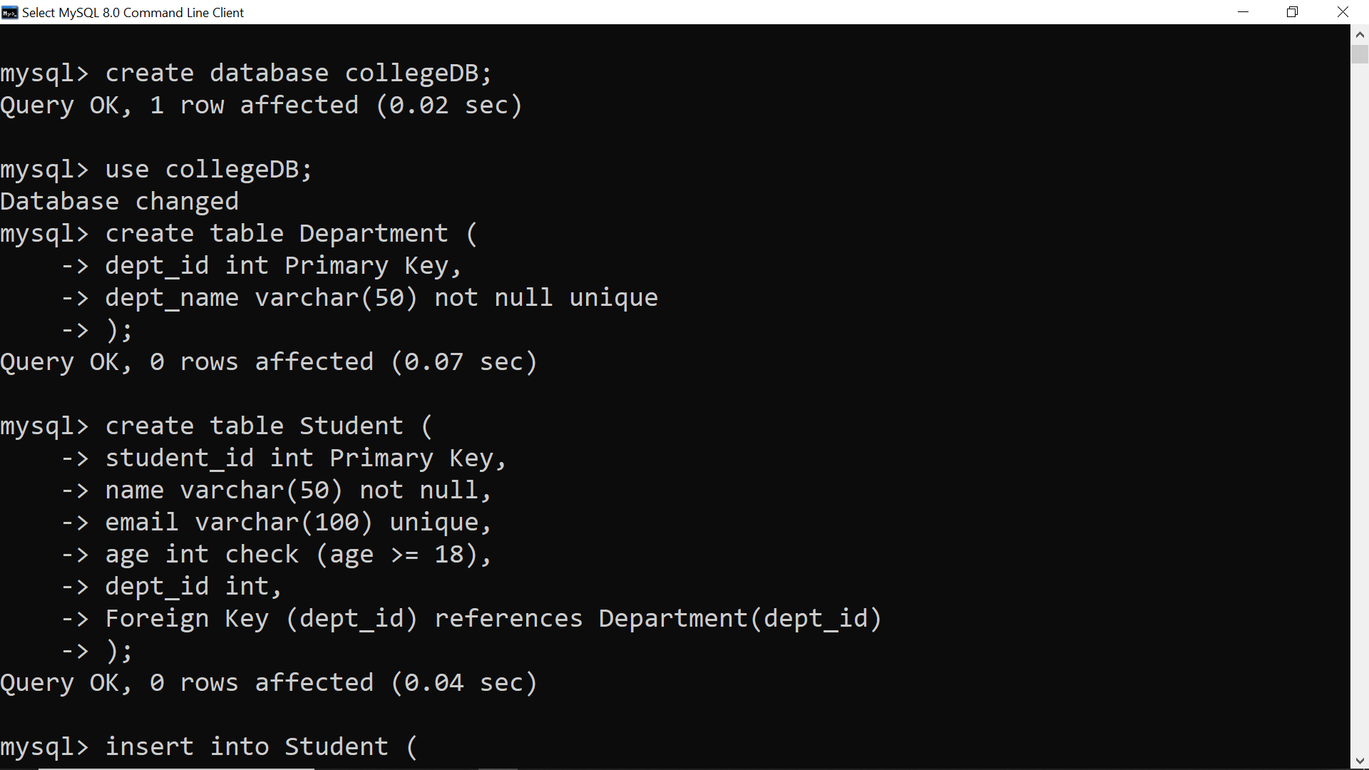
-- Step 2: Create Department Table

-- Step 3: Create Student Table with Constraints

-- Step 4: Insert Data into Department
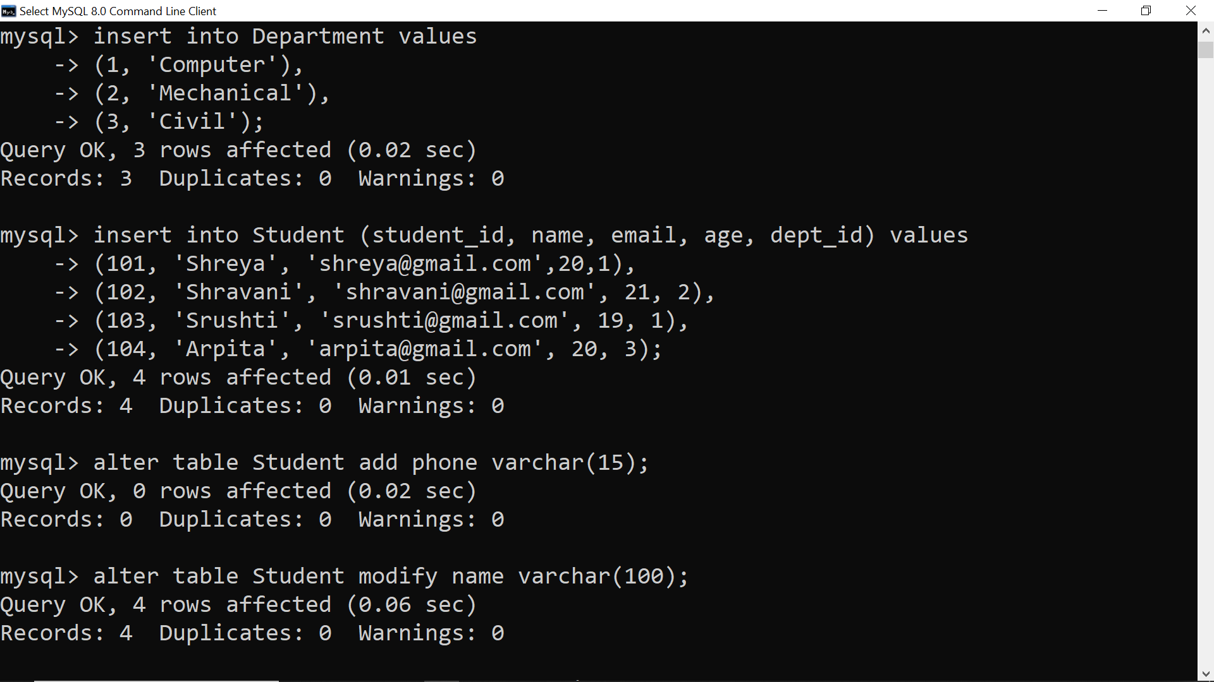
-- Step 5: Insert Data into Student

-- Step 6: ALTER Table (Add Column)


-- Step 7: ALTER Table (Modify Column)

-- Step 8: RENAME Table
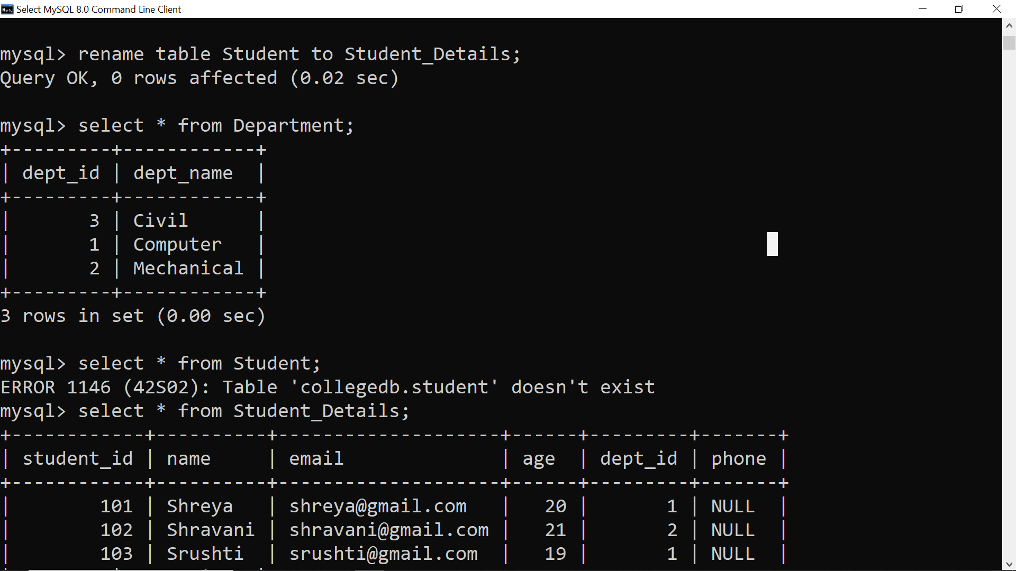
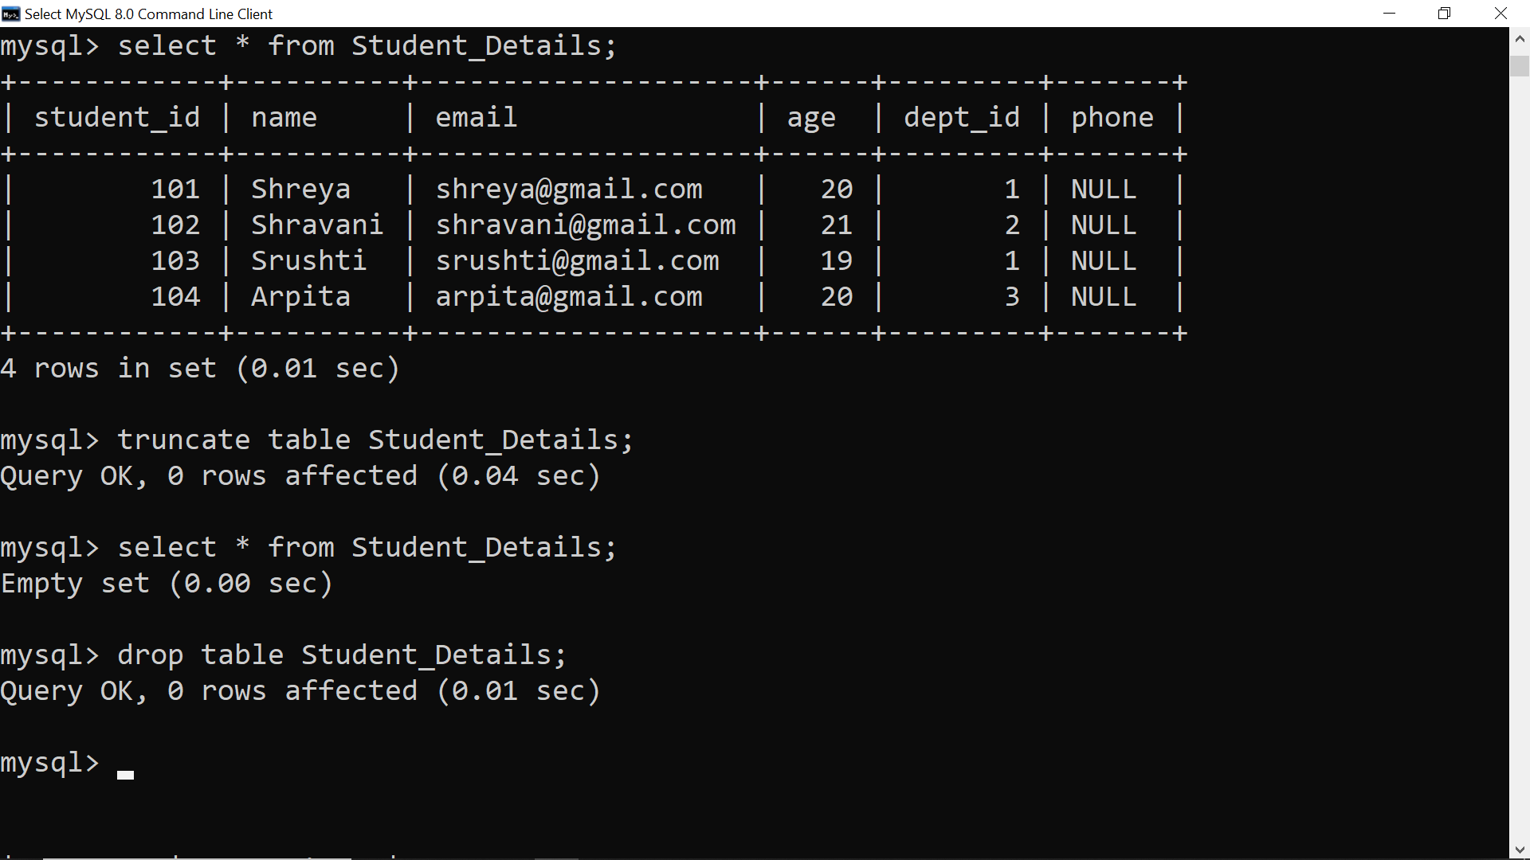
-- Step 9: TRUNCATE Table (Delete all records)

-- Step 10: DROP Table


