Practical No. 3
Data Manipulation Language (DML)
Create Database
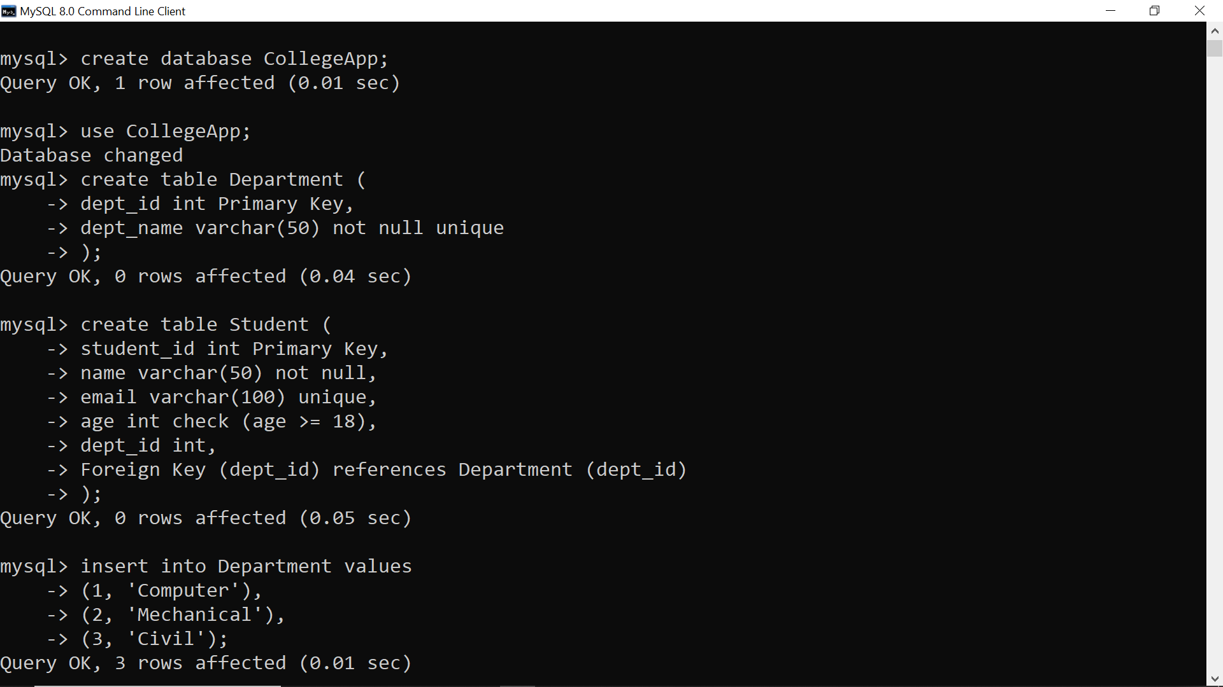
Create Tables

Insert Into Database

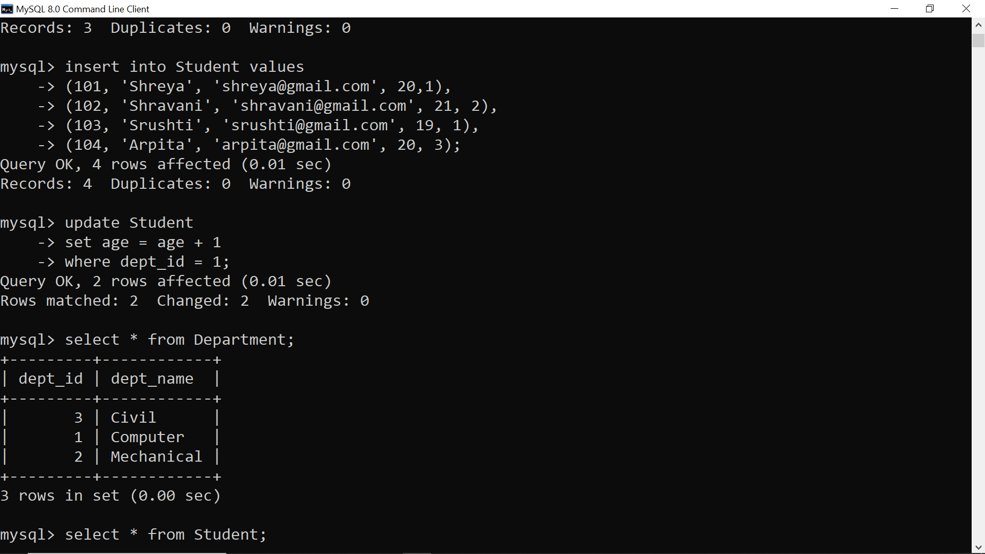
Update Table


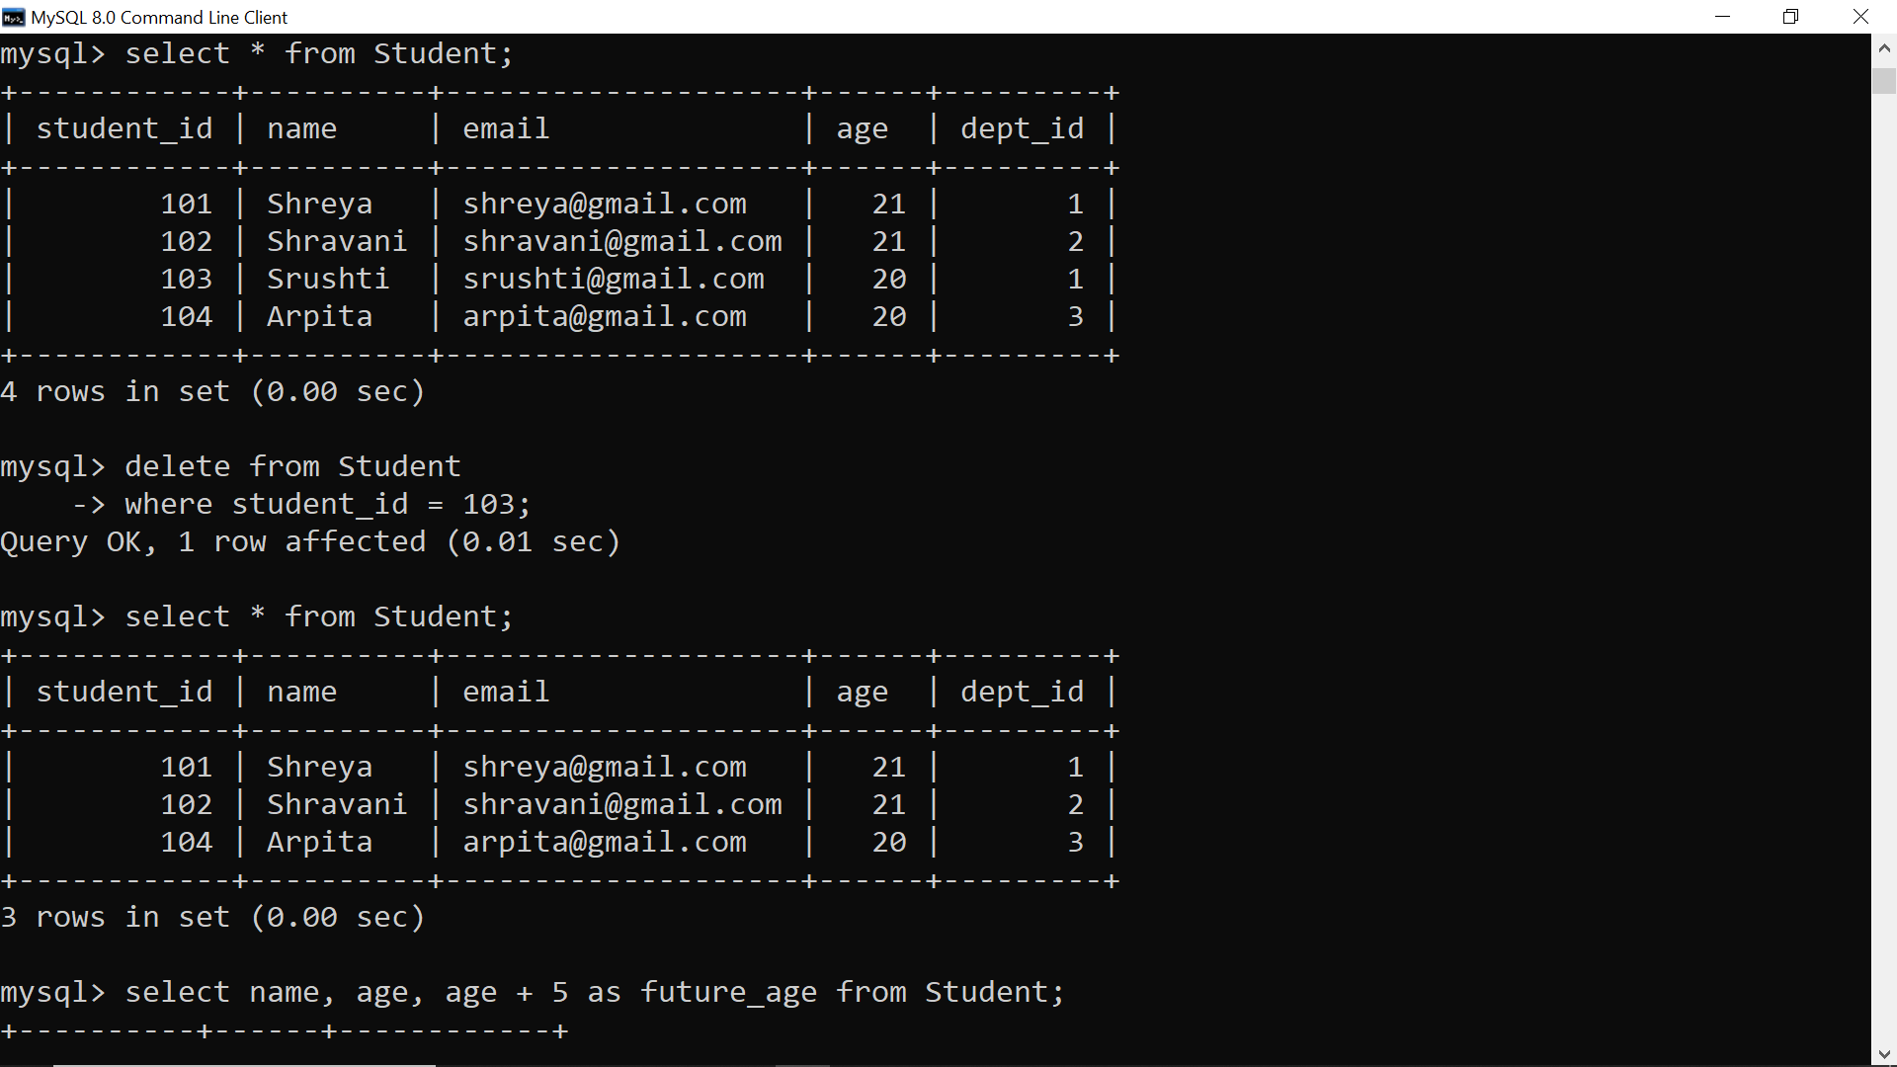

Delete Tables

Select Columns
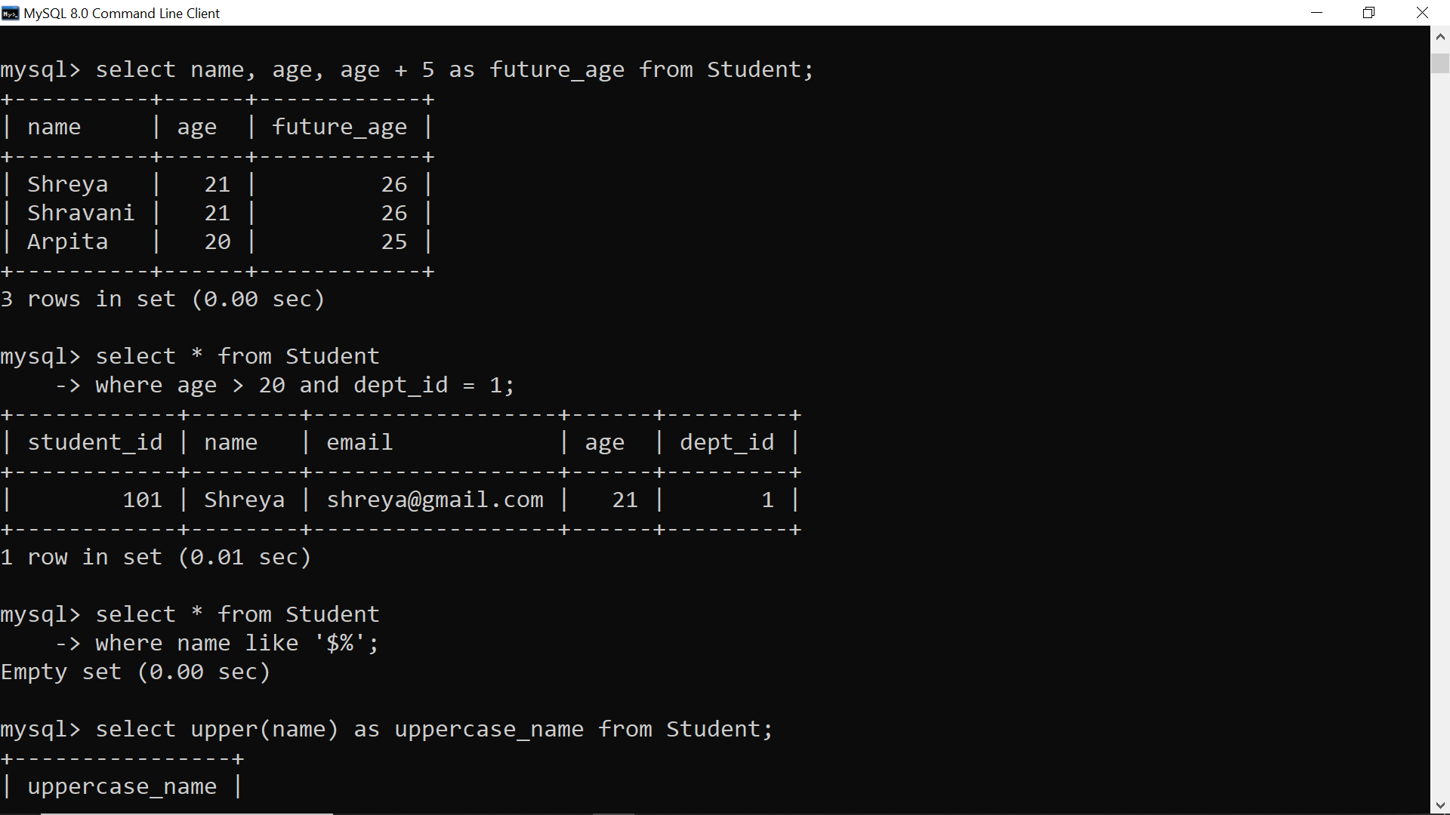
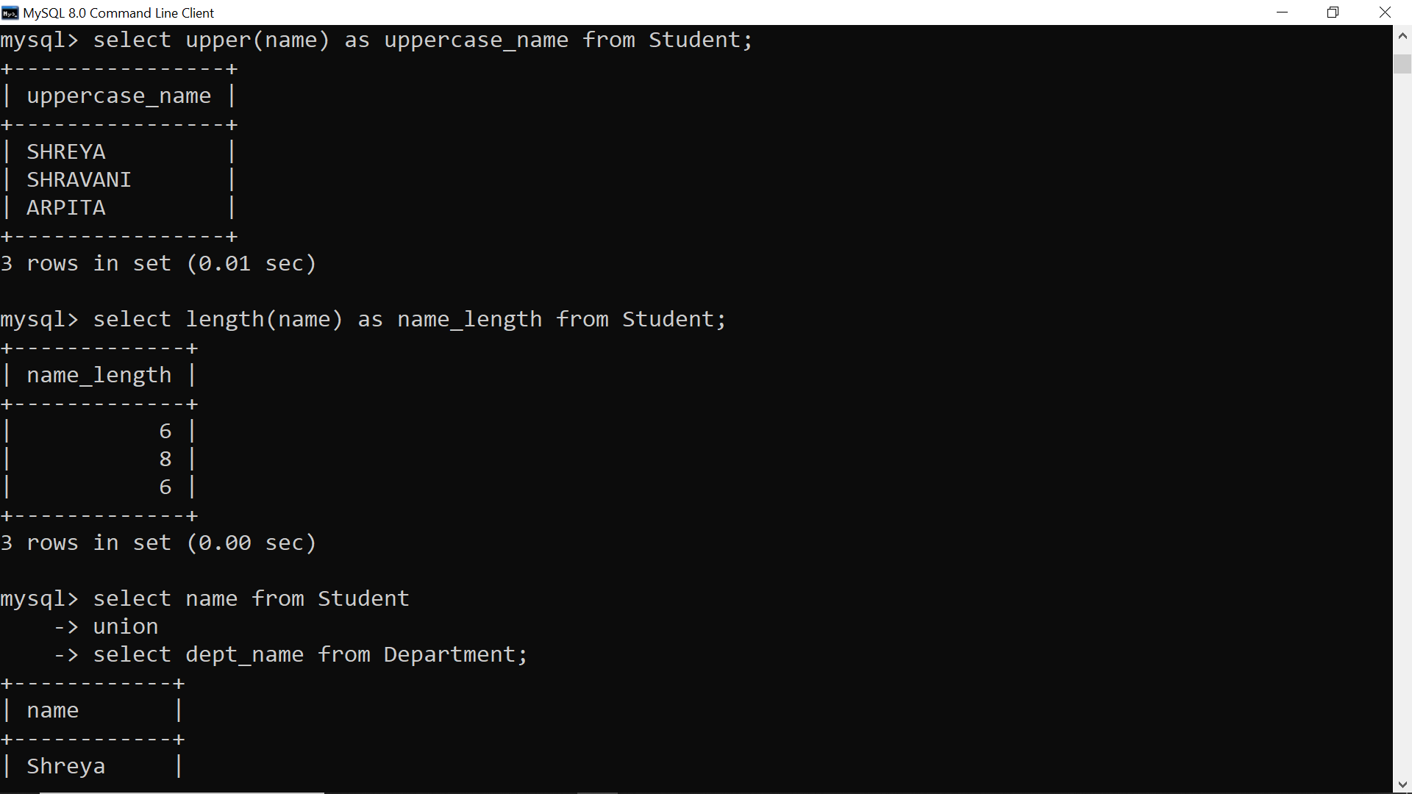
Alter Table
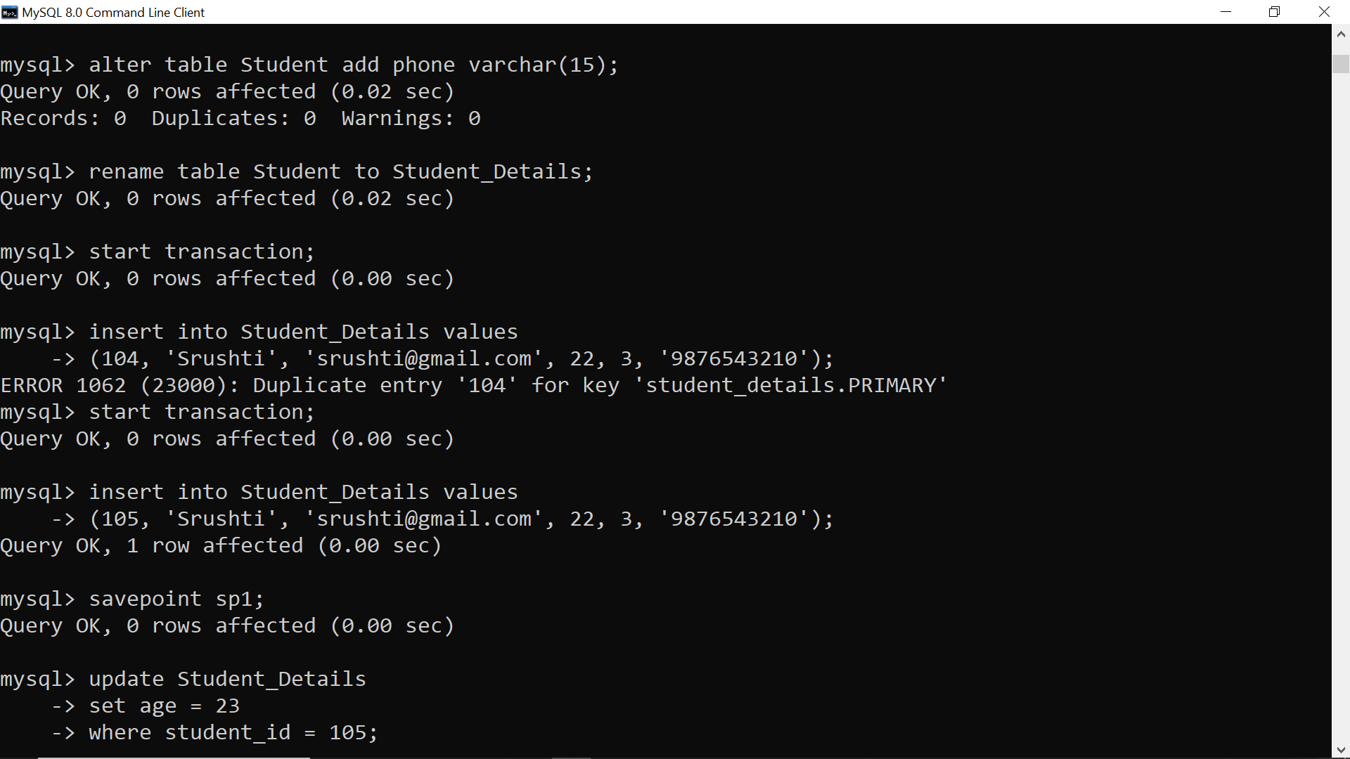
Rename Table


Transaction Control Language (TCL) and Data Control Language (DCL)
Start Transaction

Savepoint

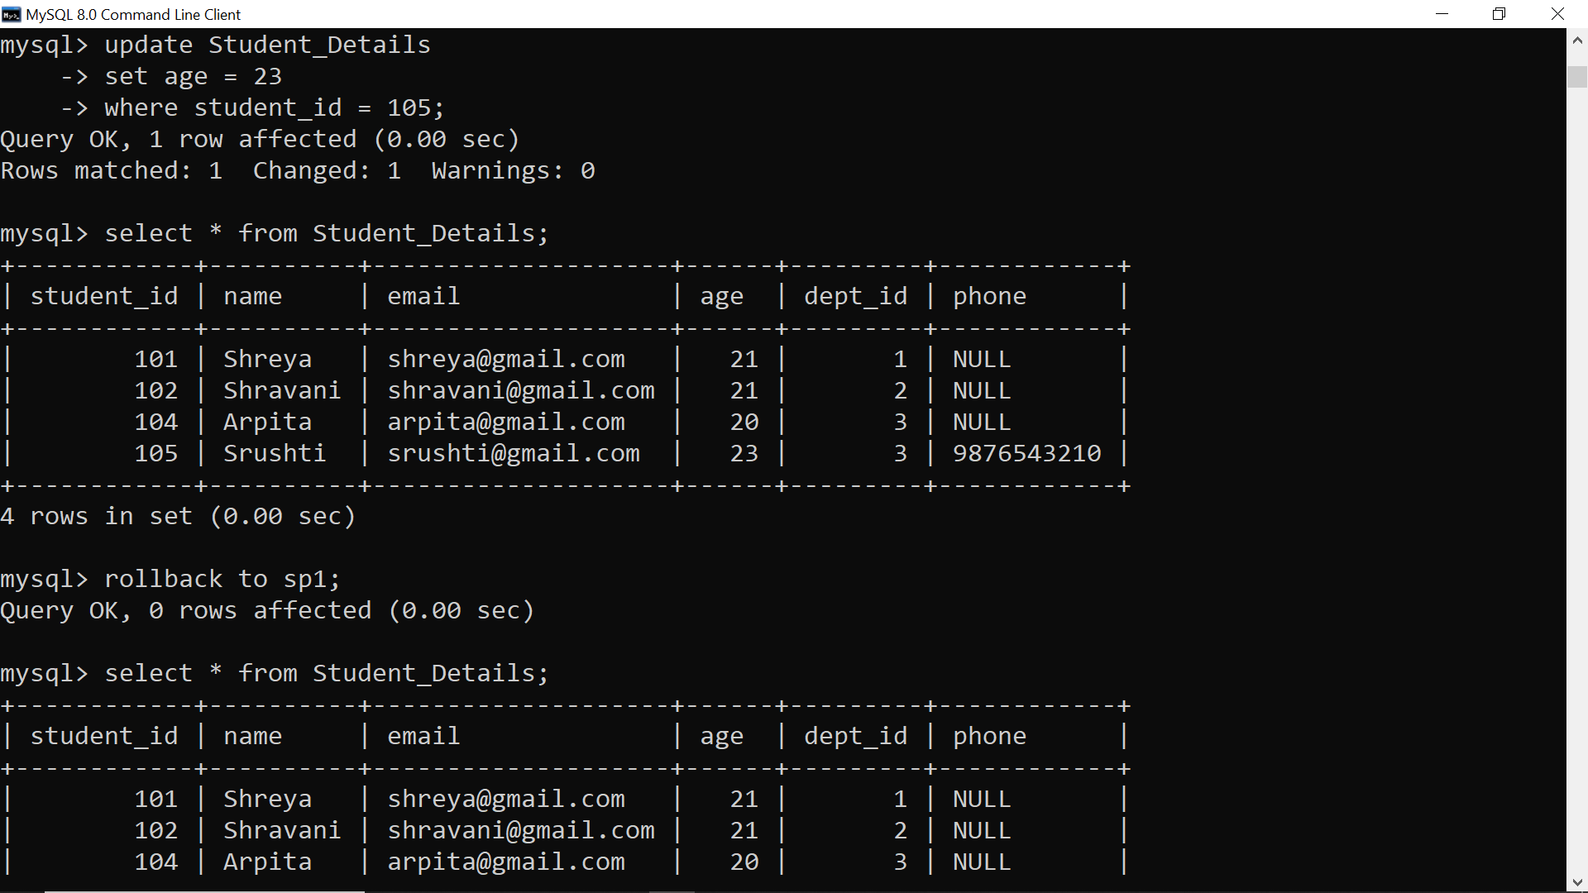
Roll Back

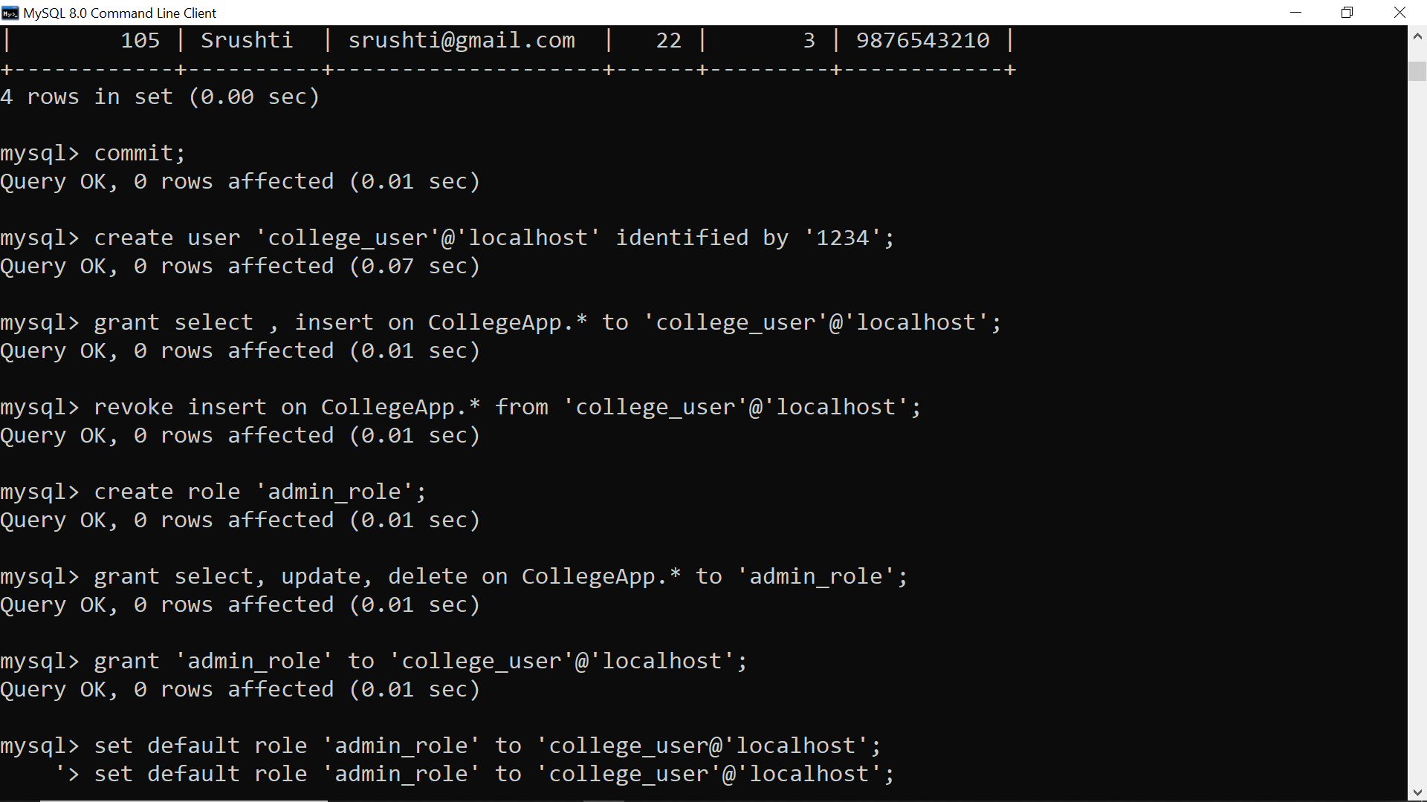
Commit

Creating User, Granting and Revoking Permissions

Create Role

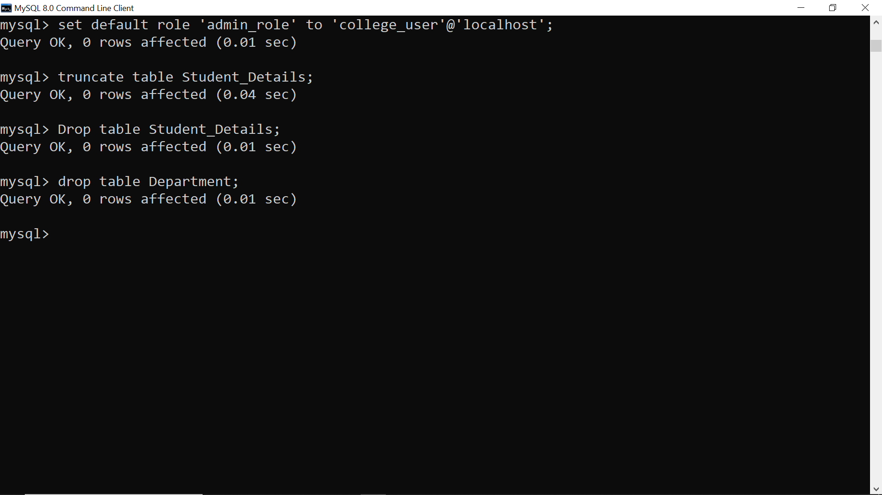
Truncate

Drop Tables


