Practical No.4
-- ========== 1. CREATE DATABASE ==========
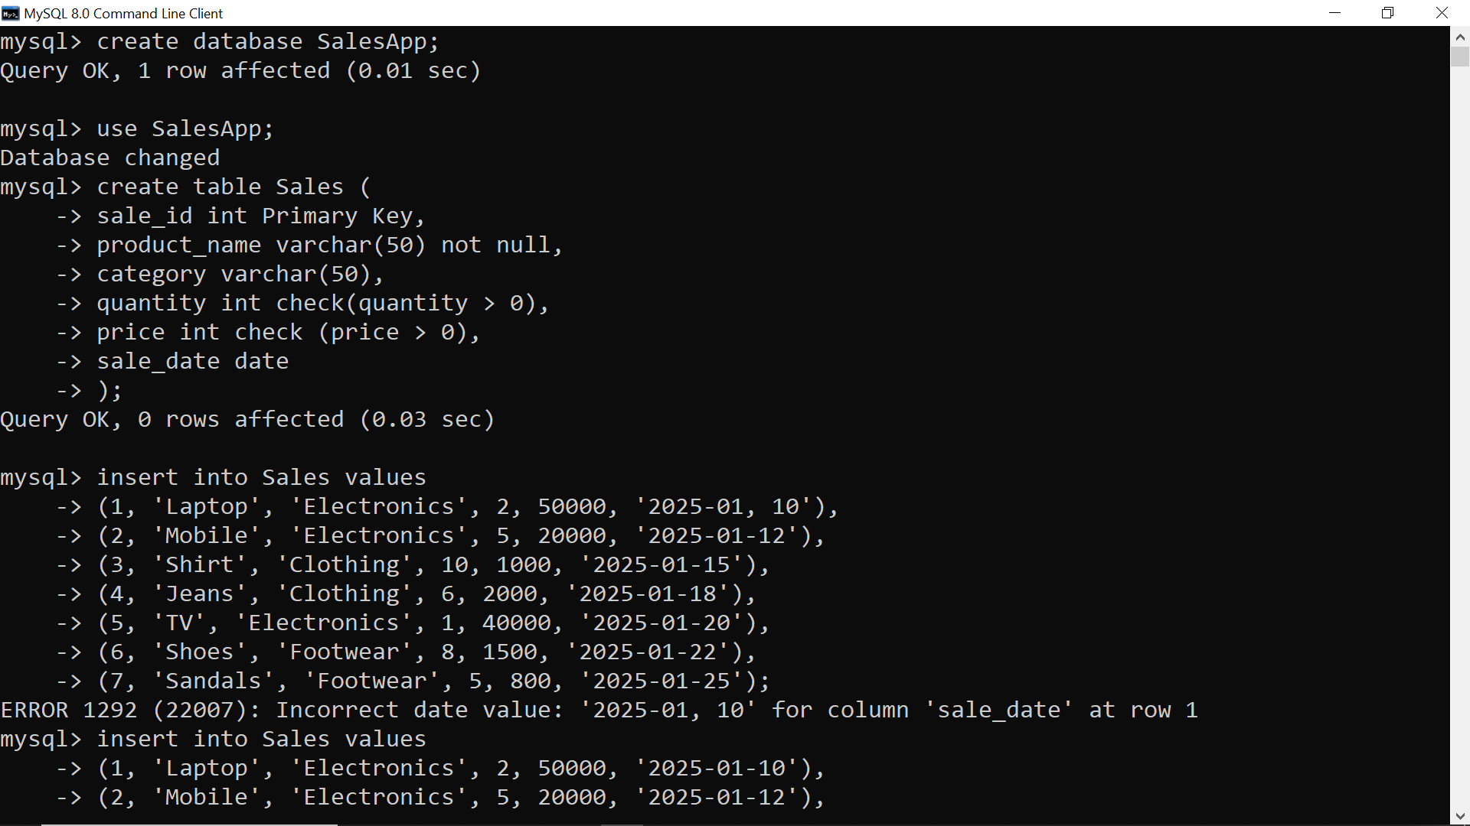
-- ========== 2. CREATE TABLE ==========

-- ========== 3. INSERT DATA ==========

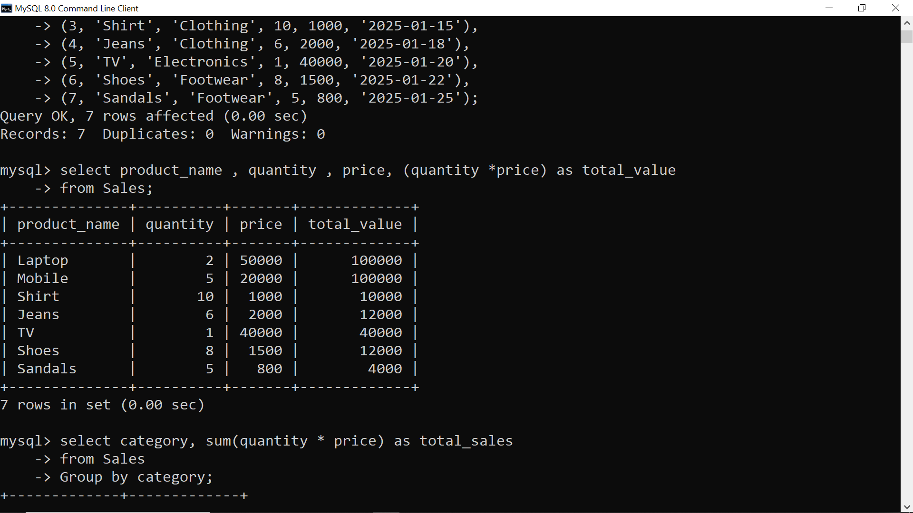
-- ========== 4. AGGREGATE FUNCTIONS ==========
-- Total Sales Value per Record

-- ========== 5. GROUP BY ==========

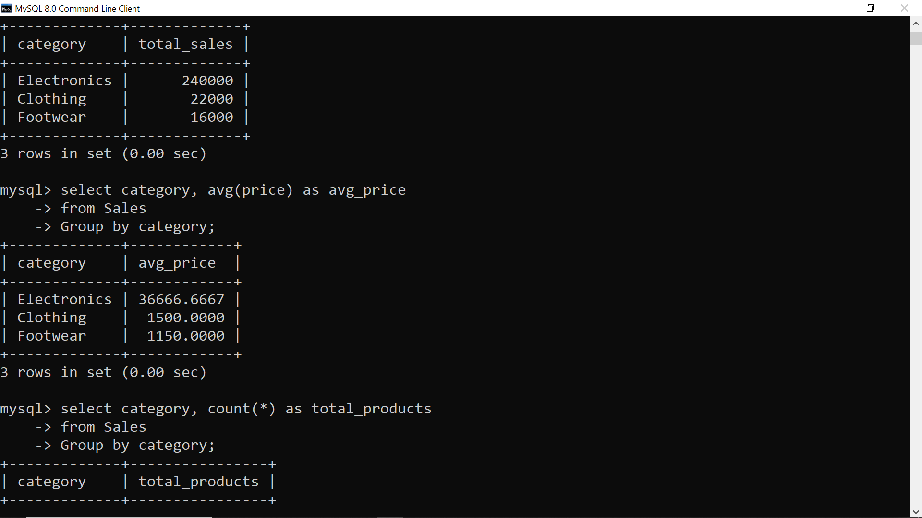
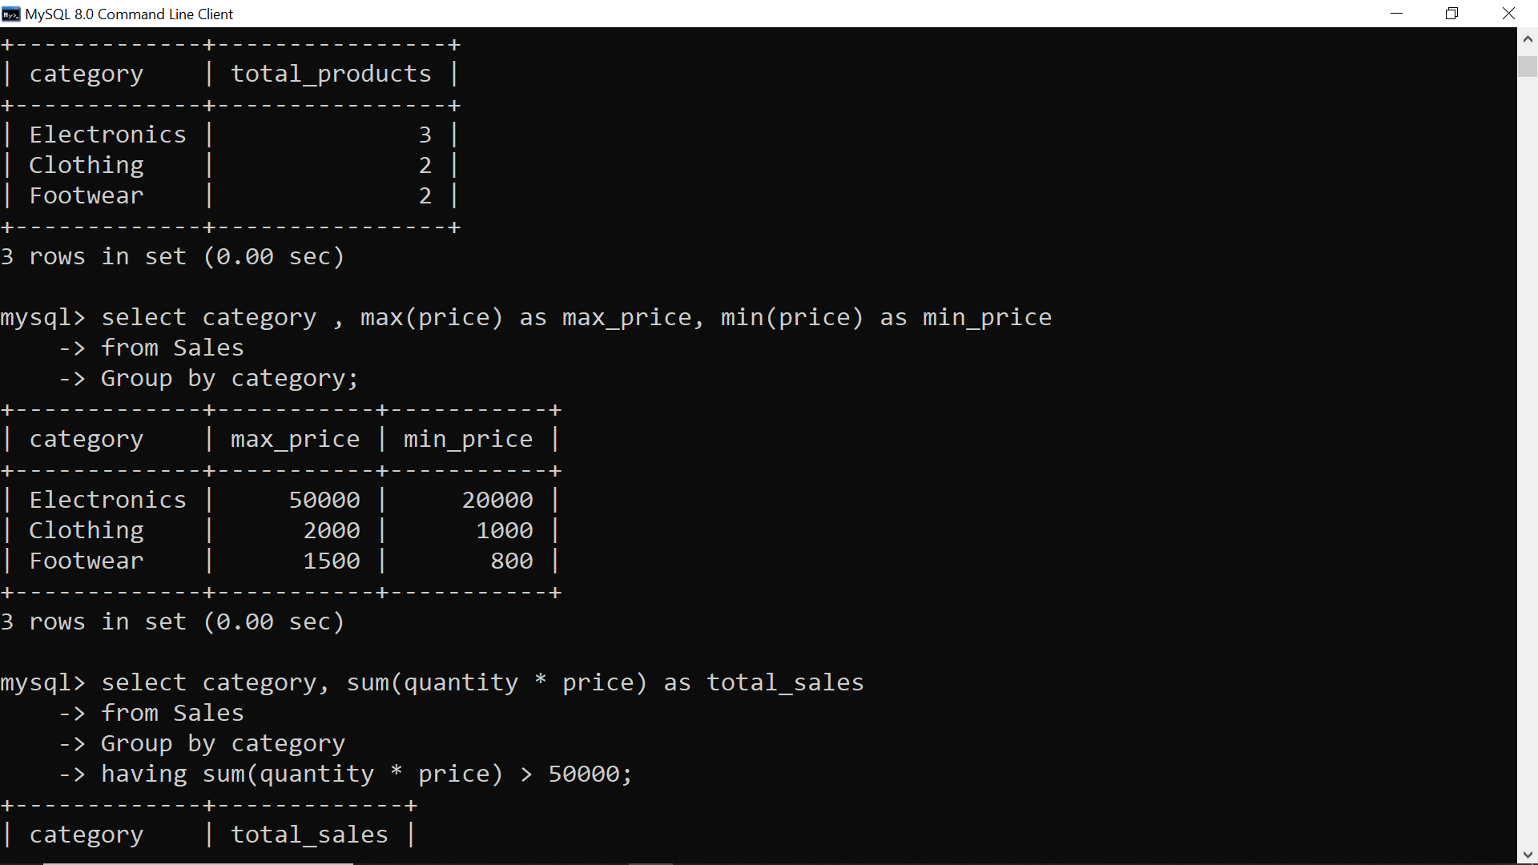
-- ========== 6. HAVING CLAUSE ==========

