Experiment 7

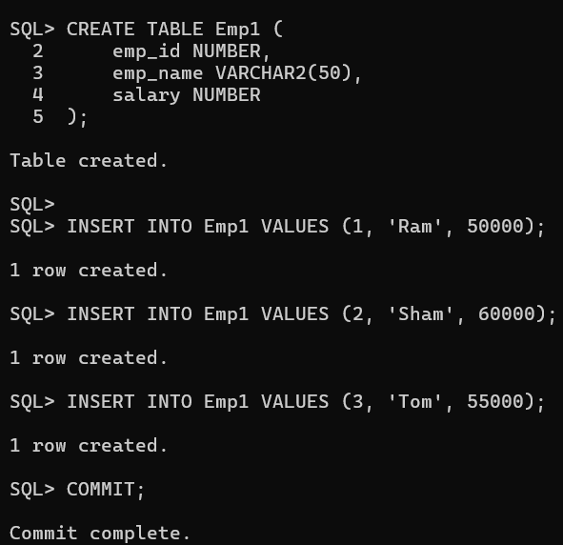

1. Stored Procedure Using Explicit Cursor

SET SERVEROUTPUT ON;
CREATE OR REPLACE PROCEDURE show_employee_details IS
CURSOR emp_cursor IS
SELECT emp_id, emp_name, salary FROM Emp1;

v_id Emp1.emp_id%TYPE;
v_name Emp1.emp_name%TYPE;
v_salary Emp1.salary%TYPE;

BEGIN
OPEN emp_cursor;

LOOP
FETCH emp_cursor INTO v_id, v_name, v_salary;
EXIT WHEN emp_cursor%NOTFOUND;

DBMS_OUTPUT.PUT_LINE(
'ID: ' || v_id ||
', Name: ' || v_name ||
', Salary: ' || v_salary
);
END LOOP;

CLOSE emp_cursor;
END;
/
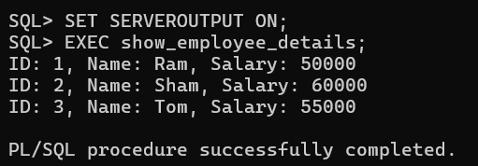

2. Stored Procedure Using Parameterized Cursor
SET SERVEROUTPUT ON;

CREATE OR REPLACE PROCEDURE show_high_salary1(p_salary NUMBER) IS
CURSOR emp_cursor IS
SELECT emp_name, salary
FROM Emp1
WHERE salary > p_salary;

v_name Emp1.emp_name%TYPE;
v_salary Emp1.salary%TYPE;

BEGIN
OPEN emp_cursor;

LOOP
FETCH emp_cursor INTO v_name, v_salary;
EXIT WHEN emp_cursor%NOTFOUND;

DBMS_OUTPUT.PUT_LINE(v_name || ' earns ' || v_salary);
END LOOP;

CLOSE emp_cursor;
END;
/
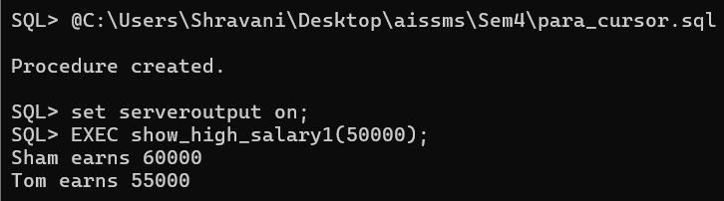

3. Function Using Cursor (Returns Total Salary)

SET SERVEROUTPUT ON;
CREATE OR REPLACE FUNCTION total_salary1
RETURN NUMBER IS

CURSOR emp_cursor IS
SELECT salary FROM Emp1;

v_salary Emp1.salary%TYPE;
v_total NUMBER := 0;

BEGIN
OPEN emp_cursor;

LOOP
FETCH emp_cursor INTO v_salary;
EXIT WHEN emp_cursor%NOTFOUND;

v_total := v_total + v_salary;
END LOOP;

CLOSE emp_cursor;

RETURN v_total;
END;
/

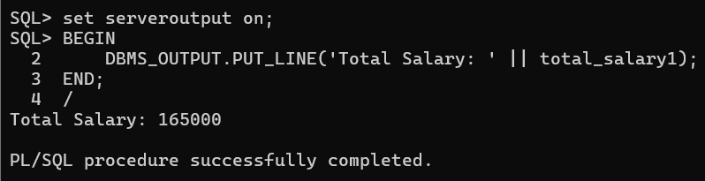
Experiment 8

