Experiment 8
1. Setup Table
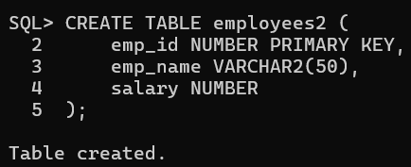
1. Trigger: Salary Validation
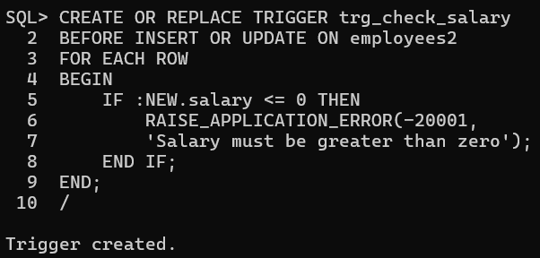
Output:
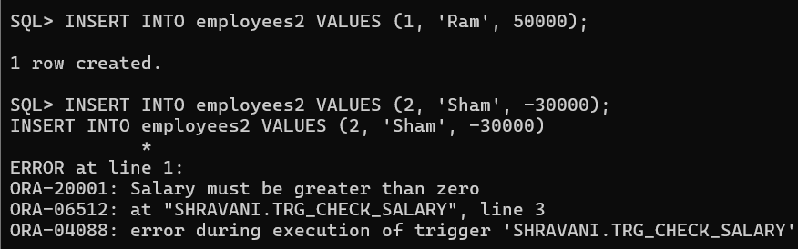
2. Trigger: Prevent Deletion (High Salary)
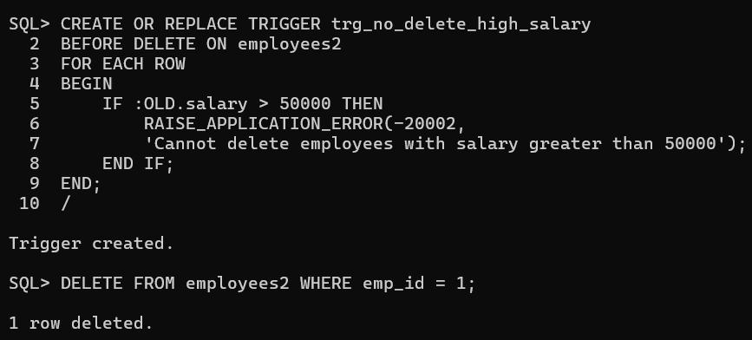

3. Trigger: Audit Log
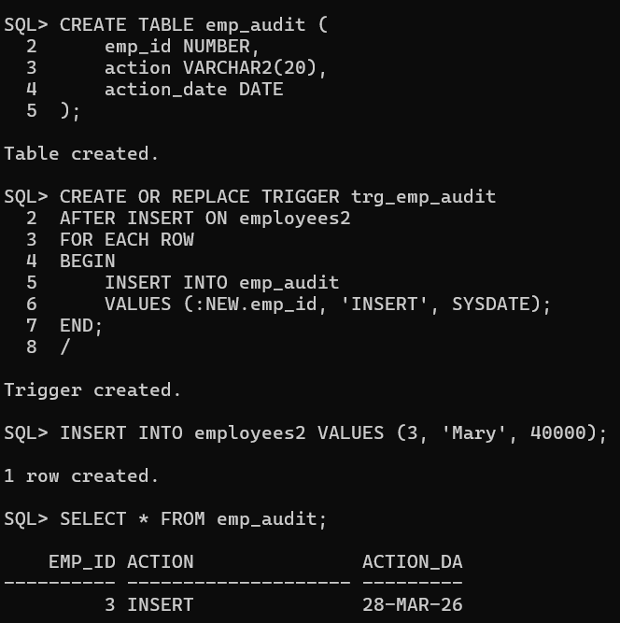
4. Trigger: Default Salary
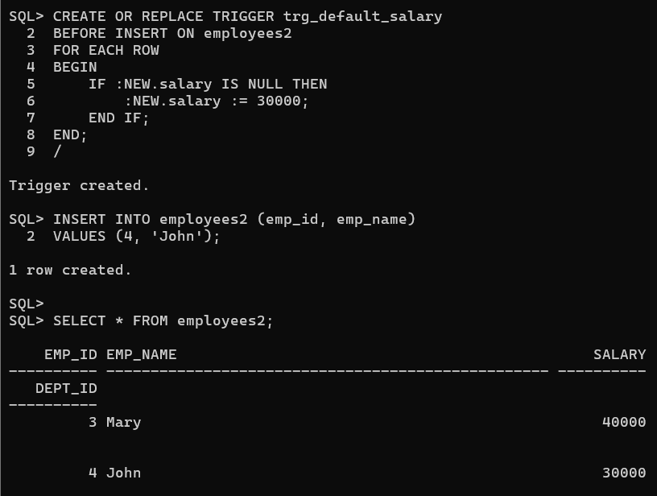

5. Trigger: Referential Integrity
