Experiment 9

1. Create Database and Collection
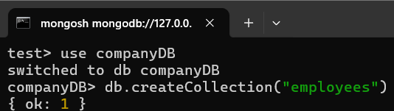

2. Insert Documents (Create)
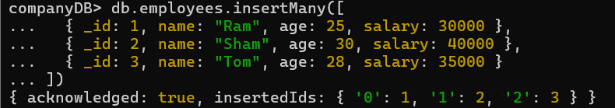

3. Read Data
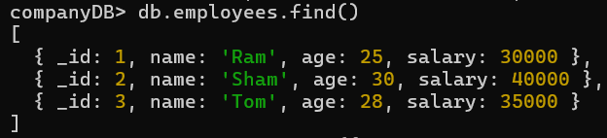

4. Using Logical Operators
$and
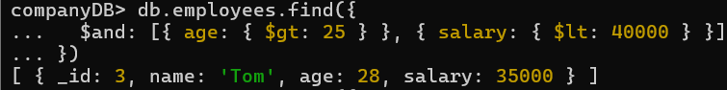
$or
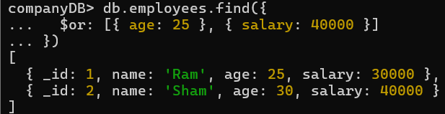

5. Update Data
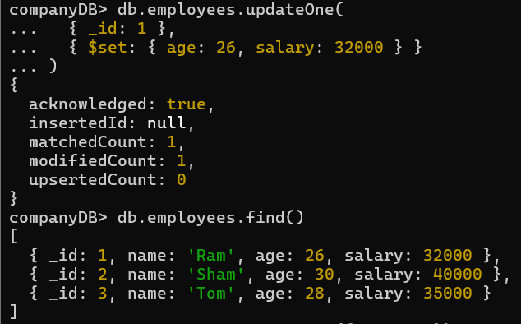
6. Delete Data
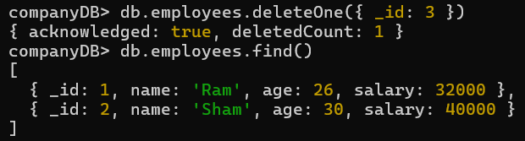

Experiment 10
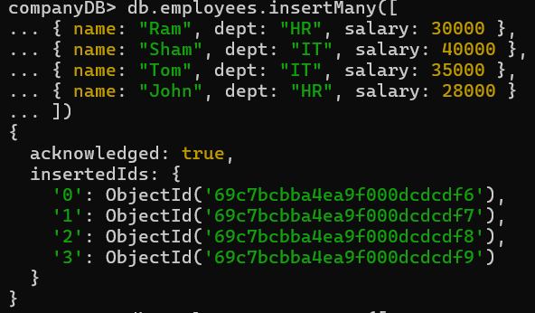
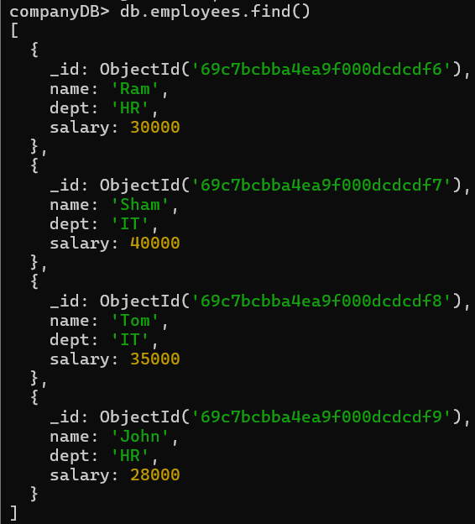
1. Aggregation
(a)Group By
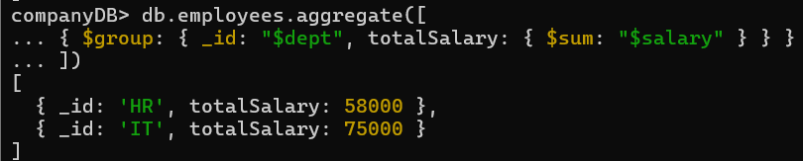
(b)Filter & Sort
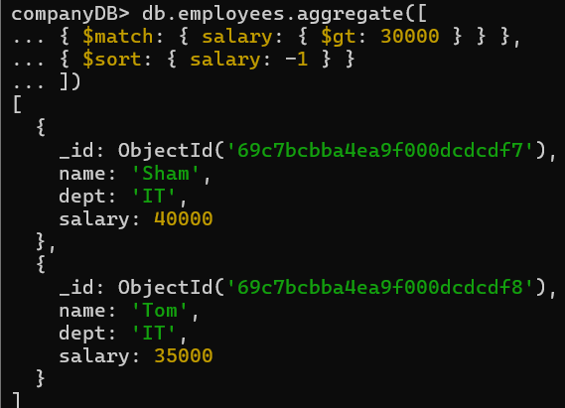
(c)Project
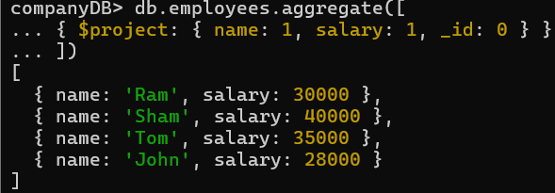
2.Indexing
(a) Create Single Field Index
(b) Create Compound Index
(c) Create Unique Index
(d) View All Indexes
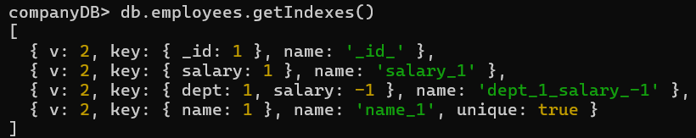
(e) Drop Specific Index
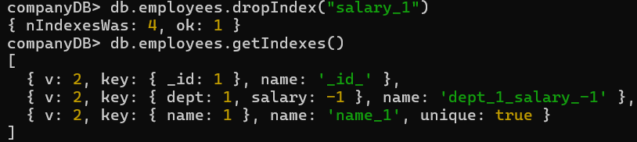
(f) Drop All Indexes
