**MINI PROJECT**

**AIM-** To implement library management system.

**THEORY-** WORKING AND ITS EXECUTION

It features the usage of database creation.

Databases can be created using the Microsoft access.

Using an appropriate IDE like Netbeans, we first create a layout for the activity screens.

In our case , screens are:-

Return Book

Add Member

Issue A Book

Then the created screen is linked with the database using the ODBC of the appropriate 32/64 bit system.

We can use the packages like AWT/Swing in JForms.

**OUTPUT: -**

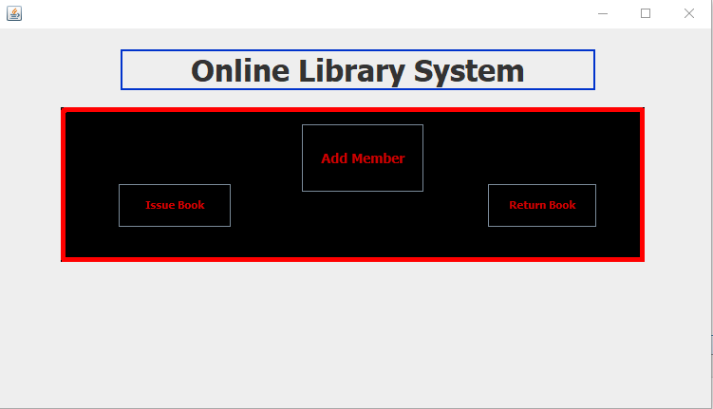

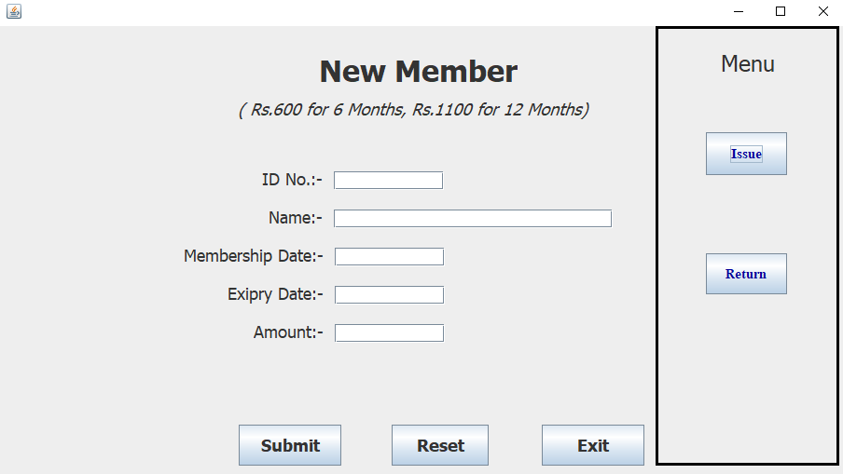

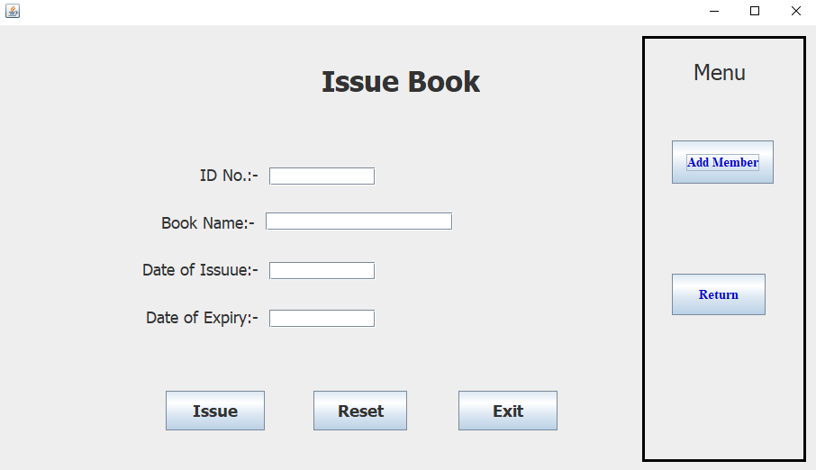

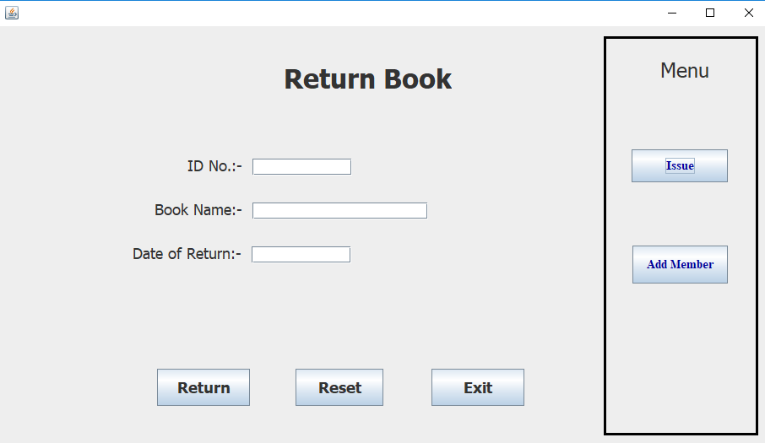

**CONCLUSION-**Thus we have successfully implemented a library management system which can be used in practical applications.