Experiment – 10

Aim:-
Load and display JSON data using fetch() and jQuery $.getJSON(); render results dynamically in a table.

Software/Tools Required:-
- Visual Studio Code (or any text editor)
- Web Browser (Google Chrome/Microsoft Edge)
- HTML, CSS, and JavaScript

Theory:-
The JSON (JavaScript Object Notation) is a lightweight and widely used data-interchange format for storing and transferring structured data. It represents information in the form of key-value pairs and arrays, making it easy for both humans and web applications to read and process. JSON is commonly used in web applications to exchange data between a client and a server.
In this experiment, JSON data is loaded and displayed dynamically in an HTML table using two different methods: the JavaScript fetch() API and the jQuery $.getJSON() method. The webpage contains buttons that allow the user to load student details such as ID, Name, and Email from a JSON file.
The fetch() API is a modern JavaScript feature used to make HTTP requests and retrieve resources such as JSON files. It returns a Promise that can be handled using .then() and .catch(). The response.json() method is used to convert the received JSON data into a JavaScript object or array. The data can then be processed using JavaScript and dynamically inserted into the HTML table.
The jQuery $.getJSON() method provides a simple way to retrieve JSON data from a specified file or URL using an HTTP GET request. It automatically parses the JSON response and passes the resulting data to a callback function. The retrieved student information can then be used to create table rows and display the data on the webpage.
The experiment also demonstrates DOM manipulation, where JavaScript is used to create or update HTML elements dynamically based on the retrieved JSON data. Instead of writing every student record directly in the HTML code, the records are generated from the JSON file at runtime. This makes the webpage more flexible and easier to update, because apparently humans eventually discovered that copying four rows of data by hand is not a sustainable software architecture.

Output:-
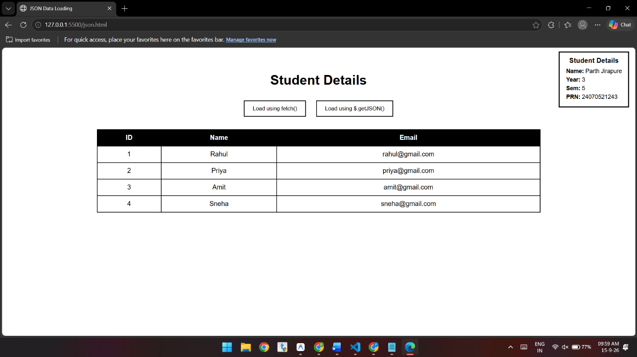

Conclusion:-
This experiment demonstrates how JSON, fetch(), $.getJSON(), and DOM manipulation are used to retrieve and dynamically display data in an HTML table. It provides practical understanding of JSON parsing and asynchronous data retrieval.

