Experiment – 8

Aim:-
Access and validate form fields using events; design a gym admission form with live input checks.

Software/Tools Required:-
- Visual Studio Code (or any text editor)
- Web Browser (Google Chrome/Microsoft Edge)
- HTML, CSS, and JavaScript

Theory:-
The Document Object Model (DOM) is a programming interface that represents an HTML document as a tree of elements. JavaScript can use the DOM to access, modify, and validate HTML elements dynamically. DOM manipulation allows web pages to respond to user actions without reloading the page.

In this experiment, DOM manipulation and event handling are used to develop an interactive Gym Admission Form. The form collects details such as the user's Full Name, Email, Mobile Number, Age, and Membership Plan. JavaScript is used to access these form fields and check whether the entered information is valid.

Event handling is used to detect user actions such as entering data, changing values, leaving fields, and submitting the form. Live validation displays appropriate error messages when invalid data is entered. For example, the name must contain at least 3 characters, the mobile number must contain exactly 10 digits, and the age must be between 16 and 80.

This experiment demonstrates how DOM methods, JavaScript events, and form validation work together to create a dynamic and user-friendly web form. It provides practical understanding of how form elements can be accessed, validated, and updated based on user interaction.

Output:-

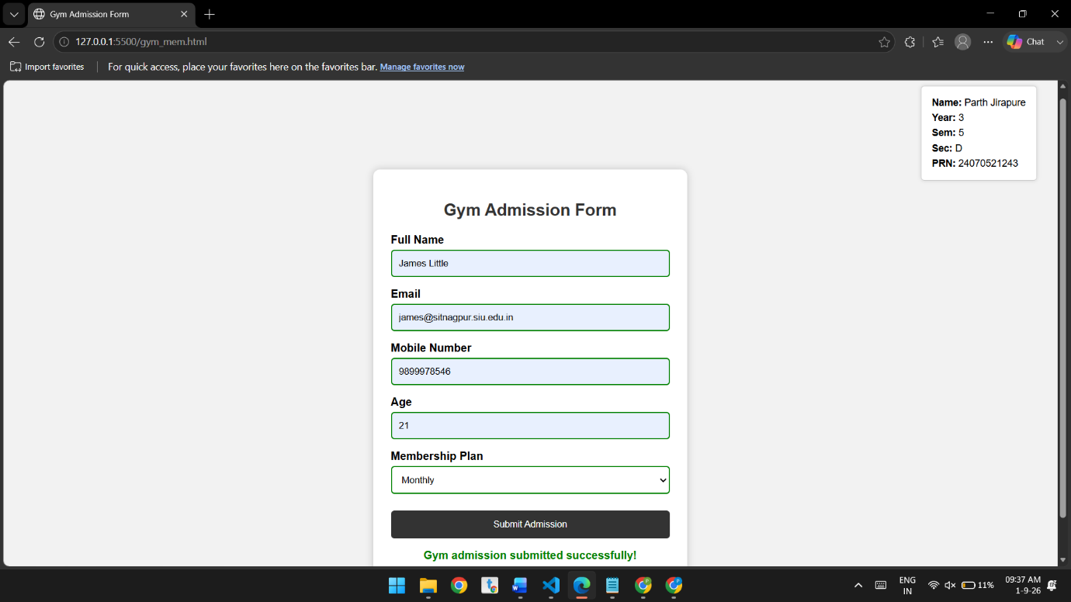
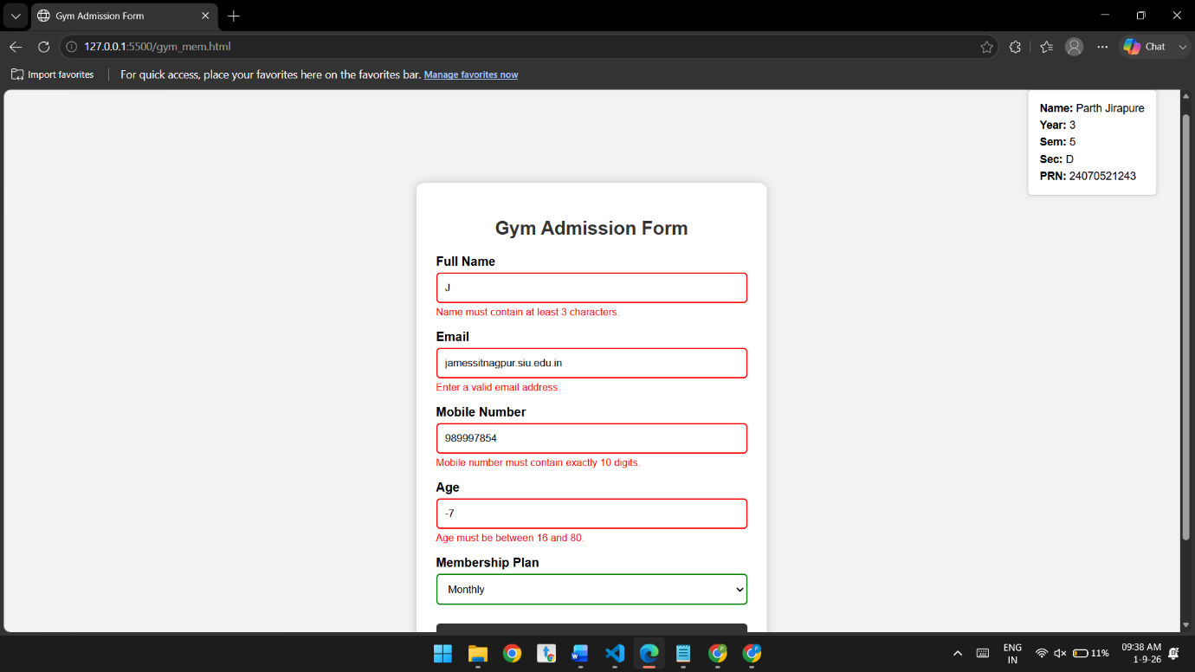

Conclusion:-
The gym admission form was successfully implemented with event-based live validation. It provides immediate feedback for invalid inputs and accepts the form only when all required details are valid.

