Experiment – 6

Aim:-
Use string functions and regex for email validation, data extraction, and text analysis.

Software/Tools Required:-
- Visual Studio Code (or any text editor)
- Web Browser (Google Chrome/Microsoft Edge)
- HTML, CSS, and JavaScript

Theory:-
String functions are used to manipulate and analyze text data, while regular expressions (Regex) are patterns used to search, match, validate, and extract specific information from strings. In this experiment, both techniques are applied to perform three important operations.
1. Email Validation:
A regular expression is used to check whether an entered email address follows a valid format. A typical pattern verifies the username, the @ symbol, the domain name, and the domain extension. For example, an address such as parthjirapure@gmail.com matches the required pattern and is considered valid.
2. Data Extraction:
Regex can identify specific types of information within a larger text. In this experiment, regular expressions are used to extract email addresses and phone numbers from the given paragraph. Methods such as match(), matchAll(), or replace() can be combined with Regex patterns to locate the required data efficiently.
3. Text Analysis:
String functions can be used to calculate the number of characters, words, and sentences in a text. Functions such as length, split(), toUpperCase(), and toLowerCase() help process the text. The experiment also converts the input into uppercase and lowercase forms, demonstrating basic string transformation and analysis.

Output:-
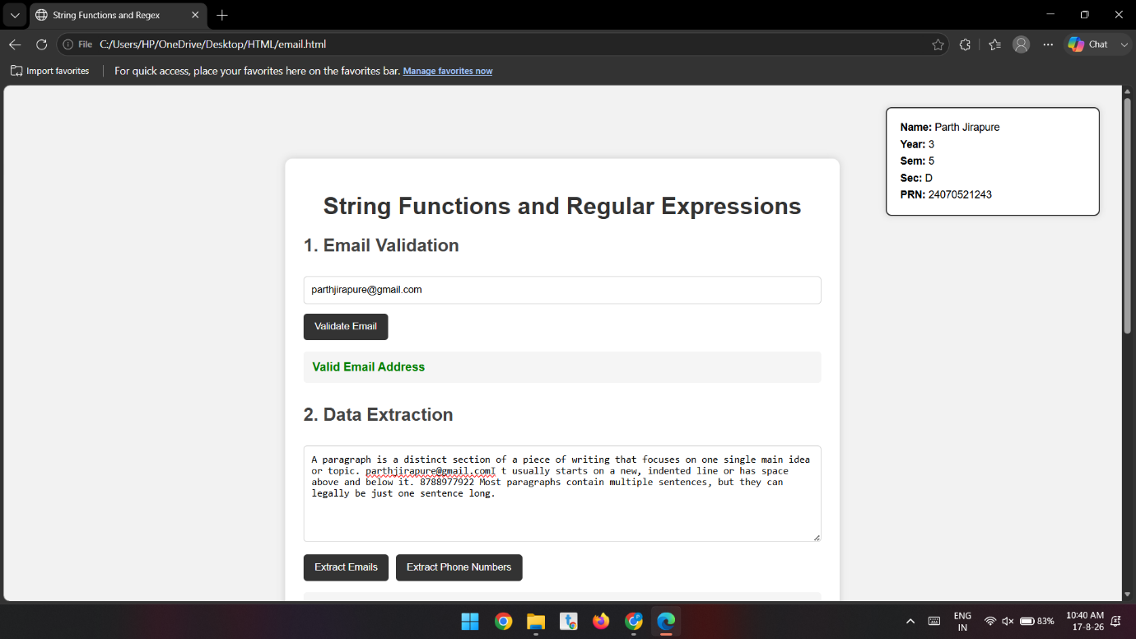
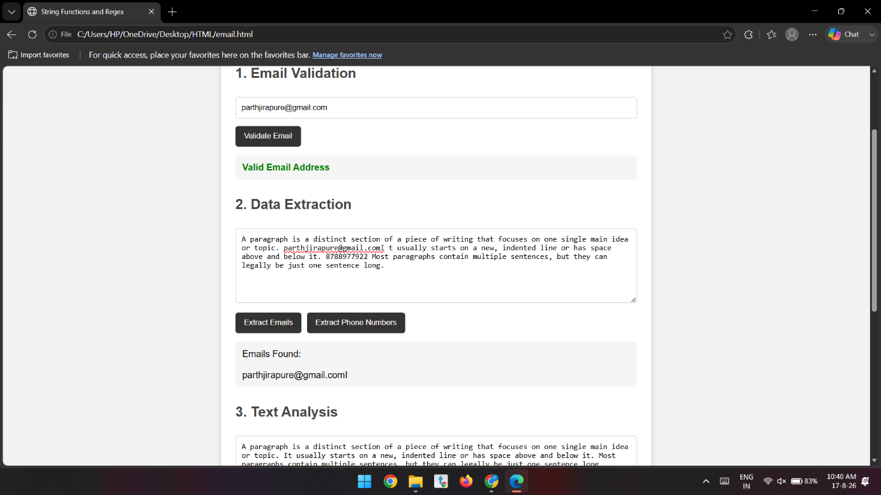
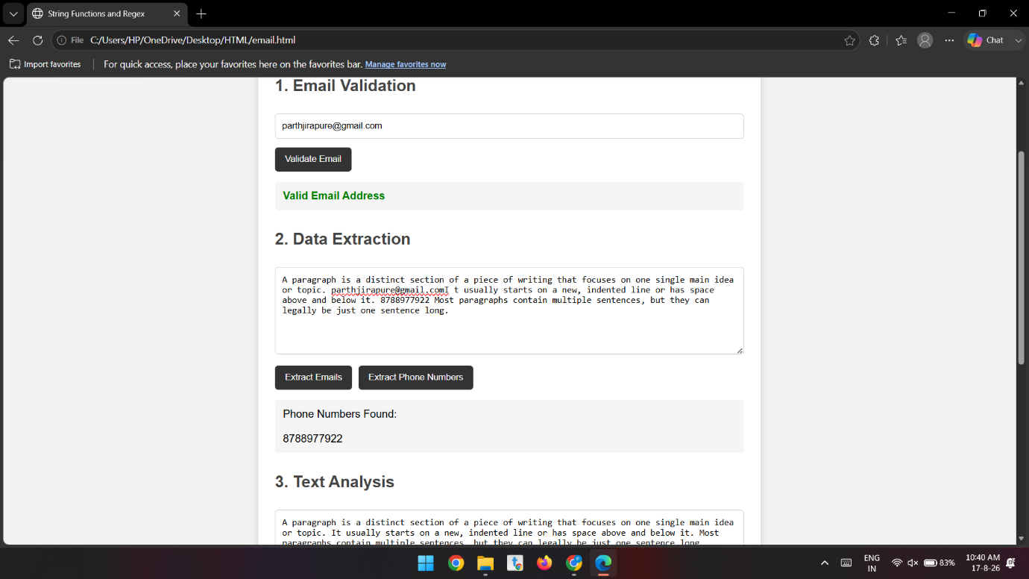

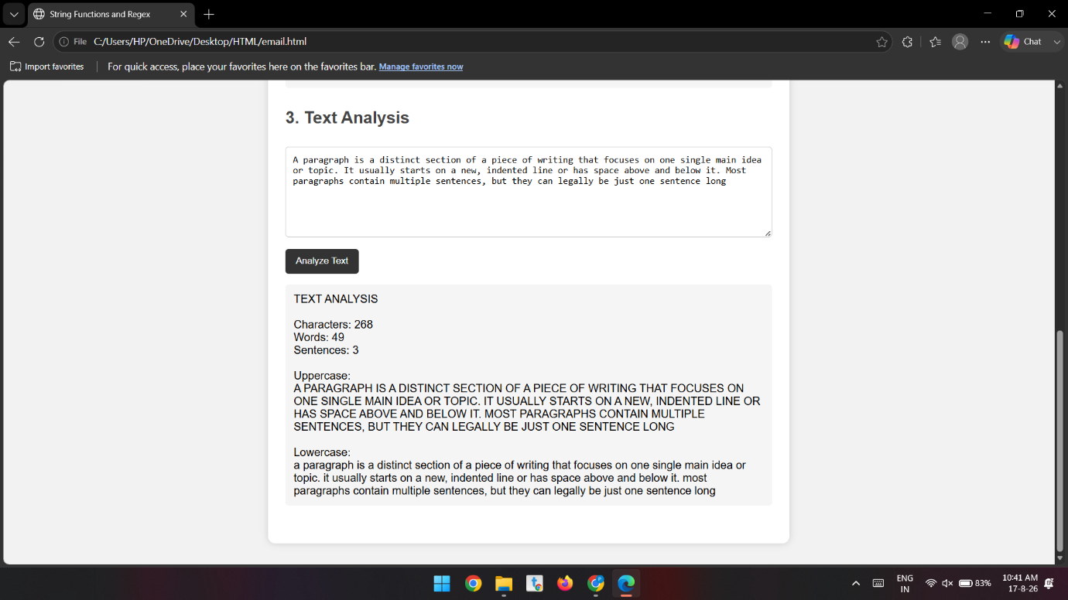

Conclusion:-
The experiment successfully demonstrated the use of string functions and regular expressions for email validation, data extraction, and text analysis. It showed that JavaScript provides efficient tools for processing and analyzing text data.

