Experiment – 5

Aim:-
Apply array methods and object handling; create a cart total calculator with discount logic.

Software/Tools Required:-
- Visual Studio Code (or any text editor)
- Web Browser (Google Chrome/Microsoft Edge)
- HTML, CSS, and JavaScript

Theory:-
A cart total calculator in JavaScript can be implemented using arrays, objects, and array methods to manage products and calculate the final payable amount. Each product can be represented as an object containing properties such as product name, price, and quantity. An array stores all the product objects in the shopping cart.

Array methods make the calculation simpler and more efficient:-

map() can be used to calculate the subtotal of each product by multiplying its price by its quantity.
reduce() can calculate the total cart value by adding all product subtotals.
filter() can be used to identify products or conditions that meet specific requirements, if needed.
Object handling allows individual product details to be accessed and modified using properties such as price, quantity, and name.
Conditional statements can implement discount logic. For example, a percentage discount can be applied when the cart total exceeds a specified amount.
The final amount is calculated by subtracting the discount from the original cart total.

A typical calculation is:

Subtotal = Σ (Product Price × Quantity)

If the subtotal satisfies the discount condition:

Discount = Subtotal × Discount Rate

Final Total = Subtotal − Discount

Output:-
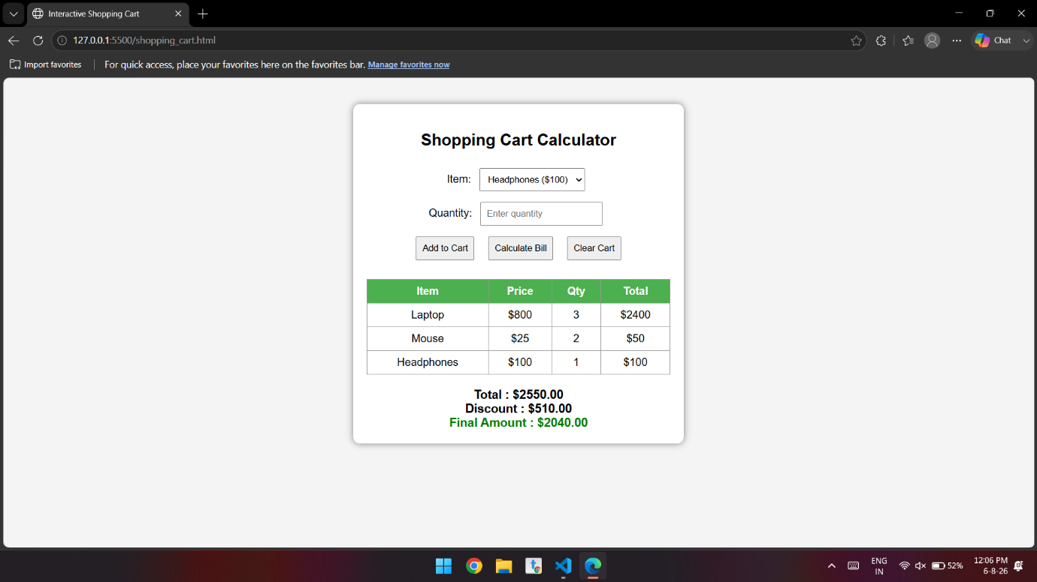

Conclusion:-
The experiment successfully demonstrates the use of arrays, objects, map(), reduce(), and conditional statements in JavaScript to create a cart total calculator. The program can calculate individual product subtotals, determine the overall cart value, and apply discounts according to predefined conditions. This provides a practical understanding of how array methods and object handling can be used to solve real-world programming problems while keeping the code organized, reusable, and efficient.

