Experiment – 4

Aim:-
Use function types, scope, and closures; apply try-catch; build a palindrome checker.

Software/Tools Required:-
- Visual Studio Code (or any text editor)
- Web Browser (Google Chrome/Microsoft Edge)
- HTML, CSS, and JavaScript

Theory:-
Functions are reusable blocks of code that perform specific tasks. They can be declared in different ways, such as named functions, anonymous functions, arrow functions, and immediately invoked function expressions (IIFEs). Function types improve code modularity, readability, and reusability.

Scope defines the accessibility of variables in a program. Variables may have global scope, function scope, or block scope. Proper use of scope prevents naming conflicts and protects data from unintended modification.

A closure is created when an inner function retains access to the variables of its outer function even after the outer function has finished execution. Closures are useful for data encapsulation, maintaining state, and implementing private variables.

Exception handling using try-catch allows a program to detect and handle runtime errors gracefully. The try block contains code that may generate an exception, while the catch block handles the error without terminating the program unexpectedly.

A palindrome checker determines whether a string or number reads the same forwards and backwards. The process generally involves removing unnecessary characters (such as spaces and punctuation), converting the text to a common case, reversing it, and comparing it with the original string. If both match, the input is identified as a palindrome.

Output:-
Palindrome Checker :-

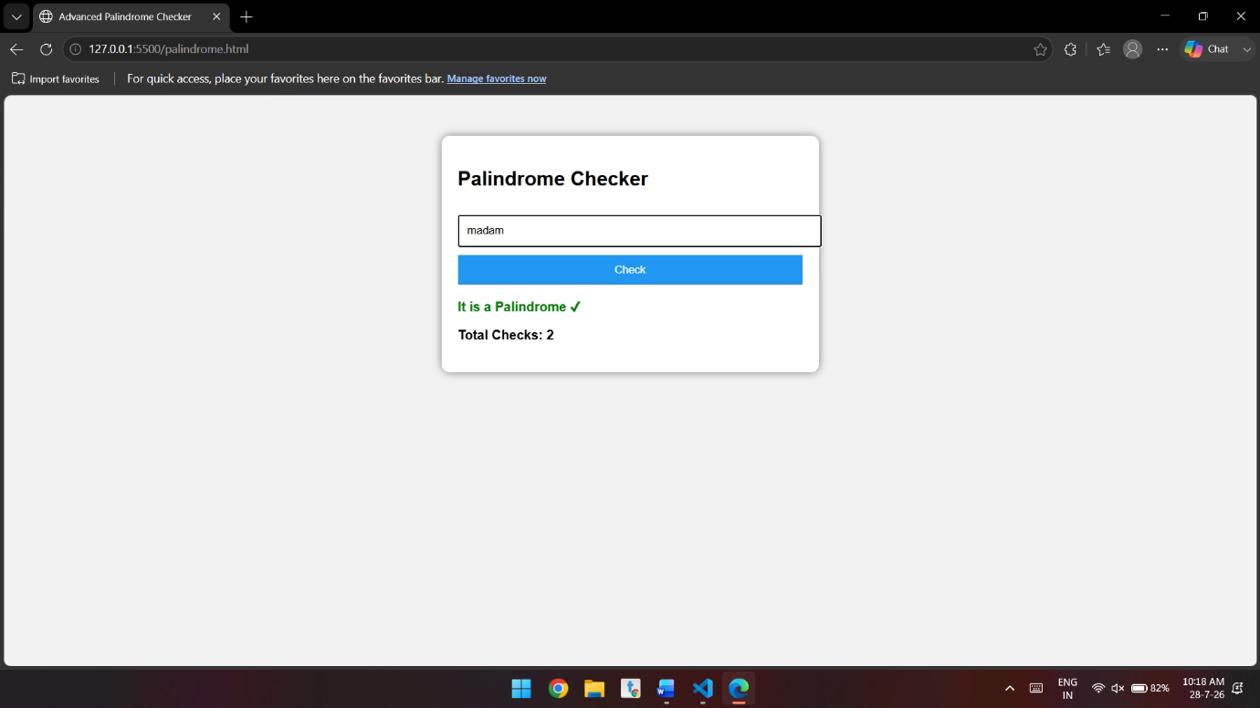

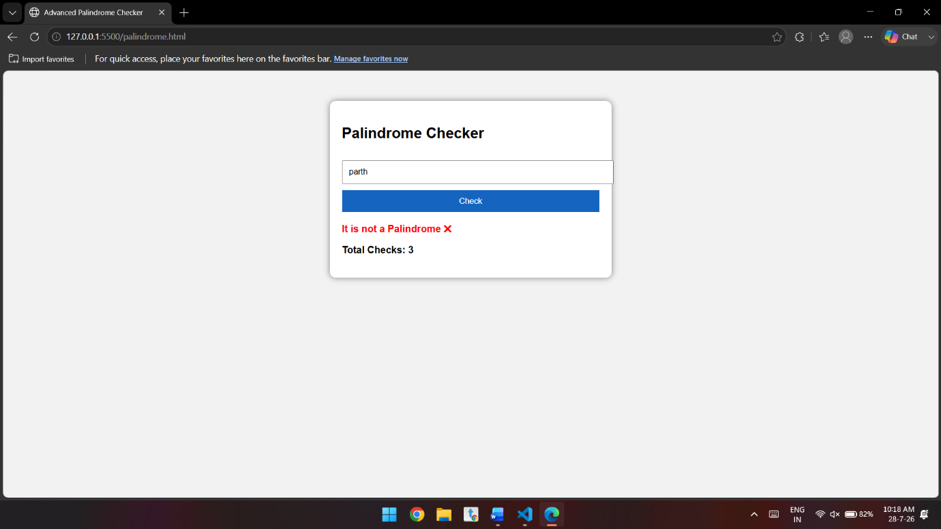

Conclusion:-
In this experiment, the concepts of function types, variable scope, closures, and exception handling were successfully studied and implemented. Different function types demonstrated flexible ways of organizing code, while scope rules controlled variable accessibility. Closures showed how functions can preserve access to outer variables, enabling data encapsulation and state management. The use of try-catch improved program reliability by handling errors effectively. Finally, the palindrome checker applied these concepts in a practical program, verifying whether a given input is a palindrome. Overall, the experiment strengthened the understanding of fundamental programming concepts and highlighted the importance of writing modular, maintainable, and error-resistant code.

