Experiment – 9

Aim:-
Implement localStorage and sessionStorage to save user preferences like theme settings.
Software/Tools Required:-
- Visual Studio Code (or any text editor)
- Web Browser (Google Chrome/Microsoft Edge)
- HTML, CSS, and JavaScript

Theory:-
The Web Storage API provides a simple way to store data in a user's web browser using key-value pairs. It allows JavaScript to save information on the client side without requiring a server or database. The two main storage mechanisms provided by the browser are localStorage and sessionStorage.
In this experiment, localStorage and sessionStorage are used to implement a Theme Settings page that allows the user to select and save a preferred Light or Dark theme. JavaScript is used to access the selected theme and store the preference in the browser's storage.
The localStorage mechanism is used when the user wants the selected theme to remain saved even after closing or reopening the webpage. The selected theme is stored using methods such as setItem() and can later be retrieved using getItem(). This makes localStorage suitable for storing permanent user preferences such as theme, language, or display settings.
The sessionStorage mechanism is used to store the selected theme temporarily during the current browser session. The preference remains available while the session is active but is removed when the browser tab or session is closed. This makes sessionStorage useful for temporary user settings that do not need to be remembered permanently.
The experiment also provides a Clear Preferences option to remove the stored theme settings. JavaScript uses methods such as removeItem() or clear() to delete the stored information. A status message is displayed on the page to indicate whether the theme was saved using localStorage, sessionStorage, or whether the preferences were cleared.
This experiment demonstrates how browser storage, JavaScript, and DOM manipulation can work together to maintain user preferences. It provides practical understanding of how data can be stored, retrieved, and removed on the client side, and how persistent and temporary storage differ in web applications.

Output:-
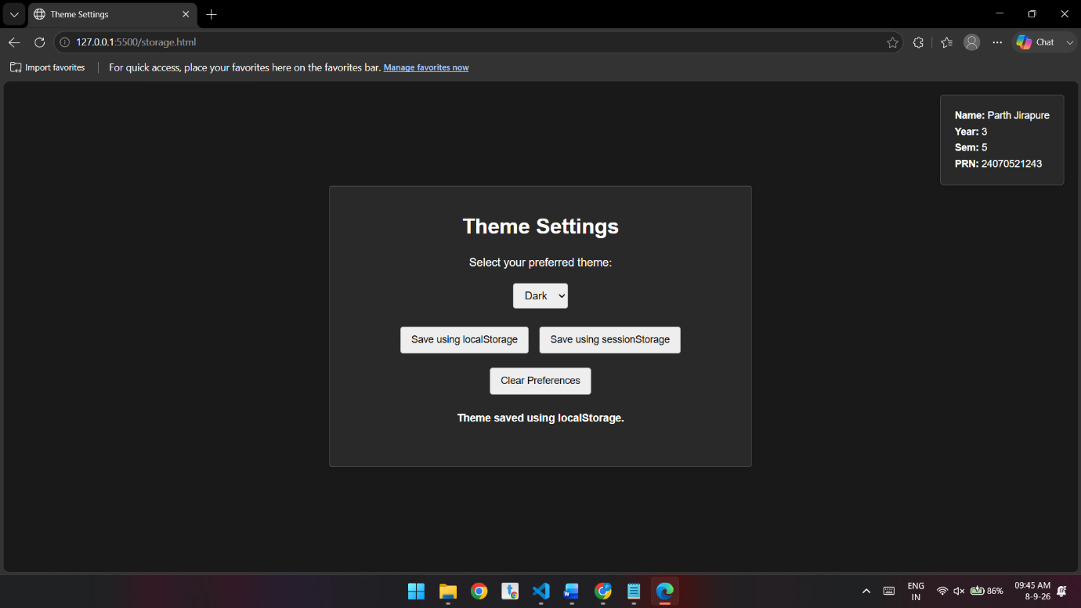
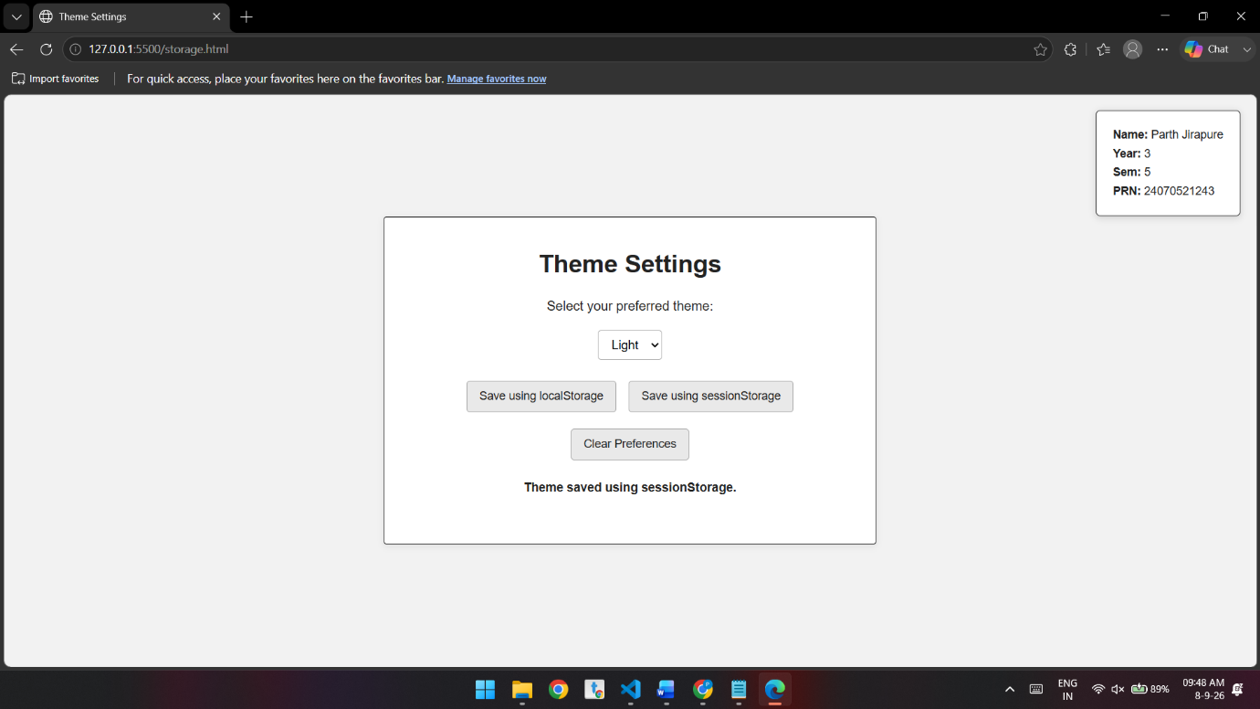

Conclusion:-
The experiment successfully demonstrates the use of localStorage and sessionStorage for storing user preferences such as theme settings. localStorage provides persistent storage, allowing preferences to remain available across browser sessions, whereas sessionStorage provides temporary storage for the current session.

