Experiment – 2

Aim:-
To demonstrate JavaScript integration methods (internal, inline, and external) in a web page and use console functions to display the user's environment information and a welcome message. Also, to understand the concepts of Internal CSS, Inline CSS, and External CSS for styling web pages.

Software/Tools Required:-
- Visual Studio Code (or any text editor)
- Web Browser (Google Chrome/Microsoft Edge)
- HTML, CSS, and JavaScript

Theory:-
This program demonstrates the use of JavaScript variables (var, let, and const), template literals, and object destructuring. The user enters customer details, product name, quantity, and price per item using prompt(). The program calculates the total amount, GST (18%), and the final bill. The result is displayed dynamically on the web page using document.write().

Output:-
Bill :-

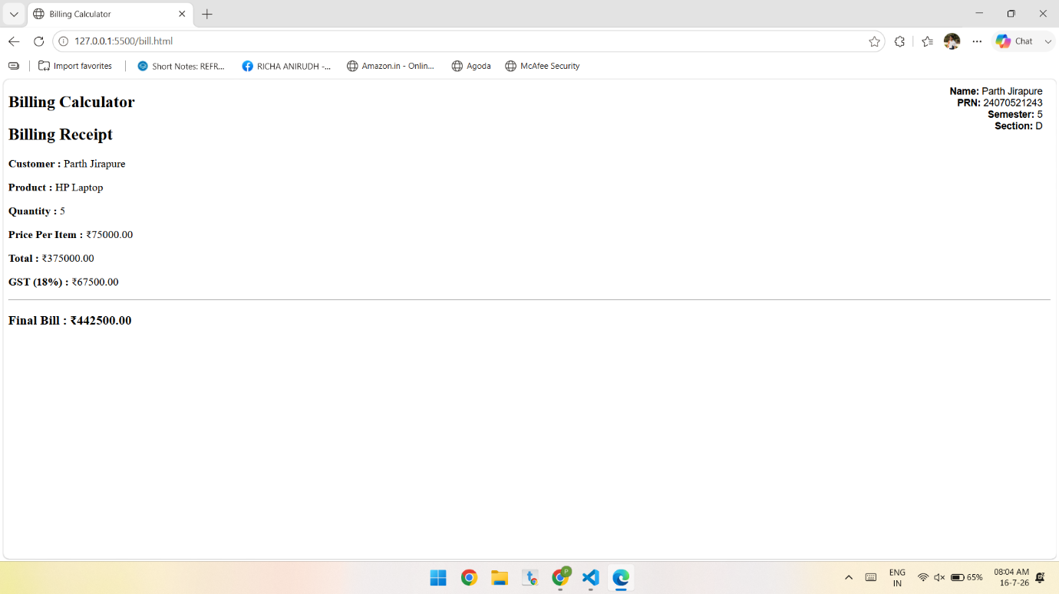
Conclusion:-
The Billing Calculator was successfully implemented using JavaScript. It accepts user input, performs bill and GST calculations, and displays the final bill. The program demonstrates the use of var, let, const, template literals, and object destructuring effectively.

