Experiment – 7

Aim:-
Perform DOM traversal and updates; develop a to-do list app with add, edit, and delete features.

Software/Tools Required:-
- Visual Studio Code (or any text editor)
- Web Browser (Google Chrome/Microsoft Edge)
- HTML, CSS, and JavaScript

Theory:-
The Document Object Model (DOM) is a programming interface that represents an HTML document as a tree of elements. JavaScript can use the DOM to access, traverse, modify, create, and delete HTML elements dynamically. DOM manipulation makes web pages interactive by allowing their content and appearance to change in response to user actions without reloading the page.

In this experiment, DOM traversal and manipulation are used to develop an interactive **To-Do List application**. The application allows the user to add new tasks, edit existing tasks, delete unwanted tasks, and mark tasks as completed. JavaScript is used to select HTML elements, create new elements, update their content, and remove elements from the document.

Event handling is used to detect actions such as clicking the **Add, Edit, Delete, and Check** buttons. When a task is completed, a visual change such as a strikethrough is applied to indicate its completed status. The user can also modify tasks whenever required, making the application simple and flexible to use.

This experiment demonstrates how DOM methods and JavaScript event handling can work together to create a dynamic and user-friendly web application. It provides practical understanding of how webpage elements can be controlled and updated based on user interaction.

Output:-
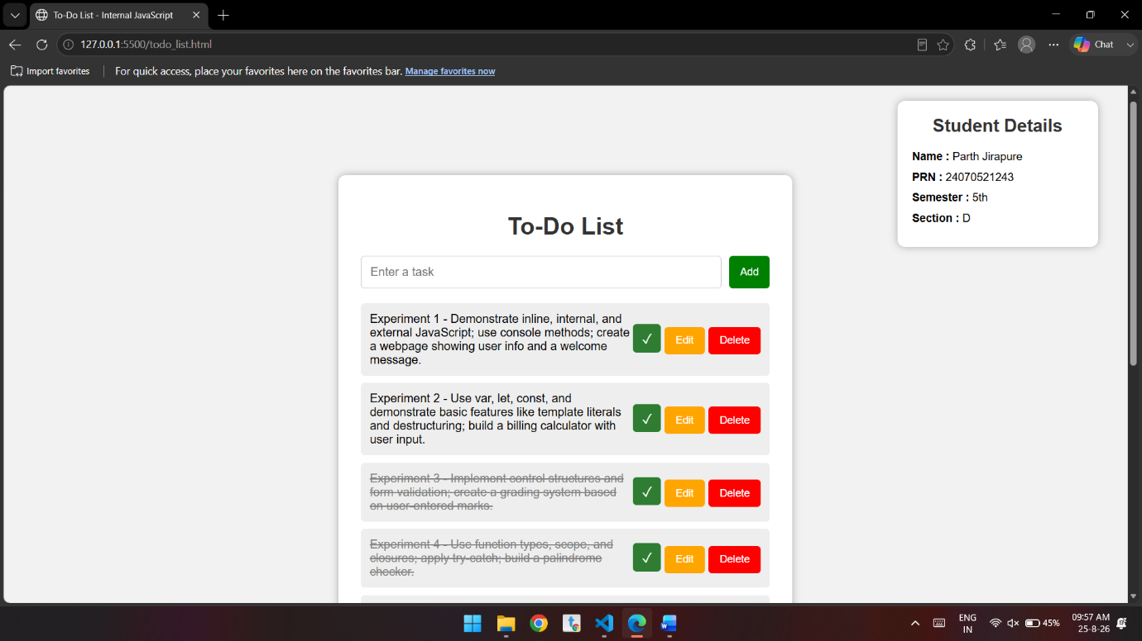
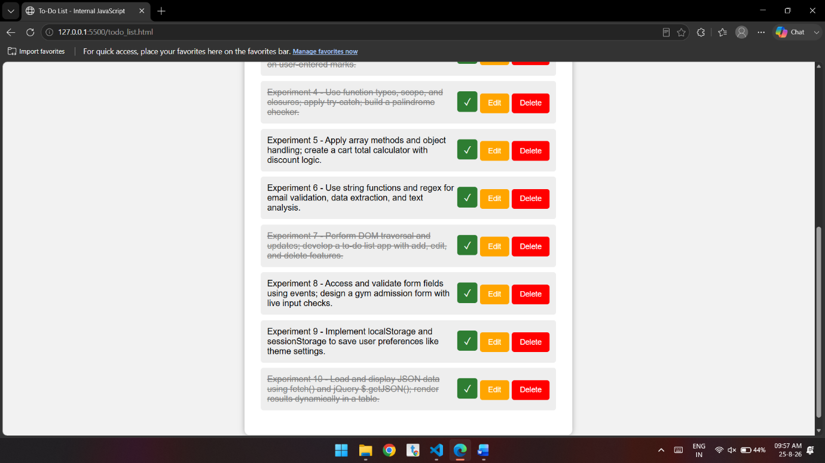

Conclusion:-
The To-Do List application was successfully implemented using HTML, CSS, and JavaScript. It demonstrated **DOM manipulation and event handling** through add, edit, delete, and complete features. The experiment helped in understanding how JavaScript creates dynamic and interactive web pages.

