Experiment – 1

Aim:-
To demonstrate JavaScript integration methods (internal, inline, and external) in a web page and use console functions to display the user's environment information and a welcome message. Also, to understand the concepts of Internal CSS, Inline CSS, and External CSS for styling web pages.

Software/Tools Required:-
- Visual Studio Code (or any text editor)
- Web Browser (Google Chrome/Microsoft Edge)
- HTML, CSS, and JavaScript

Theory:-
JavaScript is a client-side scripting language used to make web pages interactive and dynamic. It can be integrated into an HTML document in three ways:

Internal JavaScript: The JavaScript code is written inside the <script> tag within the HTML file. It is suitable for small projects or page-specific scripts.
Inline JavaScript: The JavaScript code is written directly inside HTML elements using event attributes such as onclick, onmouseover, etc. It is useful for simple actions but is not recommended for large applications.
External JavaScript: The JavaScript code is stored in a separate .js file and linked to the HTML document using the <script src="..."></script> tag. This improves code reusability, readability, and maintenance.
Similarly, CSS (Cascading Style Sheets) is used to style web pages and can be applied in three ways:
Inline CSS: Styles are applied directly to an HTML element using the style attribute.
Internal CSS: Styles are written inside the <style> tag within the HTML document and apply to that page only.
External CSS: Styles are written in a separate .css file and linked to the HTML document using the <link> tag. This is the most efficient and widely used method for styling multiple web pages.

Output:-

Internal Javascript:-

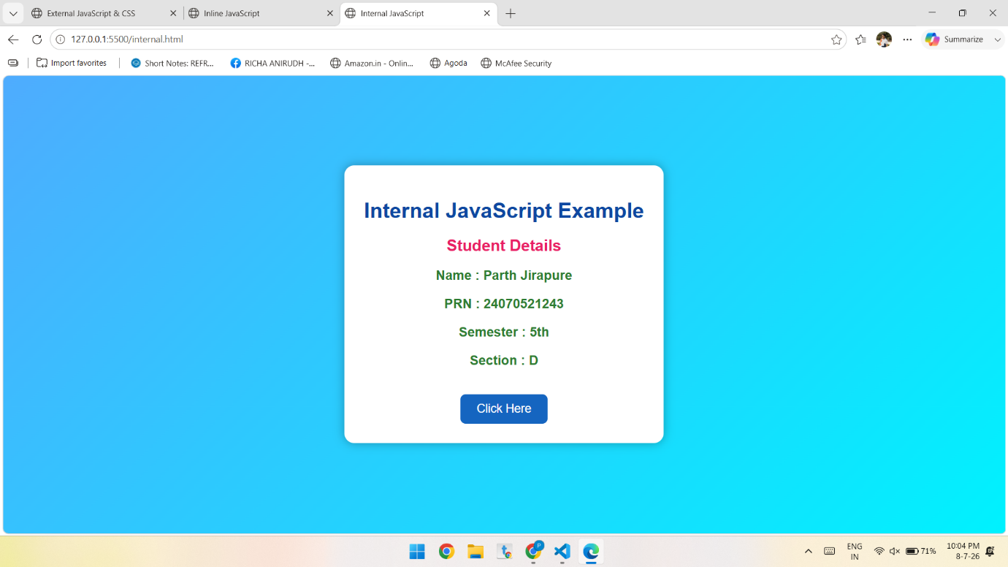

Inline Javascript:-

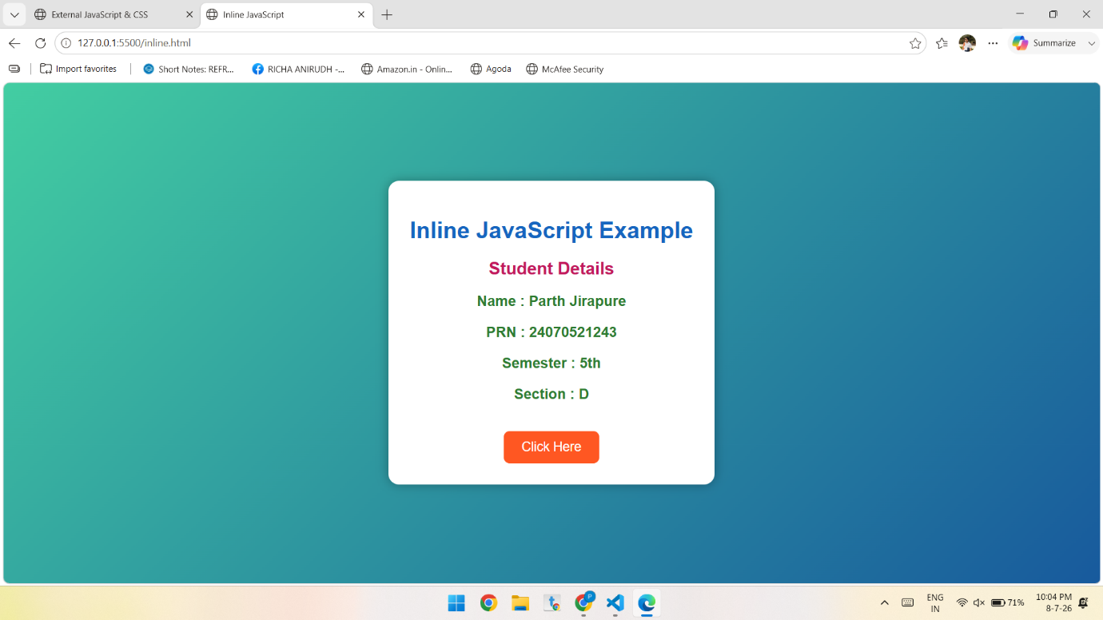
External Javascript:-

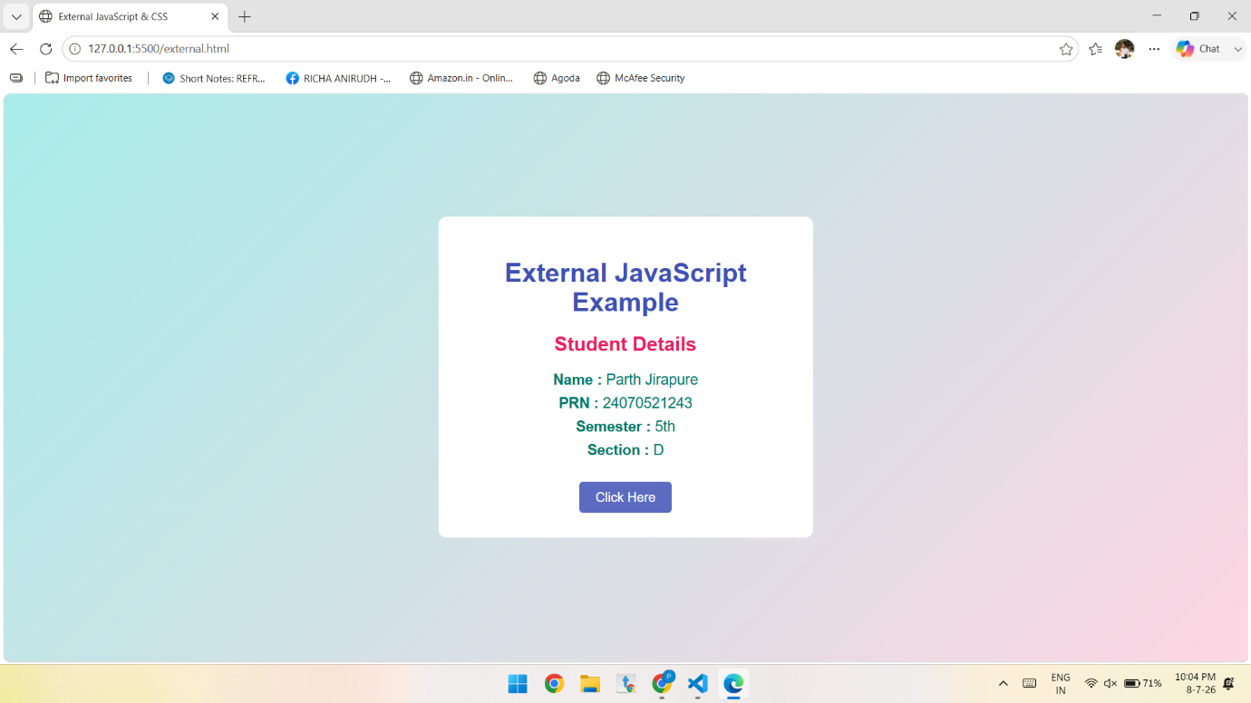

Conclusion:-
The experiment demonstrated the three methods of integrating JavaScript—internal, inline, and external—and showed how console functions can display a welcome message and user environment details for debugging and development purposes. It also explained the three CSS integration methods—inline, internal, and external—which provide different ways to style web pages. Understanding these techniques helps in creating well-structured, interactive, maintainable, and visually appealing web applications.

