Experiment – 3

Aim:-
Implement control structures and form validation; create a grading system based on user-entered marks
Software/Tools Required:-
- Visual Studio Code (or any text editor)
- Web Browser (Google Chrome/Microsoft Edge)
- HTML, CSS, and JavaScript

Theory:-
This program demonstrates the use of JavaScript control structures such as while loops, for loops, and if-else statements along with regular expressions for input validation. The user enters the student's name, PRN, number of subjects, subject names, and marks through prompt() dialogs. The program validates the PRN, subject count, and marks to ensure correct input. It then calculates the total marks, percentage, and assigns a grade based on the percentage obtained.

Output:-
Grade sheet :-

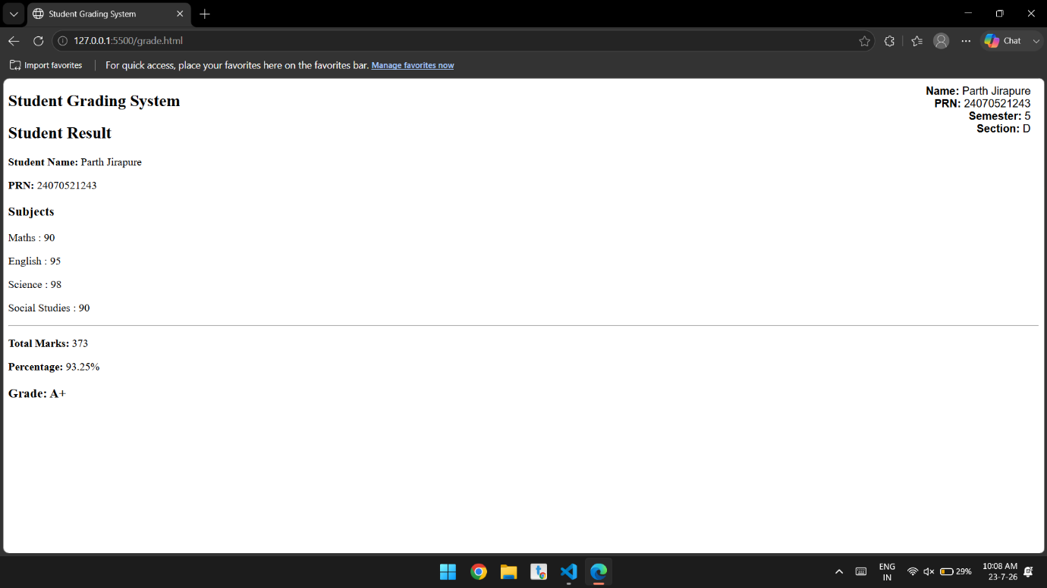

Conclusion:-
The Student Grading System was successfully implemented using JavaScript. It accepts and validates user input, calculates the total marks and percentage, and assigns grades using control structures. The program demonstrates the effective use of loops, conditional statements, regular expressions for form validation, arrays, and dynamic output generation using document.write(). It provides a simple and efficient way to automate student result calculation.

