# Inputs To Mail.

Get Keyboard,Mouse,ScreenShot,Microphone Inputs and Send to your Mail. Purpose of the project is testing the security of information systems

## INSTALLATION

You don't need to do anything for installation just run the script

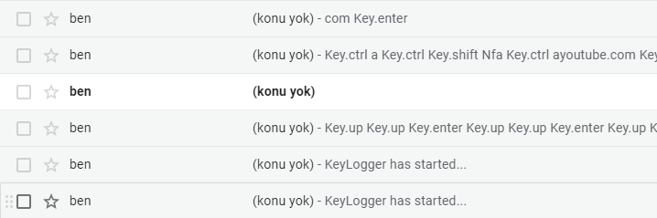

## USAGE

•Create an account on "<https://mailtrap.io/>" using a temp mail.

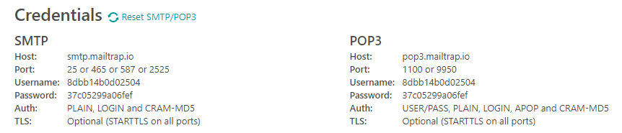

•Set your own SMTP USERNAME and SMTP PASSWORD on "keylogger.py".

•pip install -r requirements.txt

•python3 keylogger.py

•Every 10 seconds,You Get the Data from the Target Computer

•If Target finds the Code and Open the File for Want to Learn your MAIL and Password The Program DELETE itself.

## ANTIVIRUS TEST

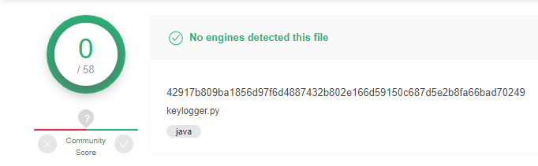

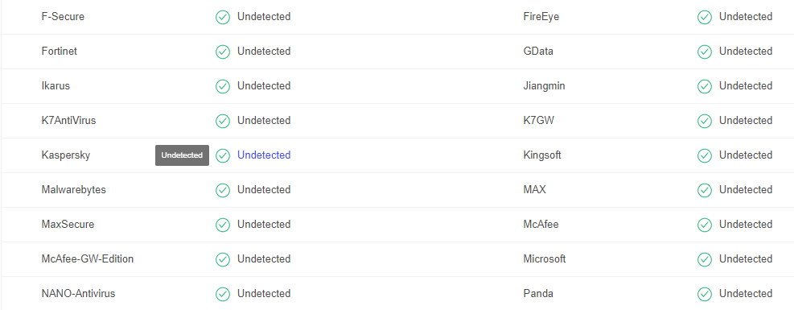

However, if you've made some money using my tools or just want to encourage me to continue creating stuff, please consider giving back on BTC Wallet : 1NqDy1VdF5wkvxBcojbADWexPhPzza6LGF my efforts and help it grow by buying me coffee - but only if you're definitely able to! 😊🎉

### Contact

   