Week 5

Spark Fundamentals, Data Cleaning, Transformation & Aggregation

Name: Parth Milind Kulkarni
Student Id: CT_CSI_DE_1167
Domain: Data Engineering

Objective:
Understand Spark fundamentals and perform data cleaning, transformation, and aggregation using DataFrames. Steps: Understand limitations of MapReduce and advantages of Spark (in-memory processing, speed). Learn Spark DataFrame concepts and immutability. Perform data cleaning operations (remove duplicates, handle null values). Apply filtering conditions on datasets (age range, category, region). Use aggregation functions (count, sum, avg, min, max). Group data using groupBy and apply conditions on aggregated results. Understand wide transformations and shuffle operations. Modify schema (casting, renaming columns). Handle inconsistent data (nulls, empty values, schema issues). Build a complete data processing pipeline combining cleaning and aggregation.

Q1. What are the key limitations of traditional MapReduce that make Spark a preferred choice for modern big data processing?

Traditional MapReduce stores intermediate data on disk, resulting in high disk I/O and slower execution. It is not suitable for iterative algorithms or real-time analytics. Spark performs in-memory computation, offers faster execution, supports multiple APIs, and includes libraries for SQL, ML, Streaming, and Graph processing.

Q2. Explain how Spark uses In-Memory Computing to speed up iterative machine learning algorithms compared to disk-based systems.

Spark caches intermediate results in RAM instead of repeatedly writing to disk. Iterative algorithms reuse cached data, reducing disk I/O and significantly improving performance.

Dataset Loading
Load the Excel dataset using Pandas and convert it into a Spark DataFrame.
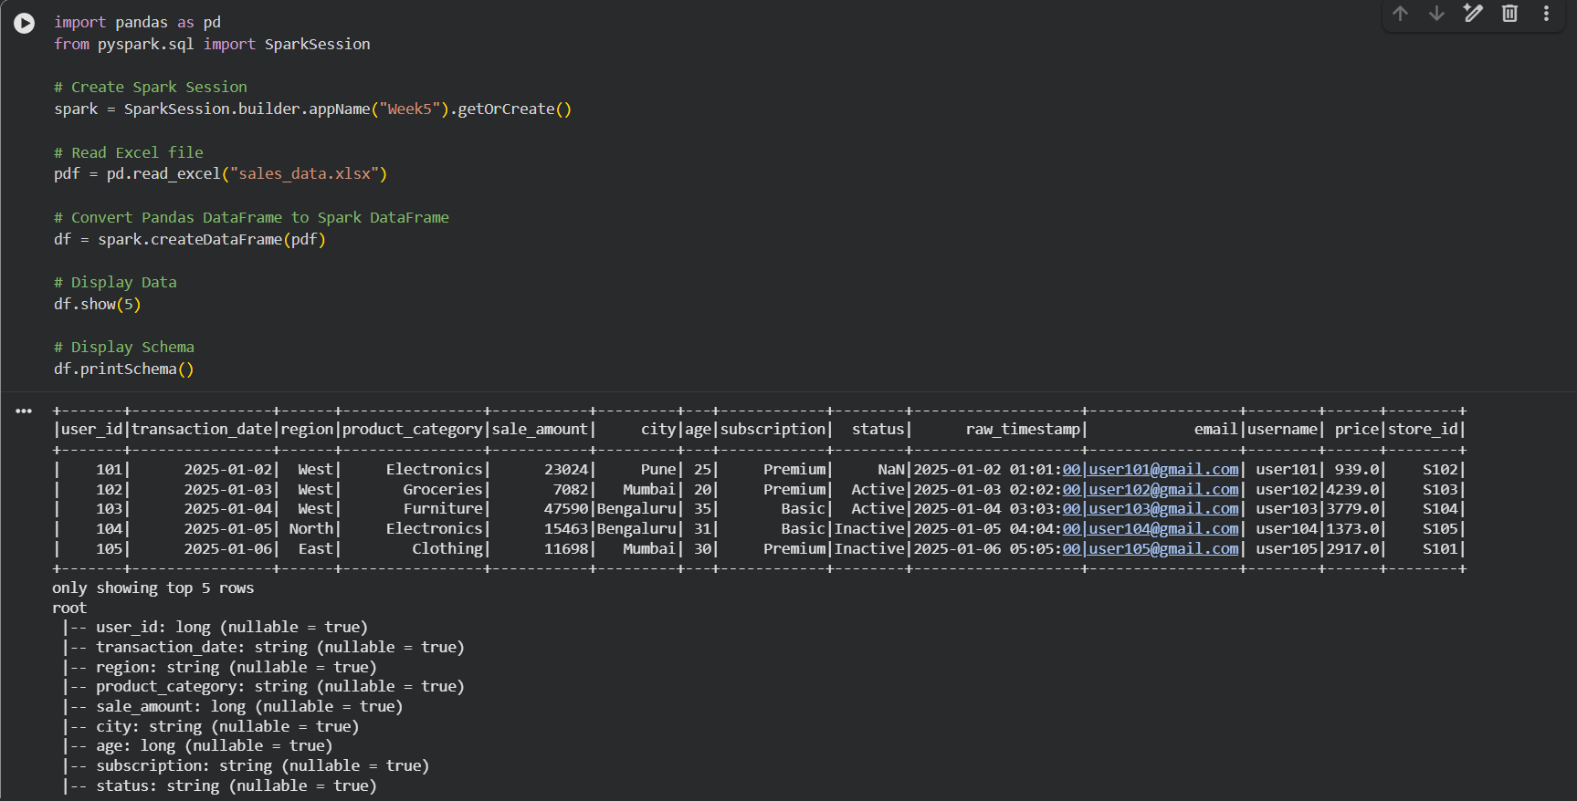

Q3. Remove duplicate rows based on user_id and transaction_date.
Code execution output:
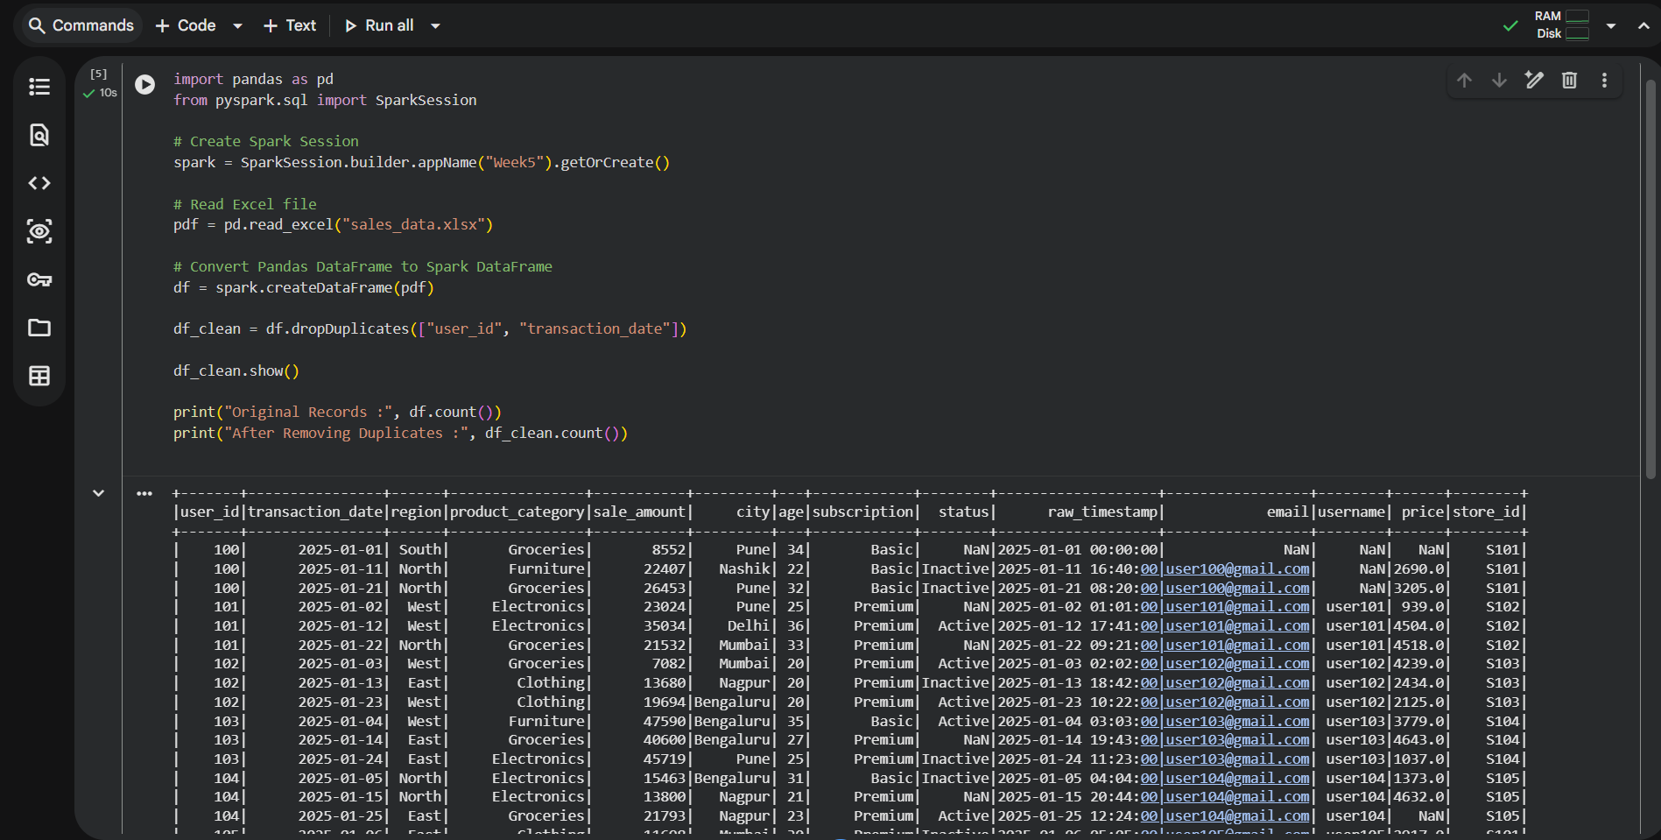

Q4. Filter region='West' and calculate average sale_amount grouped by product_category.
Code execution output:
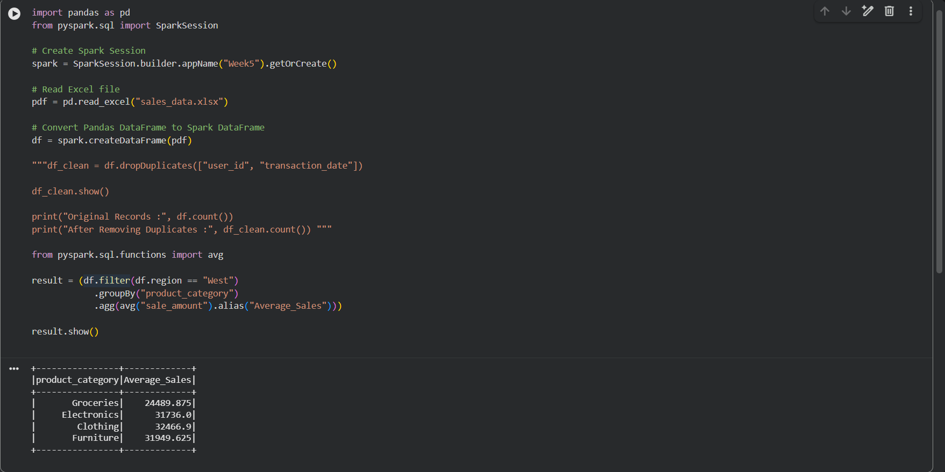

Q5. Difference between .na.drop() and .na.fill(). Fill null status with 'Unknown'.
.na.drop() removes rows containing null values, whereas .na.fill() replaces null values with a specified value.
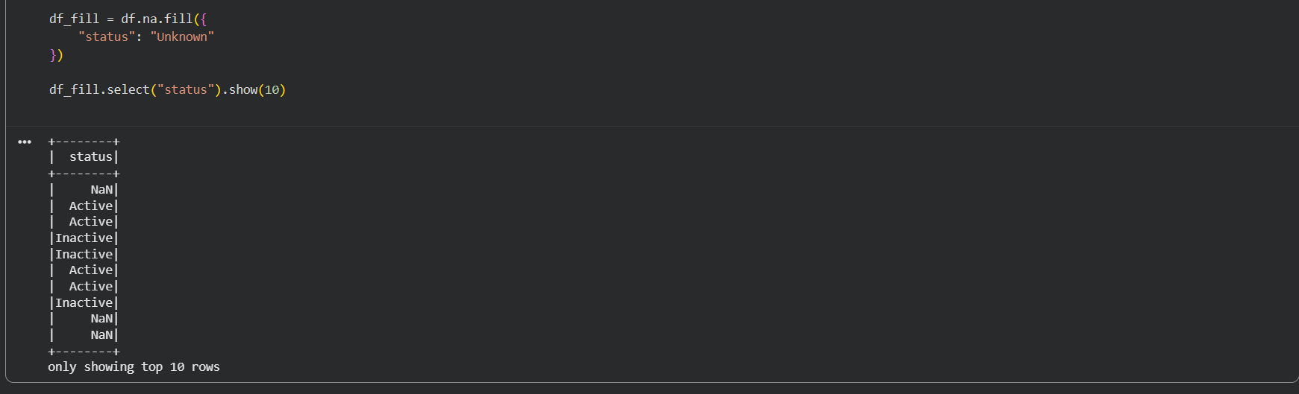

Q6. Find total count of records for each city where count > 100.
from pyspark.sql.functions import count
result = df.groupBy("city").agg(count("*").alias("Total")).filter("Total > 100")
result.show()
Observation: No city in the generated dataset has more than 100 records, so the result is empty.

Q7. How does DataFrame immutability affect data cleaning?

Spark DataFrames are immutable. Operations such as dropping, renaming, or modifying columns create a new DataFrame instead of changing the original DataFrame.

Q8. Filter age between 18 and 30 with Premium subscription.
Code execution output:
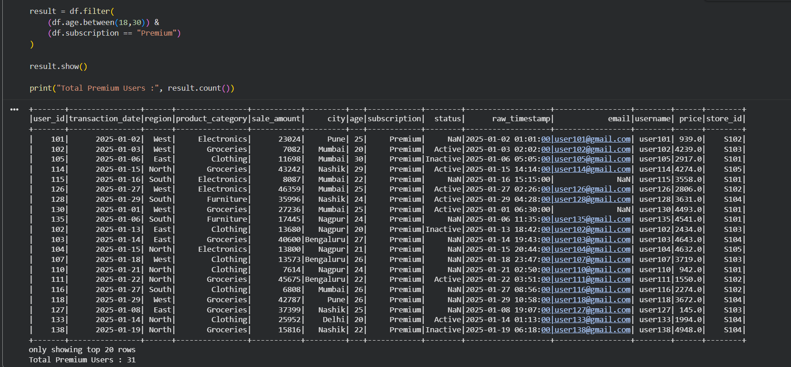

Q9. Why handle null values before aggregations?
Null values can produce inaccurate aggregation results or unexpected outputs. Cleaning or replacing null values before applying sum(), avg(), or other functions ensures reliable results.

Q10. Cast raw_timestamp to TimestampType and rename it to event_time.
Code execution output:
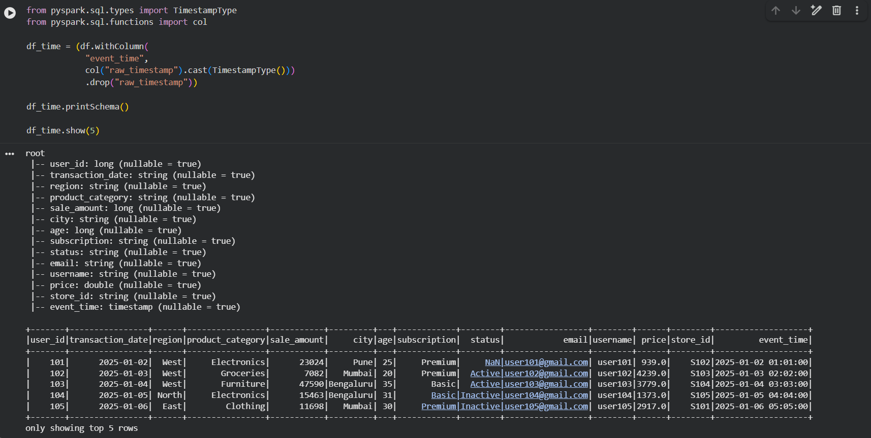

Q11. Explain Shuffle and why it is a wide transformation.
Shuffle redistributes data across partitions during operations such as groupBy or join. Since data moves between partitions, it is called a wide transformation and is more expensive than narrow transformations.

Q12. Remove rows where email is null OR username is empty.
Code execution output:
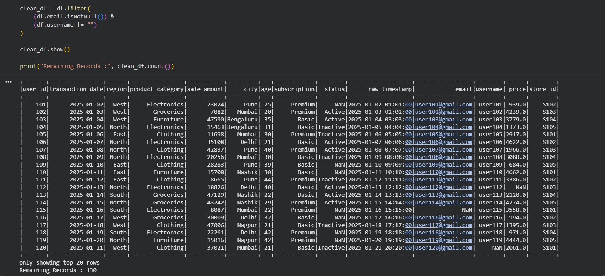

Q13. Calculate min, max and average of the price column using .agg().
Code execution output:
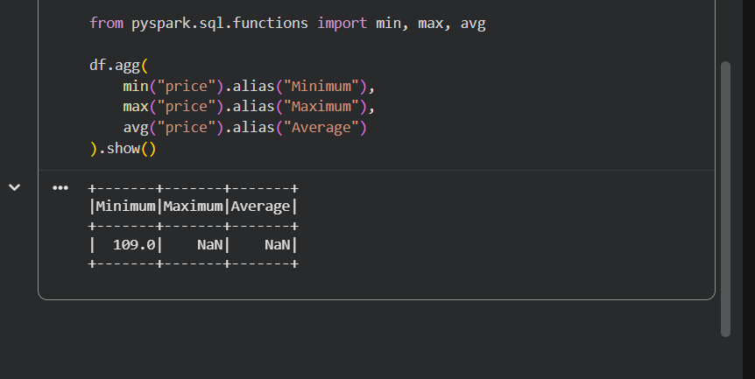

Q14. What is the risk of using inferSchema=True with inconsistent date formats?

Spark may infer incorrect data types or convert invalid date values to null, resulting in inconsistent schemas and incorrect analysis. Using an explicit schema is safer.

Q15. Build a processing pipeline: remove duplicates, fill null prices with 0, group by store_id and calculate total revenue.
Code execution output:
