WEEK 4 TASK

Name: Parth Milind Kulkarni
ID: CT_CSI_DE_1167
College: Sanjivani College of Engineering

Objective:
Understand Azure cloud concepts and build an end-to-end data pipeline using Storage Account and Azure Data Factory. Steps: Explore Azure Portal and create a Resource Group. Create a Storage Account, Blob Container, and upload a CSV file. Create Azure Data Factory and explore ADF UI (Author, Monitor, Manage). Create Linked Service (Blob Storage) and datasets (source and destination). Use Get Metadata activity to retrieve file information. Build a pipeline using Copy Data activity and configure source and destination. Execute the pipeline using Debug/Trigger and monitor execution. Assign IAM roles (Reader, Contributor) and ensure access between ADF and Storage. Implement an end-to-end pipeline (Blob → ADF → Destination) with metadata validation. Output: Screenshots (Resource Group, Storage, ADF, Pipeline) + pipeline execution results + brief summary.

Resources:
https://www.kaggle.com/datasets/vivek468/superstore-dataset-finalhttps://celebaltech.sharepoint.com/:w:/s/Celebal-LMS/IQDu6KrxRjt_Q4oeUYRJ1VcYATzbNIVoanpDrzZiW9VEIaY?e=2iujIU

Below is the Step by Step Execution of all the Tasks

Step 1: Create Resource Group
Created a new Resource Group named RG_Assignment in Azure Portal. A Resource Group acts as a logical container that holds all Azure resources used in this project.
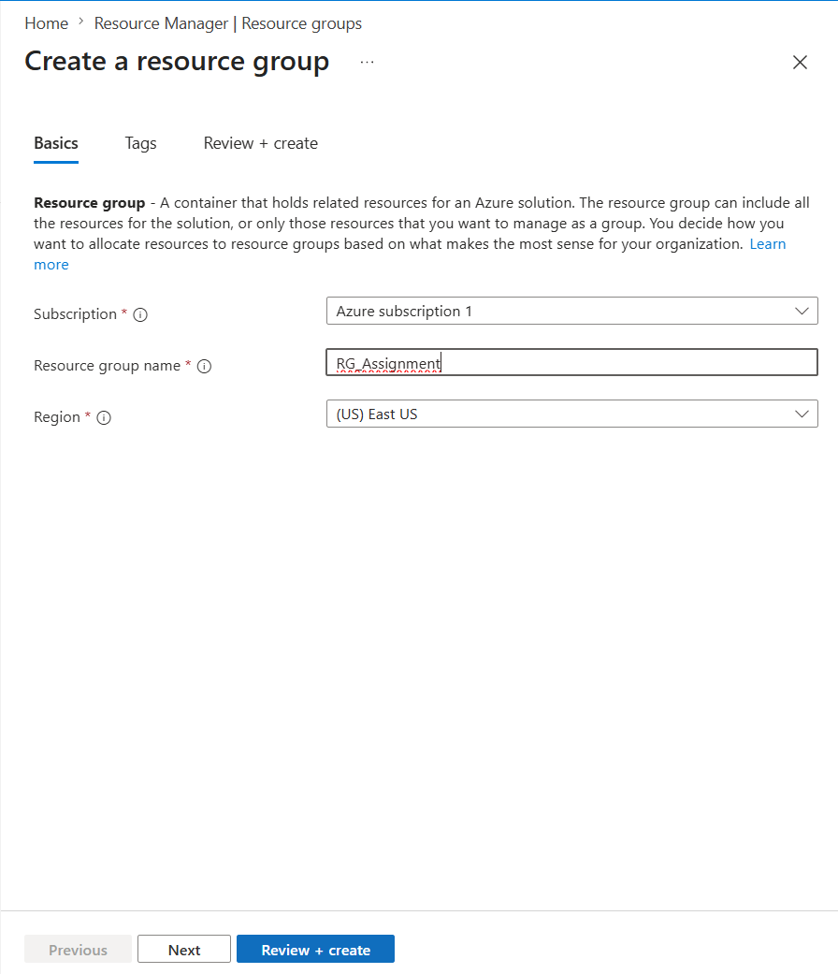
Figure: Step 1: Create Resource Group

Step 2: Verify Resource Group
Verified that the Resource Group was successfully created and is available in Azure Resource Groups.
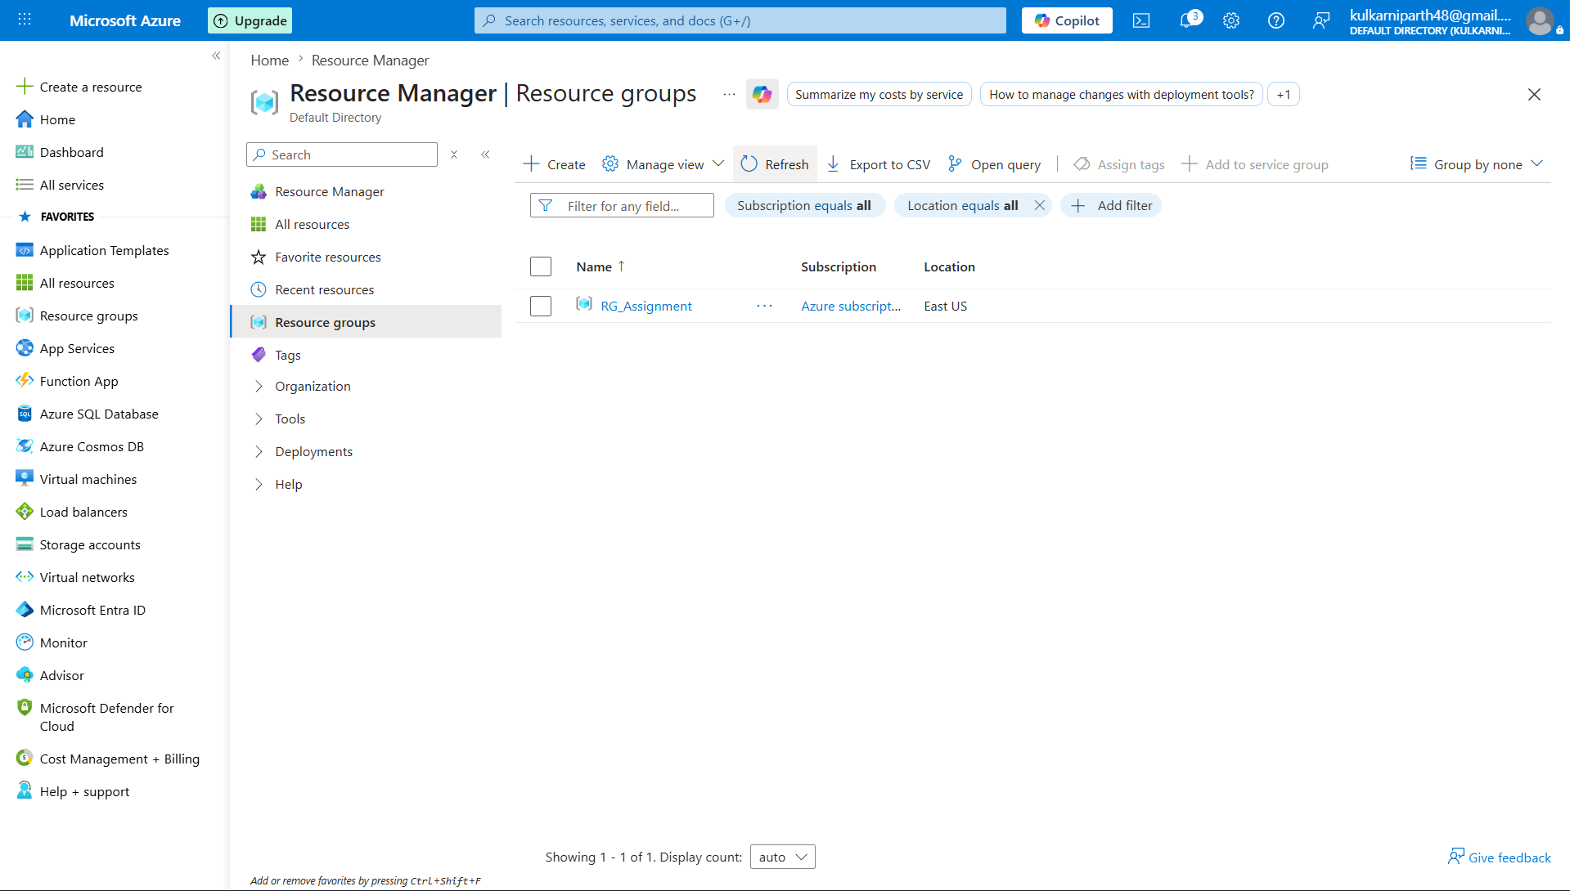
Figure: Step 2: Verify Resource Group
Step 3: Create Storage Account
Created an Azure Storage Account that will be used to store the source and destination CSV files.
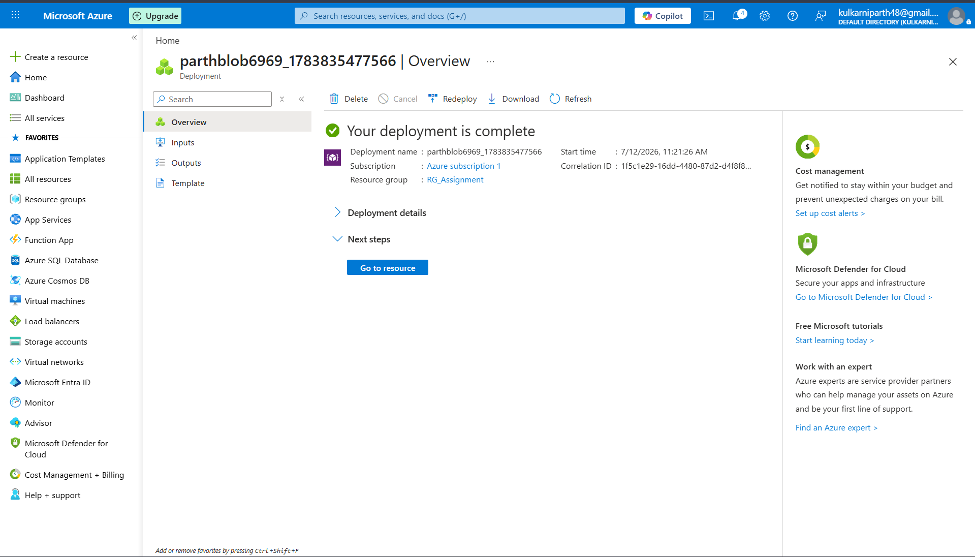
Figure: Step 3: Create Storage Account
Step 4: Storage Account Deployment
Verified that the Storage Account deployment completed successfully.
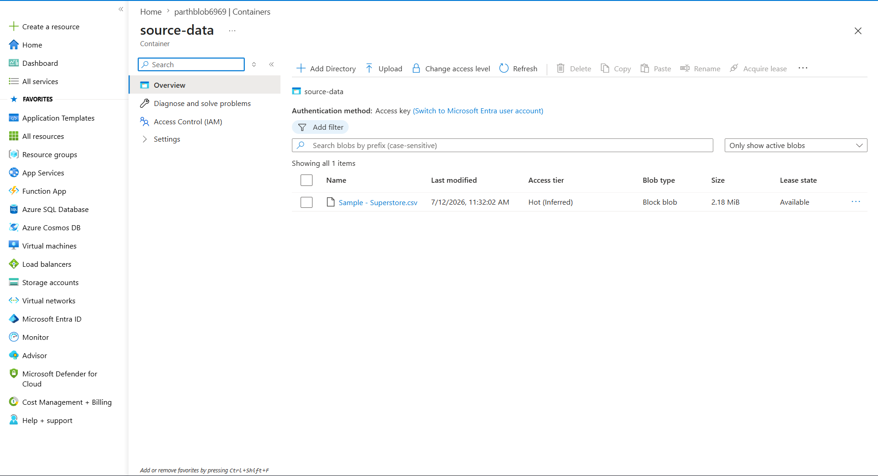
Figure: Step 4: Storage Account Deployment
Step 5: Create Blob Containers
Created Blob containers named source-data and destination-data for storing input and output files.
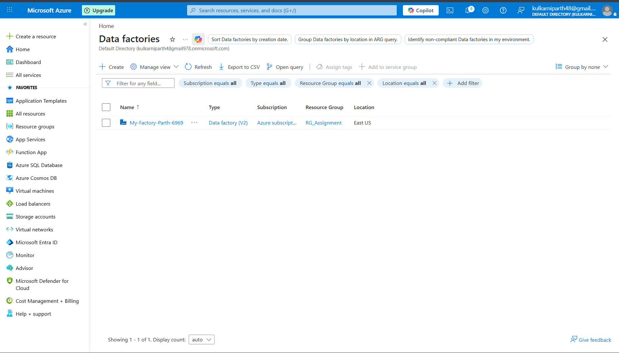
Figure: Step 5: Create Blob Containers
Step 6: Upload Source CSV
Uploaded the Sample - Superstore.csv file into the source-data Blob container.
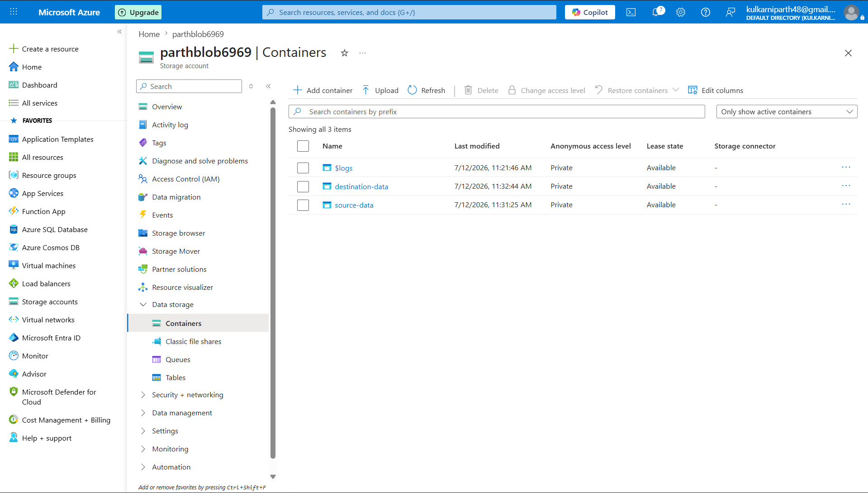
Figure: Step 6: Upload Source CSV
Step 7: Create Azure Data Factory
Created an Azure Data Factory instance named My-Factory-Parth-6969.
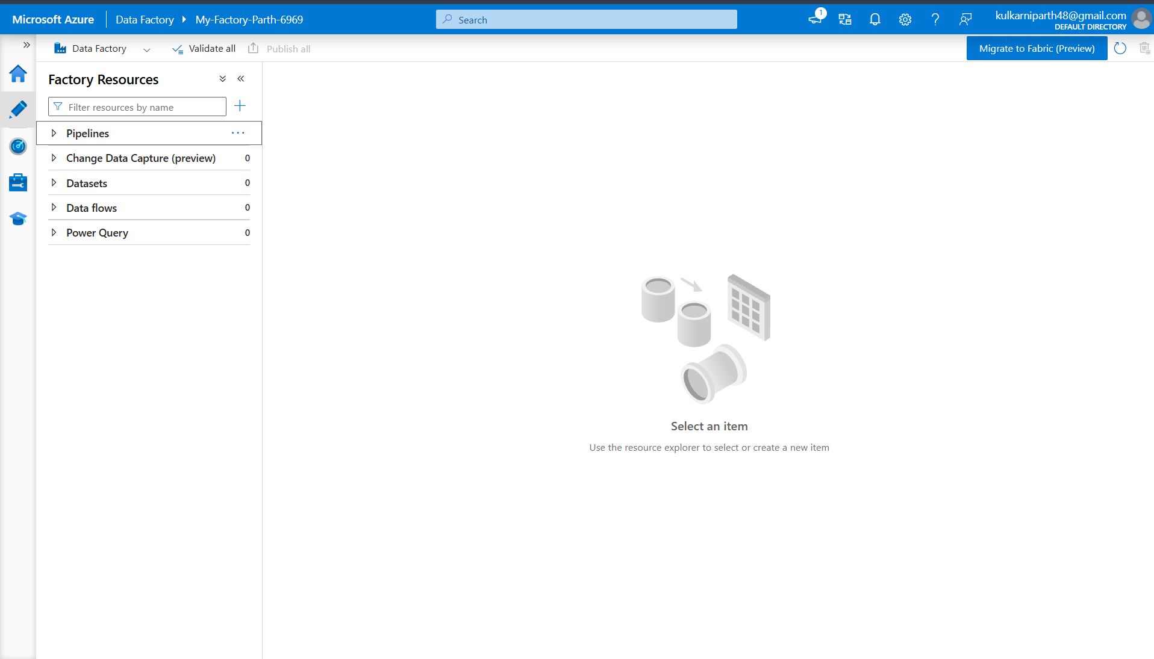
Figure: Step 7: Create Azure Data Factory
Step 8: Open ADF Studio
Opened Azure Data Factory Studio to author and manage data pipelines.
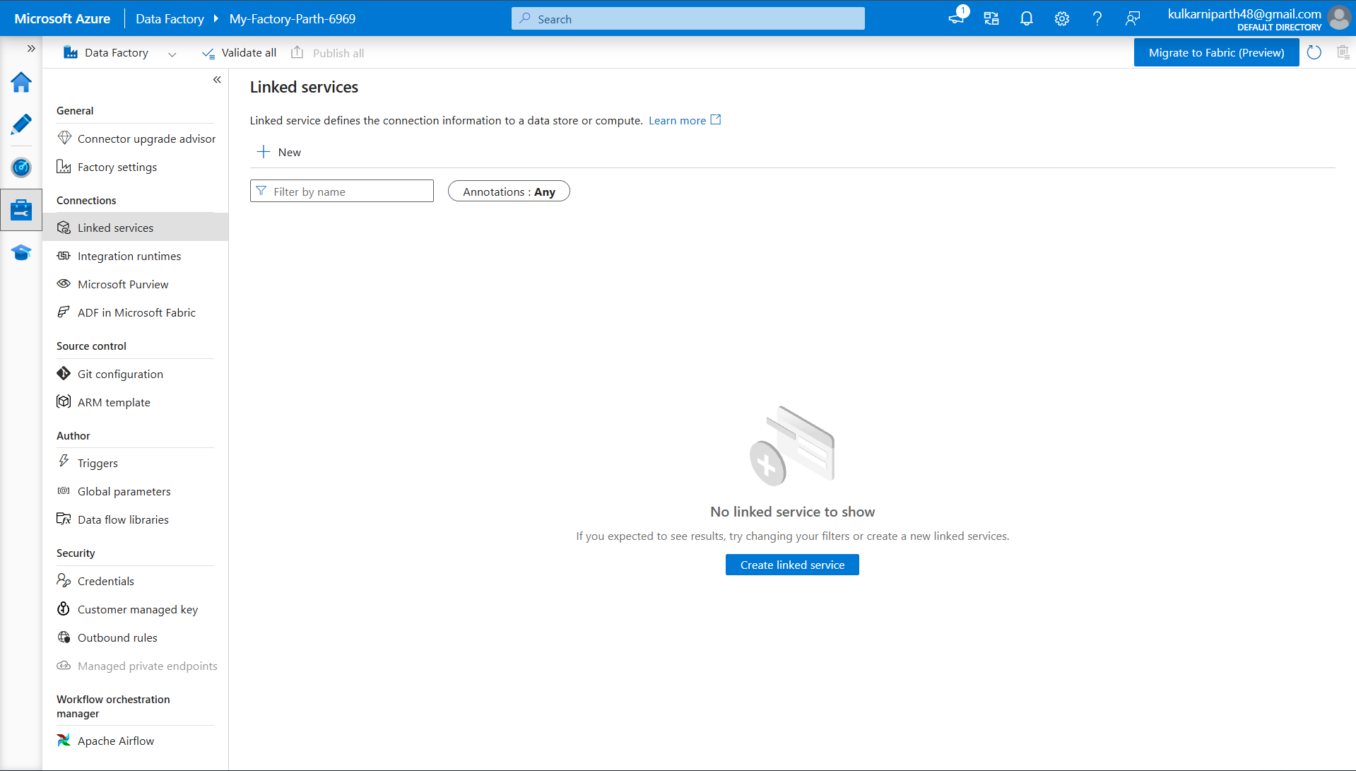
Figure: Step 8: Open ADF Studio
Step 9: Create Linked Service
Created a Linked Service to connect Azure Data Factory with the Azure Blob Storage account.
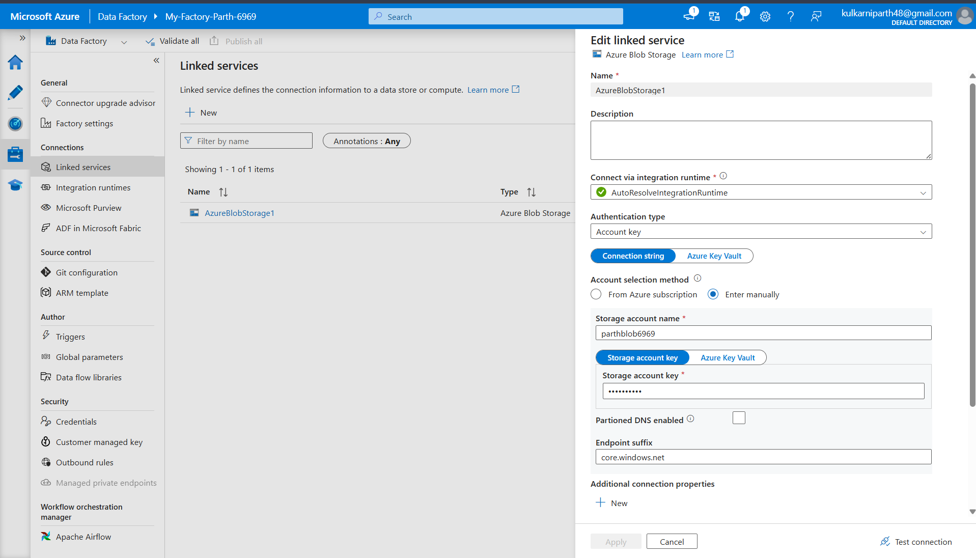
Figure: Step 9: Create Linked Service
Step 10: Configure Linked Service
Configured the Azure Blob Storage linked service using Storage Account credentials and tested the connection.
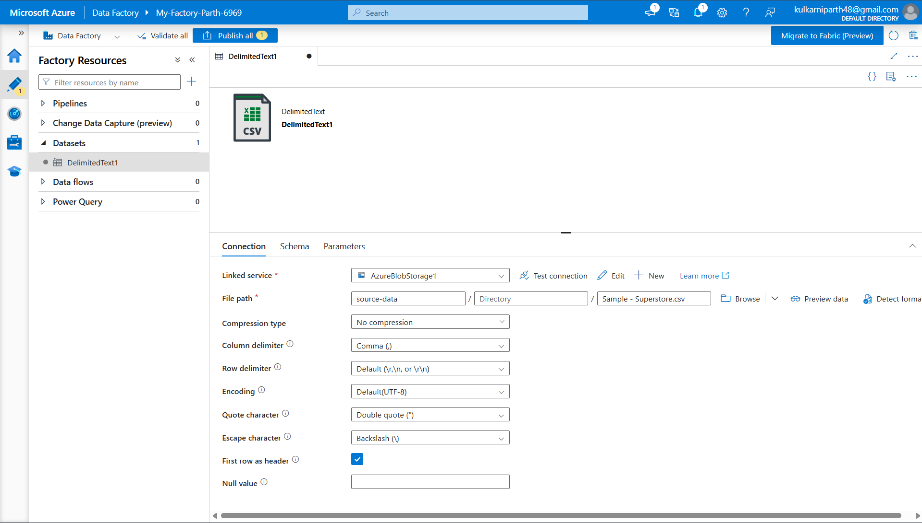
Figure: Step 10: Configure Linked Service
Step 11: Create Source Dataset
Created a source dataset pointing to the Sample - Superstore.csv file in the source-data container.
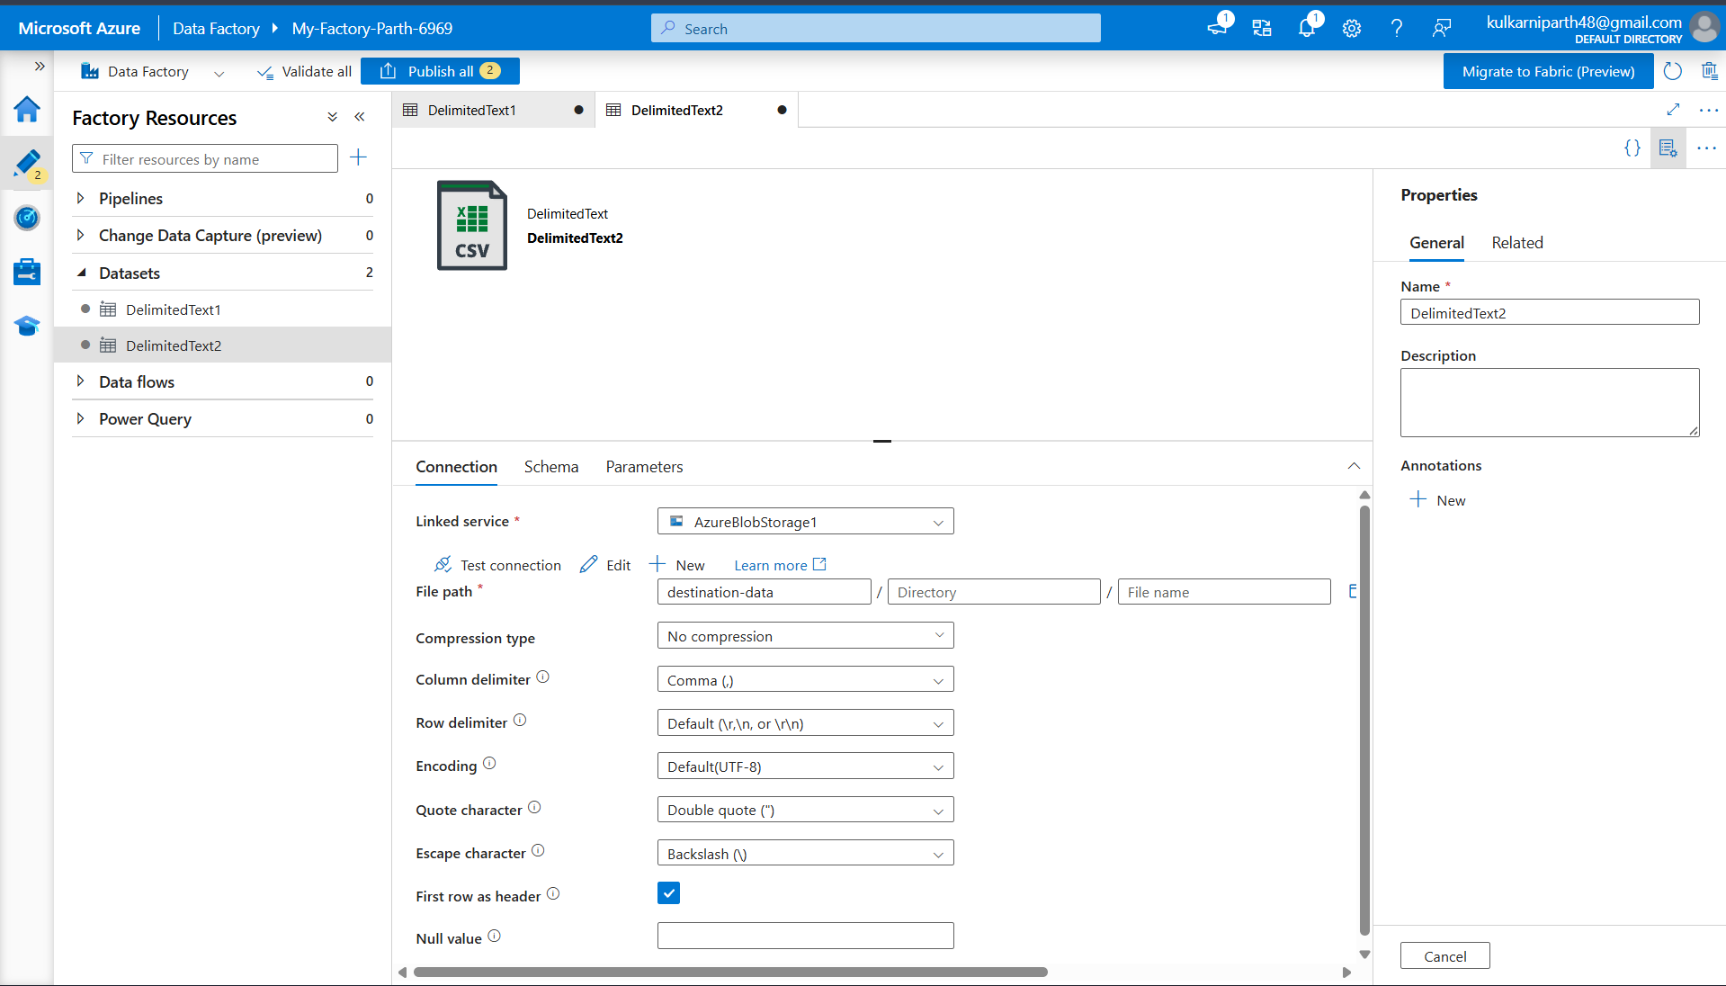
Figure: Step 11: Create Source Dataset
Step 12: Create Destination Dataset
Created a destination dataset pointing to the destination-data container where the copied file will be stored.
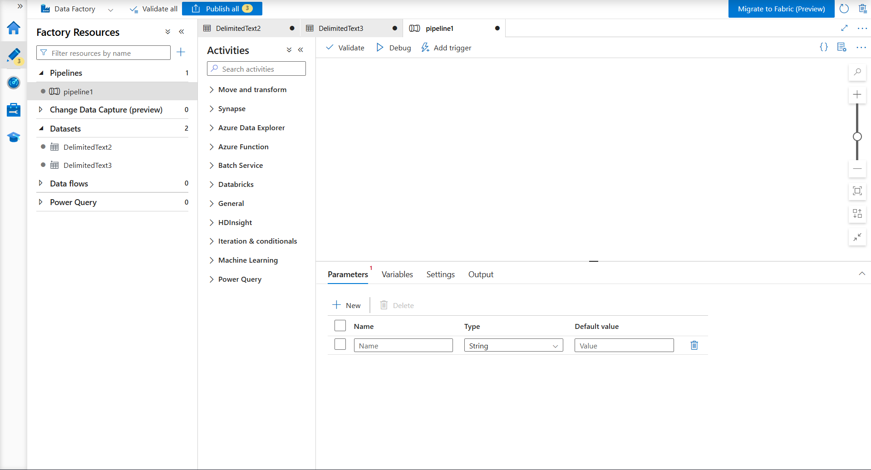
Figure: Step 12: Create Destination Dataset
Step 13: Create Pipeline
Created a new pipeline in Azure Data Factory for implementing the data movement process.
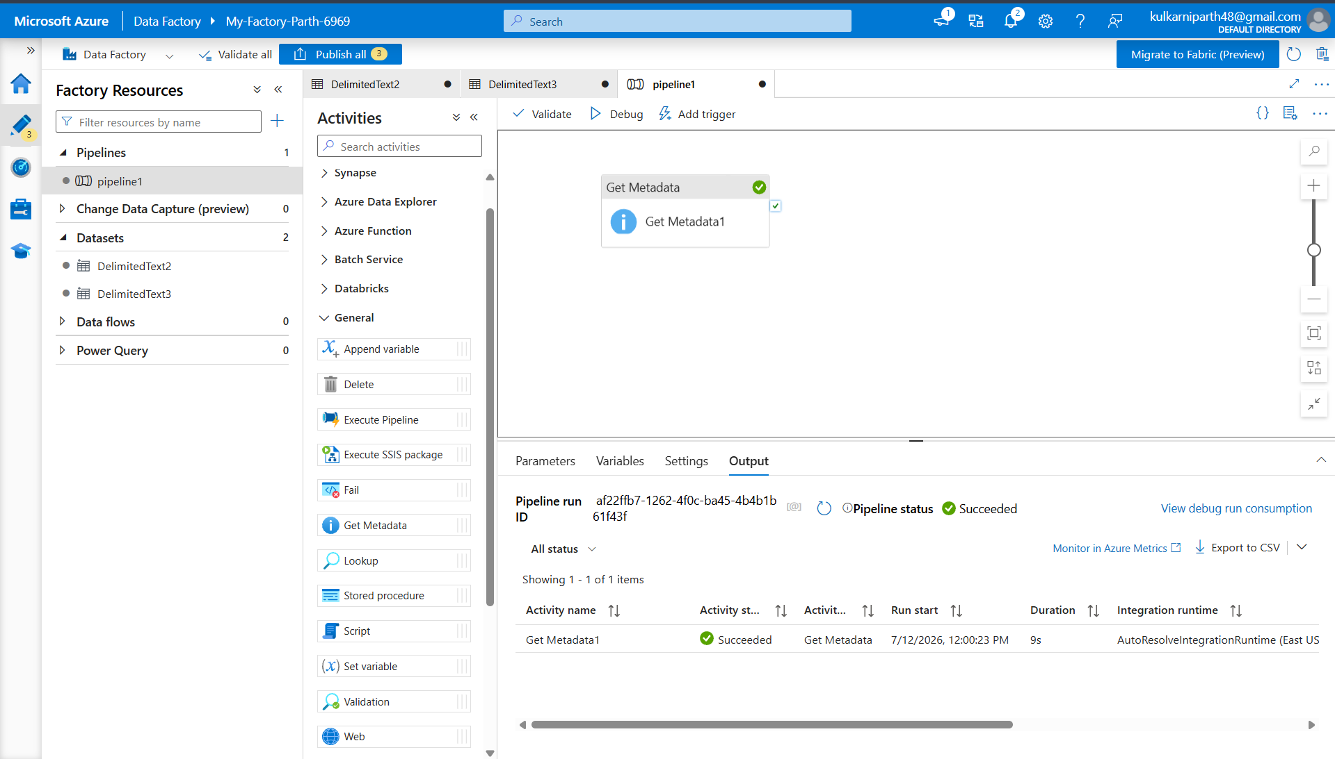
Figure: Step 13: Create Pipeline
Step 14: Configure Get Metadata
Added the Get Metadata activity to validate the source file before copying.
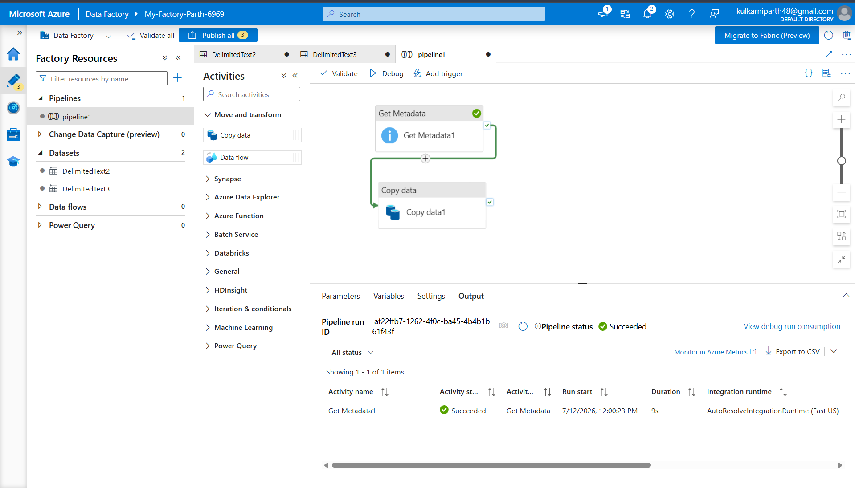
Figure: Step 14: Configure Get Metadata
Step 15: Configure Copy Data
Added the Copy Data activity and connected it with the successful completion of Get Metadata.
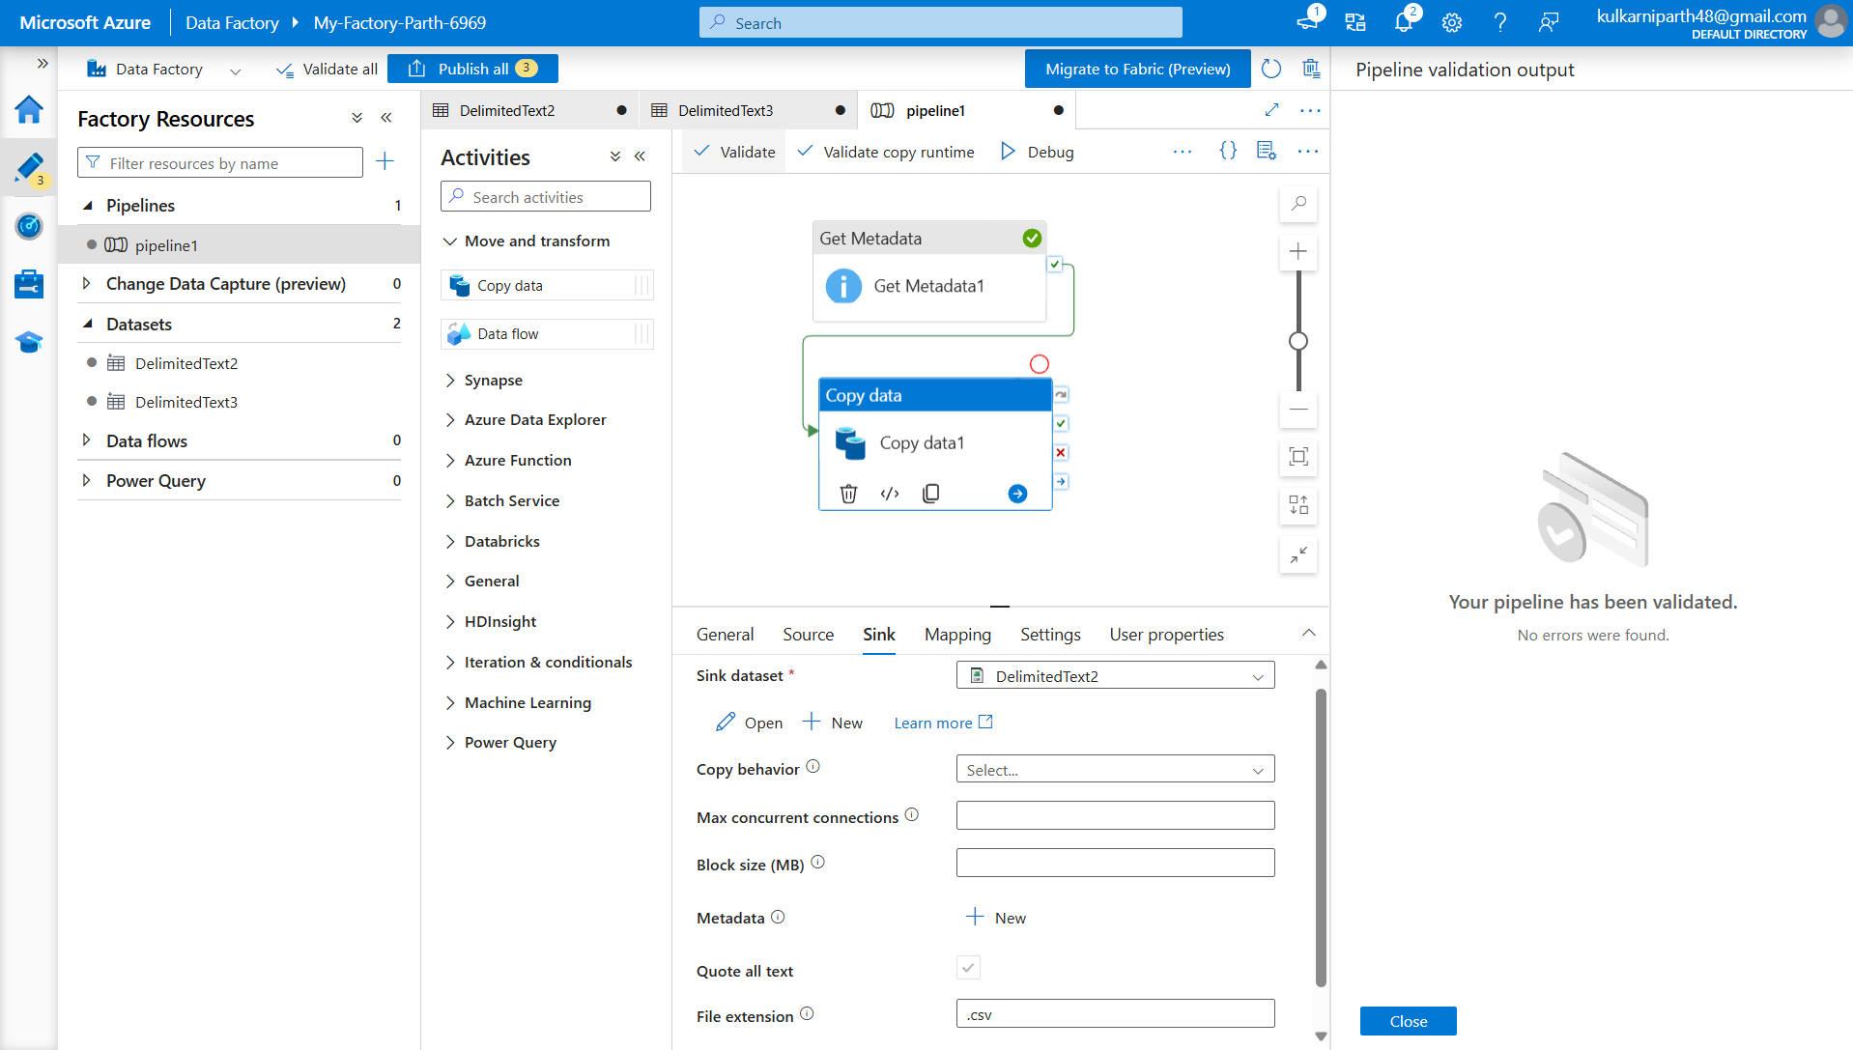
Figure: Step 15: Configure Copy Data
Step 16: Validate and Publish
Validated the pipeline configuration and published all changes successfully.
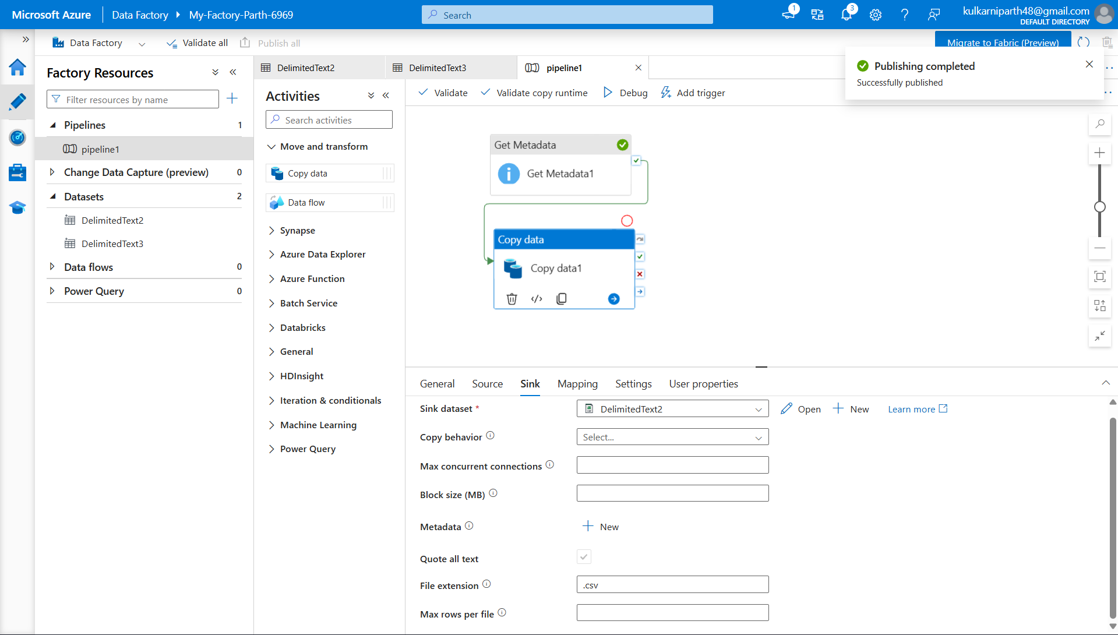
Figure: Step 16: Validate and Publish
Step 17: Execute Pipeline
Executed the pipeline using Debug. Both Get Metadata and Copy Data activities completed successfully.
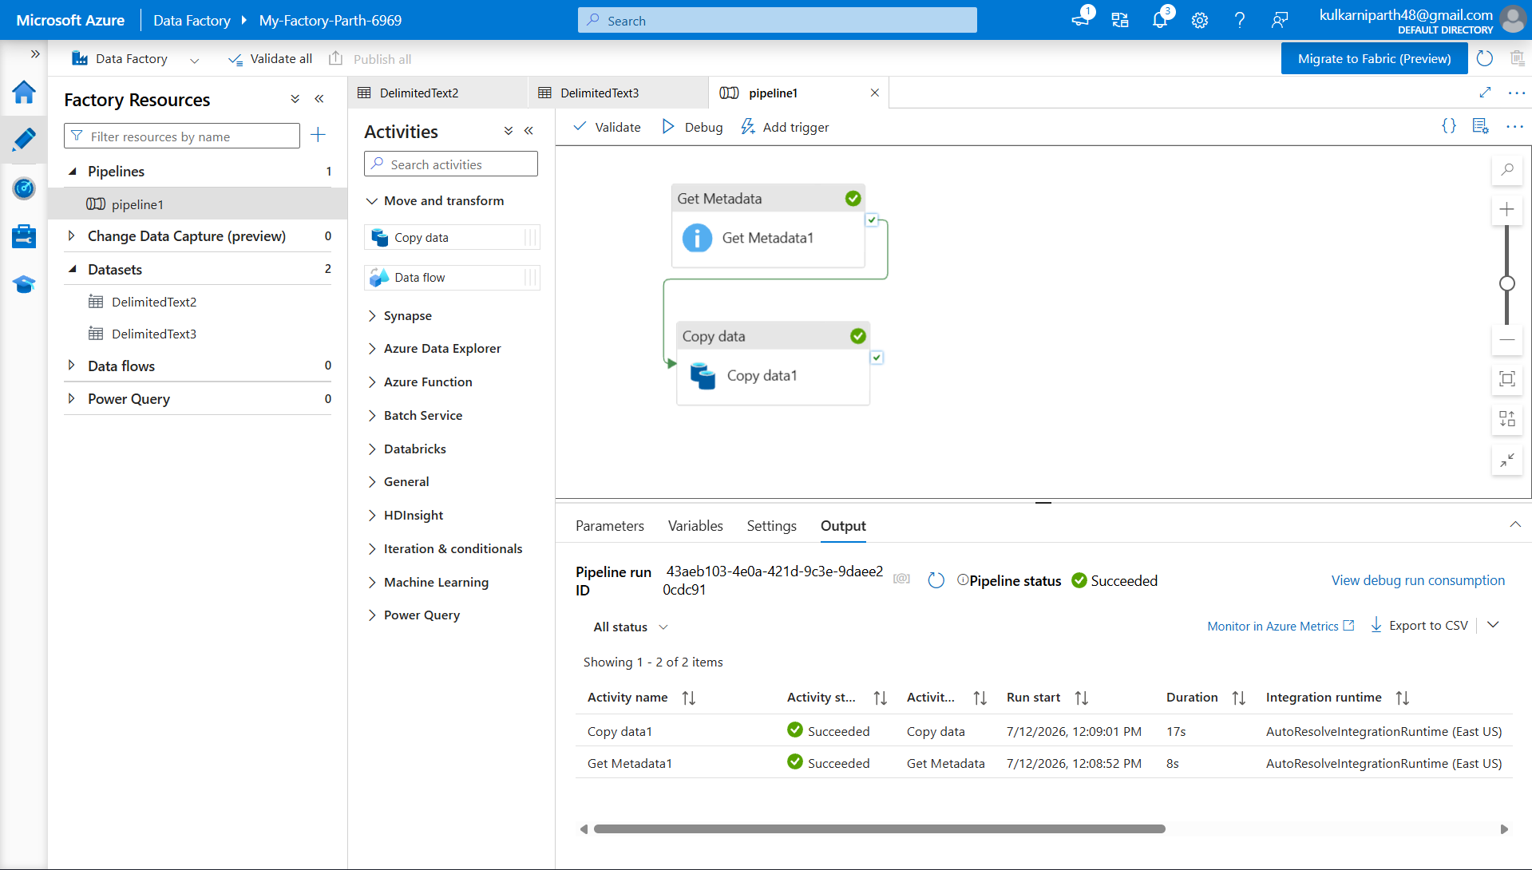
Figure: Step 17: Execute Pipeline
Step 18: Verify Destination File
Verified that the CSV file was successfully copied into the destination-data Blob container.
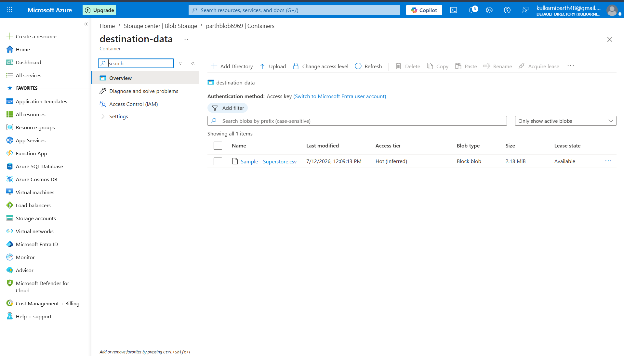
Figure: Step 18: Verify Destination File
Step 19: IAM Role Assignment
Assigned the required Storage Blob Data Contributor role through Azure IAM to provide access for storage operations.
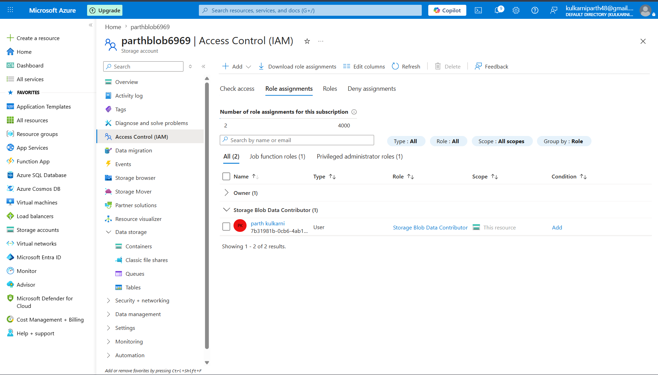
Figure: Step 19: IAM Role Assignment
Conclusion:
This assignment provided practical experience in using Microsoft Azure cloud services to build an end-to-end data pipeline. A Resource Group and Azure Storage Account were successfully created, followed by the creation of Blob containers to store the source and destination CSV files. Azure Data Factory was configured by creating a Linked Service and datasets to establish connectivity with Azure Blob Storage.
The Get Metadata activity was used to validate the source file before execution, and the Copy Data activity successfully copied the CSV file from the source container to the destination container. The pipeline was validated, published, and executed successfully, and the execution was monitored through the Azure Data Factory Monitor. Finally, IAM role assignments were configured to ensure secure access between Azure Data Factory and Azure Storage.
Overall, this assignment helped in understanding the fundamental concepts of Microsoft Azure, Azure Blob Storage, Azure Data Factory, data movement, metadata validation, pipeline execution, monitoring, and access management. It provided valuable hands-on experience in building and managing cloud-based data integration solutions.

