Apache Spark Assignment - Week 6
Name: Parth Milind Kulkarni
Student Id: CT_CSI_DE_1167
Domain: Data Engineering

Objective: Understand Spark architecture and perform efficient data processing using transformations, filtering, schema handling, and optimized file formats.

Q1. Explain the roles of the Driver, Cluster Manager, and Executor in a Spark application.
Driver:
• Creates the SparkSession and coordinates execution.
• Converts user code into jobs and tasks.
• Maintains the DAG and sends tasks to executors.
Cluster Manager:
• Allocates cluster resources (CPU and memory).
• Launches executors on worker nodes.
• Examples: Standalone, YARN, Kubernetes, Mesos.
Executor:
• Executes tasks assigned by the Driver.
• Stores cached data.
• Returns computation results to the Driver.

Q2. How does Spark’s Lazy Evaluation strategy improve performance?
Spark records transformations without executing them immediately. It builds a Directed Acyclic Graph (DAG) and waits until an action such as show(), count(), or collect() is called. This allows Spark to optimize the execution plan, combine operations, reduce unnecessary computation, and minimize data movement.

Q3. Read a CSV file with header and inferSchema enabled.
Code:
spark.read.option('header',True).option('inferSchema',True).csv('data/source.csv')
Execution Result:
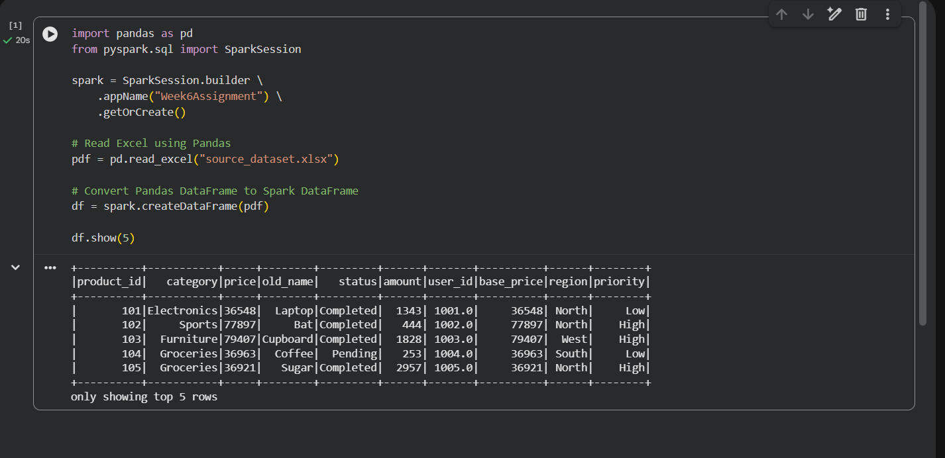

Q4. Difference between CSV and Parquet.

CSV is a row-based text format, whereas Parquet is a compressed columnar storage format. Parquet stores schema information, supports predicate pushdown, and reads only required columns, making it much faster and more storage-efficient for analytics.

Q5. Select product_id and price where category is Electronics.
PySpark:
df.filter(df.category=='Electronics').select('product_id','price').show()
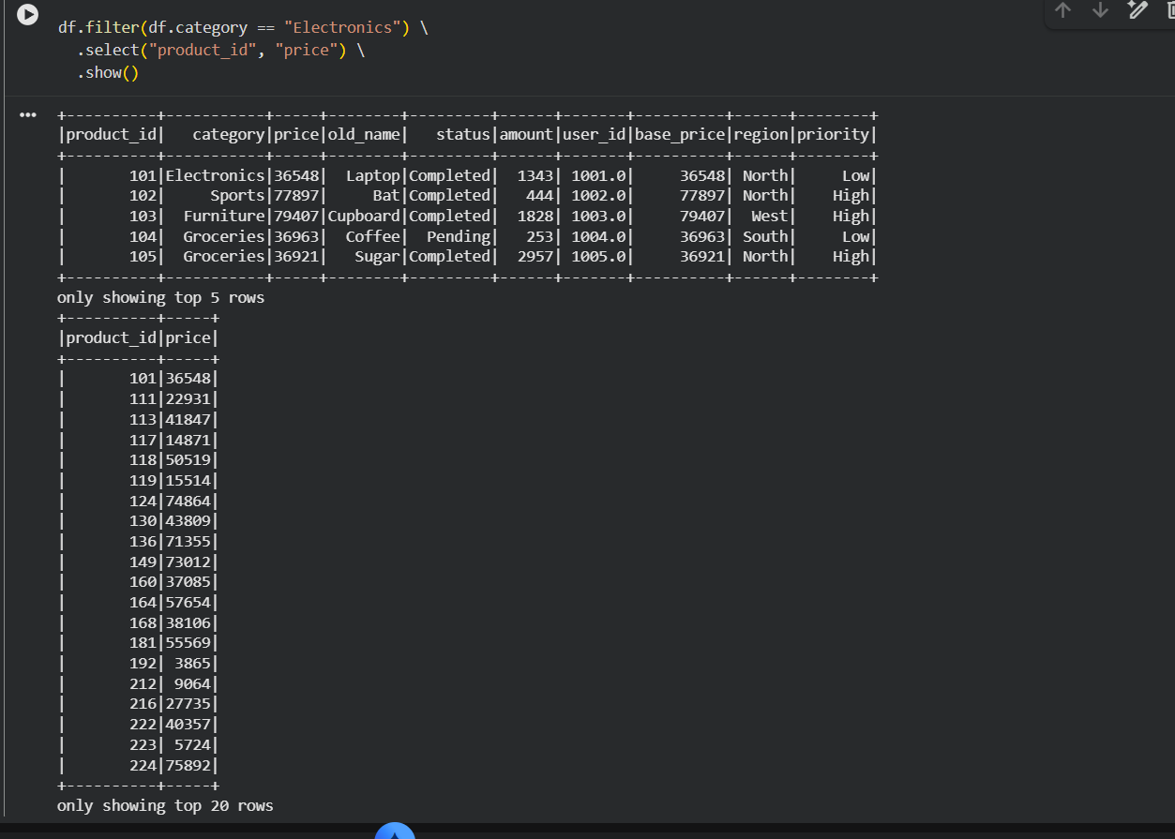
Execution Result:

Q6. Rename old_name to new_name and cast price to Double.
PySpark:
df=df.withColumnRenamed('old_name','new_name')
df=df.withColumn('price',col('price').cast('double'))
Execution Result:
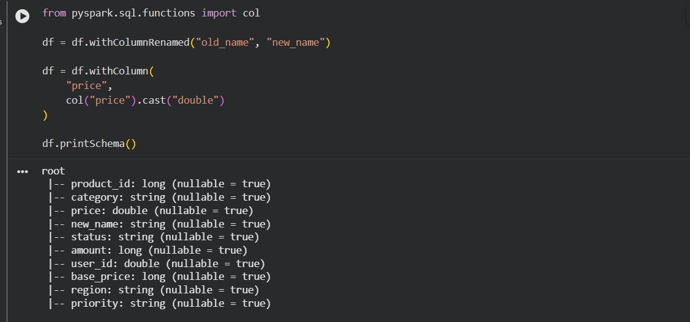

Q7. How does DAG provide fault tolerance?
Spark keeps the lineage (DAG) of all transformations. If an executor fails, Spark recomputes only the lost partitions from the lineage instead of reprocessing the entire dataset.

Q8. Filter status='Completed' AND amount>1000.
PySpark:
df.filter((df.status=='Completed') & (df.amount>1000)).show()
Execution Result:
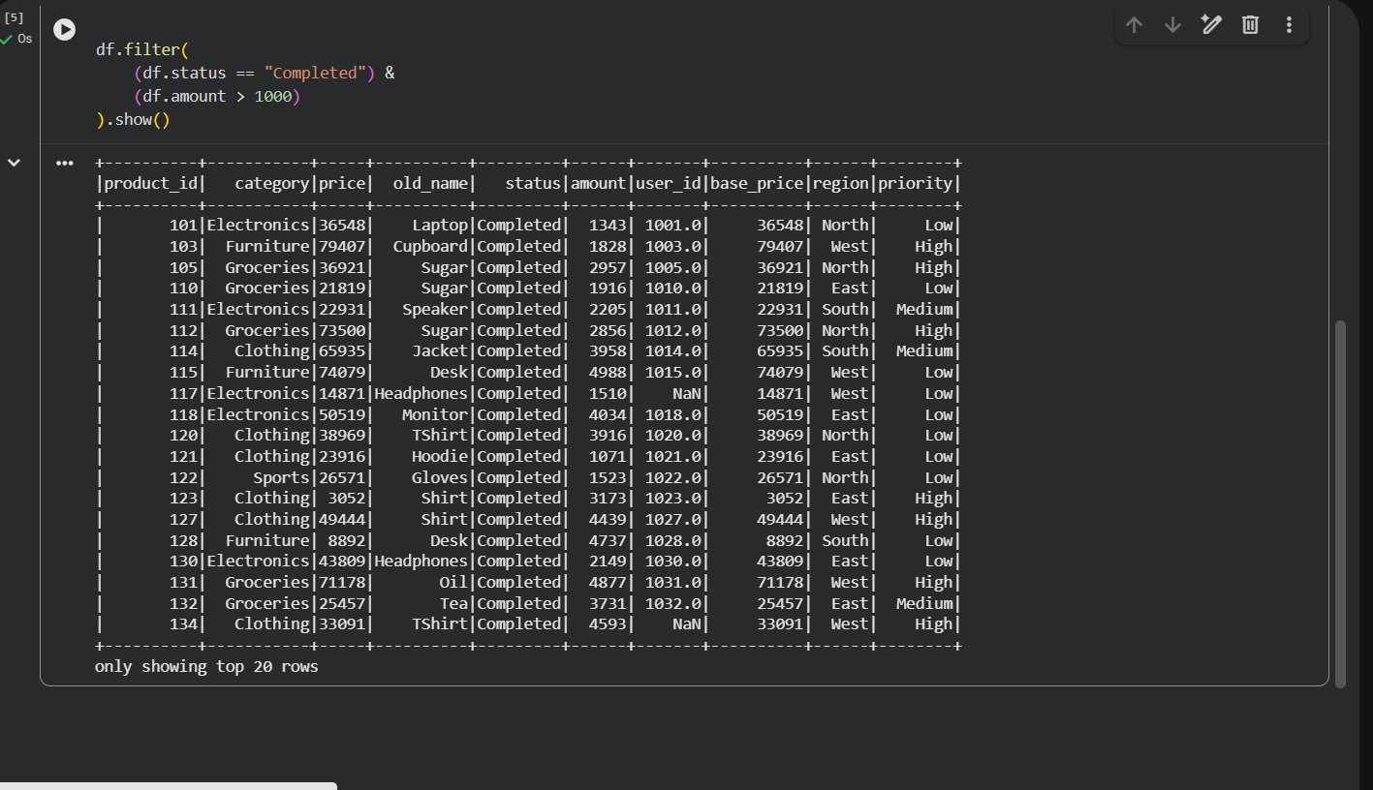

Q9. Predicate Pushdown in Parquet.
Predicate Pushdown sends filter conditions to the storage layer. Only the matching rows/columns are read from disk, reducing I/O, memory usage, and improving performance.

Q10. Add final_price = base_price × 1.18.
PySpark:
df=df.withColumn('final_price',col('base_price')*1.18)
Execution Result:
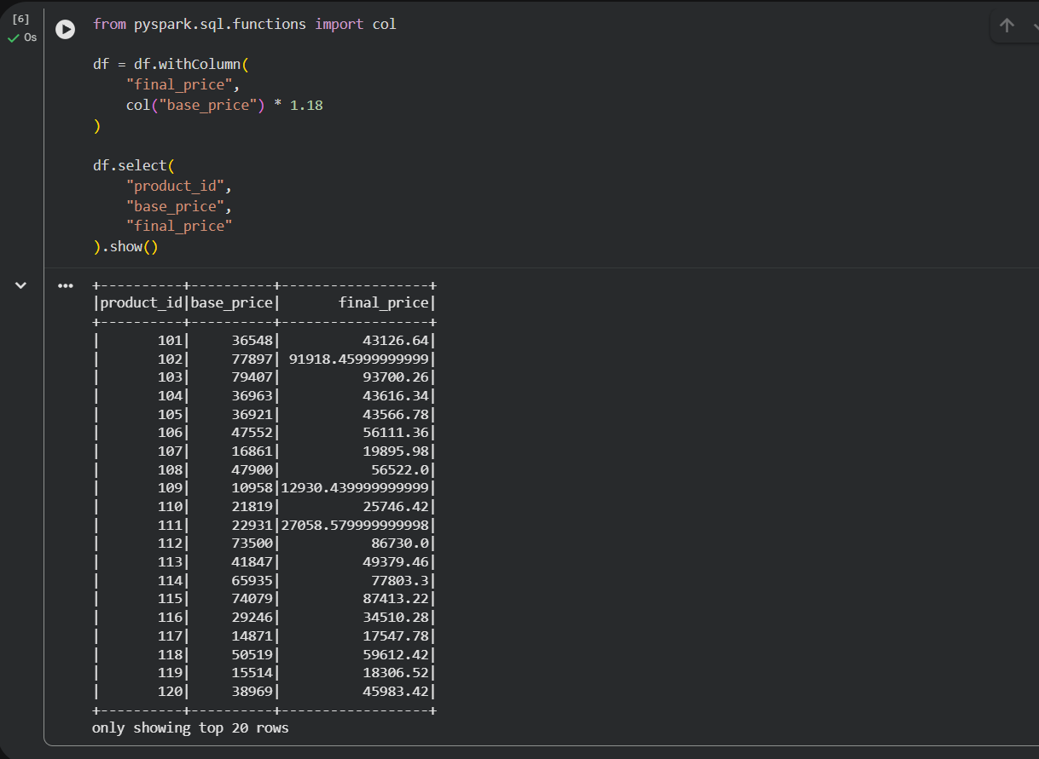

Q11. Difference between Transformations and Actions.
Transformations create a new DataFrame/RDD and are lazily evaluated (e.g., filter(), select(), withColumn(), groupBy()).
Actions trigger execution and return results (e.g., show(), count(), collect(), first()).

Q12. Read Parquet, remove null user_id, save as CSV.
PySpark:
parquet_df=spark.read.parquet('data/parquet_data')
filtered_df=parquet_df.filter(parquet_df.user_id.isNotNull())
filtered_df.write.mode('overwrite').option('header',True).csv('output/result_csv')
Execution Result:
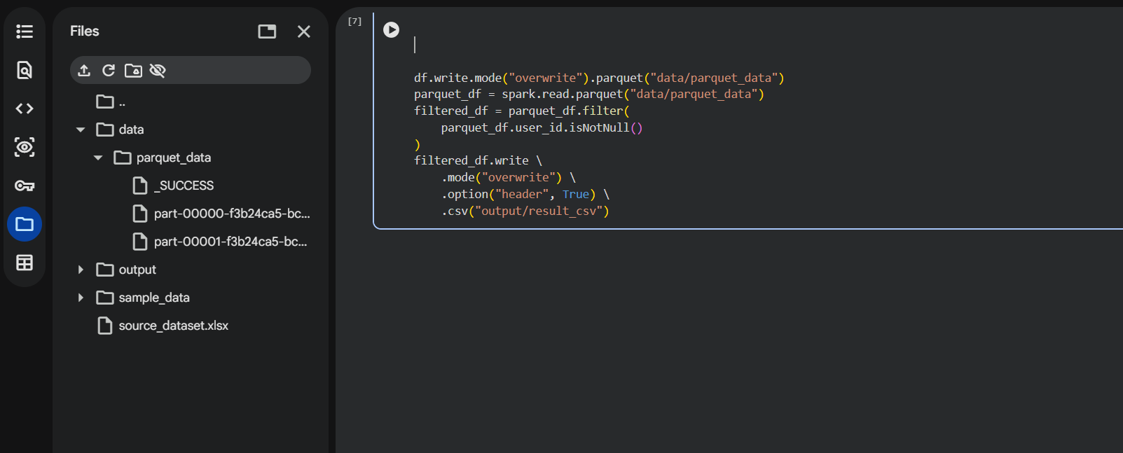

Q13. Client Mode vs Cluster Mode.
Client Mode: Driver runs on the client machine. Suitable for development.
Cluster Mode: Driver runs inside the cluster. Suitable for production and better fault tolerance.

Q14. Filter rows where region='North' OR priority='High'.
PySpark:
df.filter((df.region=='North') | (df.priority=='High')).show()
Execution Result:
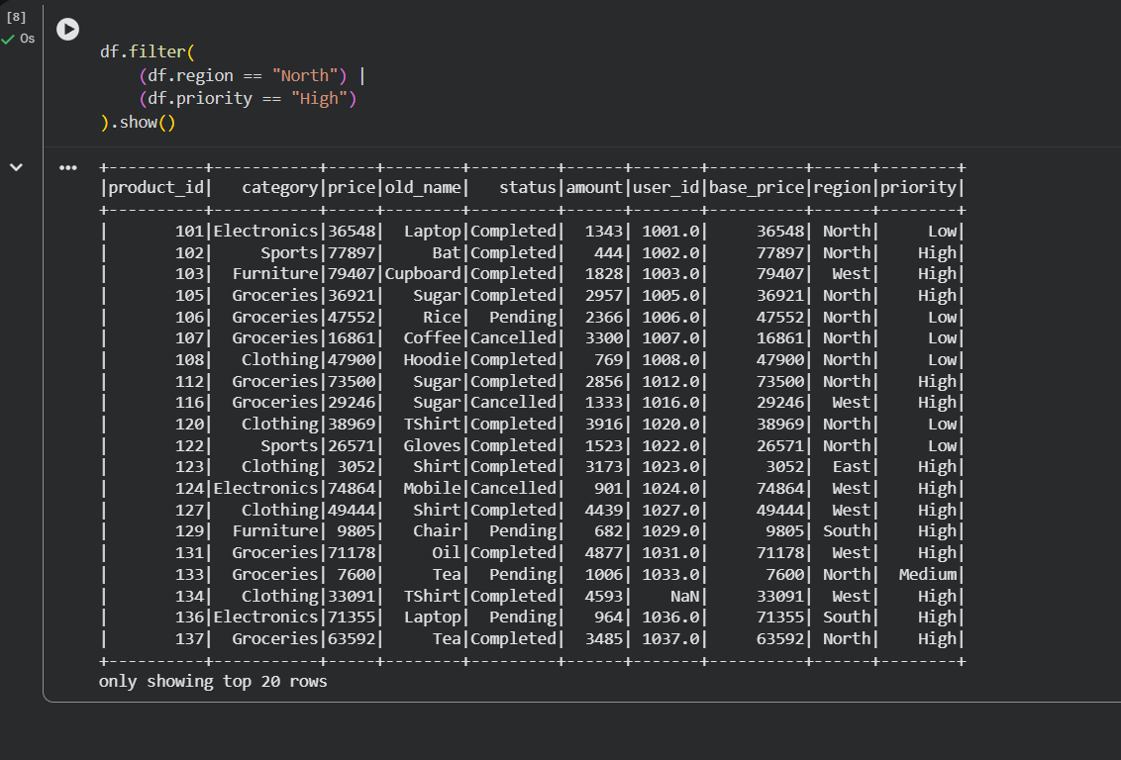

Q15. Why use show(5) instead of collect()?
show(5) displays only a few rows and is memory efficient. collect() loads the entire dataset into the Driver memory and can cause OutOfMemoryError on large datasets.

Conclusion
Apache Spark provides a distributed computing framework capable of processing large datasets efficiently. Using DataFrame transformations, lazy evaluation, DAG optimization, Parquet storage, and proper filtering techniques improves performance and scalability. In this assignment, Spark architecture, schema handling, transformations, actions, null handling, and file format conversions were successfully implemented and verified using execution results.

