Week 7 Report: Delta Lake MERGE Implementation
Objective: Perform incremental data processing using Delta Lake MERGE in Databricks.

Name: Parth Milind Kulkarni
College: Sanjivani College of Engineering
Domain: Data Engineering
Student ID: CT_CSI_DE_1167

Data Loading
Loaded the master CSV dataset into Spark.
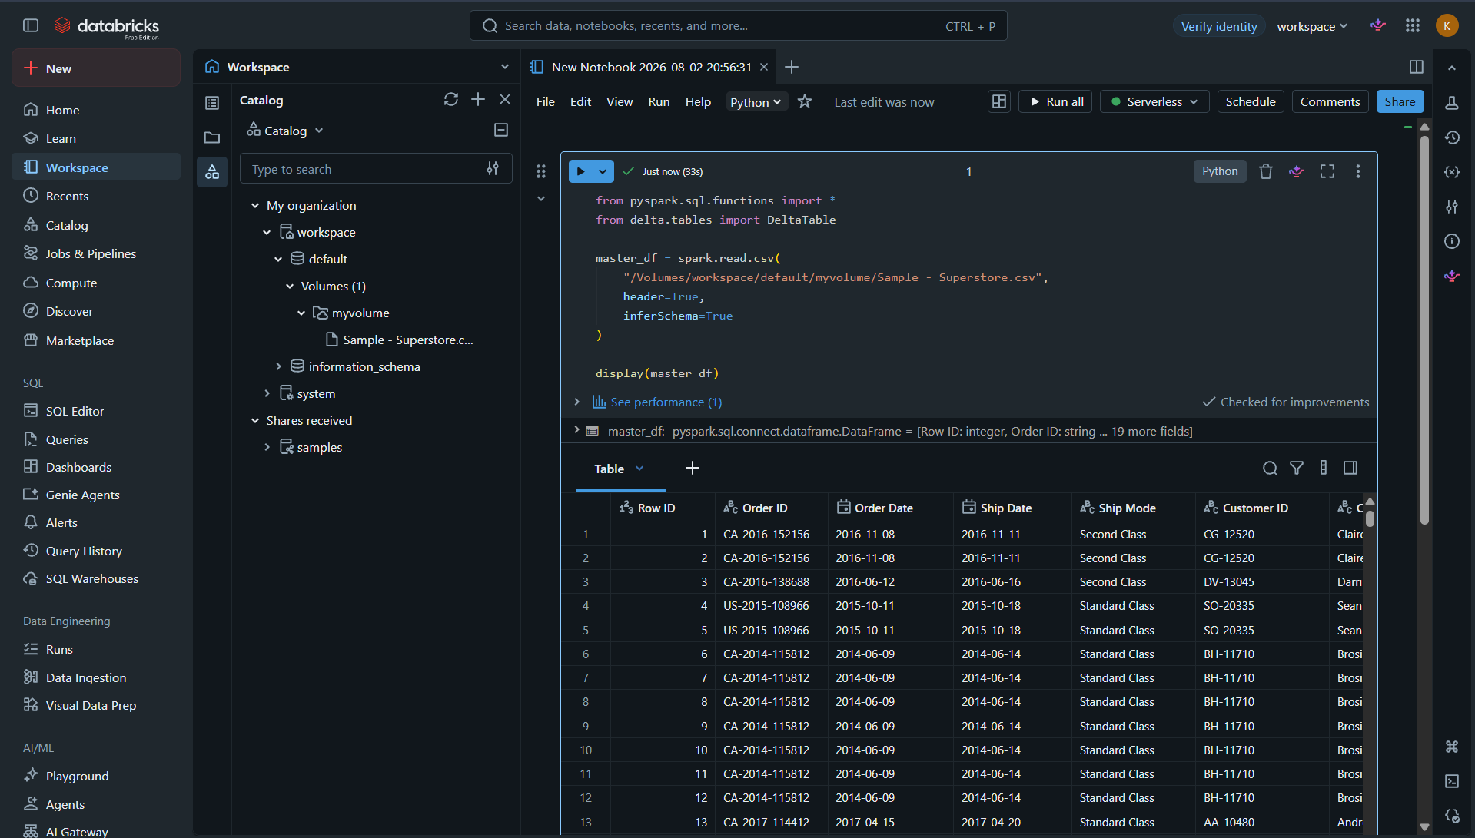

Data Cleaning
Performed null checking, removed nulls and duplicates.
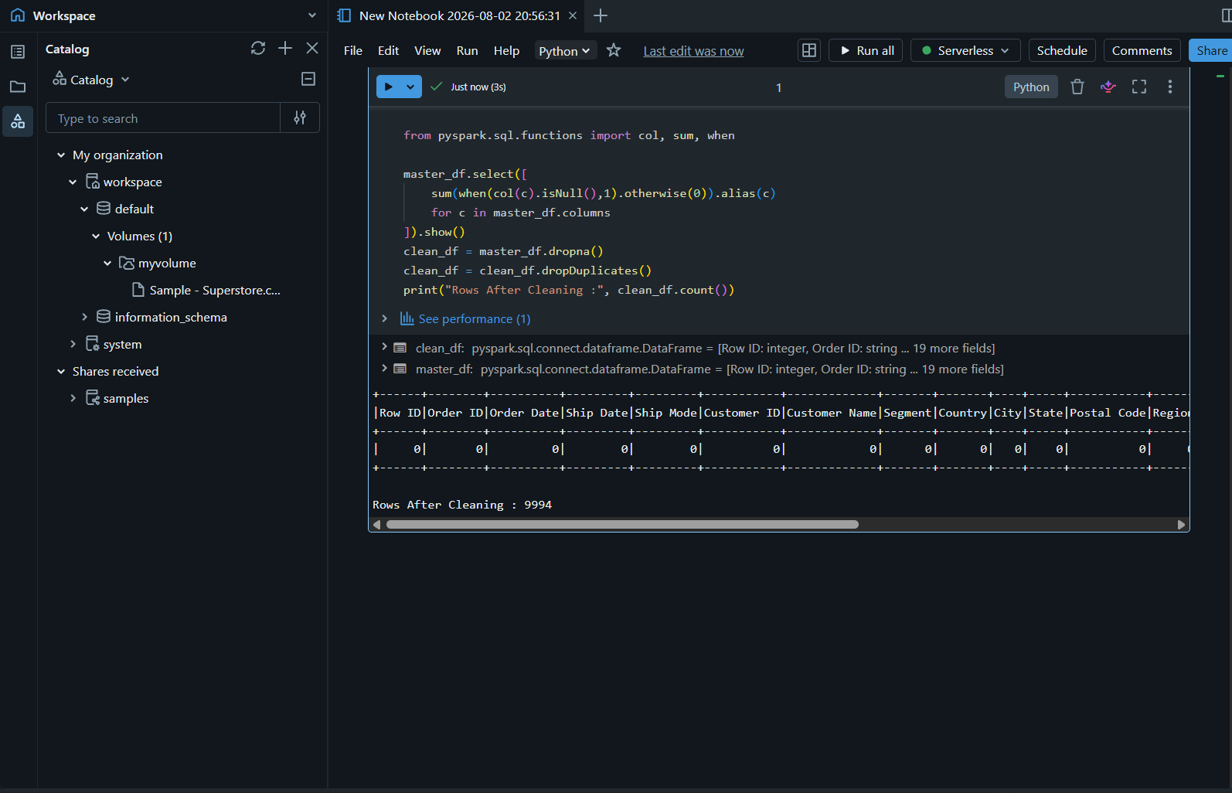

Scd1
Created the managed Delta table superstore_master.
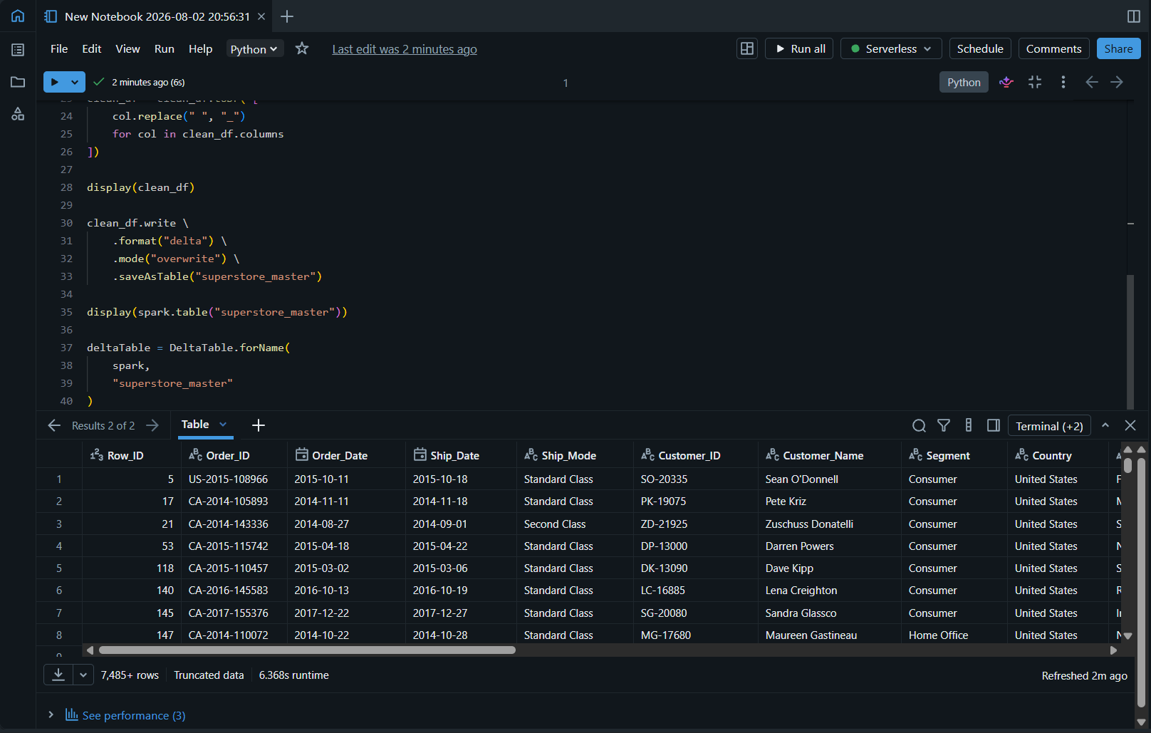

Scd2
Created an incremental dataset from the master table.
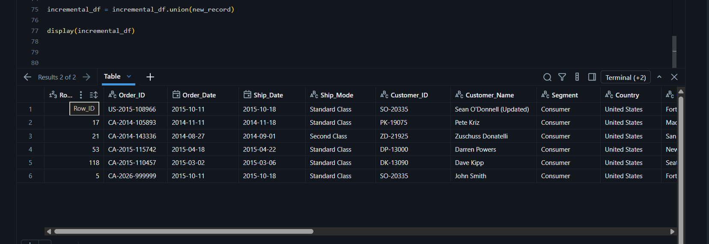

Scd2
Modified an existing record to simulate an update.
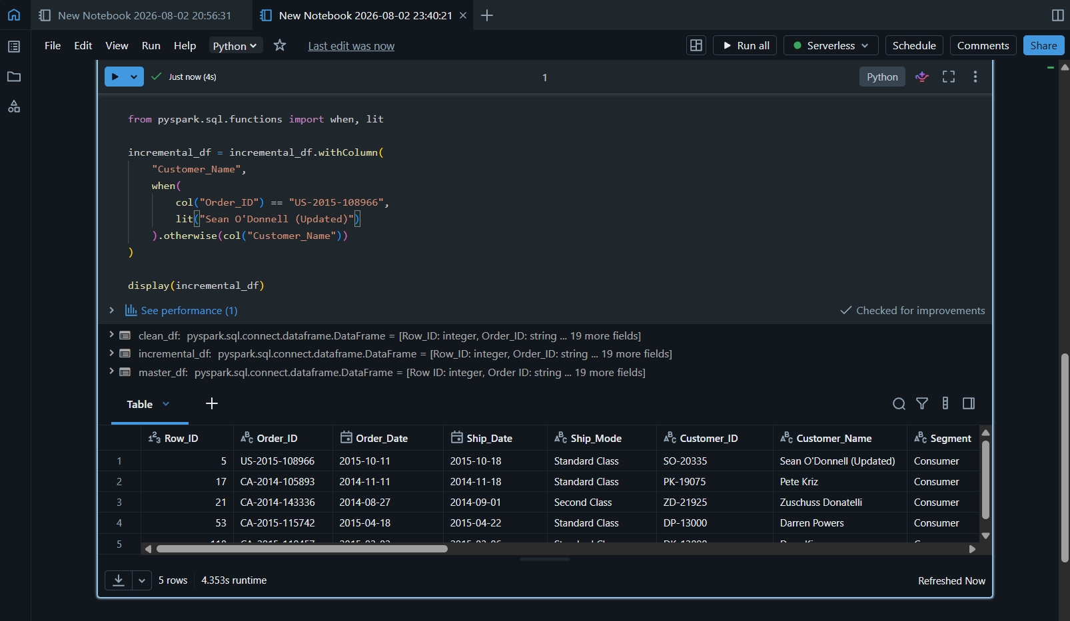

Scd2
Created a new record to simulate an insert.
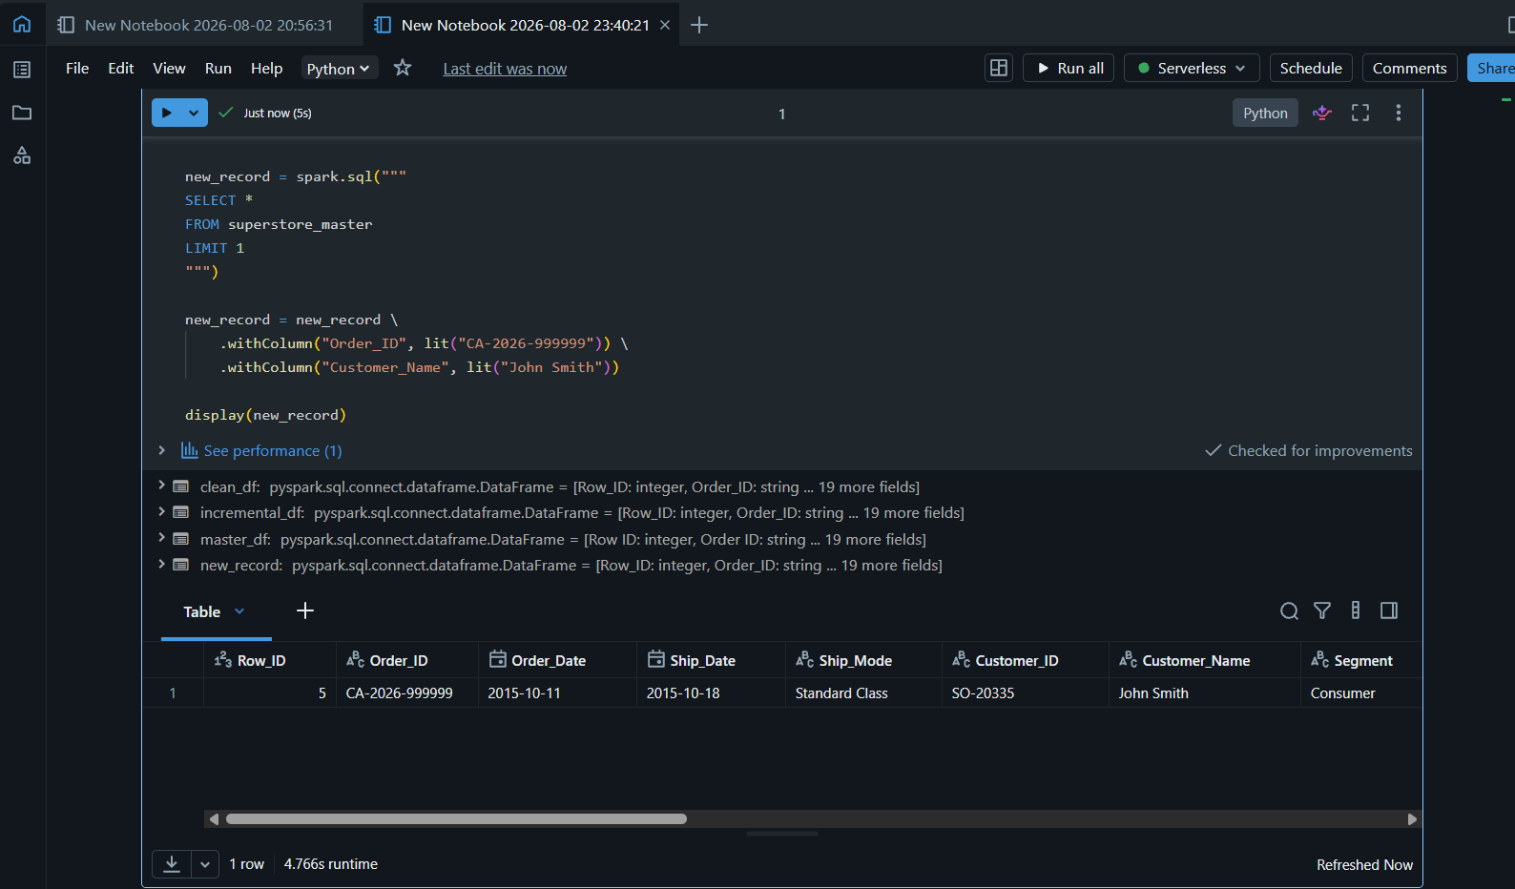

Scd2
Executed the Delta Lake MERGE operation.
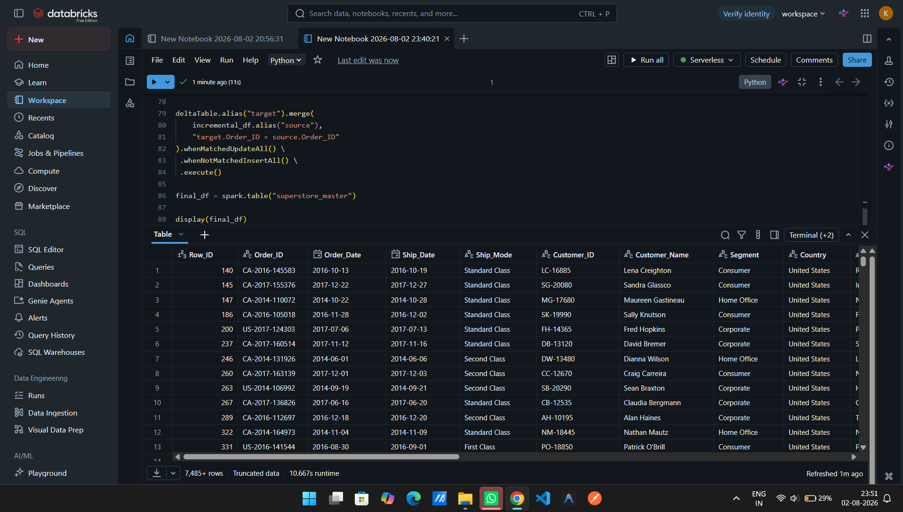

Validation
Verified the updated record after MERGE.
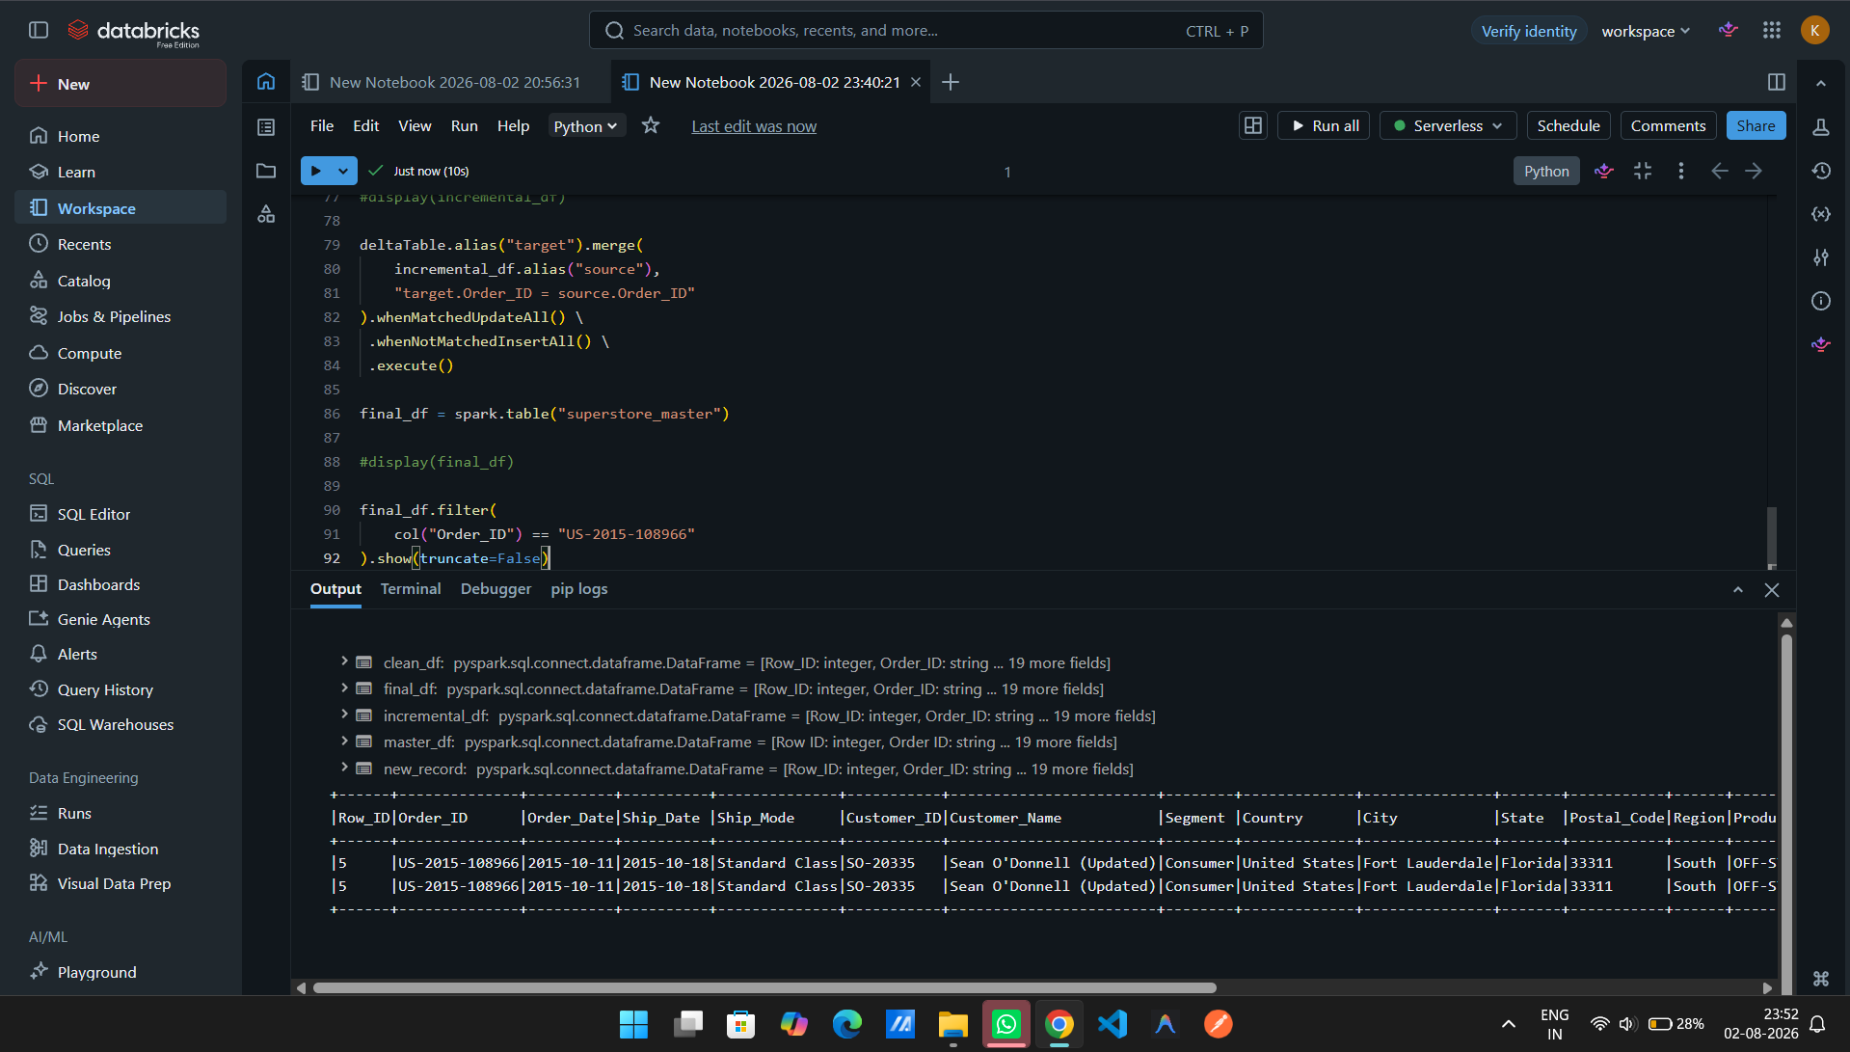

Validation
Verified the newly inserted record.
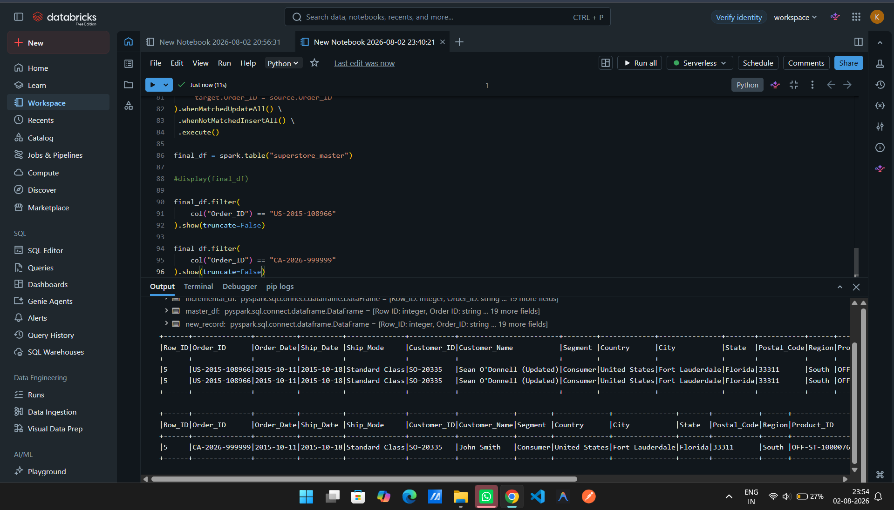

Validation
Validated row count before and after MERGE.
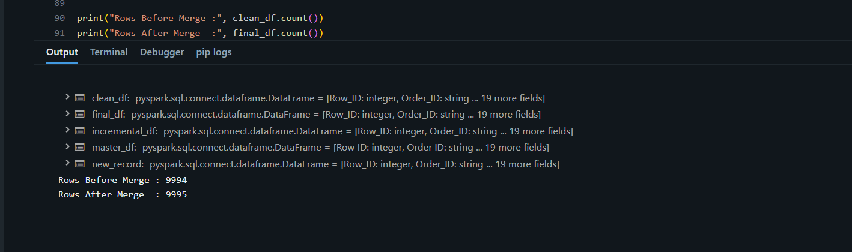

Final Output
Displayed the final Delta table after MERGE.
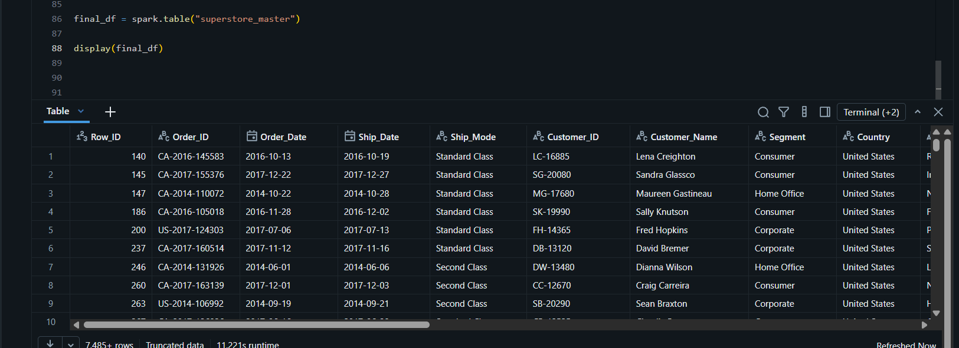

Conclusion
The Delta Lake MERGE implementation successfully demonstrated incremental processing by updating existing records and inserting new records into the Delta table.

