Supermarket Sales Executive Decision Report
Author: Parth More | IBM SkillsBuild Data Analytics with AI Internship

1. Executive KPIs (Level 1)
Metric | Value
Total Revenue | $321,655.27
Total Orders | 1,000
Average Order Value (AOV) | $321.66
Average Rating | 7.48 / 10
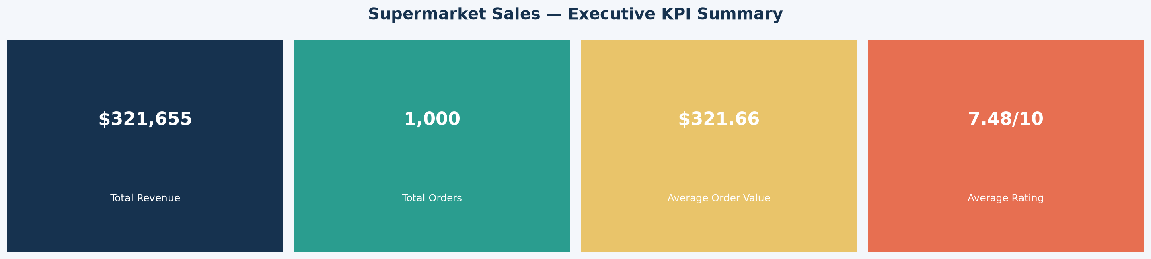

2. Revenue Drivers (Level 3)
Electronic accessories is the leading product line, generating $56,724.33. Fashion accessories is the lowest-revenue category at $50,493.26.
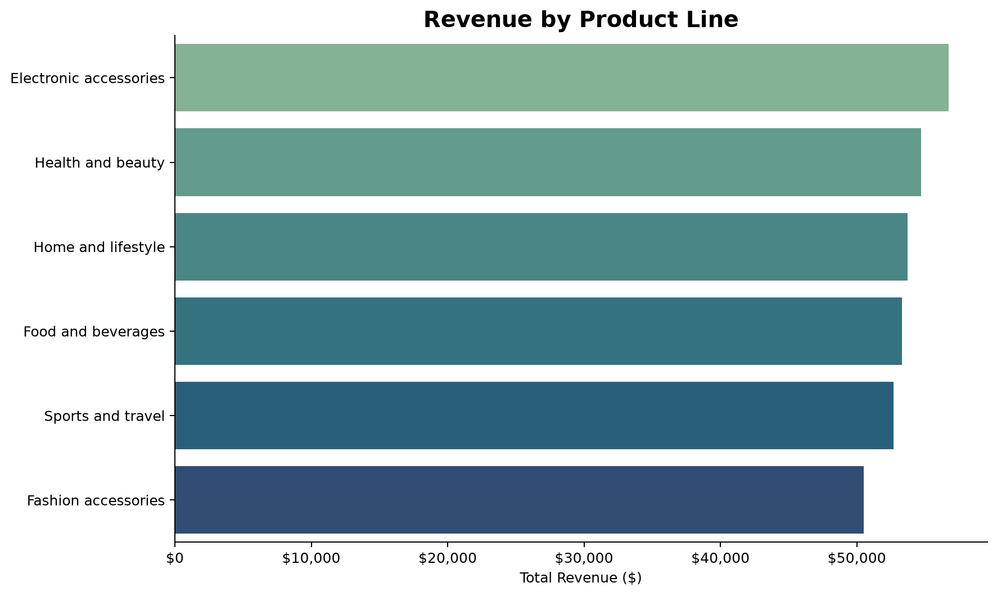

3. Risk Analysis (Level 4)
The overall customer rating is 7.48/10. Categories below this benchmark represent potential customer experience and churn risks:
- Electronic accessories: 7.35/10 average rating.
- Food and beverages: 7.39/10 average rating.
- Sports and travel: 7.45/10 average rating.
- Fashion accessories: 7.46/10 average rating.

4. Strategic Recommendations
- Fact: Electronic accessories leads revenue at $56,724.33. Insight: demand is concentrated in a category leader. Opportunity: increase basket size through complementary products. Action: test cross-sell bundles and track AOV for four weeks.
- Fact: Fashion accessories is the lowest-revenue category at $50,493.26. Insight: visibility, assortment, or pricing may be limiting demand. Opportunity: recover revenue with a targeted intervention. Action: run an end-cap or price test against a control period.
- Fact: 4 product categories are below the overall rating benchmark of 7.48/10. Insight: category-level service or product issues may affect repeat purchase. Opportunity: address root causes before churn grows. Action: collect category-specific feedback and set a rating recovery target.

