Project: Task Management Application

Problem Definition
Problem: People often struggle to manage their tasks efficiently, especially with multiple tasks and deadlines. Many users use basic tools (e.g., to-do lists) without any structured system to track priorities, deadlines, and progress.

Objectives and Expected Outcomes
- Objective 1: Provide a clean user interface to manage tasks.
- Objective 2: Allow users to categorize tasks by priority, due date, and status.
- Objective 3: Allow users to set reminders for upcoming tasks or deadlines.
- Objective 4: Provide the ability to view tasks in a list or calendar format.
Expected Outcomes:
- A web or desktop application where users can create tasks, set deadlines, and prioritize them.
- A notification system to remind users of deadlines.
- Task visualization in a way that helps users easily track their progress (e.g., color-coded tasks by priority).
Concepts Learned in the Course
For this application, we would use concepts like:
- Data Structures: Store tasks and their attributes (title, description, priority, deadline, status) using lists or dictionaries.
- Modularization: Separate different parts of the application (e.g., task creation, task listing, notifications) into separate functions or classes.
- Algorithms: Sort tasks by deadlines, priorities, or status (e.g., tasks due soonest).

Requirement Analysis
Functional Requirements:
- Create tasks: Users should be able to create tasks, specify their title, description, priority (low, medium, high), and due date.
- View tasks: Users should see their tasks in a list or calendar view.
- Update tasks: Users can edit or delete tasks.
- Set priorities: Users can set the priority for each task.
- Task status: Users can mark tasks as "To Do", "In Progress", or "Completed".
- Notifications: Reminders for tasks that are near their deadline.
Non-Functional Requirements:
- The system should be simple, responsive, and quick to load.
- The system should be secure (basic validation to prevent invalid inputs).
- The user interface should be intuitive and user-friendly.

Top-Down Design / Modularization

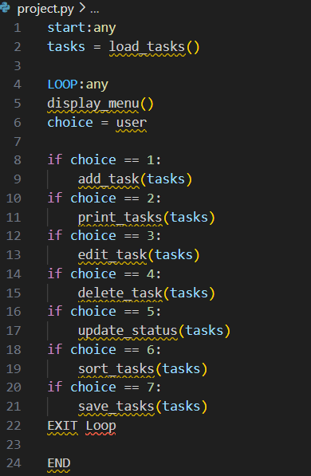

Implementation
Step 1: Task Creation and Storage
- Create a function to add a task to the list.
- Store each task as a dictionary with keys like title, description, priority, due_date, and status.
Step 2: Task Display
- Create a function to render the tasks in a list format.
- Allow users to filter and sort tasks by status, priority, or deadline.
Step 3: Notifications
- Add a basic notification system to alert users when a task's deadline is approaching (can be a simple console log or use browser notifications).

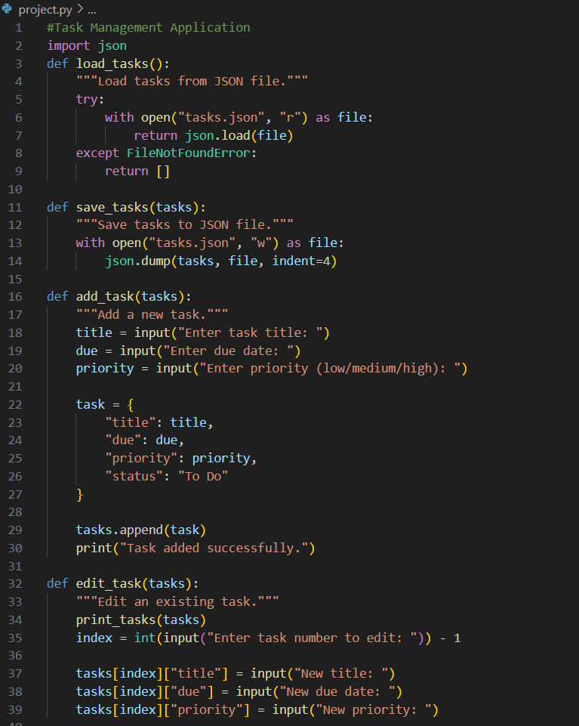
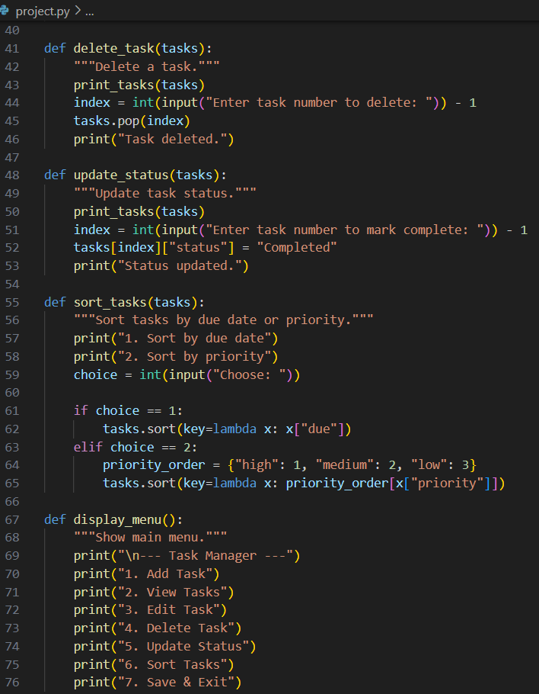

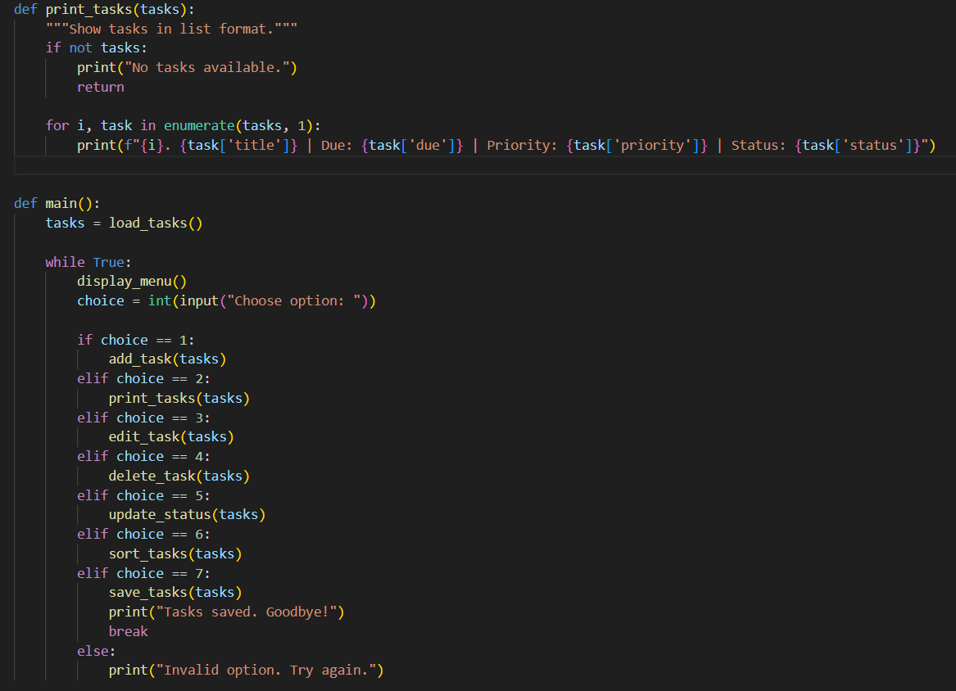

- Testing and refinement

