Hello sir, This is readme file for my Practical Test

Steps:

1 Update Composer

2 Create Database and set credential into .env file

3 Run commands:

* php artisan migrate
* php artisan db:seed (It will create Admin User and Sample Products with Inventory)
* php artisan serve

4 <http://127.0.0.1:8000/admin/login> to login in admin panel

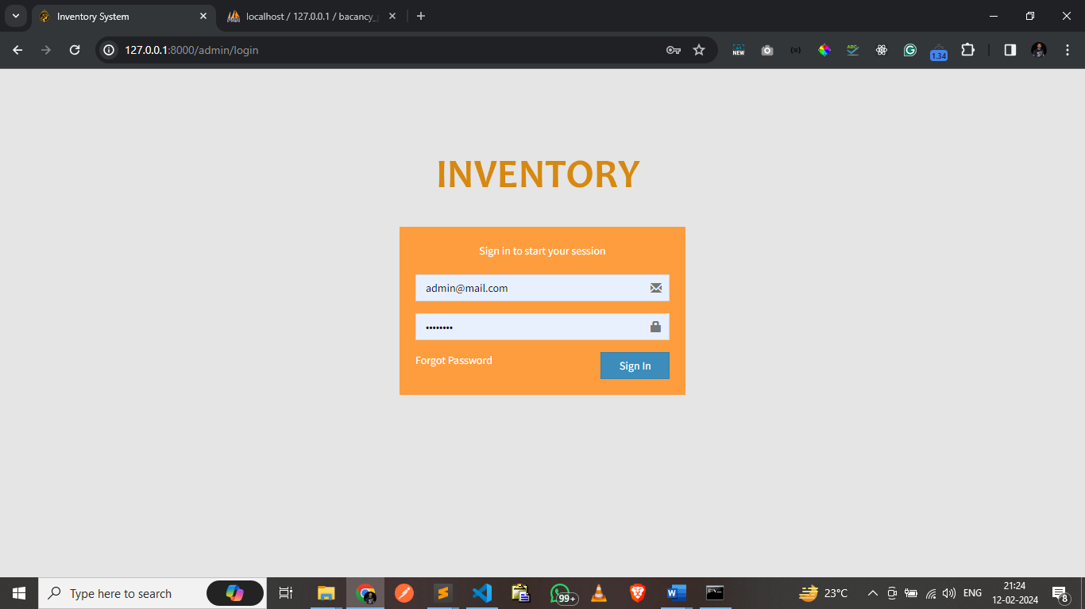

5 Credentials: [admin@mail.com](mailto:admin@mail.com) Password: 12345678

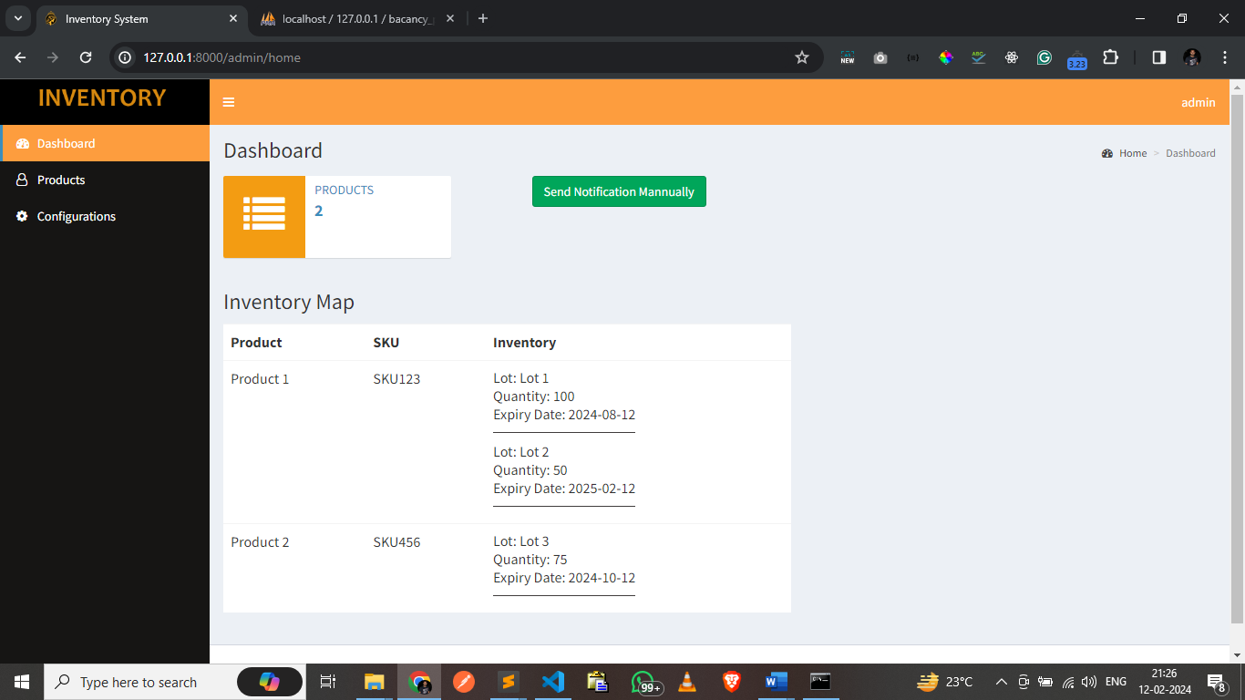

Here Products Count and Inventory Map along with Manually Sent Notification for Stock

Mail for empty:

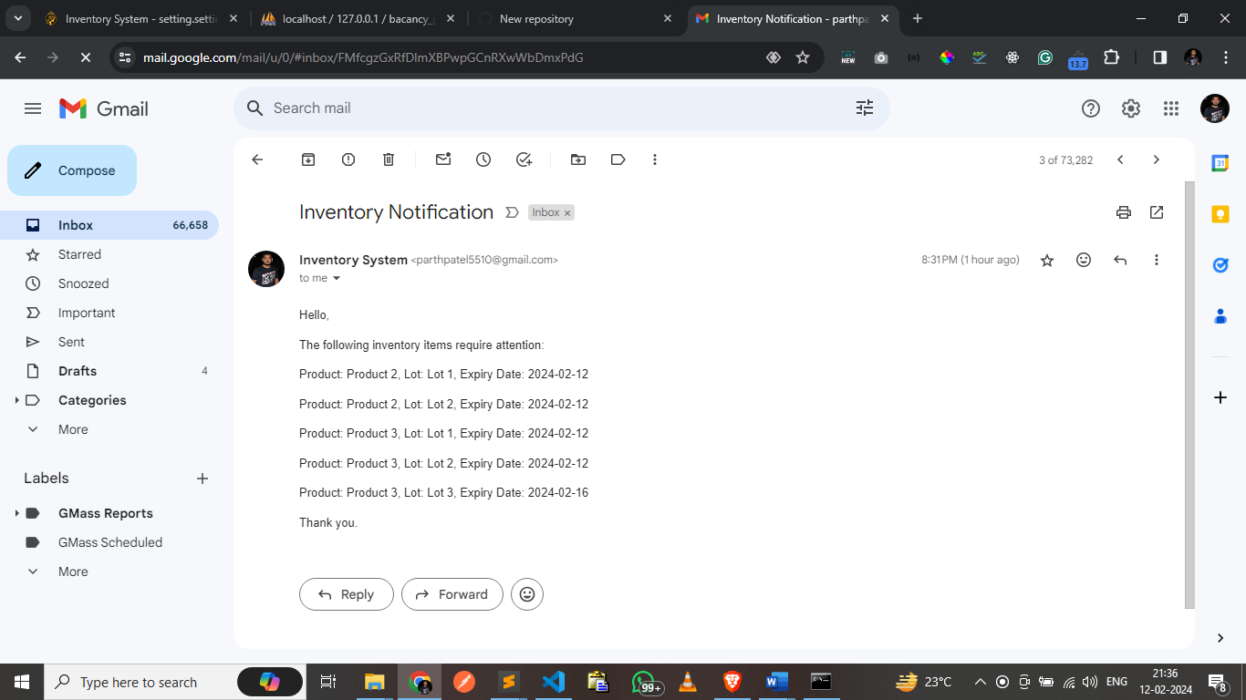

6 <http://127.0.0.1:8000/admin/products>

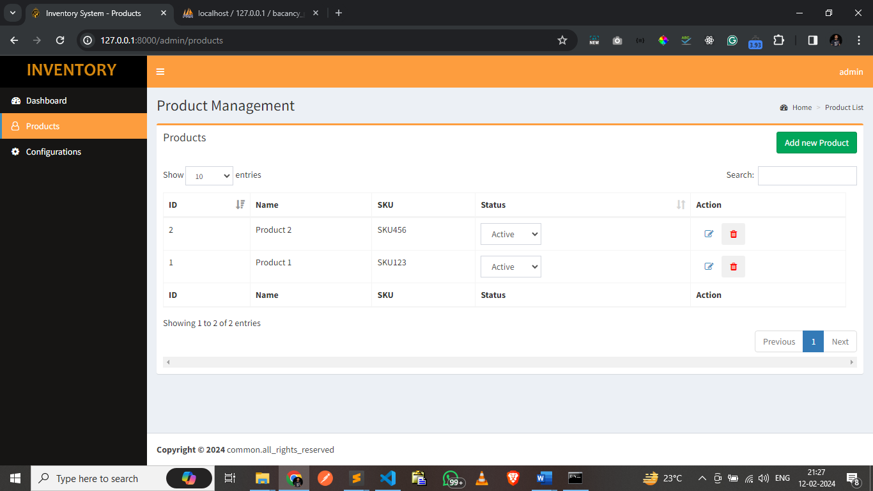

List of Products and also pls click on Add new Product button, you will get product add screen

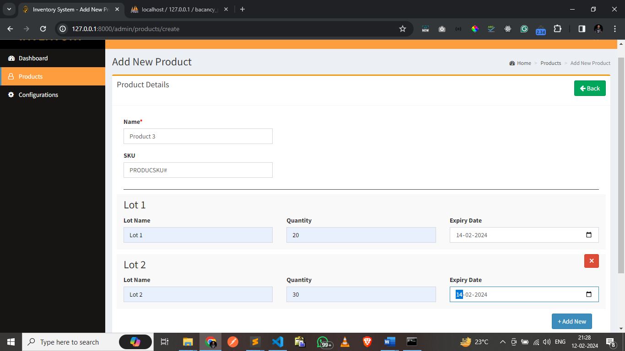

7 click on Configurations: <http://127.0.0.1:8000/admin/setting>

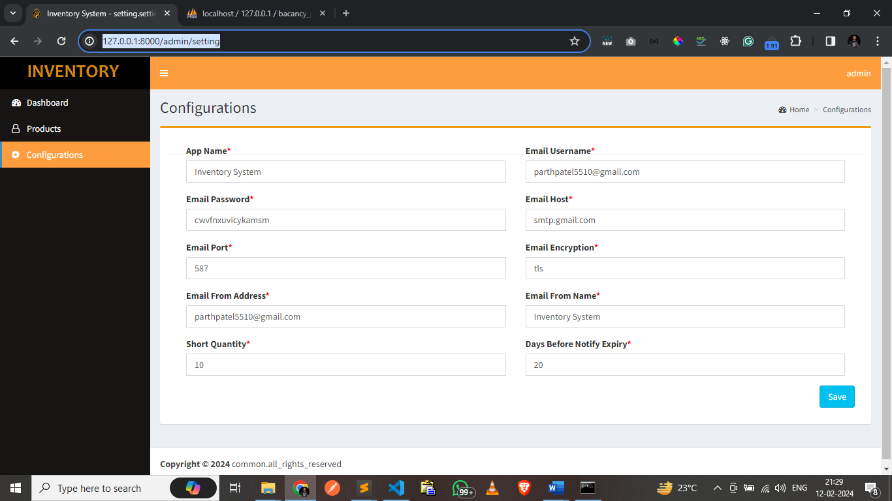

You can Update **Short Quantity** and **Days Before Notify Expiry** parameter to set low stock notification configuration also SMTP credential also can be uodated.

Command to Get Low Stock Notification for CRON  
**php artisan low_stock_notification**

**Thank You**

* Parth Patel