Company Profile



NILMAY SYSTEM

10, 1ST Floor, Ghanshyam Complex, Beside Anand Urban Bank, Gamdiwad,
ANAND – 388 001 (Gujarat) India

Phone: +91-2692-241122 | Mobile: 091-94263 99922 | E-mail: nilesh@nilmay.com

www.nilmay.com

ABOUT US

NILMAY is trading Information Technology Products and providing IT Solutions since 1991 to SME, Educational Institutes. Government Enterprises, IT Re-sellers. We have vast experience of different verticals and dedicated team of experts. NILMAY has partnership with Industry's leading manufacturers like IBM, Lenovo, Red Hat, Netgear, D-link, Digisol, Canon, Epson, HP, Symantec, Kaspersky, Iomega, APC, Cyberoam, Tally, Smart Station, BSNL, Vodafone etc.

We deliver ITeS like:
- Project reporting and feasibility studies
- Project Budgeting & Implementation
- Implementation and Planning
- Project execution according to time line
- Documentation & ISO like standardization
- Cyclic Review of projects
- Corporate Training

We have solutions for Servers, Storage, LAN, WAN Network using copper/fiber/Wi-Fi, Surveillance Camera, Backup & Disaster Planning, UPS, VoIP, video Conferencing, E-mail & collaborative communication suit, Firewall & UTM etc.

We want to associate with you to deliver IT services. Please register us in you IT supplier list and let us know your needs.

MISSION

We are a market-focused, process-centered organization that develops and delivers innovative solutions to our customers, consistently outperforms our peers, produces predictable earnings for our shareholders, and provides a dynamic and challenging environment for our employees.

OUR VISION

Delivering Intelligent Solution for Comfortable Work life.

Delivering = Our actions speak louder than words. We are accountable: doing what we say we're going to do efficiently and on time.

Winning = We act with confidence. We're proud to win. We push ourselves to greater heights. And we don't settle for less than being the best.

Solutions = We listen to our customers and understand their needs. We offer products, services and innovative thinking that enable our customers to achieve success.

Inspire = Our inspiration is contagious and enables us to unleash creativity to help people achieve their goals. Our motivation and enthusiasm inspire others to succeed.

Work life = We combine our energy for work with our passion for life. We are creating a fuller, more enriched lifestyle. We share the desire to maximize human potential to achieve personal dreams.

Our Clients

Educational Institutes
- Information Technology Center, Anoopam Mission, Mogri
- SVIT College, Vasad
- GCET College, V.V.Nagar
- R H Patel Institute of Technology, Goblej
- Anand Pharmacy College, Anand

Heavy Engineering / Manufacturing Companies
- Swiss Glascoat Equipments Ltd., V.U.Nagar
- EITL ( Elecon Group company), V.U.Nagar
- Anoopam Adhesive Industries, V.U.Nagar
- Polycraft Puff Machinery Manufacturing Pvt. Ltd, Vadodara
- Dhruv Pipe Line Products Pvt. Ltd., Savli

FMCG / Food Industries
- Laxmi Sancks Pvt. Ltd. (Real Namkeen), Nadiad
- ETG Agro Products (Parle), Mumbai

Government Organizations
- District Civil Court, Anand
- Charotar Gas Sahkari Mandli Ltd.

Telcos and ISP
- BSNL (Government of India Enterprises)
- Snet Internet Services, V.V.Nagar
- Reliance Jio

Chemical Industries
- Soyventic Chemicals Pvt. Ltd., Vadodar

Infrastructure Industries
- Patel Infrastructure Pvt. Ltd., Anand

KPO
- Collabera, Vadodara

Hospitals & Health Care
- Aarna Multi specialty Hospital, Paldi, Ahmedabad
- Anand Leproscopy Hospital, Anand
- Shriji Hospital, Dr. Savan, Anand

Servers, Systems & Parts
Server | 
Desktop / Workstation | 
Processor | 
Mother Board | 
Hard Disk | 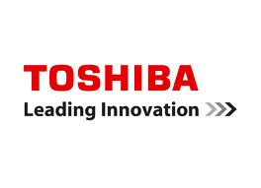
Key Board / Mouse | 
Cabinet | 
Monitor | 
Thin Client | 

Network Products
Switches / Router | 
Cables , Connectors & Accessory | 
Racks | 
Voice / Video Gateway | 
Surveillance | 
Access Control | 
Storage | 
UTM / Firewall | 
Wireless Indoor | 
Wireless outdoor
ISP |   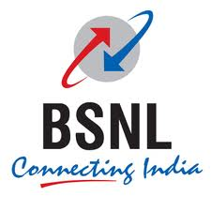

Software
OS & NOS | 
Anti Virus | 
Accounting Package | 
ERP Solution | 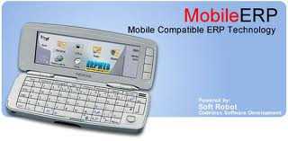
End Point Security

Peripherals
U.P.S
Scanner | 
Projector | 

* We acknowledge and respect trademarks & Logo of their owners.

