Business Health Report
A Mid-Size Pharmaceutical Distribution Firm In India
Prepared 27 June 2026 · covers FY 2022-23 to 2025-26
Portfolio version — identities anonymised, firm name withheld.

Executive summary
Business Health Index: 69.9/100 (grade D).
Stable with clear improvement areas — solid core, specific risks to manage.
Revenue is in multi-year decline (4-year CAGR -1.9%) while gross margin is easing from recent levels — A Mid-Size Pharmaceutical Distribution Firm In India is trading at tighter volumes but better margins. Collections and cash conversion are strong (a cash-heavy, route-based model); the main pressure points are customer retention and inventory efficiency.
The three highest-value actions:
• Protect the recovery: secure top-decile customers with service SLAs. — expected impact: high impact on sales.
• Open annual rate/scheme negotiations with the top-3 suppliers. — expected impact: up to ₹459,182 (suppliers).
• Hand route salesmen a weekly churn/at-risk call list to re-engage silent retailers. — expected impact: up to ₹13,776,759 (customers).
Health Index under different strategy lenses: Balanced 70, Conservative 74, Growth 64, Cash Preservation 81, Profit Optimization 73, Custom 71.
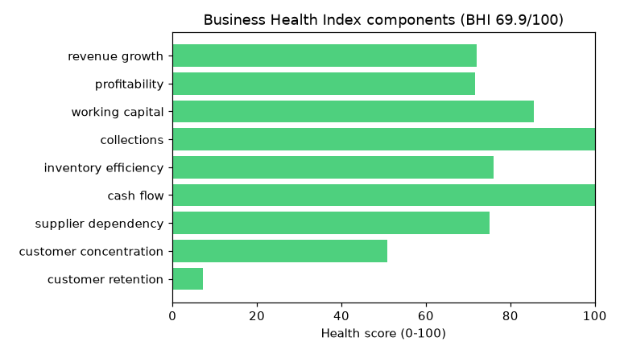

Multi-year trend analysis
Measure | 22-23 | 23-24 | 24-25 | 25-26 | CAGR | Trend
Revenue (₹) | 141,945,897 | 128,325,029 | 126,074,184 | 134,159,770 | -1.9% | falling
Gross profit (₹) | 6,410,612 | 6,335,615 | 6,728,703 | 7,194,207 | +3.9% | rising
Purchases (₹) | 136,196,507 | 119,752,233 | 123,314,923 | 127,218,632 | -2.2% | falling
Bills (count) | 39,009 | 40,254 | 41,213 | 42,846 | +3.2% | rising
Gross margin (%) | 4.51% | 4.90% | 5.29% | 5.15% | +4.5% | softening

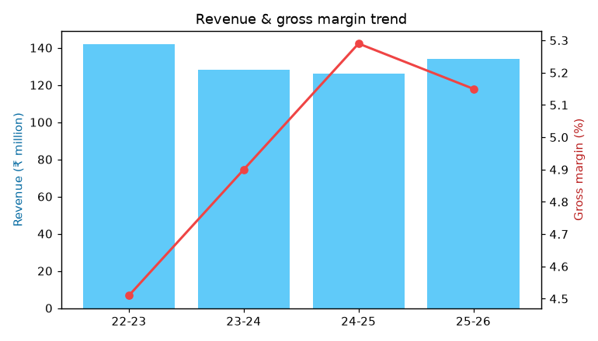
So what: profit growth on softer revenue is a margin/mix gain — protect the pricing discipline that produced it.

Findings by domain
Sales · scorecard 72/100 (C)
What happened: Revenue grew 6.4% YoY to ₹134,159,770 across 42,846 bills.
Why: Driven by higher bill volume and higher average bill value.
Business impact: ₹8,085,586 change in top-line revenue.
Profitability · scorecard 73/100 (C)
What happened: Gross margin 5.15% (profit ₹7,194,207), -0.14pp YoY.
Why: Margin movement reflects pricing/mix more than volume.
Business impact: ₹465,504 change in gross profit.
Customers · scorecard 26/100 (F)
What happened: 1,793 customers billed this year; of 1,307 established retailers, retention is 57.2% (456 churned, 104 at-risk).
Why: Churn here is repeat retailers going silent vs their own ordering cadence — a route-coverage/service issue, not walk-in attrition.
Business impact: ₹13,776,759 of prior-year billings sit with churned retailers who could be won back.
Products · scorecard 100/100 (A)
What happened: 6,909 products sold; top-10 concentration 5.7%.
Why: Revenue rests on a core set of fast movers with a large slow tail.
Business impact: Pricing and SKU-mix decisions are the main profit levers here.
Suppliers · scorecard 75/100 (C)
What happened: 63 active suppliers; top-5 dependency 48.7%.
Why: Procurement is concentrated among a few principals.
Business impact: Negotiation leverage and continuity risk both sit with the top suppliers.
Inventory · scorecard 80/100 (B)
What happened: Closing inventory ₹15,052,079; turnover 7.8x (~47 days).
Why: Turnover reflects how tightly stock is matched to demand.
Business impact: Every excess day of stock is cash locked up.
Working Capital · scorecard 90/100 (A)
What happened: Cash conversion cycle ≈28 days (down from 40).
Why: Inventory days dominate; receivables are minimal (cash-heavy model).
Business impact: The cash cycle sets how much working capital the business ties up.
Territory · scorecard 58/100 (E)
What happened: 32 active areas; top-5 concentration 59.6%.
Why: Sales are geographically concentrated around the core market.
Business impact: Geographic diversification is a growth lever.
Cash Flow · scorecard 100/100 (A)
What happened: Operating cash proxy ≈ ₹9,251,256.
Why: Working capital released ₹2,057,050 of the ₹7,194,207 gross profit.
Business impact: Cash generation depends on holding the working-capital line.

Key risks (ranked by severity)
# | Risk | Severity | Score | Description
1 | Customer churn | warning | 56 | 35% of established retailers have stopped ordering relative to their own cadence.
2 | Customer concentration | warning | 49 | Top-10 customers account for 32.3% of revenue.
3 | Margin erosion | warning | 43 | Gross margin is declining year-on-year.

Key opportunities (ranked by impact)
# | Opportunity | Est. impact (₹) | Confidence | Detail
1 | Win back churned retailers | 13,776,759 | 50% | 456 established retailers lapsed; they billed ₹13,776,759 in 24-25. Route-level win-back could recover a large share.
2 | Nurture high-growth customers | 4,866,214 | 60% | The 3 fastest-growing customers added ₹4,866,214 this year; deepen share-of-wallet with them.
3 | Release cash by trimming inventory days | 2,241,799 | 50% | Cutting days on hand from 47 to 40 would free ≈₹2,241,799 of working capital.
4 | Volume-based negotiation with largest suppliers | 459,182 | 60% | The top-3 suppliers represent ₹45,918,153 of annual spend; a 1% improvement in terms is worth ≈₹459,182.
5 | Pricing potential on high-volume, low-margin products | 106,823 | 50% | 89 high-revenue SKUs run below 3% margin; a 1-point price/discount correction is worth ≈₹106,823.
6 | Develop underperforming territories | — | 40% | The smallest active areas (e.g. 1/1 BELHE, WAGHOLI-(N/M-Party), MR ORDER) are well below the leaders — targeted coverage could lift them.

Prioritised recommendations (impact vs effort)
High-impact / low-effort actions come first. Each carries an expected business impact.
 | Low effort | High effort
High impact | ★ Protect the recovery: secure top-decile customers with service SLAs.  ★ Open annual rate/scheme negotiations with the top-3 suppliers.  ★ Hand route salesmen a weekly churn/at-risk call list to re-engage silent retailers. | • Set reorder levels by SKU velocity to cut slow-mover stock.  • Focus cash-cycle improvement on inventory, the dominant component.  • Review discount policy on the high-volume, low-margin SKUs identified.
Low/med impact | • Track the cash conversion cycle monthly to keep working capital from outrunning profit.  • Negotiate longer supplier credit to extend creditor days where relationships allow. | • Run a product-level margin review to prune chronically low-margin SKUs.  • Trigger proactive outreach when a retailer crosses its at-risk gap threshold.  • Rationalise the slow-moving long tail to cut carrying cost.  • Run a coverage/route review for the bottom-quartile territories.  • Diversify the customer base to reduce reliance on the top-10 accounts.

Ranked action list with expected impact:
# | Recommendation | Impact | Effort | Conf. | Expected business impact
1 | Protect the recovery: secure top-decile customers with service SLAs. | high | low | 65% | high impact on sales
2 | Open annual rate/scheme negotiations with the top-3 suppliers. | high | low | 65% | up to ₹459,182 (suppliers)
3 | Hand route salesmen a weekly churn/at-risk call list to re-engage silent retailers. | high | low | 60% | up to ₹13,776,759 (customers)
4 | Track the cash conversion cycle monthly to keep working capital from outrunning profit. | medium | low | 60% | medium impact on cash flow
5 | Negotiate longer supplier credit to extend creditor days where relationships allow. | medium | low | 55% | medium impact on working capital
6 | Set reorder levels by SKU velocity to cut slow-mover stock. | high | medium | 60% | up to ₹2,241,799 (inventory)
7 | Focus cash-cycle improvement on inventory, the dominant component. | high | medium | 60% | high impact on working capital
8 | Review discount policy on the high-volume, low-margin SKUs identified. | high | medium | 55% | up to ₹106,823 (products)
9 | Run a product-level margin review to prune chronically low-margin SKUs. | medium | medium | 60% | medium impact on profitability
10 | Trigger proactive outreach when a retailer crosses its at-risk gap threshold. | medium | medium | 55% | up to ₹13,776,759 (customers)

Appendix — method & assumptions
The Business Health Index is a weighted average of KPI health scores; thresholds and weights are documented in the codebase (KPI registry and health-index profiles) and tuned to route-based pharma distribution. Figures reconcile to the ERP totals to the rupee. Forecasts (separate strategic report) carry confidence intervals and backtested accuracy. Customer churn is measured by recency relative to each retailer's own ordering cadence.
Components and scores: revenue growth +6.4% → 72 · profitability 5.15% → 72 · working capital 28 days → 86 · collections 8 days → 100 · inventory efficiency 7.8x → 76 · cash flow 6.90% → 100 · supplier dependency 48.7% → 75 · customer concentration 32.3% → 51 · customer retention 57.2% → 7

